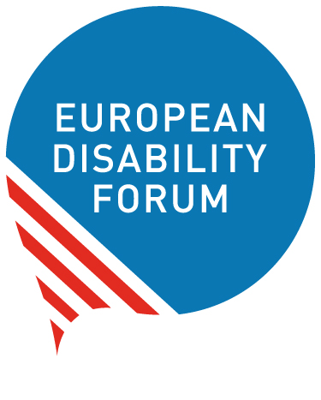 | European Disability Forum  nothing about us without us  Avenue des Art 7-8  1210  Bruxelles  www.edf-feph.org

EDF Artificial Inteligence Grants Programme

The European Disability Forum (EDF) is opening a new funding stream under the “Disability inclusive Artificial Intelligence” with grants of up to 3,000 euro to support our members who want Artificial Intelligence (AI) to be designed so it better serves people with disabilities.
Artificial Intelligence and automated decision making are transforming the world. But too often these technologies are developed without consideration for the needs of persons with disabilities. With the launch of AI that can generate text, audio and video, AI has become a mainstream issue and there is new urgency to address its impacts. Now more than ever, it is important that organisations representing persons with disabilities have the skills and capacity to drive the inclusive AI debate forward in the public interest.

Scope of the grants
The EDF AI Grants Programme offers project funding for a specific set of activities or objectives. Funding is available for the following areas:
- Capacity building around AI
- Narrative building around AI
- Advocacy towards new policy developments around AI
- Research (AI-related topics)
- Organising or participating in AI–related events
The total amount available for EDF AI Grants in 2023 is 20.000 euro.
Individual grants can be from 500 up to 3.000 euro.
The duration of the grant is flexible, activities should be completed no later than the 30th of March 2024.

How to apply?
Please download and complete the short application form and budget template, fill them in and send these documents by email to EDF Funding and Grant Coordinator – Magdalena Verseckas by email: Magdalena.verseckas@edf-feph.org. Please write “#grant23” in the email subject line.
Applications can be submitted until 24th of September 2023.
The application form and budget template are the only documents required for an application. However, we may ask you for additional documentation before issuing of the grants.
The results will be announced to grantees by end of October 2023.

Who can apply?
The European disability Forum supports our Members from across Europe that want to shape policies so that Artificial Intelligence better serves people with disabilities and society.
Criteria for applications:
- Organisations must be EDF’s Members or members of EDF Members
- Organisations must be non-profit
- The activities must include needs of persons with disabilities and have disability angle
- Activities can be carried on national or European level
- All activities and outcomes must be accessible.
If you have any questions concerning the application process, please contact EDF Funding and Grant Coordinator – Magdalena Verseckas by email: Magdalena.verseckas@edf-feph.org

Evaluation
An assessment will be carried out by the EDF’s team. In case of doubts we will consult AI & Society Fund team.
The award criteria for this call are as follows:
− Relevance: extent to which the proposal matches the priorities and objectives of the call; clearly defined needs and robust needs assessment; clearly defined target group (20 points)
− Quality: clarity and consistency of project; logical links between the identified problems, needs and solutions proposed (logical frame concept, organisation of work, timetable, allocation of resources); feasibility of the project within the proposed time frame; financial feasibility (sufficient/appropriate budget for proper implementation; cost-effectiveness (20 points)
− Impact: ambition and expected long-term impact of results on target groups/general public; potential for a positive multiplier effect (10 points)
The following criteria will be taken under consideration:
Award criteria | Minimum pass score | Maximum score
Relevance | 15 | 20
Quality — Project design and implementation | n/a | 20
Impact | n/a | 10
Overall (pass) scores | 35 | 50
Maximum points: 50 points.
Individual threshold for the criterion ‘Relevance’: 15/20 points.
Overall threshold: 35 points.
Proposals that pass the individual threshold for the criterion ‘Relevance’ AND the overall threshold will be considered for funding — within the limits of the available call budget. Other proposals will be rejected.

Legal and financial set-up of the Grant Agreements
If you pass evaluation, your project will be invited for grant preparation, where you will be asked to prepare the Grant Agreement together with EDF Funding and Grants Coordinator.
This Grant Agreement will set the framework for your grant and its terms and conditions, in particular concerning deliverables, reporting, payments and funder’s acknowledgement.

Reporting

Deadline
Technical and financial reports should be submitted by 30th of April 2024.

Reporting templates
Reporting templates are 2 separate documents, but you can see how they look like below. Financial report can be submitted in excel or Word document.

The financial report shall be supported by a list of receipts, with adequate translation in English, documenting the project expenses. The invoices or equivalent documents shall be part of this financial report.

Technical report template
- General Information
  - Legal Name of organisation:
  - Contact person (name and email address):
  - Grant start date:
  - Grant end date:
- Project Summary
Please copy a short description of your project here, including the main goals outlined in your application
Insert text here
- Activities
Please tell us about your activities and outputs that you produced. If there have been any major changes in activities and outputs, please explain why the initial plan needed to evolve.
Insert text here
- Learnings
What are the key lessons you have learnt as part of this project? Can you tell us about the challenging aspects of your work and your successes?
Insert text here
- Impact
Please provide a short update on the impact you have achieved with your work. (E.g.: Did you create meaningful connections with other grantees and/or AI experts and policy makers?)
Insert text here
- Budget
Please mention and explain any budget variances here
Insert text here
5. Additional information/feedback
Is there additional information/feedback that you would you like to share that has not been captured in previous questions?
Insert text here

Financial report template (simple version)
 | Name of the organisation:
 | Contact email:
 | Expenses | Amount in local currency | Amount in euro | Comments
1
2
3
4
5
6
7
8
9
10
 | TOTAL | 0 | 0

