# Logo of the European Disability Forum

EDF Youth Committee

2022 Annual Report

|  |  |
| --- | --- |
|  | **The EDF Youth Committee poses for a photo with two members of the Executive and one member of the Secretariat.**  This publication has received financial support from the European Union. Views and opinions expressed are however those of the author(s) only and do not necessarily reflect those of the European Union or the European Commission’s CERV Programme. Neither the European Union nor the granting authority can be held responsible for them. |

# Table of Contents

Table of Contents 2

Introduction 2

Easy to Read 4

Activities in 2022 7

Representation and Participation of EDF Youth Committee 8

The Youth Committee as a Resource 10

Bringing the Youth Perspective in EDF Work and Policy 11

Publications 11

The EDF Youth Committee 12

Document credits 17

# Introduction

2022 was an important year for the EDF Youth Committee. In September a new youth Committee was selected, and in November the former Youth Committee handed over to the new one the keys to bring changes within the disability and youth movement. Another event made this year special for our youth committee: this year was dedicated to Young People. The European Commission declared 2022 as the **European Year of Youth (EYY).** We were present in the Stakeholder group along many organisations and the European Commission, and we were also represented in 2 Youth Dialogues with Commissioners and in other events organised within the framework of the EYY. Another reason to say this year was special is that the Youth committee helped the International Disability Alliance Youth Committee to organize the 24-hour Global Disability Summit GDS Youth for the MENA Europe Region. This was the first Youth Global Disability Summit ever organised.

For the year 2022, the Youth Committee held its activities under the topic of **Mental Health.** The main outcomes of this work were the webinar on Mental Health and social media and the tips to keep a good mental health when using social media.

The Committee organised or co-organised 2 webinars, 3 workshops, 2 committee meetings, out of which one was online and one in person, and took the floor in 20 other events. The Committee also wrote a newsletter on Youth, and messages for Youth Day and the European Day of Persons with Disabilities. Members of the Youth Committee, together with other young people participating in youth events, wrote 7 blog articles on our website and 2 news items. Members of the Committee participated in various events, one very interesting was the LevelUP Event at the European Parliament in Brussels, where 20 young people with disabilities joined in and EDF also gave a workshop on how to organize inclusive events.

With the occasion of the European Disability Forum’s 25th anniversary, the Youth Committee was invited in Episode 4 of the podcast series that draws the history of our organisation.

Finally EDF launched a [photo competition on Youth](https://www.edf-feph.org/edf-photo-competition-2022-shining-a-light-on-young-persons-with-disabilities/) as part of the European Year of Youth, in which the Committee was involved.

# Easy to Read

|  |  |
| --- | --- |
| Easy-to-read logo | The EDF Youth Committee is a **group of young people with disabilities**.  They talk about   * **Problems** of young people with disabilities. * **How to make things better** for young people with disabilities. |
| A person watering flowers growing out of a head. | In 2022 the Youth Committee talked about **Mental Health and about the European Union**.  The meetings were one online and one in person because there is less **coronavirus**. |
| The EDF Youth Committee poses for a photo with two members of the Executive and one member of the Secretariat. | The Youth Committee organised   * 2 talks * 3 training * 2 meeting of the Committee 1 online and 1 in Brussels   The Youth Committee took part in many European and international meetings. |
| Banner from the evernt "Mental Health and Social Media" | The Youth Committee wrote   * Tips to have a good **mental health** when using **social media** * A newsletter about young people. * A message on International Youth Day. * A message on the European Day of Persons with Disabilities. * Made a podcast about young people with disabilities. They speak about what they want in the future. |
| RulesA book of rules | The Youth Committee helped the European Union make new rules. |

|  |  |  |
| --- | --- | --- |
| Document with arrow pointing away from it | Easy to read logo | If you want more of this document in Easy to Read, go to [our website](https://www.edf-feph.org/easy-to-read/) |
| Telephone  **+ 32 2 329 00 56** | Email  [**info@edf-feph.org**](mailto:info@edf-feph.org) | You can phone us at  **+ 32 2 329 00 56**  Or email us at [**info@edf-feph.org**](mailto:info@edf-feph.org) |

# Activities in 2022

Mental Health was chosen by the members of the Youth Committee as the leading thread for our activities in 2022. The pandemic, that is still part of our lives, has shown more than ever the lack or precarity of the services in place to support the mental health of persons with disabilities. From one day to the other people were left without support, and the only support provided in this area, at best, was online. If young people without disabilities had a hard time during lockdowns, it was even more difficult for us with a disability. Additionally, mental health is still taboo in some of our Member States, and access to such services for persons with disabilities is not available in the mainstream networks. The EU also took steps forward, and during the EYY Mental Health was one of the pillars. Therefore, the Youth Committee decided to take a look into the effects of Social Media on our Mental Health. Social Media was very much used during COVID to stay in touch and have a discussion around the topic, when you have a disability seemed relevant. So the Committee went for a webinar with young people taking the floor, and a representative from Meta, one of the giants of social media, was with us. The tips gathered during the meeting to watch over one’s own mental health when using social media were nicely gathered and spread widely via our website and social media.

To continue our activism trend from last year and become real changemakers, the Committee continued its work in the 25% Project and gathered more than 500 ideas from young people with disabilities, and a group of young people joined for the first time in their lives a large scale youth activism event in the European Parliament in Brussels.

Making change does not happen so, you need to meet and discuss with decision makers. So did our Youth Committee. This year they were part of some of the Youth dialogues organised with Commissioners. It was not a first for our Youth Committee only, but also for the youth movement. We hope this was not a single opportunity, but it will become a tradition in the future.

The Youth Committee ended the year by making their dream come true. They have taken over the European Commission Conference co-organised with EDF “The European Day of Persons with Disabilities” and for 2 hours they brought up some issues important for the young people with Disabilities community: mobility in the EU, participation in decision-making, etc.

The other activities organised by the Youth Committee can be considered from three perspectives:

* Representation and participation
* The Youth Committee as a resource: giving workshops and taking the floor
* Bringing the youth perspective into policy work

## Representation and Participation of EDF Youth Committee

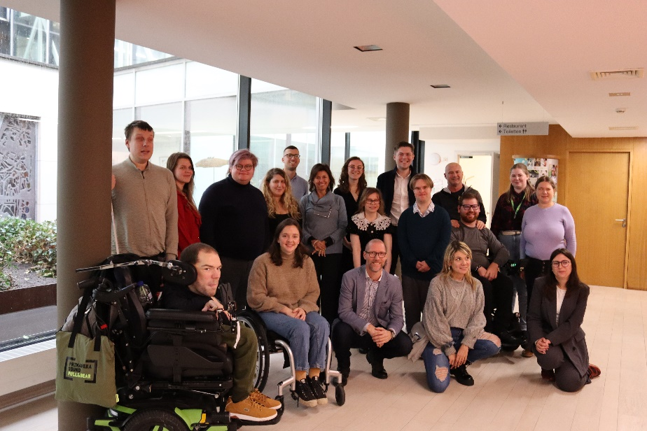

In 2022 the Committee organised or co-organised 2 webinars, 1 online meeting and a meeting in person, ran 3 workshops and took the floor in 20 events. In two of the events we organised, high-level representatives were present. while representatives from the EU Commission took the floor during the second multiplier event our partner organised in Porto, as well as in the final conference of the Inclusive Universities Working for inclusion, we organised and was hosted by the European Economic and social Committee in Brussels.

Below are some important events to which the Youth Committee has participated, represented by one or more members, and has often taken the floor.

* Participated to LevelUp, a large scale Youth Event organised in Brussels to celebrate Youth Activism in the framework of the European Year of Youth. For two days, young activists took over the European Parliament and had the opportunity to learn choosing from over 80 workshops. EDF was there with a group of 22 people. EDF gave a workshop on organising inclusive events.

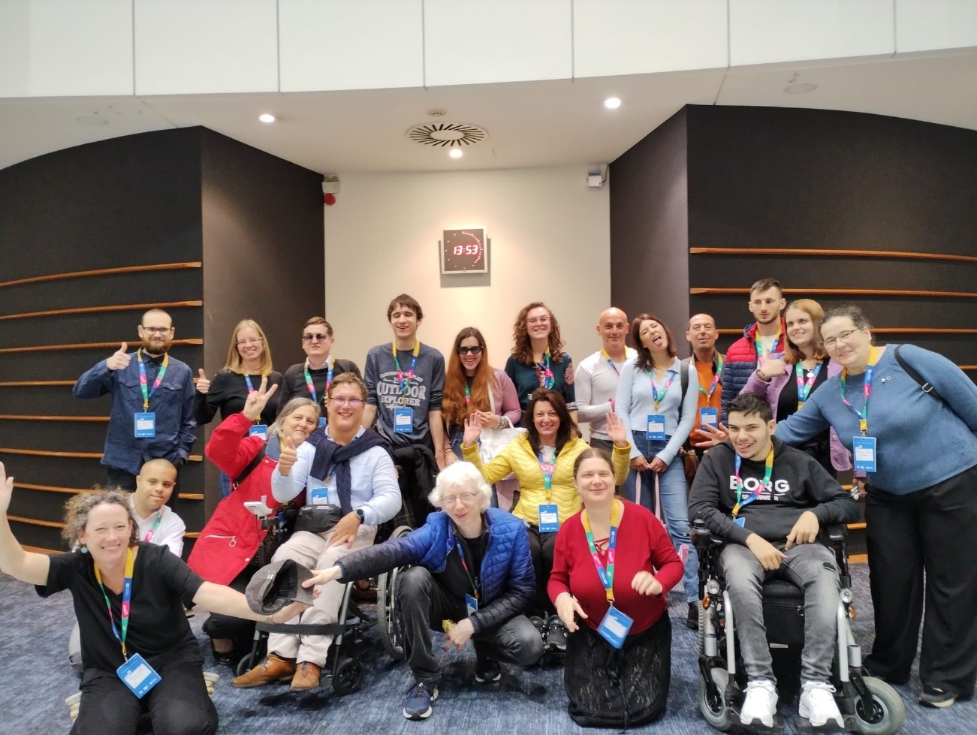

* Took part to a stakeholder group meeting on the European Year of Youth in January, April, June, September and December.
* Participated in the Council of Members of the European Youth Forum April 2022
* Participated in two youth Dialogues with [Commissioner Dalli](https://youth.europa.eu/news/family-of-policy-dialogues-4-equality-bodies-work-all-of-us_en) and Commissioner Schmit.
* 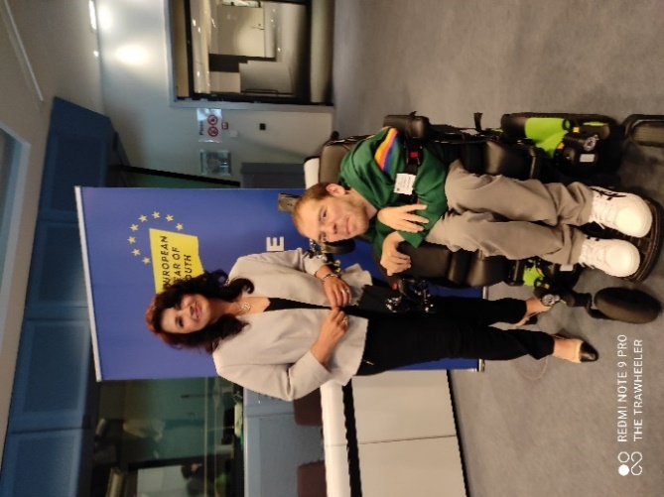Held online Youth Committee meetings in June and November 29th, jointly with the new and former Youth Committee.
* Took the floor during a [hearing of the European Economic and Social Committee on the Employment of Young People with Disabilities](https://www.eesc.europa.eu/en/news-media/news/eu-must-break-down-barriers-employment-young-people-disabilities)
* Participated in the Second Multiplier Event of the European Universities working on Inclusion in Porto and moderated a panel during the Final Conference of the same project in Brussels. This last event our EDF has organised it.

### Our youth committee is part of:

* European Commission’s stakeholders’ group on the European Year of Youth;
* Erasmus+ Coalition (and attended its 4 meetings in January, April, June, and September);
* Representing EDF at the External Advice Mechanism of European Climate Pact, and attended meeting on 16th November;
* Co-Chair of the Constituency of persons with disabilities within the regional civil society engagement mechanism (RCEM) of the Economic Commission for Europe;
* Inclusive Mobility Alliance;
* Advisory Group developing the training courses for future volunteers in the European Solidarity Corps.

## The Youth Committee as a Resource

The members of the EDF Youth Committee can provide interventions, trainings, or workshops.

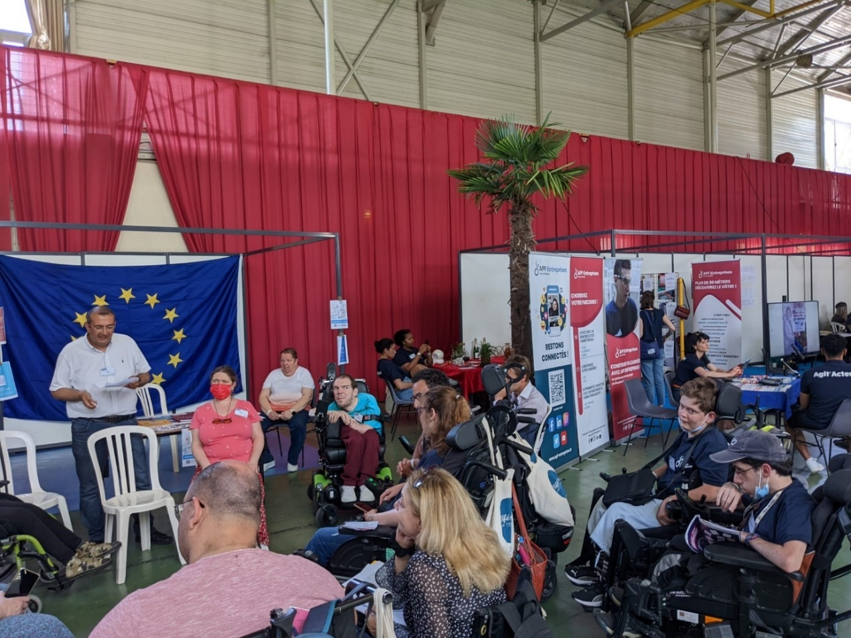

This year the Youth committee was once again invited in France to give a workshop on Your Rights in the EU. It was a large scale event with more then 400 young people with disabilities.

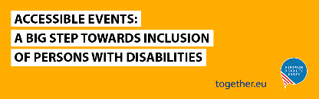[Accessible events: a step towards inclusion](https://together.europarl.europa.eu/event/accessible-events-a-big-steps-towards-the-inclusion-of-persons-with-disabilities-2022-12-08-1081/register) was a workshop given to young people within the Together EU network managed by the European Parliament.

## Bringing the Youth Perspective in EDF Work and Policy

The main mission of the Youth Committee is to bring the youth perspective within EDF and within the disability movement in general. With this goal, the Youth Committee brought its contribution to several items and publications:

* Provided feedback and testimonials for the 7th Human Rights Report on Employment as well as during the hearing organised on the topic by the European Economic and Social Committee.
* Gave feedback consultation on the Quality Framework of Traineeships
* Updated the Terms of Reference of The Youth Committee
* Provided Feedback on Equality bodies to Commissioner of Equality during the Youth Dialogue
* Provided feedback on to commissioner on Employment and Social Affaires within the Youth Dialogue.
* Provided feedback on the European Year of Youth.

Our organisation is undertaking a revision of its statutes where the Youth Committee is involved. This revision is an ongoing work for several years.

## Publications

|  |  |
| --- | --- |
|  | * [Messages for the International Youth Day 2022](https://www.edf-feph.org/international-youth-day-2022-the-voices-of-young-people-with-disabilities-at-edf/) * [Disability Voice 6 Dedicated to youth](https://mailchi.mp/edf-feph/dvapril2022-2514004?e=%5bUNIQID%5d) * [Messages from the Youth Committee on the European Day of Persons with Disabilities](https://www.edf-feph.org/blog/messages-from-the-youth-committee-with-the-occasion-of-european-day-of-persons-with-disabilities-2022/) 24 -25 November 2022. * Mental health and social media: tips from young people on how to take care of your mental health in the digital world * [Page on the European Year of Youth](https://www.edf-feph.org/eu-year-of-youth-page/) * Podcast on [EDF and Young People with Disabilities: the future of the movement](https://play.acast.com/s/for-the-record-25-years-of-the-european-disability-forum/edf-and-young-people-with-disabilities) |

### Other resources and articles published by our committee.

Below is a list of other contributions of the Youth Committee members in our work via their participation in one or several actions.

* [How to contribute to the European Year of Youth?](https://www.edf-feph.org/how-can-you-be-involved-in-the-european-year-of-youth/)
* [Policy dialogue of Commissioner Schmit with young people from across Europe](https://www.edf-feph.org/policy-dialogue-of-commissioner-schmit-with-young-people-from-across-europe/)
* [Our Trip to the House of European History](https://www.edf-feph.org/blog/our-trip-to-the-house-of-european-history/)
* [Advocating for ourselves: "I was able to realise what potential we have, despite our disabilities or special needs"](https://www.edf-feph.org/blog/advocating-for-ourselves-i-was-able-to-realise-what-potential-we-have-despite-our-disabilities-or-special-needs/)
* [LevelUp: representing persons with disabilities from Hungary at the European Parliament](https://www.edf-feph.org/blog/levelup-representing-hungarians-with-disabilities-at-the-european-parliament/)
* [Accelerating advocacy: a report from LevelUP at the European Parliament](https://www.edf-feph.org/blog/accelerating-advocacy-a-report-from-levelup-at-the-european-parliament/)
* [Travelling and attending an event as a wheelchair user](https://www.edf-feph.org/blog/travelling-and-attending-an-event-as-a-wheelchair-user/)
* [Inclusive Volunteering and the European Solidarity Corps – Interview with Ioannis Malekos, DG EAC](https://www.edf-feph.org/blog/inclusive-volunteering-and-the-european-solidarity-corps-interview-with-ioannis-malekos-dg-eac/)
* [Young Persons with Disabilities; real actors in the society?](https://www.edf-feph.org/blog/young-persons-with-disabilities-real-actors-in-the-eu-society/)
* [EUni4All-Network: fostering inclusion in higher education](https://www.edf-feph.org/euni4all-network-fostering-inclusion-in-higher-education/)
* Young European Voices Platform [Kamil Goungor’s Contribution](https://t.co/juQvhXf3j1)

## The EDF Youth Committee

### What is the Youth Committee?

The Youth Committee is an advisory governing body of EDF. It is composed of nine members aged 22 to 28 from all over Europe who represent all categories of disability. Since 2022 the young candidates who were not selected as part of the Committee are observers and support the work of the Committee, strengthening even further the youth work. It is chaired by one of its members, who is supported by a vice-chair, as well as by another member of the Committee, and by two of the members of EDF’s Executive Committee and by a staff member from the Secretariat to achieve its plans. The Youth Committee is devoted to representing the interests of young persons with disabilities – within the EDF and throughout Europe.

#### Members of the Youth Committee

Below you can get to know the members of the new Youth Committee. They started their work as of November 2022, until then the former Youth Committee represented EDF.

|  |  |
| --- | --- |
| Elias Tebibel chair of the youth committee | Elias Tebibel (Chair) was born in 1998 in Stockholm, Sweden. He is a proud born deaf from a deaf family with roots from Morocco and Algeria. He is a bachelor’s student of global development at Stockholm University. He is actively involved in different human rights defenders’ non-governmental organizations. He also works with equality questions on the national level, with a project called "Real Man". The purpose of the project is to work preventatively against men’s violence against women, i.e. destructive masculinity, violence and sexual violence, targeting young deaf men in particular. |
| Charlotte Aelbrecht vice chair | Charlotte Aelbrecht (Vice-Chair) was born in 1997 in Belgium, and joined the Youth Committee in 2022. Her motto is 'Everything happens for a reason.' After becoming paralysed at the age of 17, she therefore believes that becoming an advocate for people with disabilities is her purpose. She works as a teamleader for Dito, an organisation by and for people with disabilities and chronic illnesses as well as their families. Besides playing wheelchair tennis and going out with friends, she loves to travel and explore the world, always searching for a piece of untouched nature, a new culture and a new story to tell. |
| Alexandre Gomes member | Alexandre Gomes is a 22-year-old young man from France. He lived in an institution during his high school period, where he started his involvement in the youth movement and activism. He is now an associate board member of APF Handicap France, in his regional chapter, where he brings the perspective of young people. From this year he is working as Communications assistant in a company called NovaSancO. As a volunteer in IRTS Nouvelle-Aquitaine, he is examiner and trainer for device coordinators. He is an artist writing poetry, slamming and rapping for 10 years and he had the opportunity to show his talents on stage. |
| Amir Alibabic Member | Amir Alibabić was born in 1995 in Ljubljana, Slovenia. He has many roles. He is currently finishing his master’s programme of Political theory, he is president of Slovenian Association of Disabled Students, and he is one of the best Slovenian para dancer. At the early age of six, he had an accident when he was snow sledding, which resulted in a brain stroke. Since then, he has been in a wheelchair. His mission is to help people with disabilities, to encourage them and help them to develop. His stand is "nothing about disabled people without disabled people'' and " we are here, we know who we are and what we want”. His advice for all persons with disabilities: "Be strong, be persistent, always keep your goal in sight and don't let anyone stop you on your way". |
| Ben Rowsome member | Ben Rowsome lives in Bray, a large seaside town just outside the capital city of Dublin in Ireland. He is studying Astrophysics at Trinity College Dublin. He first became involved with the Irish Autism group AsIAm back in 2015, and has since partook in several conferences and exhibitions through his work with AsIAm. He has even appeared on TV in 2020 as part of the RTE 1 documentary “Changing Ireland — His Big Idea.” Some of his interests include music, chess, poetry, running and quizzing. |
| Jonathan Elebjörk Wahlström, member | Jonathan Elebjörk Wahlström is a Swedish lawyer with a passion for human rights, taxation law and EU-law. He is a long-time disability activist with a special interest for accessibility advocacy. Jonathan is currently working as Secretary General at the Swedish Organisation for Young Hard of Hearing People |
| Lydia Vlagsma, member | Lydia Vlagsma is 27 years old, and she comes from the Netherlands. Lydia is a young professional who brings her own lived experience as a chronically ill person to the table. She has a lot of international experience, studying the United Nations as a student in International Relations and as a professional in the CRPD monitoring process. She also gained international experience as a student through her involvement in a student debating society. Lydia’s expertise lies in the field of education, and she strives to connect education to work and income. |
| Nina Portolan, member | Nina Portolan studies molecular biology and physiology at the University of Belgrade. She is a human rights and disability rights activist. In 2020, she completed a long-term European Solidarity Corps exchange, volunteering at the European Network on Independent Living (ENIL). During that time, she developed and carried out the Independent Living survey, as well as getting involved with the preparation of various contributions and learning more on the topics of inclusive education, freedom of movement and others. She completed the “Vojin Dimitrijević” human rights school, organised by the Belgrade Centre for Human Rights, in 2021. Currently, she is a member of the UN Youth Advisory Group (YAG) for the UN office in Belgrade, as well as a Serbian disabled youth initiative IM-PACT 21. In her free time, Nina practices karate and is part of the national para karate team of Serbia. |
| Tamara Byrne, member | Tamara Byrne is a self-advocate from Ireland representing young people with intellectual disabilities in the Youth Committee. She has been speaking up for her rights and other people’s rights for many years. She is passionate about equality, human rights and fighting against discrimination. She worked with Inclusion Ireland on a project to make public services more accessible. She now works on a project with journalists to make sure the voices of persons with disabilities are heard in the media and not being discriminated against: “We are not objects, we are people.” |

# Document credits

This document was prepared by Loredana Dicsi with the contribution of the EDF Youth Committee

Proofread by Giulia D’Agnolo Communication & Knowledge Officer

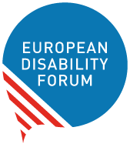

The European Disability Forum  
Mundo Madou  
Avenue des Arts 7-8  
1210 Brussels, Belgium.

[www.edf-feph.org](http://www.edf-feph.org)

[info@edf-feph.org](mailto:info@edf-feph.org)

This publication has received financial support from the European Union. The information contained in this publication does not necessarily reflect the official position of the European Commission.

