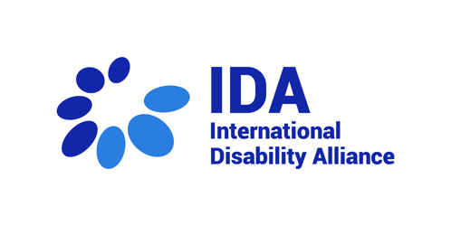
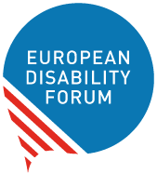

Statement on the situation of persons with disabilities and the Pakistan Floods 2022

The European Disability Forum and the International Disability Alliance present this joint statement to the EU Subcommittee on Human Rights (DROI) to highlight the situation of persons with disabilities during the ongoing situation of floods in Pakistan caused by torrential monsoon rains and melting glaciers in Pakistan’s northern mountain regions. While the situation is emerging, UN data has been released that 3.4 million children are in need of assistance and at increased risk of waterborne diseases, drowning and malnutrition and that (UNICEF). An estimated 33 million people have been affected through loss of homes, livestock and transportation options (CNN). By 9 September, more than 664,000 people were sheltering in displacement camps, with many lacking adequate shelter and access to adequate food, clean water and sanitation (UNICEF). 72 districts in Pakistan have been declared calamity-hit by the Government (UN Pakistan).

No disaggregated data has been published so far on the impact of the floods on lives, health and livelihood of persons with disabilities, however with the destruction of public health facilities, water systems and schools the impact on persons with disabilities is tremendous, especially based on the experience of earlier flood situations (STEP, 2011). International aid is supporting the situation, including the European Union that provided E350,000 in immediate assistance to people most affected by the climate catastrophe, especially in Jhal Magsi and Lasbella districts in the western Balochistan province (Deutsche Welle).

In line with Articles 11 and 32 of the Convention on the Rights of Persons with Disabilities, we request that DROI as well as the EU delegations in Pakistan meet with the organisations of persons with disabilities, in particular those representing underrepresented groups of persons with disabilities, including those listed at the end of this email. We also request that the EU uses its influence to urge the government of Pakistan and humanitarian agencies to ensure the inclusion of persons with disabilities in humanitarian action as provided in the IASC Guidelines Inclusion of Persons with Disabilities in Humanitarian Action, 2019. Due to its key role in supporting humanitarian response, EU may urge humanitarian responders to ensure collection of disaggregated data based on age, gender and disability; that the goods and services provided to survivors as well as process to access them is inclusive of and accessible to persons with disabilities; and finally, meaningful participation of persons with disabilities through their representative organizations in emergency response planning, implementation and monitoring.

For more information please contact Marion Steff, International Cooperation Manager, European Disability Forum (marion.steff@edf-feph.org) and Elham Youssefian, Inclusive Humanitarian Action and Disaster Risk Reduction Adviser, International Disability Alliance (eyoussefian@ida-secretariat.org)

Organisations of persons with disabilities in Pakistan/representatives of underrepresented groups

Special Talent and Exchange Programme, Mr. Muhammad Atif Sheikh, Executive Director atif@step.org.pk
National Forum of Women with Disabilities, Ms. Abia Akram, Founder abia.akram@gmail.com
Danishkadah, Mr. Muhammad Akram, President danishkadah@gmail.com
Growing Stronger (OPD of little people), Ms. Manaza Altaf, munaza.qmar@gmail.com
Mr. Waqar Puri, persons with psychosocial disabilities w.puri@tci-ap.org
Mr. Mohammad Iqbal, youth with disabilities, iqbaladrali@gmail.com
Mr. Qaim Ali, Indigenous persons with disabilities, qaimali1100@gmail.com

