
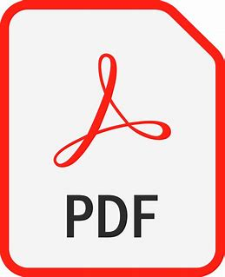
Please, save the form as a PDF document when you have filled it out and put a copy of the receipts on the form.



You can email the PDF copy of the form to
muriel.davia@edf-feph.org


Details of this meeting are:
NAME: Name of the event PLACE: Place of the event DATE: Date of the event
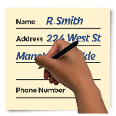
Personal Information and Payment information

Name of person who attended the meeting:
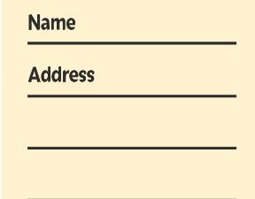
Name of the organisation:

Name of the person to receive the refund:
Address:
Email address:
Telephone Number:
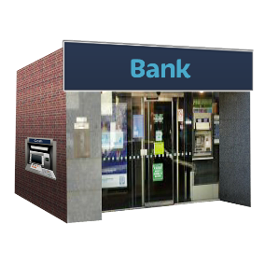
Bank Account Name and bank address of person to receive the refund:
IBAN Number:
BIC Number:

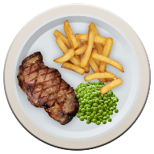
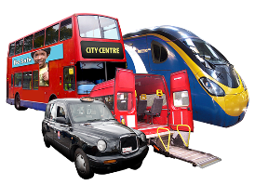
Travel and Accommodation Expense:
Please include a picture of all the receipts.
What type of expense are you claiming? | How much was the cost in € Euro? | This is the maximum amount that you can claim | EDF remarks  (for accountancy use only)
Travel costs - plane or train or bus  or if traveling by car you must explain why you had to drive. |  | Max amount repaid €400 per flight. This is all EDF are allowed by the funding department of the European Commission.  If you drive the milage rate is €0.41 per km.
Meals (attached receipt) |  | Max 20 € for lunches  Max 25 € for dinners
Accommodation Cost  (only paid back if bill is attached) |  | Maximum: look at the list on last page
Total

Signed: |  | Date:

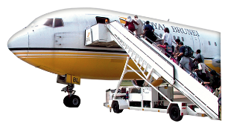
Travel Costs:
Flight ticket and boarding passes or train ticket.
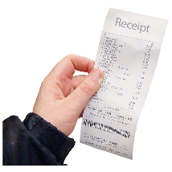
If you used your own car, please explain why.

Save the image of your receipt here:


Food and Additional Costs:
If EDF have planned a meal for the group they will not pay for another meal somewhere else.
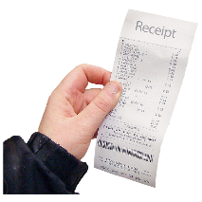

Save the image of your receipt here:

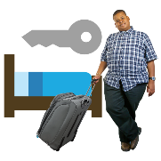
Accommodation Costs:

Save the image of your receipt here:

This is how much EDF will pay for a night’s accommodation in each country.

Destination | Hotel € | Destination | Hotel €
Austria | 130 | Luxembourg | 145
Belgium | 140 | Latvia | 145
Bulgaria | 169 | Macedonia | 160
Cyprus | 145 | Malta | 115
Czech Rep | 155 | Netherlands | 170
Germany | 115 | Poland | 145
Denmark | 150 | Portugal | 120
Estonia | 110 | Romania | 170
Greece | 140 | Sweden | 160
Spain | 125 | Slovenia | 110
Finland | 140 | Slovakia | 125
France | 150 | Turkey | 165
Croatia | 120 | United Kingdom | 175
Hungary | 150 | Iceland | 160
Ireland | 150 | Lichtenstein | 95
Italy | 135 | Norway | 140
Lithuania | 115 | Serbia | 140

