EDF Annual Report
2023

In honor of Jolijn Santegoeds, our board member, representative of the European Network of (ex) Users and Survivors of Psychiatry (ENUSP) and co-chair of the World Network of Users and Survivors of Psychiatry, and a tireless disability activist and voice for people with psychosocial disabilities, whose unwavering dedication and passion have left an indelible mark on our community.

We will always remember Jolijn’s kindness, sense of justice and commitment to support and fight for our rights.

We will continue Jolijn’s fight for a just world, one that does not put aside people with psychosocial disabilities. A world that is free of coercion, torture, and forced treatment.

Contents

Remarks by the President 4
Introduction 5
Chapter – Top highlights in 2023 6
Chapter – Key figures in 2023 7
Chapter - Campaigns highlights in 2023 8
Chapter – Other successes by work area 12
Accessibility 12
Passengers Rights and Freedom of movement 12
Digital Rights 12
Human rights and non-discrimination 12
International Cooperation and Humanitarian Action 13
Social policy 13
Women and girls with disabilities 13
Children and youth with disabilities 13
Chapter - Flagship events 14
Chapter – Making our voice heard: Communication impact 16
Chapter - Who we are? Meet our team 17
Chapter - Our members 23
Chapter - Transparency 27

Remarks by the President

2023 showed the power of the European disability movement to effect change when we present a strong, united front. The 5th European Parliament of Persons with Disabilities showed the strength of our movement and the pressing need for ensuring our rights.
While we welcome the legislative progress on our longstanding campaign for a European Disability Card this year, it's crucial to acknowledge that challenges still remain. Persistent barriers such as stigma, discrimination, inadequate support services, and economic disparities continue to hinder the full realisation of disability rights and inclusion in Europe. And let's not forget persons with disabilities in Ukraine – and in other regions – that are disproportionately affected and hurt by war and left behind in emergency situations. EDF remains committed to supporting them and offering our unwavering assistance.
In 2023, our demands resonated loudly in policy-making circles. This progress owes much to our dedicated members and advocates across Europe, whose collective efforts drive us all toward a future where "Nothing About Us Without Us" becomes our lived reality. More than that, we want a future where there is truly “Nothing Without Us”.
As we anticipate the 2024 European elections, our commitment remains steadfast: advocating for a more accessible and inclusive Europe for 100 million persons living with disabilities and their families.
Similarly, it has been a year in which, sadly, we mourn the loss of a truly valued colleague and disability champion, Jolijn Santegoeds. This adds to the truly terrible loss in 2022 of Rodolfo Cattani, a pillar of the disability rights community in Europe and longstanding Executive Committee member of our association. We will miss their relentless dedication to our rights. We vow to continue our fight also in their memory.
Yannis Vardakastanis
President of the European Disability Forum

Introduction
The European Disability Forum (EDF) defends the interests of over 100 million persons with disabilities living in Europe. We are an umbrella organisation of persons with disabilities, created in 1996 to ensure that decisions at European level concerning persons with disabilities are taken with and by persons with disabilities.

We are run by persons with disabilities and their families, and serve as a strong united voice of persons with disabilities in Europe.

Our values

EDF’s values are built on the principles of the United Nations
Convention on the Rights of Persons with Disabilities (UN CRPD):

- Respect for inherent dignity
- Individual autonomy including the freedom to make one's own choices.
- Non-discrimination
- Full and effective participation and inclusion in society
- Respect for difference and acceptance of persons with disabilities as part of human diversity and humanity
- Equality of opportunity
- Accessibility
- Equality between men and women
- Respect for the evolving capacities of children with disabilities, and respect for the right of children with disabilities to preserve their identities

Chapter – Top highlights in 2023

- After a long-campaigned advocating for an ambitious European Disability Card, the European institutions approved the proposal for an EU Directive meeting most demands of the disability movement. We also ensured that the Parking Card scheme revision was improved in conjunction with the Disability Card.
- We continued working for the protection and safety of persons with disabilities and their families in Ukraine. Collaborating with partners, our projects have impacted directly over 18.000 people. We're also involved in the Proposal for a Regulation establishing the Ukraine Facility, aimed at supporting Ukraine's recovery, which addressed our key concerns: accessibility of investments, inclusion of persons with disabilities in line with the CRPD, and civil society participation in decision-making.
- We co-hosted the 5th European Parliament of Persons with Disabilities with the European Parliament, gathering over 700 attendees. Alongside persons with disabilities, notable speakers included the President of the European Parliament, 3 Commissioners, 2 national Ministers, and several Members of the European Parliament. During the event, we adopted the EDF Manifesto for 2024 on European elections.
- In 2023, EDF advocated for the rights of women and girls with disabilities to be included in the proposed Directive on Combating Violence Against Women, focusing on ending forced sterilisation. The European Parliament and the Council of the EU were aligned with EDF's demands, aiming to ban forced sterilisation and implement inclusive measures to prevent violence against women with disabilities.

Chapter – Key figures in 2023
119.000
visits on the website
Over 49.000 followers on our social media channels
112
references in media (EU and national media)
60
total of events and
Over 3000 total of attendees
18 Governing
Body meetings
and 37
meetings with
members
46
high-level meetings and letters
to institutions

29
EDF contributions
to EU consultations

17
policies & positions adopted

36
policies changed and adopted or other concrete policy outcomes
285
advocacy meetings

Chapter - Campaigns highlights in 2023
European Disability Card and European Parking Card

2023 has been the year of a significant leap forward for the advancement of the legislative proposal for the Disability Card in Europe. EDF warmly embraced the Directive establishing the European Disability Card and the European Parking Card, aligning with our decade-long advocacy efforts.

We were pleased with the expanded scope of the European Disability Card Card, meeting the demands of the disability movement, including:
- Providing proof of disability status across EU countries
- Being used to access support during EU Mobility programmes
- Requiring EU countries to issue and renew the Card free of charge, in both physical format and in digital format
- Ensuring publicly accessible information on the conditions and procedures
- Being available in all EU Countries
- A stronger legal framework for the European Parking Card
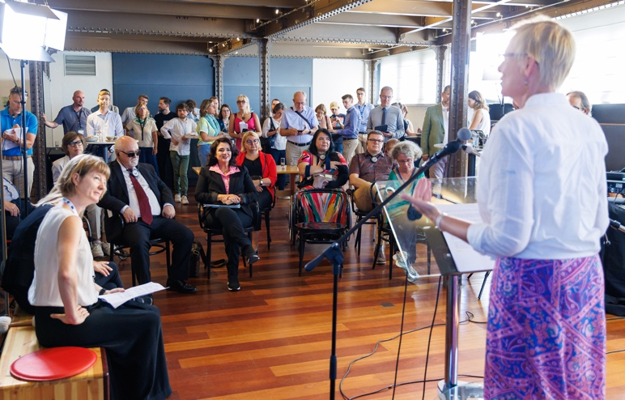
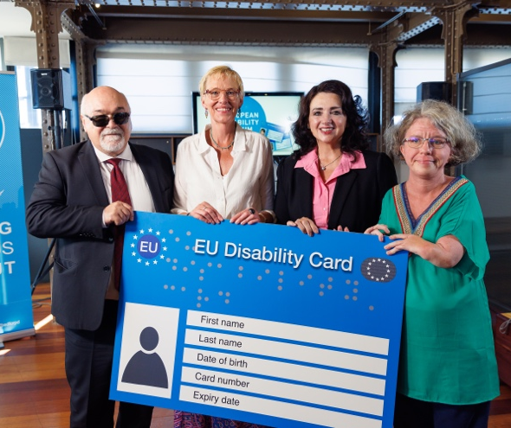
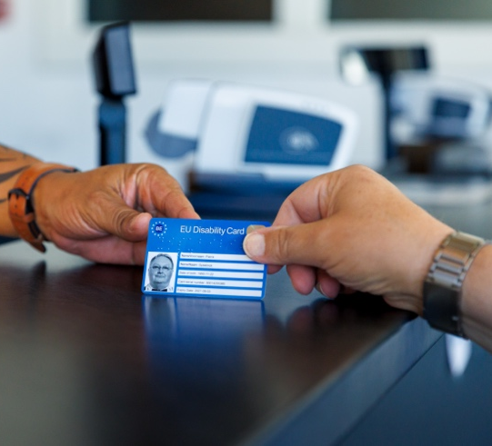
We organised a press conference with Commissioner Dalli and Belgian Minister for Disability, Lalieux.
Quote from a card holder – pilot project
on the importance of EDF with emphasis on advocacy efforts to bring the Disability Card closer to becoming a reality.
It was the most visited page on the website in 2023.
11 references in European media including Politico, Euronews and Euractiv.
The Council of the EU adopted its General Approach on 27 November 2023

The European Commission published the proposal of the Directive on 6 September 2023

End violence against women and criminalise forced sterilisation

The European Commission presented a proposal for a Directive on Combating Violence Against Women and Domestic Violence to the European Parliament and the Council of the EU on the 8th of March 2022.
During 2023, we strongly campaigned to include the criminalisation of forced sterilisation in this proposed Directive. Allowing forced sterilisation in Europe is accepting an intrusive form of violence that destroys lives. We also called for measures to ensure the protection of women with disabilities such as:

- The adoption of measures at EU and Member States levels to ensure access to justice, including adequate criminal sanctions, and compensation for victims.
- The ratification of the Istanbul Convention by all EU Member States and Council of Europe members.
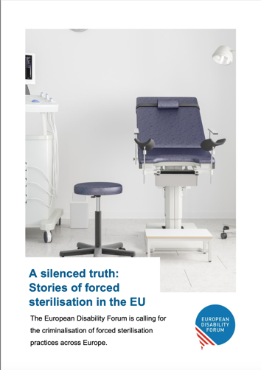
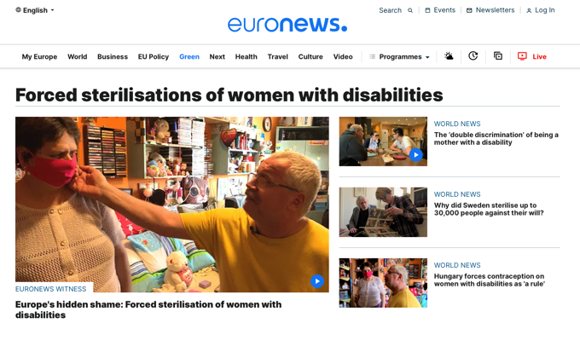
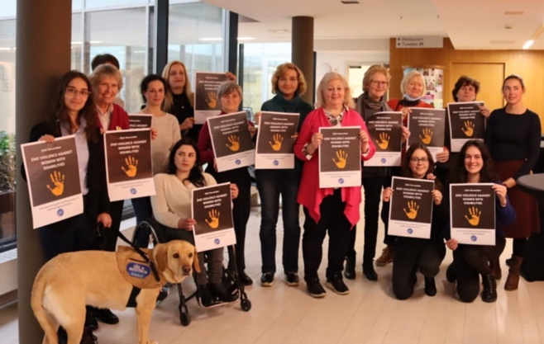
We launched the briefing “A silenced truth”, collecting stories about the impact of forced sterilisation and countries that have banned this terrible practise.
Media coverage on forced sterilisation of persons with disabilities increased significantly, including a series of cases at Euronews, an article on the New York Times, a documentary on ARTE and on ZSD.
European Parliament’s Committees agreed on a position on the Directive a to end violence against women that included our demands.
“EDF campaign on forced sterilisation has been exceptionally powerful to raise awareness into this horrendous violation of women’s rights committed against women with disabilities primarily; and to highlight the need for EU action to address this issue.

I find EDF’s advocacy and communication work was excellent and extremely valuable, providing a platform to survivors to voice the terrible life-long consequences suffered and raise public attention.

I am very grateful for the joint work developed and we look forward to continuing our cooperation to ensure access to justice and protection for women with disabilities!”
Irene Rosales, Senior Policy Advisor at the European Women’s Lobby

Political Participation and the right to vote

On the 23 May 2023, disability rights advocates gathered in the hemicycle of the European Parliament in Brussels with a purpose: Building an inclusive future for persons with disabilities in the EU.

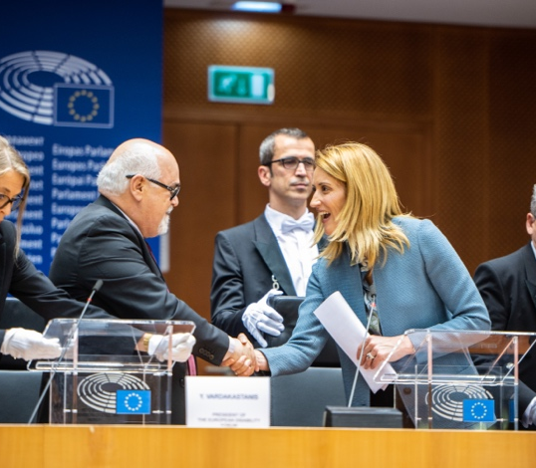
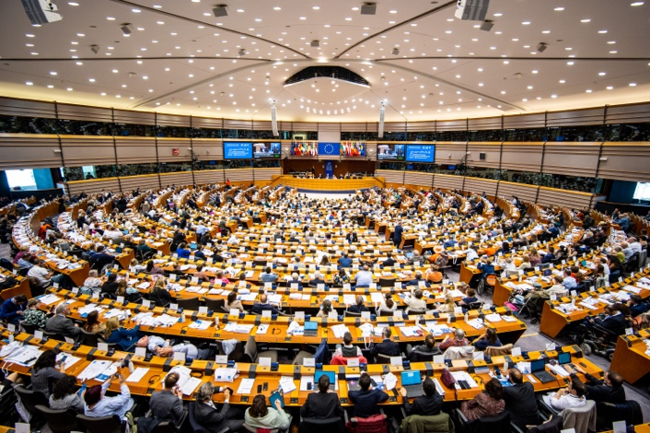
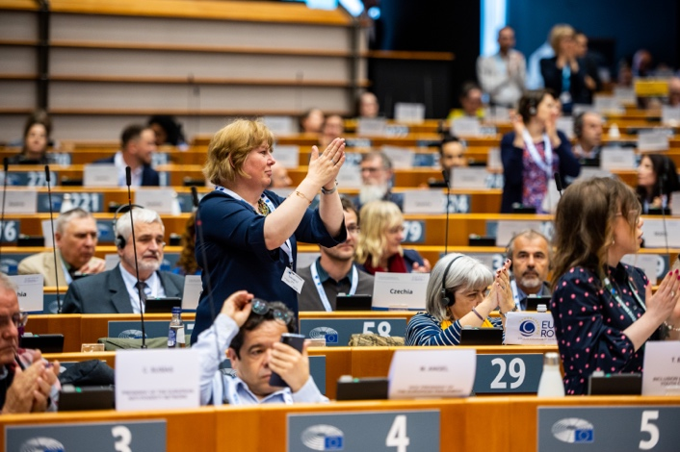
Jointly organised by the European Parliament, the 5th European Parliament of Persons with Disabilities (EPPD) created an opportunity to discuss the demands of the disability movement. During the EPPD, we agreed on the EDF Manifesto on the European Elections 2024 with the aim of guiding the political programmes of candidates for the European Parliament, the work programme of the European Commission after 2024 and all the relevant policies affecting the future of persons with disabilities in Europe and beyond.
Ukraine
Adopted the Manifesto “Building an inclusive future for persons with disabilities in the EU”
Speakers included the President of the European Parliament, 1 Vice-President of the Commission and 2 Commissioners, The European Ombudsman, a national Ministers, and several MEPs.
MFOPD's membership with EDF is very important for us and the European Parliament of Persons with Disabilities was a significant event for our organisation.

It marked the first participation for the Maltese delegation and a unique experience for the young lady who has Down syndrome and addressed the Parliament on our behalf, leaving a lasting impact nationally.

The EDPD provides a platform for persons with disabilities to advocate in the EU's legislative body. It sends the message that persons with disabilities' voice must be heard and taken on board by the legislators.Additionally, it fosters collaboration among disability advocates from diverse backgrounds and this enriches the occasion.

It is an opportunity for the EU policy makers to be informed directly by the persons with disabilities themselves about our needs and situation, reinforcing our motto 'Nothing About Us Without Us’.
Marthese Mugliette, President of the Malta federation of organisations persons with disability
Over 700 disability rights advocates gathered at the European Parliament
Since the start of the war, EDF has been supporting and protecting persons with disabilities and their families in Ukraine.
Our programme focus on 3 objectives:
- Immediate needs: including access to accommodation, health and other basic services.
- Advocacy: influencing government departments, larger humanitarian organisations and other international organisations including the EU and the UN.
- The future: concentrating efforts on the long-term goal of strengthening the disability movement within the country.
We work in eight countries: Ukraine, Latvia, Lithuania, Poland, Slovakia, Hungary, Romania and Moldova.
We are implementing this work together with other 14 organisations of persons with disabilities.
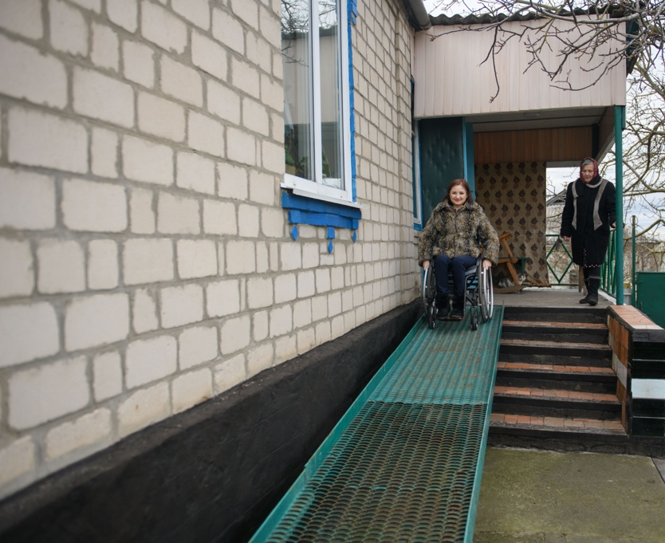
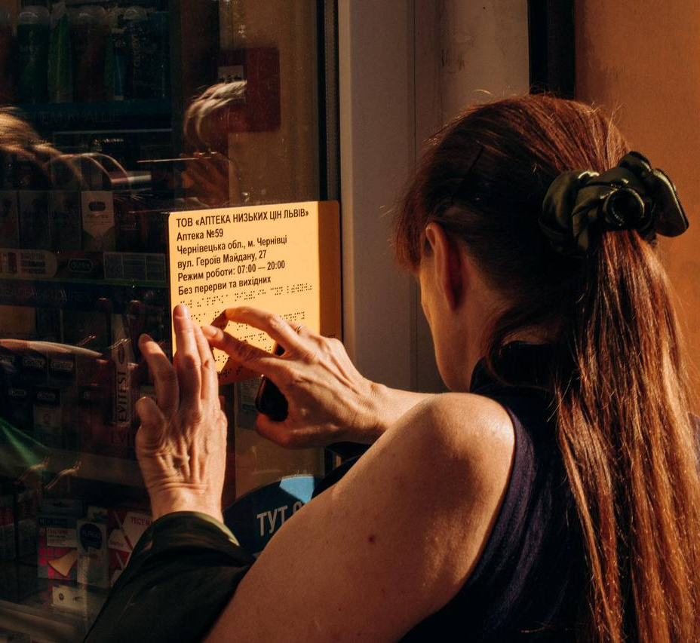
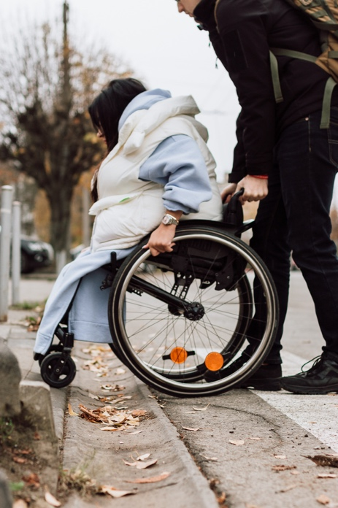
“I would like to thank EDF and CBM for the support since the invasion.
This project has saved many people’s lives.
The assistance from EDF and CBM has been crucial in allowing us to persist in our efforts to ensure that persons with disabilities receive the support they need for independent living.

Uliana Pcholkina, Deputy Head of the Board of Group of Active Rehabilitation (GAR) and Head of the Board of The League of the Strong
“"Persons with disabilities could not believe that they actually received help. For 20 years, many have come here, but the most vulnerable are often overlooked.

This time was different. We will always remember those who stood by us and took tangible actions on our behalf. As Ukrainians, gratitude runs deep within us."
National Association of Persons with Disabilities in Ukraine (NADP): Starosta of Mamaivtsi
Note:
Methodology of identification of disability status varies between countries
Since July 2023, EDF is working only in Ukraine, Moldova, Poland and Latvia, plus our advocacy work at EU and International level.
31% of all people reached are women with disabilities
(over 18 years)
19% of all people reached are children with disabilities
(under 18 years)
In 2023 we reached over 18.000 people with direct services.
70% of the total are persons with disabilities

Chapter – Other successes by work area

Accessibility

Passengers Rights and Freedom of movement

- We published the report on air passenger rights ‘End the nightmare: Passengers with disabilities deserve to travel by air’ calling for EU legislation to better protect passengers with disabilities, especially when travelling by air.
- Publication of the revision of the Passengers’ Rights Regulations, with some improvements including enhanced reporting obligations and the obligation to airlines to provide a ticket free of charge when they mandate passengers travel with an accompanying person.

Digital Rights
- The publication of the European Digital Identity Regulation met our demands and following the accessibility requirements of the European Accessibility Act.
- The provisional agreement on the Artificial Intelligence Act included the accessibility requirements for high-risk artificial intelligence systems.

Human rights and non-discrimination

- We co-publish a comprehensive briefing with ILGA-Europe that analyses most relevant data about the experiences of LGTBQ+ persons with disabilities in Europe.
- We supported members from Austria, Germany, Lithuania, Finland and Slovenia in their review by the UN Committee on the Rights of Persons with Disabilities and organised a well-attended online workshop on the 2024 CRPD and CEDAW review as
- We published two information notes on “Disability priorities at the European level” for the UN Committee eon the Rights of Persons with Disabilities
- EDF continued to advocate for equality, non-discrimination and intersectionality in our work, and advocacy towards the EU, including in relation to standards for equality bodies, victims’ rights, protection of adults, anti-trafficking, mental health, and violence against women specifically:
  - We call for inclusion of persons with disabilities in the directive on standards of equality bodies – in the future equality bodies will have to provide accessibility and reasonable accommodations for persons with disabilities.
  - We launched a campaign on ensuring the rights of persons with disabilities in cross-border situation, to influence the proposed regulation on protection of adults.
  - We continued our campaign against coercion in mental health in the Council of Europe, influencing future recommendations on autonomy in mental healthcare.

International Cooperation and Humanitarian Action

- We co-hosted the Global Action on Disability (GLAD) Network Annual General Meeting with the EU, fostering unity among donors, state agencies, foundations and coalitions in the disability rights movement.
- We actively participated in the Bonn Climate Change Conference and the UN Conference on Climate Change (COP28) to advocate for the inclusion of disability in climate negotiations.
- We published two toolkits for EU Delegations and OPDs to enhance collaboration among EU Delegations and Organisations of Persons with Disabilities.
- We presented our work on Ukraine at the high-level Council of the EU ‘Working Party on Humanitarian Aid and Food Aid’.

Social policy

- We published our 2023 Human Rights Report on employment with significant media attention around it.
- EDF advocated for EU companies to be held more accountable for disability inclusion on the Corporate Sustainability Reporting Directive. We achieved to add reporting requirements on employment policies and the situation of workers with disabilities in large companies, as well as rules on accessible reporting.
- We achieved to had a strong disability and de-institutionalisation elements in the European Semester Spring Package and recommendations to the Member States.

Women and girls with disabilities

- EDF prepared and adopted the EDF third manifesto on women and girls with disabilities.
- We updated the CEDAW Guide for Organisations Persons with Disabilities and training on CRPD and CEDAW review.

Children and youth with disabilities

- EDF organised two activities in the European Youth Event 2023 in Strasbourg, France, organising two activities. This event, hosted every two years by the European Parliament, gathered over 8.000 young people. With a group of 34 young persons with disabilities, EDF conducted a workshop on "Your Rights in the EU" and hosted a panel discussion titled "Work in the EU Accessible for All?" featuring MEP Dragos Pislaru and experts from the International Labour Organisation.
- Thanks to our advocacy, a young persons with a disability participated for the very first time in the jury responsible for selecting the next EU Youth Capital.

Chapter - Flagship events

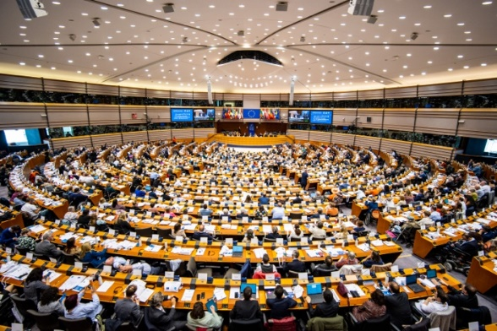
The 5th European Parliament of Persons with Disabilities
The European Parliament of Persons with Disabilities (EPPD) was a one-day event that brought together over 700 disability advocates, policymakers, and other stakeholders. We convened at the hemicycle of the European Parliament in Brussels. It provided a platform for discussing our rights and determining the political demands of the European Disability Movement.

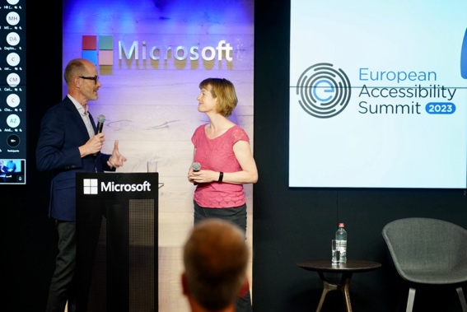
European Accessibility Summit
The European Accessibility Summit, hosted with Microsoft's support, is an annual event uniting stakeholders across sectors to promote awareness of accessibility's significance.

In 2023, 200 joined this open event to discuss the importance of accessible technology in work, education, and leisure for persons with disabilities in Europe.

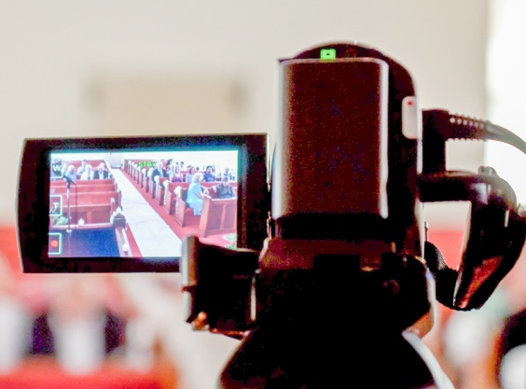
High level European Regional Disability Summit
Together with other 10 non-governmental organisations we organised this event to explore ways to ensure that international cooperation in the broader European region is inclusive of persons with disabilities.
The event gathered a range of stakeholders, including representatives of governments, donors, United Nations country teams, Civils Society Organisations (CSOs), and Organisations of Persons with Disabilities (OPDs)

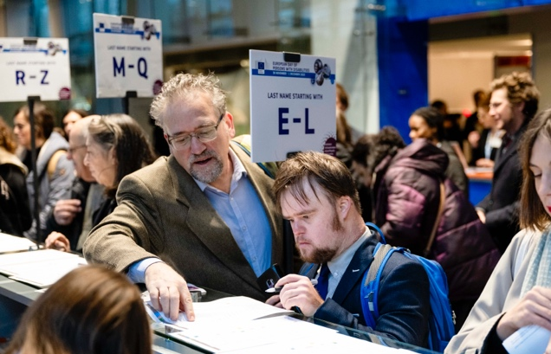
European Day of Persons with Disabilities
Conference
Together with the European Commission, we organised the European Day of Persons with Disabilities Conference (EDPD) to mark the International Day of Persons with Disabilities.
In 2023, this 2-day event brought together more than 600 participants, policy-makers, high-level experts and disability advocates, covering the right to vote and stand for elections, the European Year of Skills 2023 and the Strategy for the Rights of Persons with Disabilities 2021 – 2030.

EDF Governing Bodies and Conferences
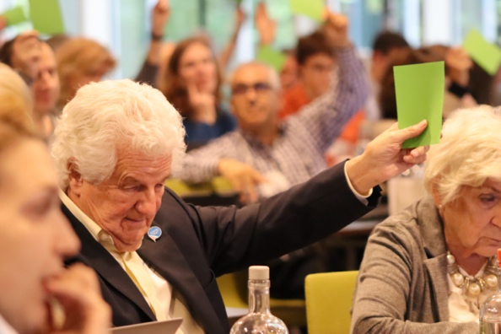

In 2023 we brought our members together in different meetings throughout the year.
In total we held 18 Governing Body meetings establishing policies, making significant and strategic key decisions, and overseeing EDF’s operations.

Chapter – Making our voice heard: Communication impact

In 2023, we reached around 80,000 people through our website, social media,
newsletters and press statements.

Our website and newsletters

Our website has made a positive impact in 2023 with 119K visits with a total of 32K users from a total of 125 countries. Last year, we posted a total of 186 web articles and created 31 new webpages.

We maintain an active blog called Disability Realities. It aims to share first-hand stories as well as editorial opinion pieces from members and partners. Last year we published more than 30 posts in the blog.

We have also 3 newsletters, each of them dedicated to different topics: the Disability Voice, the Women’s Voice, the Global Action newsletter and the Members’ Mailing

Social media engagement

Through our social media platforms, we reach over 40.000.


Linkedin: over 7.000
Twitter: over 23.000



Instagram: around 2.000
Facebook: over 16.000

EDF in the news
We continued with a strong visibility in mainstream and disability-specific media in 2023 with:

112 appearances on media
9 press releases sent
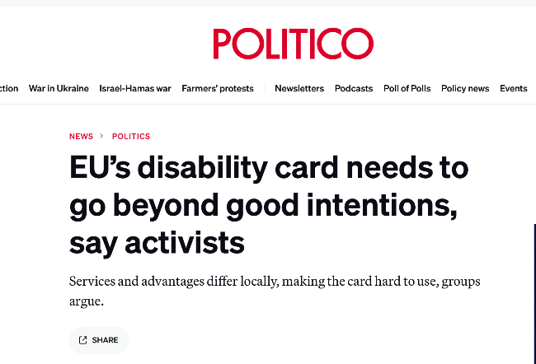
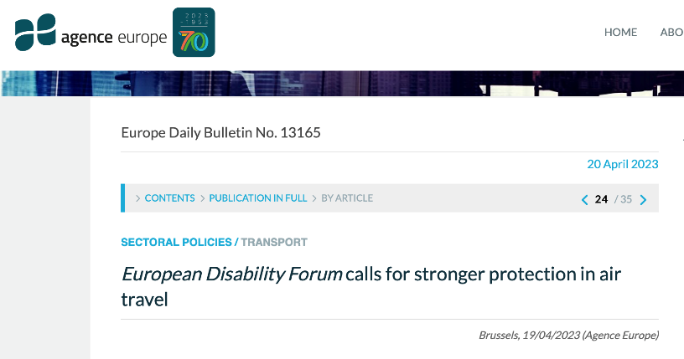

Chapter - Who we are? Meet our team

Our organisation: Governing bodies and staff

Executive Committee Members

Yannis Vardakastanis - EDF President
National Confederation of Disabled People of Greece (NCDP)
Gunta Anca - EDF Vice President
Latvian Umbrella Body for Disability Organisations (SUSTENTO)
John Patrick Clarke - EDF Vice President
European Down Syndrome Association (EDSA)
Ana Peláez Narváez - EDF Secretary General
Spanish Committee of Representatives of Persons with Disabilities (CERMI)
Maureen Piggot - EDF Treasurer
Inclusion Europe
Vera Bonvalot
Brain Injured People and Families – European Confederation (BIF- EC)

Nadia Hadad
European Network on Independent Living (ENIL)
Humberto Insolera
European Union of the Deaf (EUD)
Klaus Lachwitz
German Disability Council (DBR)

Pirkko Mahlamäki
Finnish Disability Forum (FDF)

Thorkild Olesen
Disabled People’s Organisations Denmark (DPOD)

Board Members

Marcel Bobeldijk
European Federation of Hard of Hearing (EFHOH)

Luisa Bosisio Fazzi
Italian Disability Forum (FID)

Pietro Cirrincione
Autism-Europe (AE)

John Dolan
Disability Federation of Ireland (DFI)

Anna Drabarz
Polish Disability Forum (PFON)

Kristijan Grdjan
Mental Health Europe (MHE)
Giampiero Griffo
Disabled Peoples International Europe (DPI Europe)

Javier Güemes
European Association of Service Providers for Persons with Disabilities (EASPD)
Pierre Gyselinck
Action Européenne des Handicapés (AEH)

Sari Hirvonen-Skarbö
European Association of Cochlear Implant Users (EURO-CIU)

Dovilé Juodkaité
Lithuanian Disability Forum (LNF)

Cato Lie
International Federation of Spina Bifida and Hydrocephalus (IF)

Marica Mirić
Croatian Union of Associations of Persons with Disabilities (SOIH)

Albert Prévos
French Council of Disabled People for European and
International Affairs (CFHE)

Jolijn Santegoeds
European Network of (Ex-)Users and Survivors of Psychiatry (ENUSP)

Borut Sever
Slovenian National Disability Council (NSIOS)

Thurídur Sigurdardóttir
Organisation of Disabled in Iceland (ÖBÍ)

Sorin Ţaţa
Romanian National Disability Council (CNDR)

Bart Verdickt
Belgian Disability Forum (BDF)

Christina Wurzinger
Austrian Disability Council

Meet our team

Catherine Naughton
Executive Director

Alejandro Moledo
Deputy Director and Head of Policy

Policy team

Marie Denninghaus
Senior Policy Coordinator

Haydn Hammersley
Social Policy Coordinator

Marine Uldry
Human Rights Policy Coordinator

Daniel Casas
Accessibility officer

Álvaro Couceiro
Employment Policy Officer (left in 2023)
Markaya Henderson
Health policy and project officer

Roberta Lulli
Project Officer

Carine Marzin
Project Manager, Web Accessibility Initiative Communities of Practice (left in 2023)

Kave Noori
Artificial Intelligence Policy Officer

Samaneh Shabani
Women's Rights Officer
Filippo Sinicato
Policy and Project Officer

International Cooperation team

Marion Steff
International Cooperation Manager

An-Sofie Leenknecht
Human Rights Coordinator

Gordon Rattray
Programme Coordinator

Phillipa Tucker
Central and Eastern Europe Coordinator
Erika Hudson
International Cooperation Policy Officer

Giulia Traversi
Humanitarian Policy Officer

Mariya Yasenovska
Human Rights Officer

Operations team
Muriel Da Via
Human Resources and Office Manager

Loredana Dicsi
Membership, Internal Communication and Youth Coordinator

Raquel Riaza
Events and Administration Coordinator

Magdalena Verseckas
Funding and Grants Coordinator

Kateryna Ostashkova
Administration and Reporting Officer

Nicoleta Ungureanu
Administration and Reporting Officer
Communications team

André Felix
Communications Coordinator

Natalia Suárez
Senior Communications Officer

Vanessa James
Communications Officer
Ciara Kristensen
Communications and Campaigns Officer

Giulia D’Agnolo
Communications and Knowledge Management Officer (left in 2023)

Chapter - Our members
In 2023 EDF had 110 members. EDF has four categories of membership:

Full members
In 2023 we had 52 full members.
29 national councils of persons with disabilities.
- Austria – Austrian Disability Forum
- Belgium – Belgian Disability Forum
- Bulgaria – National Council of People with Disabilities in Bulgaria
- Croatia – Croatian Union of Associations of Persons with Disabilities
- Cyprus – Cyprus Confederation of Organisations of the Disabled
- Czech Republic – Czech National Disability Council
- Denmark – Disabled People’s Organisations Denmark
- Estonia – Estonian Chamber of Disabled People
- Finland – Finnish Disability Forum
- France – French Council of Disabled People for European and International Affairs
- Germany – German Disability Council
- Greece – National Federation of Disabled People of Greece
- Hungary – Hungarian National Council of Federations of People with Disabilities
- Iceland – Icelandic Disability Alliance
- Ireland – Disability Federation of Ireland
- Italy – Italian Disability Forum
- Lativa – Latvian Umbrella Body for Disability Organisations
- Lithuania – Lithuanian Disability Forum
- Luxembourg – National Disability Council of Luxembourg
- Malta – Malta Federation of Organisations Persons with Disability
- Netherland – Dutch Network for People with Disabilities or Chronic Illnesses
- Norway – Norwegian Federation of Organisations of Disabled People
- Poland – Polish Disability Forum
- Portugal – National Confederation of Organisations of Disabled People in Portugal
- Romania – Romanian National Disability Forum
- Slovakia – Slovak Disability Council
- Slovenia – Slovenian National Disability Council
- Spain – Spanish Committee of Representatives of Persons with Disabilities
- Sweden – Swedish Disability Rights Federation

23 European non-profit organisations representing persons with disabilities:

- Autism-Europe (AE)
- Brain Injured People and Families – European Confederation (BIF EC)
- Cerebral Palsy – European Communities Association (CP-ECA)
- DEBRA International
- Disabled Peoples International Europe (DPI Europe)
- Action Européenne des Handicapés (AEH)
- European Alliance of Neuromuscular Disorders Associations (EAMDA)
- European Association of Cochlear Implant Users (EURO-CIU)
- European Blind Union (EBU)
- European Council of Autistic People (EUCAP)
- European Deafblind Union (EDbU)
- European Down Syndrome Association (EDSA)
- European Dyslexia Association (EDA)
- European Federation of Hard of Hearing (EFHOH)
- European Federation of Parents of Hearing Impaired Children (FEPEDA)
- European Network of (Ex-) Users and Survivors of Psychiatry (ENUSP)
- European Network on Independent Living (ENIL)
- European Union of the Deaf (EUD)
- Inclusion Europe
- International Federation for Spina Bifida and Hydrocephalus (IF)
- International Federation of Persons with Physical Disability (FIMITIC)
- Rare Diseases Europe (EURORDIS)
- Retina Europe

Ordinary members
Our ordinary members are European organisations for persons with disabilities that are consistent with EDF’s aims and objectives.
In 2023 we had 12 ordinary members.

- Alzheimer Europe
- Association for Research and Training on Integration in Europe (ARFIE)
- Association Internationale Aphasie (AIA)
- Design for All Europe (EIDD)
- European Association of Service Providers for Persons with Disabilities (EASPD)
- European Deafblind Network (EDbN)
- European Guide Dog Federation (EGDF)
- European Multiple Sclerosis Platform (EMSP)
- European Platform for Rehabilitation (EPR)
- European Union of Supported Employment (EUSE)
- Mental Health Europe (MHE)
- Social Firms Europe (SFE CEFEC)

Associate members

Associate members are non-profit organisations or companies that are committed to promoting EDF’s aims.
In 2023 EDF had 42 associate members.

- Ålands handikappförbund The organisation of Persons with Disabilities in Ålands
- Aprobata Foundation
- Association Alliance of Organizations for Persons with Disabilities
- Association of Teacher Special Educational Lists
- Associazione Nazionale Mutilati ed Invalidi Civili (ANMIC)
- CBM Global Disability Inclusion
- CBM Italia
- Centre for the Rights of Persons with Disabilities (CDPD) Moldova
- Coalition for Independent Living (CIL)
- Commission for the Rights of Persons with Disability (CRPD)
- Confederation of Family Organisations in the European Union (COFACE)
- Disability Rights Agenda
- DysNet
- Ente Nazionale per la protezione e l’assistenza dei Sordi (ENS)
- European Deaf Students Union (EDSU)
- Euro Psy Rehabilitation (EPR)
- European Federation of Hereditary Ataxias (Euro-ataxia)
- European and Ibero-American Academy of Yuste Foundation (FAEY)
- European Institute for Research, Training and Vocational Guidance (I.E.R.F.O.P. Onlus)
- European Myalgic Encephalomyelitis Alliance (EMEA)
- European Ostomy Association (EOA)
- European Polio Union (EPU)
- European Union of the Deaf Youth (EUDY)
- Faroese Disability Organisations (MEGD)
- Gelijke Rechten voor Iedere Persoon met een handicap
(GRIP)
- Hilfsgemeinschaft der Blinden und Sehschwachen Österreichs
(HBSO)
- Housing Options Scotland (HOS)
- International Association of Accessibility Professionals (IAAP Europe)
- International Federation of Hard of Hearing Young People
(IFHOHYP)
- Kosovo Disability Forum (KDF)
- League of the Strong
- Light for the World
- ONCE Foundation
- Norwegian Association of Youth with Disabilities
- Saint Lazarus Foundation
- Swiss national organisation of persons with disabilities (AGILE)
- Union of Disabled People in Bulgaria (UDPB)
- Union of Disabled People Organizations (UDPO) of the
Republic of Azerbaijan
- Vittime Italiane Talidomide
(VITA)

Observer members
Our observer members are national organisations of persons with disabilities from countries in Europe outside the EU.
In 2023 EDF’s observer members were:
- Confederation of the Disabled of Turkey (TDC)
- National Assembly of Persons with Disabilities of Ukraine (NAPD)
- National Council of Disability Organisations of North
- Macedonia (NSIOM)
- National organisation of persons with disabilities of Serbia (NOOIS)

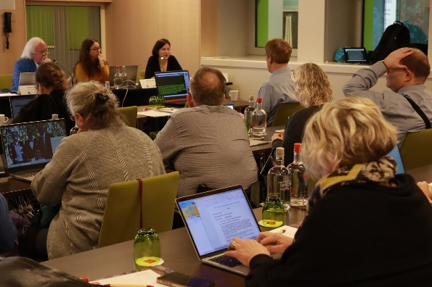
Committees and expert groups
Human Rights and Non-Discrimination Committee
This committee ensures that national and European leaders are closely involved
in – and fully informed about – our work on human rights, equality and non-
discrimination, and especially on the UN CRPD.

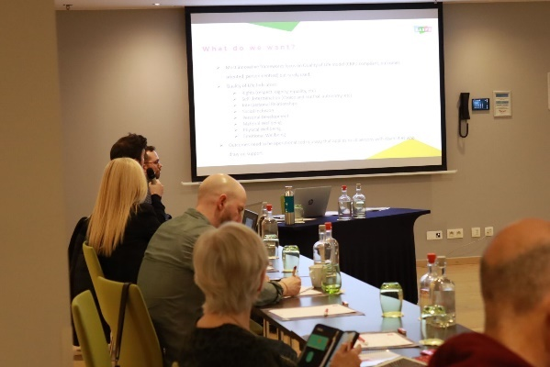
Social Policy and Inclusion Committee
This committee contributes to EDF’s work on social and employment policy, and
supports members by providing expertise on social rights, including the right to
work and employment, social protection and full inclusion in society.

Women’s Committee
The Women’s Committee mainstreams gender in all EDF policies and documents
to raise awareness of the situation of women and girls with disabilities, and to work
towards the inclusion of women and girls with disabilities in society.

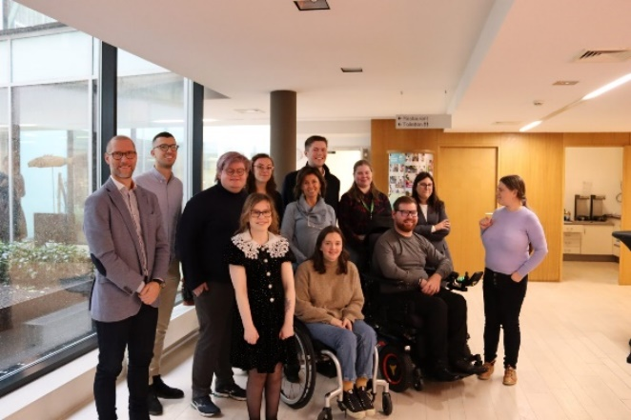
Youth Committee
The role of the Youth Committee is to ensure that EDF’s work takes into account
the perspective of young people with disabilities, and also to represent young
people with disabilities in both EDF and external events.

Chapter - Transparency

Our partners and close collaborators

- Academy of European Law
- AGE Platform Europe
- Airports Council International (ACI) – Europe
- ANEC – The European consumer voice in standardisation
- Association of Commercial Television in Europe (ACT)
- CONCORD
- Community of European Railway and Infrastructure Companies (CER)
- Digital Europe
- Equinet (The European Network of Equality Bodies)
- ERASMUS student’s network
- European Broadcasting Union (EBU)
- European Digital Rights (EDRi)
- European Economic and Social Committee (EESC)
- European expert group on transition from institution to
community-based services
- European Network Against Racism (ENAR)
- European Network for Corporate Social Responsibility and Disability (CSR-D Network)
- European Network of National Human Rights Institutions (ENHRI)
- European Trade Union Confederation
- European Women’s Lobby (EWL)

- European Youth Forum
- Funka
- Global Accessibility Reporting Initiative by the Mobile & Wireless Forum (GARI)
- Human Rights Democracy Network (HRDN)
- IncluD-ed network
- International Association of Public Transport (UITP)
- International Disability Alliance (IDA)
- International Disability and Development Consortium (IDDC)
- International Lesbian, Gay, Bisexual, Trans and Intersex Association (ILGA)
- International Road Transport Union (IRU)
- Reference Group on Inclusion of Persons with Disabilities in Humanitarian Action
- Semester Alliance
- Social Platform
- The European Agency for Fundamental Rights (FRA)
- The European Passengers’ Federation (EPF)
- The United Nations International Children’s Emergency Fund (UNICEF)
- Transmedia Catalonia Research Group

Our funders

EDF deeply appreciates all contributions received. EDF is relying on grants, donations (from individuals, corporations, and foundations), as well as membership fees to fulfill our mission effectively.

In 2023, we extend our heartfelt gratitude for the financial support provided by:

- European Commission
- European Parliament
- European Regional Development Fund – Interreg Central Europe
- European AI & Society Fund
- Wellspring Philanthropic Trust
- Ford Foundation
- Open Society Foundation
- Citi Foundation
- CBM International
- Fundación ONCE
- Fundación CERMI Mujeres
- Global Green Grants
- Just Foundation
- National Confederation of Disabled People (NCDP) in Greece
- Swedish Disability Rights Federation
- German Federal Foreign Office (GFFO)
- Swedish Ministry of Social Affairs
- Swedish Postal Telecom Agency
- Google.org
- Microsoft
- Apple
- Meta
- Elastic Cares
- Gregg Vanderheiden

Financial report

Author:
Editor:
Contributors:
Proofread by:
Designed by:

The European Disability Forum
7-8 Avenue des Arts
1210 Brussels – Belgium
info@edf-feph.org
www.edf-feph.org
Follow us on social media!

Views and opinions expressed are, however, those of the author(s) only and do not necessarily reflect those of the European Union or the European Commission. Neither the European Union nor the granting authority can be held responsible for them.

