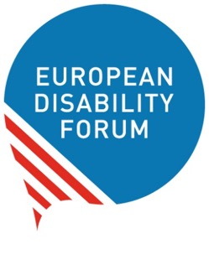

Our manifesto on the rights
of women and girls with disabilities
Easy-to-read version

Easy-to-read is information
that is written in a simple way
so that all people can understand it.
You can find more information at:
www.inclusion-europe.eu/easy-to-read.

The difficult words in the text are marked in bold.
You can find their explanation at the end of this booklet.
This text was created thanks to money we received from the European Union.
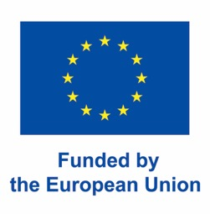

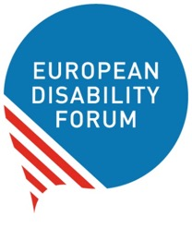
WHO WE ARE
We are the European Disability Forum.
The European Disability Forum
is an organisation that protects the rights
of all people with disabilities in Europe.
In short, it is called ‘EDF’.

WHAT THIS BOOKLET IS ABOUT
This is the easy-to-read version of our recent manifesto
on the rights of women and girls with disabilities in Europe.
Our manifesto is a document we wrote to explain:
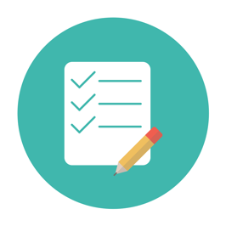
- What is the situation
of women and girls with disabilities in Europe?
- What should the European Union
and its countries do to protect the rights
of women and girls with disabilities?
To write this manifesto,
we asked women with disabilities around Europe
to tell us about their experiences and views.
Around 500 women from 33 countries in Europe
shared their experiences and views with us.
Most of them were women with disabilities.
Some of them were mothers of children with disabilities.

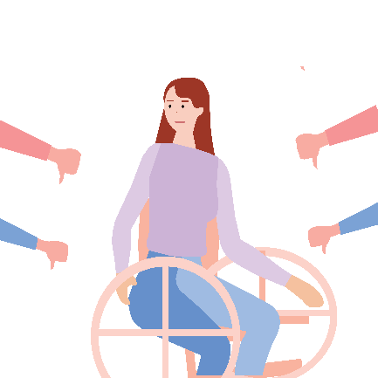
THE SITUATION OF WOMEN AND GIRLS
WITH DISABILITIES IN EUROPE
Unfortunately, Europe is not yet a place
where all women and girls
can enjoy their rights safely and freely.
Things can be even harder
for women and girls with disabilities.

Amongst others:

Many women and girls with disabilities have experienced different kinds of violence
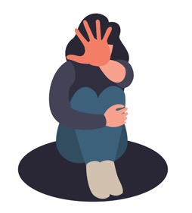
For example, they may have been:
- Threatened, attacked or hurt by someone.
- Forced to have sex against their will.
- Insulted or called names.

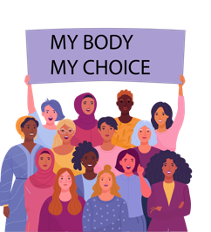
Many women and girls with disabilities are not allowed
to decide about their bodies
For example, they may not be allowed to decide
if they want to have children or not.
Many women and girls with disabilities in Europe
are forced to have a medical procedure
that makes it impossible for them to have children.
This is against their rights.
Women should have the right to decide
if they want to have children or not.

Women with disabilities are at higher risk of being poor and without a job
It is often hard or impossible
for women with disabilities to get a job.
Without a job and without the right support,
women with disabilities may not have
enough money to live on.
As the cost of life gets higher,
women with disabilities are at higher risk
of being left out.
COVID-19 made things much worse.
Due to COVID-19, many women with disabilities
lost their jobs and struggle to survive.

The impact of climate change is bigger on women
and girls with disabilities
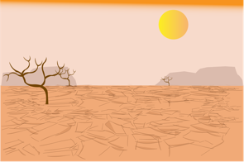
Climate change means
the temperature and the weather in the world change.
For example, there may be extreme heat
or lack of rain in some areas.
Many people need to move from these areas
because they cannot live there anymore
or cultivate the earth to get food.
This is even harder for women and girls with disabilities
who were already poor and struggled to survive.

The impact of war is bigger on women
and girls with disabilities.
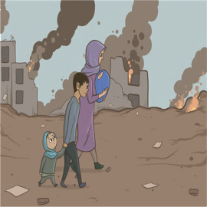
In times of war,
the shelters people use to save their lives
may not be accessible
so women and girls with disabilities
may not be able to get in.
It is also harder for women and girls with disabilities
to flee their countries.
Many women and girls with disabilities
are left behind without any support.
Some people may take advantage of the situation.
They may help women and girls with disabilities to flee
and then force them to marry or have sex against their will.

What the European Union and its countries should do
At EDF, we believe that all women and girls with disabilities
should have the right to:
- Lead their own lives and make their own decisions,
- Enjoy their rights,
- Have the same chances in life as everyone else.
Amongst others, we ask the European Union and its countries to:
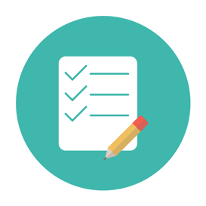
- Carry out studies and collect usefull information
about women and girls with disabilities.
This will help countries undertand the situation
of women and girls with disabilities
and work to make things better.
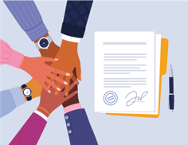
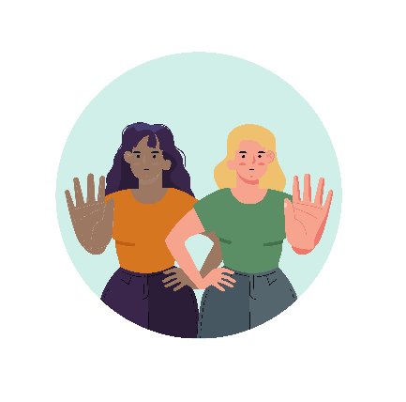
- Work to make all the rights of the UN Convention
happen in Europe.
They should not forget the women
and girls with disabilities
who are at even higher risk of being left out.
For example, women with intellectual disabilities,
women living in institutions
and women with more than one disability.
- Make laws to stop violence
against women and girls with disabilities
and punish the people who treat them badly.
Also, countries should make it easier
for women and girls with disabilities
to get help when they are treated badly.
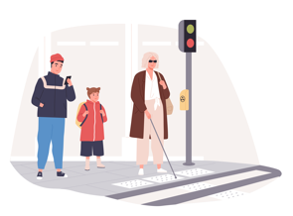
- Make things and services in Europe accessible
so that all people with disabilities
can live independently.
For example:
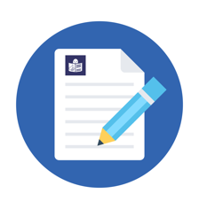
- Buses, trains, streets and buildings
should be accessible
so that people with disabilities
can use them to get around
without problems.
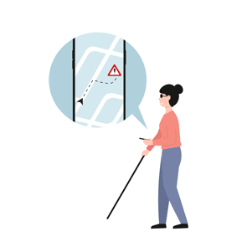
- All laws, texts and information
should be available in accessible forms
like easy-to-read
so that people with intellectual disabilities
can understand them.
- Technology should be accessible
so that people with disabilities
can use it like everyone else.
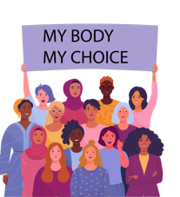
- Recognise the right of all women and girls
to make their own decisions
and choices in life.
For example, women with disabilities
should have the right to buy a house,
have a job, or make a family if they want to.
It is ok to get support to make decisions.
But it is not ok if someone else
makes the decisions for them.
- Protect the right of women and girls
to decide about their bodies and lives.
Women with disabilities should have the right
to decide if they want to have children or not.
Nobody else should decide for them,
or force them to do anything against their will.
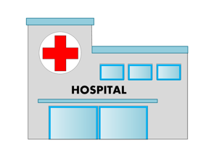
- Make sure women and girls with disabilities
can get good health care.
Doctors, nurses and other people
who work in health care
should be trained to help
women and girls with disabilities.
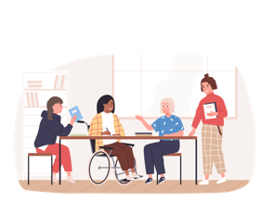
- Make sure girls with disabilities
can study and grow their skills
as everyone else.
For this to happen,
schools should be accessible.
Also, teachers should get training to know
how to meet the needs of girls with disabilities.
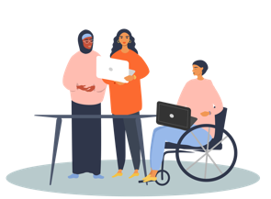
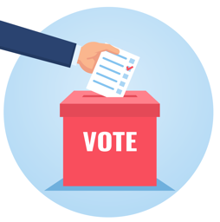
- Make sure that women with disabilities
have the chance to get a job
and be paid fairly for this job.
They should not be paid less
because they have a disability
or because they are women.
Also, mothers of children with disabilities
should get support to look after their child
and be able to work if they want to.
- Make sure that women with disabilities
can vote and stand for elections.
Many women with disabilities in Europe
cannot vote or stand for elections.
This is unfair.
The European elections 2024
is an opportunity to change that.
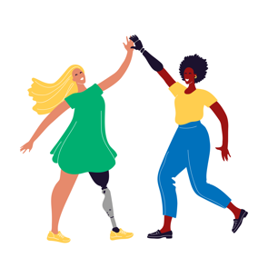
- Spread the word about the rights
of women and girls with disabilities.
They should make campaigns
to help people understand that
women and girls with disabilities
are no different than other people
and should enjoy the same rights.
Organisations of women
and girls with disabilities
should take the lead in these campaigns.
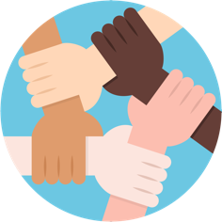
- Listen to the views of organisations
of people with disabilities
when they make decisions and laws
that concern their lives.
They should also give money to organisations
of women and girls with disabilities
to continue doing their important work.

More information
You can find more information about the work we do at EDF
on our website at: www.edf-feph.org.
For any questions,
you can send us an email at: info@edf-feph.org.

Explanation of difficult words

European Union
The European Union is a group of 27 countries in Europe.
These countries came together
to make things better, easier and safer for people.
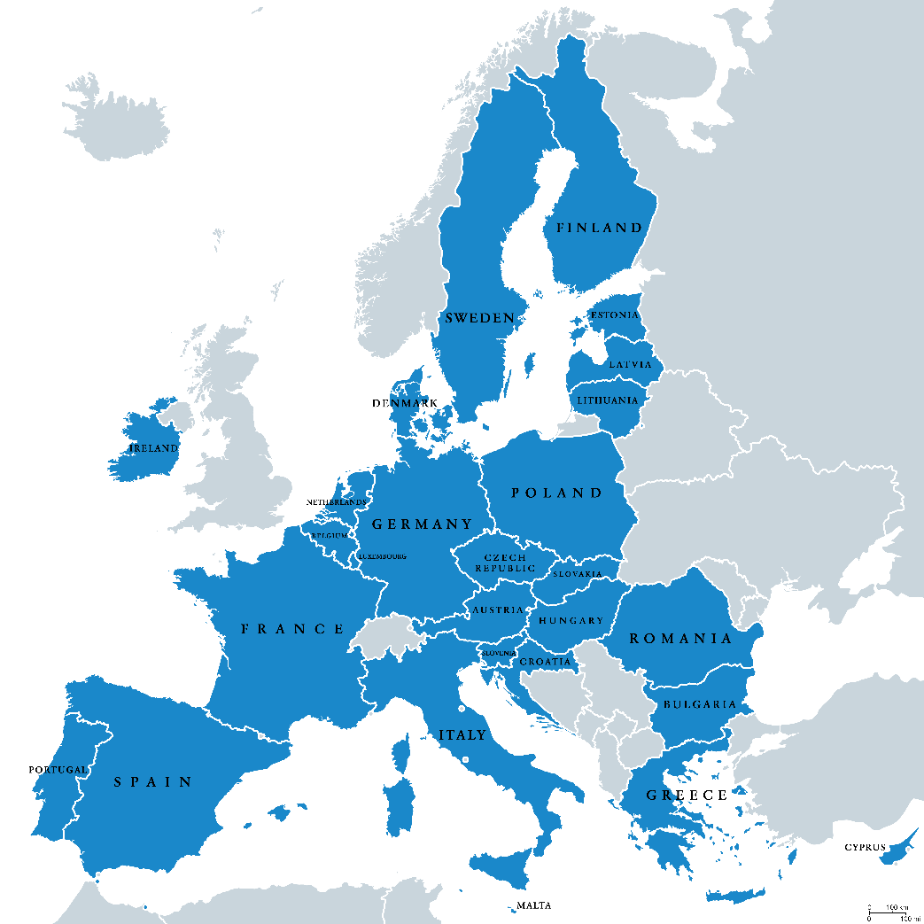

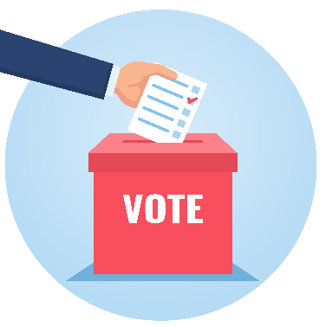
European elections
Every 5 years,
the people who live in the European Union
vote who they want
to make laws and decisions in Europe.
The next European elections will be in May 2024.

Vote and stand for elections
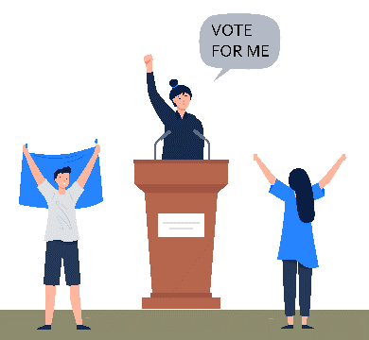
To vote in the elections means you can choose
which people will represent you
and make decisions and laws in Europe.
To stand for elections means you ask people
to vote for you so that you can represent them
and make decisions and laws
in Europe.

UN Convention
‘The UN Convention on the Rights
of Persons with Disabilities’ is an agreement
that many countries in the world have signed.
It says persons with disabilities
have the same rights as everyone else.
It also says how countries
can protect these rights.
In short, we call it ‘the UN Convention’
or ‘the CRPD’.

COVID-19
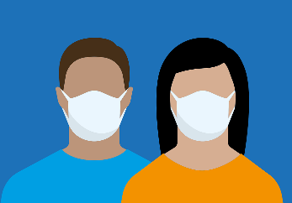
‘COVID-19’ is a disease
that can pass easily from one person to another.
We also call it ‘coronavirus’ or ‘pandemic’.
Sadly, in recent years,
too many people in the world
have been ill from coronavirus.
Most of the people recover
but many people die from it.

Institutions
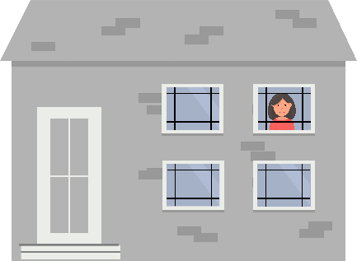
Institutions are places
where people with disabilities often live
away from other people
and from the community.
Often people who live in institutions
must follow the rules of the institution
and cannot decide for themselves.

