Report on EDF Women’s Committee work and achievements - 2023

Introduction
A new EDF Women’s Committee was appointed by the EDF Executive Committee in September 2022. The new Committee adopted a workplan from 2023 to 2026 in November 2022. The detailed workplan for 2023 was then approved. It is available on the Committee’s webpage.
This report gives an overview of the activities undertaken by the Committee in 2023.
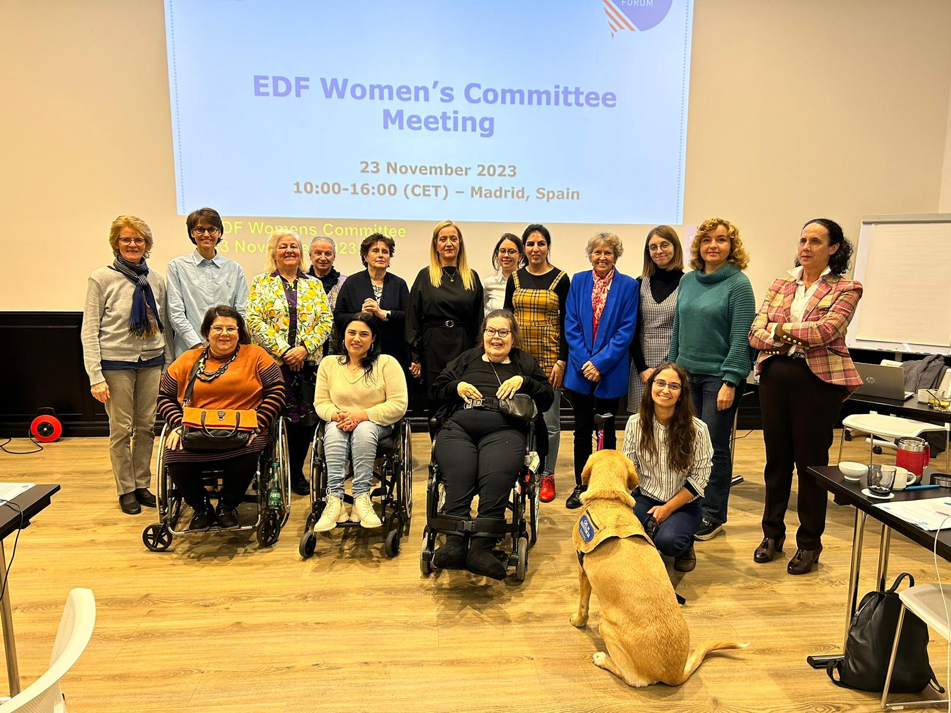

Highlights
- 2 meetings of the Committee took place in June and November 2023, online and in Madrid, Spain.
- Advocacy on the rights of women with disabilities in EU initiatives on combating violence against women, victims’ rights and harmful practices. EDF continued its campaign to ban forced sterilisation.
- Preparation and adoption of the EDF’s third Manifesto on Women and girls with Disabilities.
- Publication of an updated version of EDF guide on engagement with United Nations Committee on Elimination of Discrimination Against Women (CEDAW).
- Establishment of Committee’s focal points on various topics improve mainstreaming of the perspective of women with disabilities within EDF’s work.
- 10 EDF Women’s Voice newsletters sent to over 400 subscribers.

Reporting under the 2023 work plan

Action area 1 - mainstream the perspective of women and girls with disabilities in EU policies and EDF’s work
The Committee supported the mainstreaming of the perspective of women and girls with disabilities through the participations in different EDF and EU levels activities.
On advocacy, the rights of women with disabilities were included in the final text of the Pay Transparency Directive adopted this year and in the proposed revision of the Victims’ Rights Directive.
On employment – a key topic of the Disability Rights Strategy - the perspective of women with disabilities was mainstreamed in EDF Human Rights Report on the topic. The Chair of the Committee spoke at the launch of the event on access to employment by women with disabilities, in April.
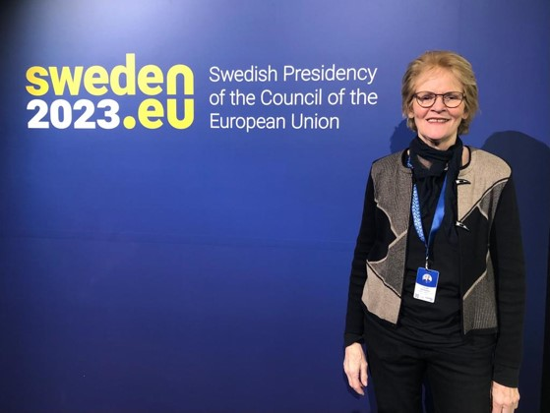
On events, a committee member – Lolo Danielsson – attended an event organised by the Swedish presidency on economic violence against women with disabilities. It led to more discussion on the rights and needs of women with disabilities and better accessibility of the event, through the provision of sign language interpretation.
The Committee established focal points on various topics to allow better mainstreaming of the perspective of women with disabilities within EDF’s work. These are as follows:
- Access to justice and victims’ rights
- Violence against women and girls (including forced sterilisation, forced contraception, forced abortion or coerced pregnancy, trafficking of women)
- Sexual and reproductive health and rights
- Employment
- Political participation
- Accessibility (built environment, transport, digital, from a gender perspective
- Healthcare
- Migration and refugees
Most of the members have expertise in more than one area.
An internal training for EDF staff on the Women’s Committee and mainstreaming was organised on the 20th of October. Sara Rocha was present as Vice-Chair of the Women’s Committee. She spoke about EDF’s women’s committee and its role and activities in details.
The Committee members and observers were invited to attend EDF webinars and workshops organised for EDF member organisations. EDF’s communication team was actively involved in sharing the upcoming activities with the committee.

Action area 2 - combating violence against women and girls with disabilities
A big focus of the work of the Committee was on the advocacy on the Directive on combating violence against women. EDF managed important successes in the position of the Council of the EU and the European Parliament with better inclusion of women and girls with disabilities, and their rights.
EDF had a communication campaign around the directive and criminalisation of forced sterilisation. EDF demands that forced sterilisation must be prohibited and criminalised by the EU and all its EU Member States. To that end, EDF launched a petition available in different languages.
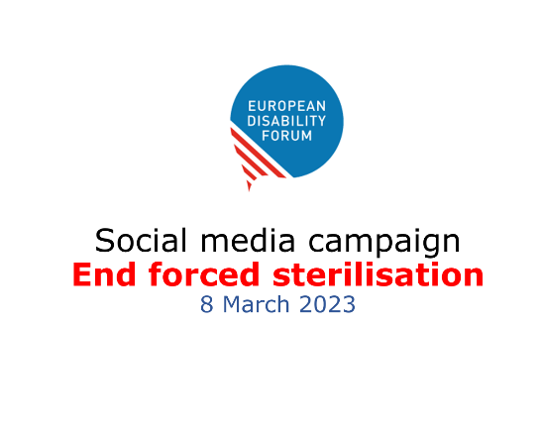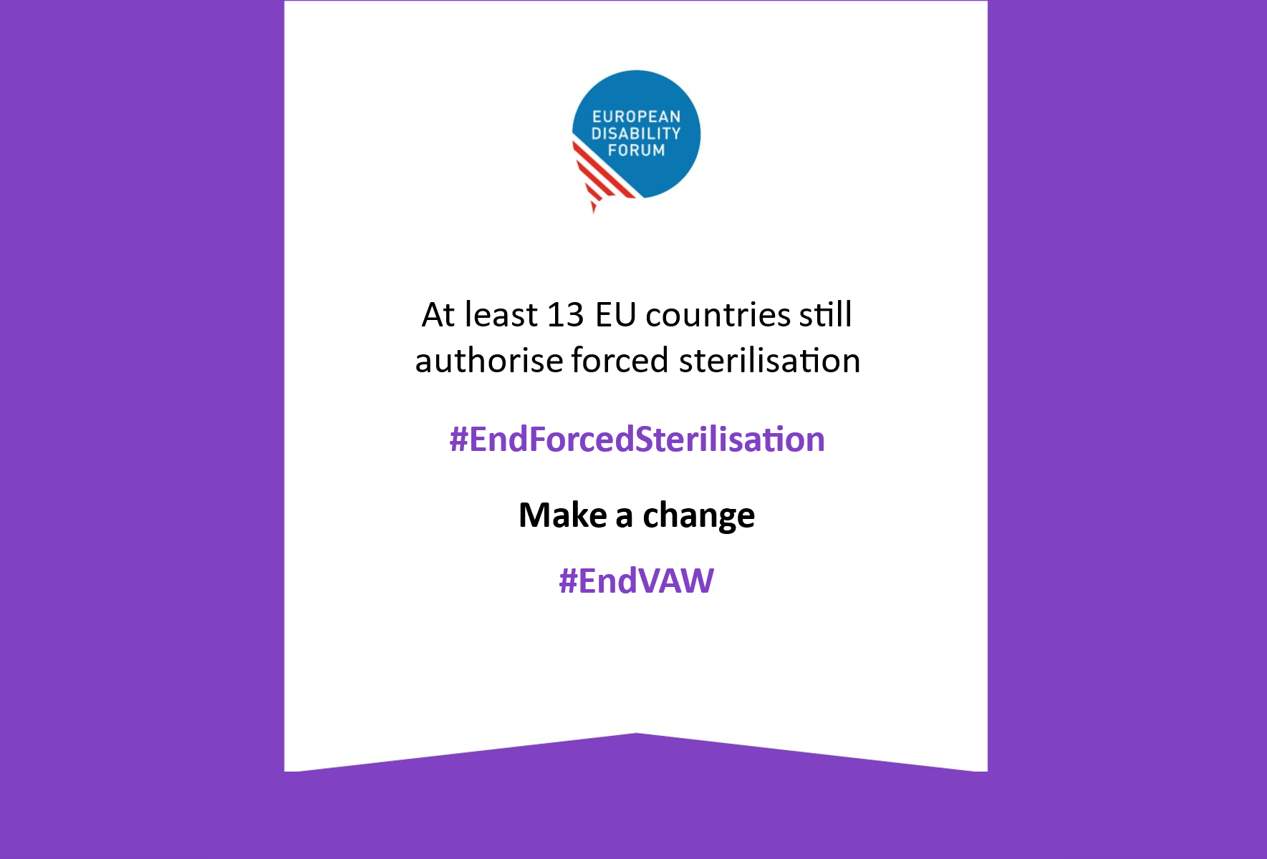
EDF continued to actively engage in the meetings of the European coalition to end violence against women and to participate in actions on the ratification of the Istanbul Convention by the EU. The EU acceded the Istanbul Convention in June. There was no additional work undertaken by the coalition the rest of the year.
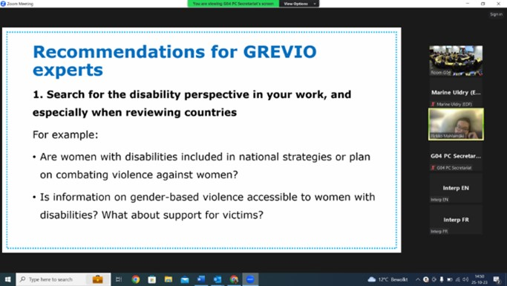
EDF engaged with the Council of Europe’s Group of Experts on Action against Violence against Women and Domestic Violence (GREVIO) to increase their understanding of the issues and rights of women and girls with disabilities. EDF Secretariat had a meeting with the GREVIO Secretariat, and the Chair of the Committee – Pirkko – gave a training to the GREVIO experts in October.

Action area 3 - advancing the human rights of women and girls with disabilities
This action area centred on the EDF campaign on ending forced sterilisation.
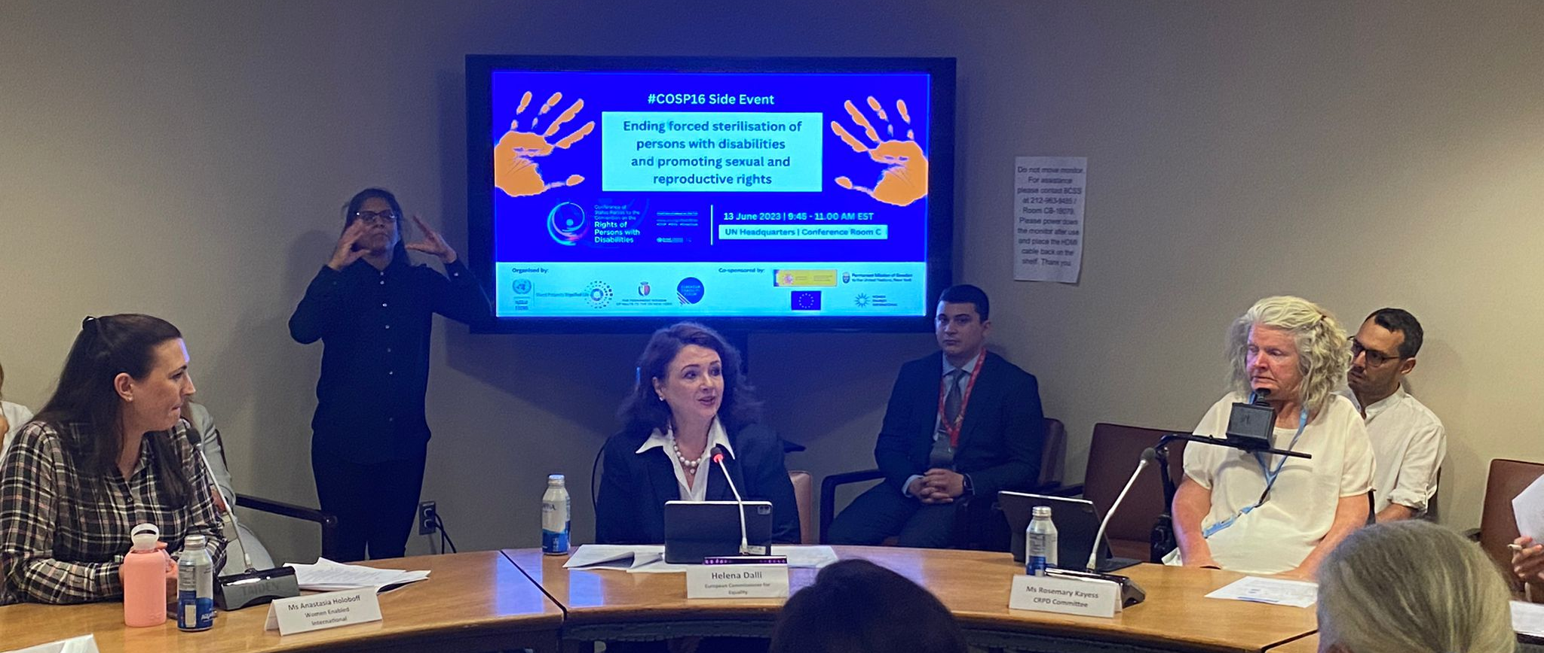
EDF organised a side-event on forced sterilisation at the annual Conference of the state parties to the CRPD in June. It included high level speakers, such as the Commissioner for Equality and the Ambassador of Malta. The Committee’s Vice Chair, Sara Rocha spoke at the event.
Sara Rocha and Ana Pelaez, two members of EDF’s Women’s Committee, spoke at a hearing on harmful practices against women with disabilities at the European Parliament on 29th of November.
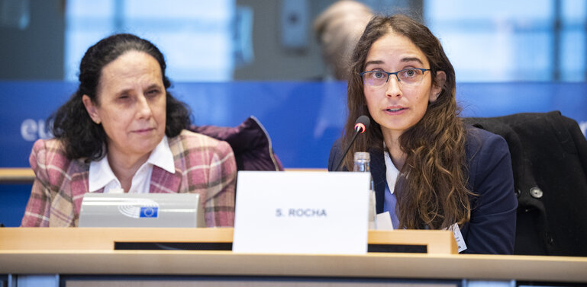
Members of the Committee supported the campaign, including by national actions on ending forced sterilisation.

Action area 4 - Women’s Committee position papers, statements and other documents
The EDF Third Manifesto on women and girls with disabilities was prepared with the feedback and valuable input of the whole Women’s Committee.
It was adopted at the Women’s Committee meeting on 23rd of November, and at the EDF Board meeting on 27th of November.
This document is based on two fundamental concepts which are empowerment and leadership. Part of the content of the manifesto is based on data from a qualitative-quantitative European survey for women and girls with disabilities developed by EDF.

Action area 5 - monitoring international human rights treaties relevant to women and girls with disabilities
EDF supported several organisations for the review by their countries by the CEDAW committee.
EDF prepared an updated guide on engagement with United Nations Committee on Elimination of Discrimination Against Women (CEDAW) , which was reviewed by the Committee.
EDF organised a training on the 2024 CRPD and CEDAW review for members on 4th October. This training was open for members of the committee, EDF members and network of women with disabilities. More than 60 participants from different organisations in Europe and outside Europe attended to this event. EDF presented the updated toolkit on how to engage with CEDAW Committee for representative organisations of persons with disabilities.

Action area 6 – networking
There were 2 meetings of the women’s Committee in 2023. The first meeting was held online in June. The committee members and observers had the chance to learn from each other’s work during this interactive session. The second meeting was held in person in Madrid on November 23rd. In addition to the official hours of the meeting that let the participants exchange ideas, there was the opportunity to have small group gatherings during the free evening afterward.
The Committee also had the opportunity to network with the Spanish movement by participating in the Social Forum of women and girls with disabilities in Léon, Spain.
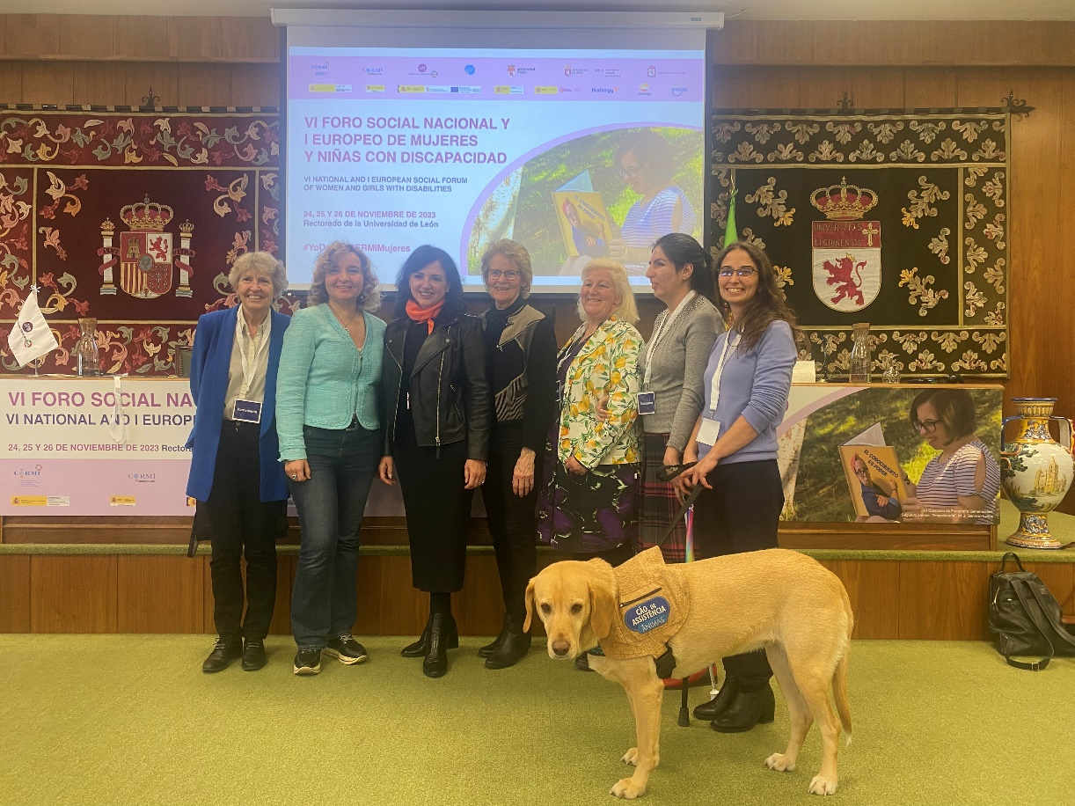
The two big events of the EDF in 2023, the European Parliament of persons with disabilities and the conference for the European Day of Persons with Disabilities, also gave the opportunity of networking to the members of the committee who could manage to participate.

Action area 7 - external representation
The Chair of the Women’s Committee, Pirkko Mahlamäki was elected as the Board member of the European Women’s Lobby.
EDF is represented in several working groups of EWL: by Luisa in the Observatory on combating violence against women, and by Pirkko in the task force on sexual and reproductive health and rights. Elena was appointed to temporarily replace Luisa in the feminist economy working group.

Action area 8 – communication
EDF continued to publish the monthly EDF Women’s Voice newsletter with several contribution from committee members. The committee members shared relevant news and thematic articles with EDF secretariat.
The Committee published a statement for the International Women’s Day, focusing on the Directive on combating violence against women.
EDF published a briefing on forced sterilisation and endorsed the statement “I Decide” of CERMI Women’s Foundation for the International Day for the Elimination of Violence against Women.
EDF partly reviewed and update its webpages related to the Committee and its women’s rights work. This activity is ongoing. We created a webpage with a mapping of organisations and networks of women with disabilities in Europe.

