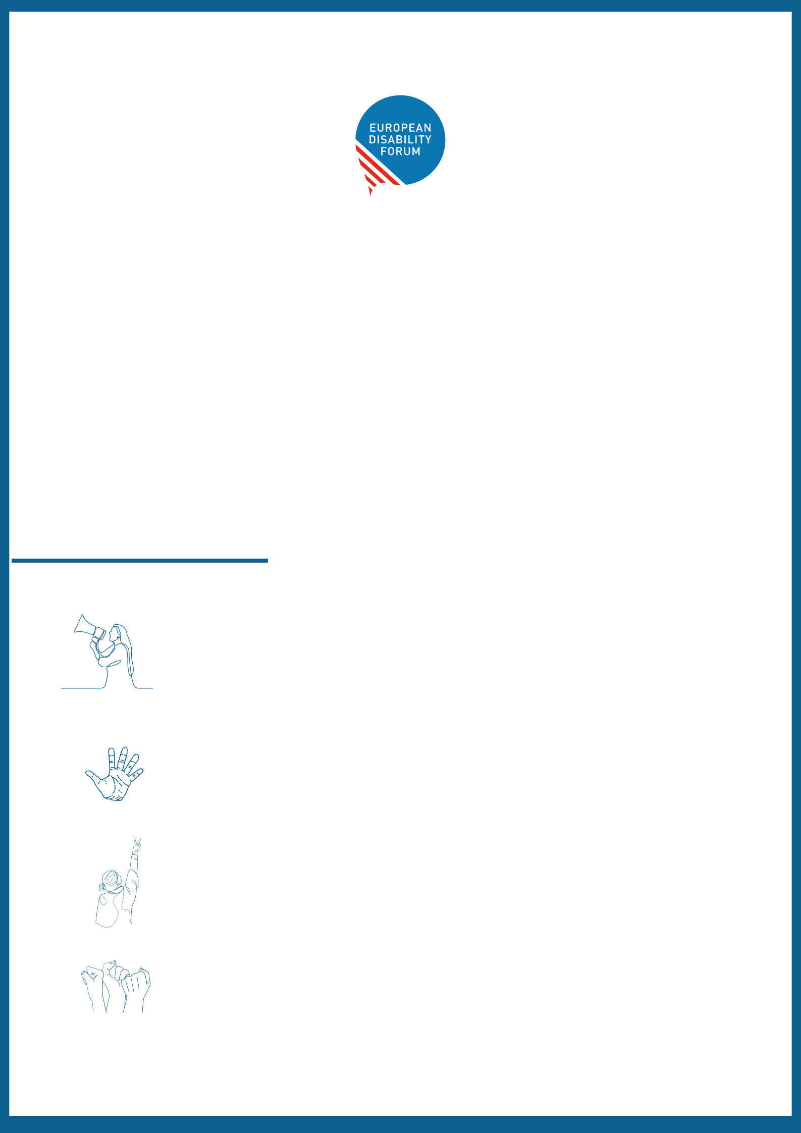

Empowerment and Leadership
Third EDF Manifesto on the Rights of Women and Girls with Disabilities

Women and girls with disabilities make up around 25.9% of women in the European Union and around 60% of the overall population of 100 million persons with disabilities in Europe. Despite its large population, they encounter systemic marginalisation and barriers, often having their voices ignored.

EDF third manifesto on their rights highlights their active involvement in decision-making, advocating for equality and non-discrimination in the EU and its Member States. It sets the stage for addressing their demands and fundamental needs, aiming to promote inclusivity and address existing disparities.

Four main ideas:

Political participation – Ensuring political participation in European elections means upholding voting and candidacy rights irrespective of legal capacity or residence. This requires accessibility measures, accommodation, ending election-related violence like harassment, and promoting awareness. Women with disabilities must receive adequate support to engage in politics at every level.

End violence against women and criminalise practising forced sterilisation and forced abortion against women and girls with disabilities in all European countries - Women and girls with disabilities are still at a higher risk of violence, including human trafficking, during humanitarian crises, and the effects of natural disasters and climate change.

Leadership – Women and girls with disabilities can lead their lives as independent persons, benefit from their rights in society and make their own decisions. Women with disabilities are key actors not only in their own lives but also in society.
Visibility and empowerment in all areas of life (access to justice, legal capacity, education, healthcare, labour market, reproductive rights…) – equal opportunities and inclusion. Included in society without discrimination based on disability, gender or other additional factors.
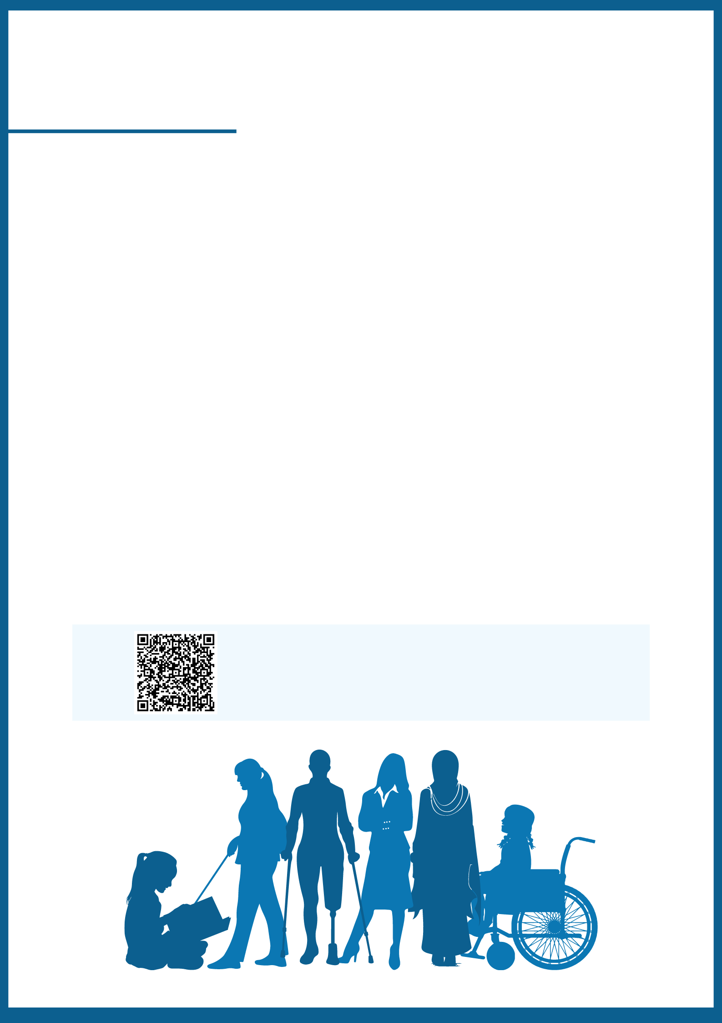

The demands:

Women and girls with disabilities in all their diversity are calling the European Union and the governments for:

- Their full participation as voters and as candidates for all elections – including for the European Parliament, and at national and local levels.
- Meaningful inclusion and leadership in decision-making, including by enhancing accessibility measures for the participation of women and girls with disabilities in all issues.
- Increased visibility and awareness of and for women and girls with disabilities. The rights of women and girls with disabilities should be mainstreamed and visible in the work of the European Union and across Europe.
- Concrete targeted actions to reduce the poverty level faced by them, including through equal employment and pay measures, and ensuring the amount of disability allowances received by women and girls with disabilities are kept regardless of employment status or the financial means of their partners and families.
- Adoption of the EU Directive on combating violence against women and the end of forced sterilisation of women and girls with disabilities across Europe
- Funding of organisations and projects that support the empowerment, leadership and improvement of rights of women and girls with disabilities.
Please, scan the QR code with your device to read the complete version of the manifesto. It is also available in Easy-to-Ready and translated in some languages.

