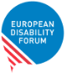
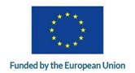
Women with Disabilities in Europe

The purpose of this survey was to obtain information that can better inform policies and programmes designed to support women with disabilities in Europe.
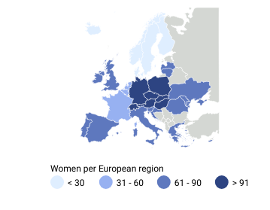
471 women in Europe responded to the survey with an average age of 42.4 years old, with more more responses from Central Europe.
8 in 10 were women with disabilities, with 11.5% also identifying themselves as mothers/ carers of children with disabilities.
2 in 10 were women without disabilities, mostly mothers or women working with persons with disabilities.
Number of disabilities

Most women had had one disability, but 15% reported 2 disabilities, while 14.2% said they had 3 or more.
Type of disabilities
Mobility
50.1%
Neurodivergent 13.6%
Hearing
9.8%
Seeing 7%
Undefined 2.3%
Psychosocial 9.8%
Pain or chronic conditions 7.2%

Most common type of discrimination

Employment
Only 6 in 10 women were employed.
European Disability Forum
Find out more in www.edf-feph.org
1

Women with Disabilities in Europe
European Disability Forum
Find out more in www.edf-feph.org
2

Advocacy participation

Engagement in civic or political movements
Less than half of the women engaged in civic or political movements.
Women were not involved because:
Women also mentioned losing faith, being burnout and having no time or capacity for volunteer work and ableism as barriers to participation in advocacy.

"Having a costly and burdensome life as a disabled"
"Lack of interests among the politicians" "Lack of support"

Women who were involved, engaged through:
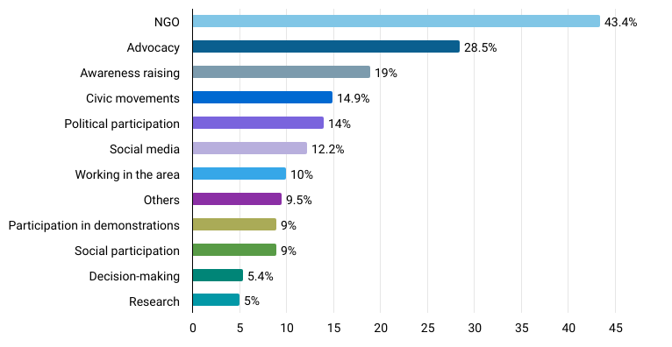

Women with Disabilities in Europe

Key issues and policy

Key issues for women and girls with disabilities in Europe
Key issues for women and girls with disabilities in Europe
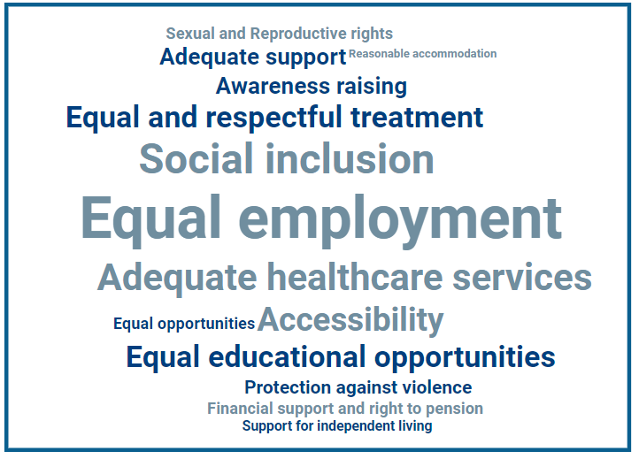
Other issues mentioned:
- Gender equality
- Political participation
- Housing
- Intersectionality
- Access to justice
- Empowerment
- Protection against harmful practices
"We need to break the taboo against disability. It should not be a dirty word. People should not feel ashamed to disclose that they are disabled. We need more openly disabled people at the highest levels of Governance, just like we need more women and more LGBTQIA people in those positions."

Biggest changes in law and policies wanted to improve the rights of women and girls with disabilities.

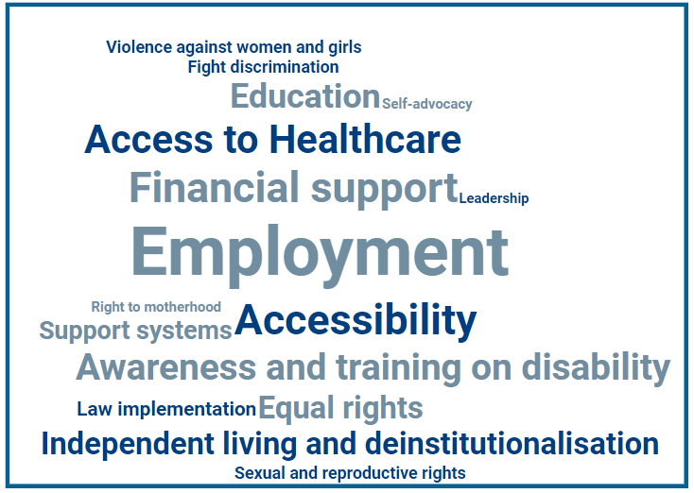
Other issues mentioned:
- Leadership
- Right to motherhood
- Housing
- Access to disability aids
- Access to justice
- Intersectionality
- Medical sexism
- Research
- Access to childcare
- Political participation
"Our current policy and structures need a radical overhaul. The policies as they stand are disabling, stigmatizing, increase vulnerability, and as a result are a breeding ground for gender-based violence."

European Disability Forum
Find out more in www.edf-feph.org
3

Women with Disabilities in Europe

Healthcare

7 in 10 women indicated the need of regular use of use of health services because of their disability.

Concerns related to healthcare: Other concerns:
- Overwhelming costs and lack of financial support;
- Lack of specialists;
- Lengthy waiting lists;
- Lack of awareness;
- Late diagnosis;
- Disregarding health problems due to disability.

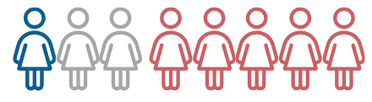

1 in 8 mothers of children with disability disability have regular access to free free and specific mental health services, with 5 in 8 never having having access.

5 in 8 never had access to free and specific mental health services
" I’m 53 and I was diagnosed with Autism mere 7 months ago after a lifetime full of pain, failure, misdiagnoses, comorbidities and in the end the inability to work. especially we autistic women and girls face horrific hurdles when it comes to proper access to assessment and then proper treatment and support."

"Recently, a wheelchair-dependent colleague with a disability died of cervical cancer, two weeks after learning she had cancer. She was too late to see her doctor. She had never had a gynecological check-up in her life. Since her death, we have spoken to 90 disabled women in Romania. I asked each one when she last had a Pap smear. Only one said more than three years ago, one said ten years ago, and another said she had a Pap test 20 years ago when she gave birth. Otherwise, none of the women with disabilities I spoke to had ever had a Pap test.
That’s worrying. We need to make it easier for women with disabilities to access gynecological care!"
European Disability Forum
Find out more in www.edf-feph.org
4

Women with Disabilities in Europe

Accessibility
Difficulties regarding accessibility:

Other accessibility difficulties:
- Environmental accessibility
- Access to public services
- Access to information
- Accessible communication
- Access to specialists

"A total lack of communication skills towards neurodiverse people from officials and state workers, impatience and impatience and intolerance when I'm scared due to not understanding something."

"Birthing facilities, children's healthcare facilities, kindergartens, school events are rarely accessible for wheelchair users like me, making it hard for me as a mother."

"I often have to ask for special access to elevators in concert halls, theatres, universities etc. I then have to explain why, as my disability is invisible, and sometimes they don't believe me."

Difficulties accessing employment:

Other difficulties accessing employment:
- Keeping the job;
- Flexibility;
- Career progression;
- Work and be a carer.

"I am afraid to mention my ADHD and Autism to my employer since I just started to work there. I do not feel safe yet because they can assume me needing some more alone time or needing medication to finish a task might mean I am not capable. However, I do need some help, not with the tasks but with my environment so I can do an as optimal job as anybody else. Since I don’t feel space to ask for that help yet, I might burn out and get migraines and they might fire me. It has happened before."

"I’ve been previously hired as the “diversity hire” which do to not receiving any reasonable accommodations or the same conditions as others (eg salary, working hours) led to bullying and harassment. The stigma also led to leadership and training opportunities being removed once my disability was disclosed."
European Disability Forum
Find out more in www.edf-feph.org
5

Women with disabilities in Europe

Violence
1 in 6 women faced violence.

Type of violence

Other types:
- Social violence as exclusion;
- Parental neglect;
- Financial abuse;
- Medical gaslighting.

Location where the violence took place Person who perpetrated the violence:

Other locations:
- Public transportation;
- Going out socially or friends gatherings;
- Online.

Other perpetrators:
- Colleague or classmate;
- Employer.

"Disabled women are extremely vulnerable to domestic violence, as many times, we are and are expected by social workers to be, dependent on our partners as caregivers. Women’s shelters are more often than not inaccessible to disabled women and it’s harder for us to get out of a violent relationship. We are more vulnerable to sexual violence because a lot of times, we are unable to physically protect ourselves, and it’s harder for us to alert others that we’re being abused by our partners because being dependent on our partners also means it's easier for them to monitor and control who we see and talk to in the home and how and where we can go outside of the home. This is something I have experienced in the past and have supported other disabled women with. None of the medical professionals or social workers I’ve spoken to have had any knowledge of this scenario."
"I faced violence and my kids, and it wasn't taken seriously because my Partner said it is all in my head because I have a disability and my medication and disability are causing psychological problems".
European Disability Forum
Find out more in www.edf-feph.org
6

