Access Denied
The (in)accessibility of European Political Party websites
This study is a collaboration between:

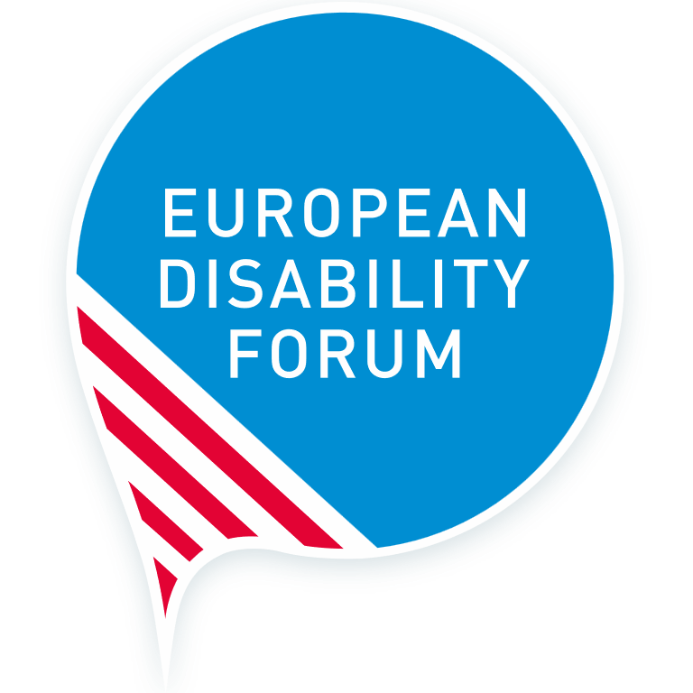
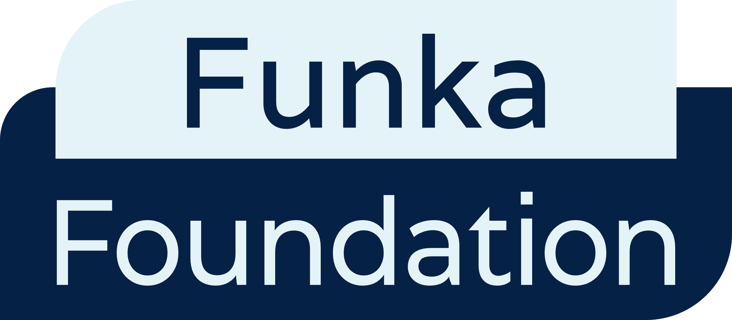

Date: March 2024
Authors: Funka Foundation - Malin Hammarberg, Péter Kemény and Susanna Laurin.
Editor: André Felix, Communications Manager – European Disability Forum
Proofreader: Ciara Kristensen, Communications and Campaigns Officer - European Disability Forum
Cover Image: Natalia Suarez, Senior Communications Officer European Disability Forum
Contact: André Felix, EDF Communications Manager : info@edf-feph.org
Press contact: press@edf-feph.org
The European Disability Forum
7 – 8 Avenue des Arts
1210 Brussels, Belgium
info@edf-feph.org
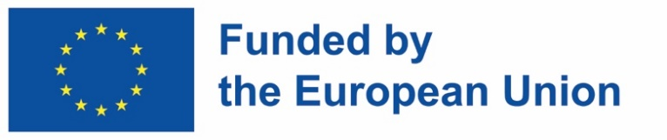
Funded by the European Union. Views and opinions expressed are however those of the author(s) only and do not necessarily reflect those of the European Union. Neither the European Union nor the granting authority can be held responsible for them.

Table of Contents
Scope 3
Needs of persons with disabilities 3
Pages and channels analysed 4
Documents analysed 5
Selected EN 301 549 and other requirements 7

Scope
A website needs to work for everyone, no matter their abilities.
A full accessibility analysis of a website requires hundreds of hours of testing with end users as well as experts. In this report, we relied on a set number of “spot checks”. We chose these spot checks based on the harmonised European standard EN 201 549, which is used to conform with EU legislation such as the Web Accessibility Directive. The spot checks cover desktop and mobile interfaces and with:
- A selection of requirements where inaccessibility risks fully excluding groups of users.
- Requirements that support diverse users: users who are blind, users with low vision, users who are hard of hearing, users with motor impairments, speech impairments or cognitive impairments.
- Analysis of important sections of the website, including the start page, the page with a manifesto or what the party stands for, the accessibility statement, contact information, and a sample of multimedia contents and documents.

Needs of persons with disabilities
The analysis focused on 10 elements that websites need to have to ensure persons with diverse types of disabilities can interact without spending more time and effort than others:
- Description of Non-text content: ensuring that buttons, icon links, video and audio only content include appropriate description to ensure access to persons that cannot access visual information.
- Captions: ensuring captioning is provided in audio and video content.
- Clear Contrast: text and images need to have an appropriate contrast ratio for visual perception.
- Keyboard navigation: ensure websites can be navigated using only the keyboard.
- Pause, Stop, Hide: Ensuring automatically moving content (videos, animations) can be paused, stopped, or hidden by the user.
- Visible indicator when focusing on page elements: ensuring that users navigating with keyboard can understand which element they are selecting.
- Error identification: there are precise instructions on how and where to fix errors when filling out forms.
The table below shows how each element interacts with diverse user needs. “Primary” means that having that element is essential for a user with a specific impairment be able to interact with the website at all. Secondary means the element being correctly implemented will help the user interact on an equal basis with the website.
 | Vision | Hearing | Speech | Motor | Cognition
Non-text content | Primary | Primary | - | - | Secondary
Captions (pre-recorded) | - | Primary | - | - | Secondary
Contrast (minimum) | Primary | - | - | - | Secondary
Keyboard | Primary | - | Secondary | Primary | -
Meaningful sequence | Primary | - | - | - | Secondary
Pause, stop, hide | Primary | Primary | - | Primary | Primary
Focus visible | Primary | - | Secondary | Primary | Primary
Error identification | Primary | - | - | - | Primary
Tagged | Primary | - | Secondary | Primary | Primary
Bookmarks | Primary | - | Secondary | Primary | Primary
Pages and channels analysed
The table below shows which specific pages, channels and documents we analysed.
Party | Start page | Manifesto | Contact | Multimedia YouTube
EPP | https://www.epp.eu | /commitments | /contact | @EPPtv
ECR Party | https://ecrparty.eu | - | /contact | @ecrparty6021
PES | https://pes.eu | /policies | /contact | @pes_pse
ALDE Party | https://www.aldeparty.eu | /vision | /contact | @aldeparty
European Greens | https://europeangreens.eu | /vision | /contact | @europeangreens
European Left | https://www.european-left.org | /manifesto2023 | /contact-us | @europeanleftparty
ID Party | https://id-party.eu/ | /program | /contact | @identitydemocracyparty6303
To check the accessibility of the documents published on the websites, we chose two files on each website where available. We aimed to choose consistently:
- the most recent “publication style” document (typically a Manifesto or a Bulletin);
- the most recent simple, informative document.

Documents analysed
For documents, the PDF/UA standard was considered, and we also checked whether the documents are tagged and have bookmarks. If a document is tagged correctly, users of assistive technology can read and navigate the content. Tagged and Bookmarks are not a legal requirement, but as they are crucial for many users, we therefore include them in document testing. Instead of Keyboard on documents we tested Meaningful sequence.

Party | Document name/URL | Document type
EPP | EPP Manifesto 2024 | Design: Manifesto
EPP | Emergency resolution Nr. 6 adopted at the EPP Congress, Bucharest (Romania), 6th – 7th March 2024 | Simple: Resolution
ECR Party | Publication of accounts 2016 | Complex: Financial report
ECR Party | Publication of accounts 2017 | Complex: Financial report
PES | PES Manifesto 2024 | Design: Manifesto
PES | Energy affordability and energy security are EU imperatives | Simple: Presidency declaration
ALDE Party | ALDE Party Liberal Bulletin 02/2023 | Design: Bulletin
ALDE Party | Air Travel and Passengers With Disabilities | Simple: Resolution
European Greens | The social dimension of the Green New Deal | Simple: Manifesto
European Greens | Green transformation of EU trade policy | Simple: Resolution
European Left | European elections manifesto | Design: Manifesto
European Left | Statutes of the Party of European Left | Simple: Statutes
ID Party | Appel d'offres : location d'une salle pour un meeting public à Paris | Simple: Call for tender

Selected EN 301 549 and other requirements
 | Website reference | Document reference
Non-text content | 9.1.1.1 | 10.1.1.1
Captions (pre-recorded) | 9.1.2.2 | Not applicable
Contrast (minimum) | 9.1.4.3 | 10.1.4.3
Keyboard | 9.2.1.1 | Not tested
Meaningful sequence | Not tested | 10.1.3.2
Pause, stop, hide | 9.2.2.2 | Not applicable
Focus visible | 9.2.4.7 | Not applicable
Error identification | 9.3.3.1 | Not tested
Tagged | Not applicable | Not in EN 301 549
Bookmarks | Not applicable | Not in EN 301 549

European standards EN 301 549 v 3.2.1

