Access Denied
The (in)accessibility of European Political Party websites
This study is a collaboration between:

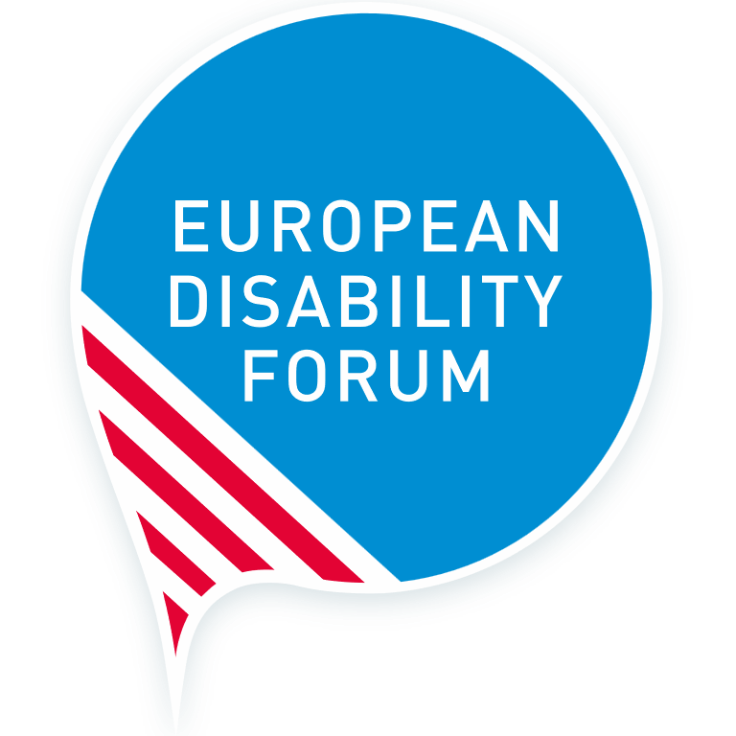
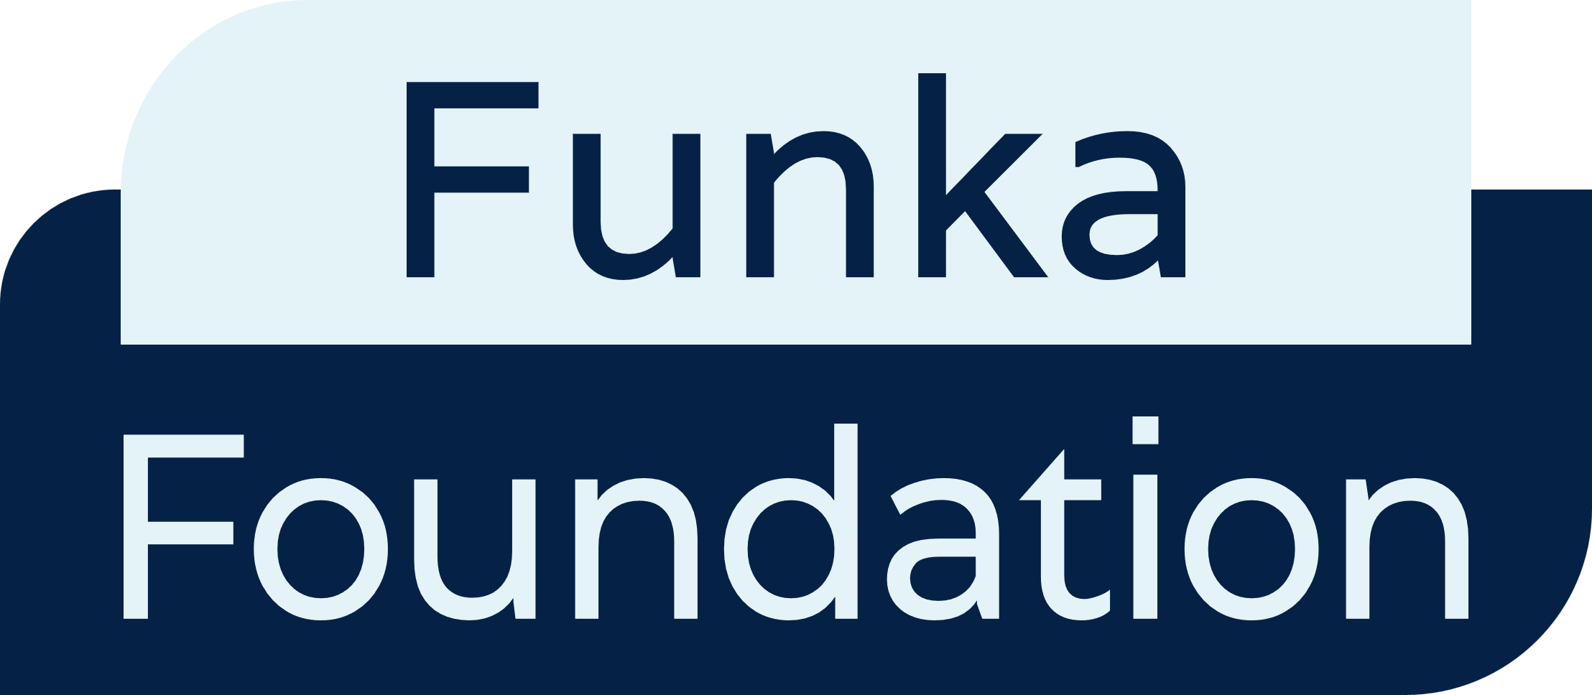

Date: March 2024
Authors: Funka Foundation - Malin Hammarberg, Péter Kemény and Susanna Laurin.
Editor: André Felix, Communications Manager – European Disability Forum
Proofreader: Ciara Kristensen, Communications and Campaigns Officer - European Disability Forum
Cover Image: Natalia Suarez, Senior Communications Officer European Disability Forum
Contact: André Felix, EDF Communications Manager : info@edf-feph.org
Press contact: press@edf-feph.org
The European Disability Forum
7 – 8 Avenue des Arts
1210 Brussels, Belgium
info@edf-feph.org
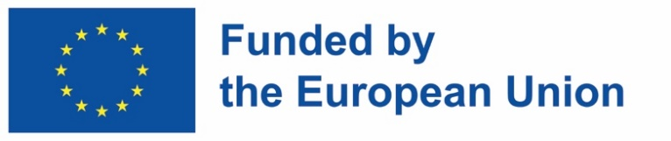
Funded by the European Union. Views and opinions expressed are however those of the author(s) only and do not necessarily reflect those of the European Union. Neither the European Union nor the granting authority can be held responsible for them.

Table of Contents
Table of Contents 2
Acknowledgements 3
Executive Summary 4
Introduction 6
About the Authors 7
Results summary 8
Summary of websites 8
Summary for documents 10
Scope 12
Needs of persons with disabilities 12
Results per party 14
European People’s Party (EPP) 14
Example – European People’s Party 15
Party of European Socialists (PES) 16
Example – Party of European Socialists (PES) 17
Alliance of Liberals and Democrats for Europe (ALDE) 18
Example – Alliance of Liberals and Democrats for Europe 18
European Conservatives and Reformists (ECR) 20
Example – European Conservatives and Reformists 20
European Greens 22
Example – European Greens 22
European Left 24
Example – European Left 24
Identity and Democracy Party (ID Party) 25
Example – Identity and Democracy 26
Conclusion 27

Acknowledgements
We thank the Funka Foundation, and especially Malin Hammarberg, Péter Kemény and Susanna Laurin for ensuring technical expertise on the revision of the accessibility of political parties' websites.

Executive Summary
Our democratic systems and political processes rely on citizens being able to cast an informed vote. However, as seen in this report, the over 100 million persons with disabilities living in Europe are largely failed by political parties in their duty to provide accessible, reliable political information.
European political parties seem to be neglecting their obligation to provide information to all voters, whether they have specific access needs or not. In doing so, they are creating a barrier not only for persons with disabilities but for the democratic process itself.
While we recognise that the majority of voters will rely on information given by national political parties – and provided through a variety of means – we consider these disappointing results to provide an accurate snapshot of the inaccessibility of the political process, especially election campaigns, when it comes to the needs of persons with disabilities.
The disappointing results show that:
- All political parties’ websites have severe accessibility issues, excluding groups of users from content while making it difficult for others to access information.
- Some instances of insufficient colour contrast were the worst that any of the involved experts had ever measured before. A depressing record.
- Some website owners had actively removed code that benefits users, thereby deliberately making the interface less accessible.
This report analyses accessibility through the angle of persons with disabilities. This means that technical and practical arrangements are in place to ensure persons with disabilities can access and interact with society and enjoy their rights on an equal basis with others. This is far from the reality displayed in our study.
We call on EU political parties and all political actors to:
- Train web authors and other relevant staff in basic accessible publishing.
- Use the European standard for accessible ICT (EN301549) when procuring, designing and developing digital interfaces. The standard is free of charge.
- Involve end users with disabilities in designing, developing and testing digital interfaces, to make sure they work for everyone.
Finally, we encourage all political actors to meaningfully involve organisations of persons with disabilities in accordance with the disability movement’s updated motto: “Nothing without us.”

Introduction
This report on European political parties’ websites is intended as a constructive exercise to call attention to the accessibility issues still present for voters with disabilities. The study presents a path for improvement for European and national political parties, and all political actors. It shows what they must do during the next five years to ensure voters with disabilities can access relevant information and guarantee that the next European elections in 2029 ensure full, informed participation of persons with disabilities.
Due to capacity constraints, the report focused on the 7 European political parties, namely:
- European People’s Party
- Party of European Socialists
- ALDE Party
- ECR Party
- European Greens
- European Left
- Identity and Democracy
We acknowledge that analysing European political parties’ websites presents a limited scope of all the actors that engage in elections, and of the means through which they share information. However, we believe the results present an accurate snapshot of how political communication is still not accessible. We hope that European political parties can also engage their national members in an in-depth process to ensure accessible communications and events during electoral campaigns.

About the Authors
The European Disability Forum (EDF) defends the interests of over 100 million persons with disabilities living in Europe. We are an umbrella organisation of persons with disabilities, created in 1996 to ensure that decisions at European level concerning persons with disabilities are taken with and by persons with disabilities.
We are run by persons with disabilities and their families and serve as a strong united voice of persons with disabilities in Europe.
The Funka Foundation is an independent not-for-profit organisation. We carry out user centred research, studies, training and assignments to support inclusion and accessibility for persons of all abilities. We are active in standardisation and believe in empowerment through involvement.
We work with all sectors and stakeholders with a mission to act as a knowledge centre on accessibility, user involvement and inclusion and collaborate closely with organisations representing persons with disabilities.
Our subject matter experts are certified by the International Association of Accessibility Professionals (IAAP), and we lead the IAAP Nordic chapter.

Results summary

Summary of websites
All tested websites have severe accessibility issues that exclude groups of users from content and make it difficult for other groups of users to access information and carry out tasks. The issues are found across the board, from technical errors in the code to graphic design problems, user interface and navigation issues, and mistakes made by web authors.
Some of the cases of insufficient colour contrast measured when testing were surprisingly bad. It is not usual to find such low readability these days, as user behaviour includes using screens outdoors, in bright sunlight etc.
The most disappointing discovery is that some website owners have actively removed code that benefits users, thereby deliberately making the interface less accessible.
The Authors ran tests on 7 elements (further developed in “Results per tested criteria” section).
All tested websites fail on “Non-text content” making interfaces hard or impossible to use for users who are blind. Non-text content on websites and documents includes images, graphics, videos, audio clips, and other interactive elements like buttons or icons. To accommodate users that cannot see or hear, the same information needs to be provided as text often called “alt-text” or “alt-attribute”.
All but one website fails the “Contrasts” requirement, making the readability difficult for everyone, including users with dyslexia, visual or cognitive impairments. Text and objects need to have sufficient contrast to the background.
All but one website fails on “Pause, stop, hide”, which makes the website difficult to read, understand and navigate for everyone, but especially for users with visual or cognitive impairments, or who are not tech-savvy. “Pause, stop, hide” means that users should be able to pause, stop or hide objects that are moving or blinking.
All but one website fails on “Keyboard navigation”, meaning that users can navigate using the keyboard, which is important for most assistive technology users.
Half of the websites fail on “Focus visible”, meaning that the object in focus is highlighted visually, which means that users with motor impairments are often excluded from content.
When it comes to “Error identification”, two websites pass, and one passes partly. However, the error identification is quite difficult to understand on all tested websites. Error identification means that users can easily find and correct errors in input fields.
All videos tested had auto captions, which is good. However, one party provides podcasts without transcripts, removing access for deaf and hard of hearing users.
The table below shows a summary of how each party performed on the tests:
 | Non-text content | Captions (pre-recorded) | Contrast (minimum) | Keyboard | Pause, stop, hide | Focus visible | Error identification
EPP | Fail | Pass | Fail | Fail | Fail | Fail | Fail
ECR Party | Fail | Pass | Fail | Fail | Fail | Fail | Fail
PES | Fail | Pass | Fail | Fail | Fail | Pass | Pass
ALDE Party | Fail | Pass | Fail | Pass | Fail | Fail | Fail
European Greens | Fail | Pass | Fail | Fail | Fail | Pass | Partly
European Left | Fail | Pass | Fail | Fail | Fail | Pass | Pass
ID Party | Fail | Pass | Pass | Fail | Pass | Pass | Fail

Summary for documents
The tested documents have very low accessibility.
Two of them were scanned with low resolution, which means they are completely inaccessible.
All documents had technical issues, making them hard or impossible to handle for users of assistive technology.
The Authors ran 5 tests:
- Non-text content
- Contrast
- Meaningful sequence
- Tagged
- Bookmarks
All documents fail the “Non-text content” requirement, making them hard or impossible to use for users who are blind.
Half of the documents fail on “Contrast”. Poor contrasts make readability difficult for everyone, including users with dyslexia, visual or cognitive impairments.
3/4 of the documents fail the “Meaningful sequence” requirement, meaning that assistive technology will not read the content of the document in the intended order, which makes it difficult or impossible to understand the content for many users with visual or cognitive impairments.
2/3 of the documents were not tagged at all and the rest seem to be automatically tagged when being exported from a word processor document, with some issues. This means that content is not accessible or is only partly accessible for users of assistive technology.
None of the documents have bookmarks or meaningful bookmarks, that would help navigating long or complex documents. The lack of bookmarks makes it more difficult for everyone to handle these documents, but especially for users with visual, motor or cognitive impairments.
Many of the issues found showed inconsistency, leading us to wonder whether the accessible parts were more of a coincidence than a strategy. For example, when parts of the documents are not tagged, elements are in focus twice or when the same type of content is sometimes focusable and sometimes not.

The table below show a summary of how each part performed on the tests:
 | Non-text content | Contrast (minimum) | Meaningful sequence | Tagged | Bookmarks
EPP | Fail | Fail | Fail | Fail | Fail
ECR Party | Fail | Pass | Fail | Fail | Fail
PES | Fail | Fail | Fail | Fail | Fail
ALDE Party | Fail | Fail | Fail | Pass | N/A  Not applicable
European Greens | N/A  Not applicable | Fail | Fail | Fail | Fail
European Left | Fail | Fail | Fail | Fail | Fail
ID Party | N/A  Not applicable | Pass | Fail | Fail | N/A  Not applicable

Scope
A website needs to work for everyone, no matter their abilities.
A full accessibility analysis of a website requires hundreds of hours of testing with end users as well as experts. In this report, we relied on a set number of “spot checks”. We chose these spot checks based on the harmonised European standard EN 201 549, which is used to conform with EU legislation such as the Web Accessibility Directive. The spot checks cover desktop and mobile interfaces and with:
- A selection of requirements where inaccessibility risks fully excluding groups of users.
- Requirements that support diverse users: users who are blind, users with low vision, users who are hard of hearing, users with motor impairments, speech impairments or cognitive impairments.
- Analysis of important sections of the website, including the start page, the page with a manifesto or what the party stands for, the accessibility statement, contact information, and a sample of multimedia contents and documents.

Needs of persons with disabilities
The analysis focused on 10 elements that websites need to have to ensure persons with diverse types of disabilities can interact without spending more time and effort than others:
- Description of Non-text content: ensuring that buttons, icon links, video and audio only content include appropriate description to ensure access to persons that cannot access visual information.
- Captions: ensuring captioning is provided in audio and video content.
- Clear Contrast: text and images need to have an appropriate contrast ratio for visual perception.
- Keyboard navigation: ensure websites can be navigated using only the keyboard.
- Pause, Stop, Hide: Ensuring automatically moving content (videos, animations) can be paused, stopped, or hidden by the user.
- Visible indicator when focusing on page elements: ensuring that users navigating with keyboard can understand which element they are selecting.
- Error identification: there are precise instructions on how and where to fix errors when filling out forms.
The table below shows how each element interacts with diverse user needs. “Primary” means that having that element is essential for a user with a specific impairment be able to interact with the website at all. Secondary means the element being correctly implemented will help the user interact on an equal basis with the website.
 | Vision | 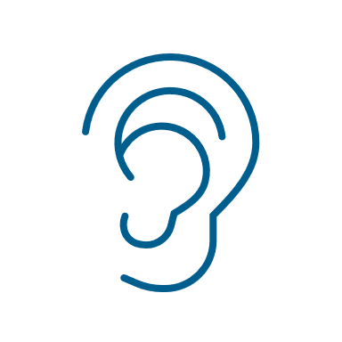Hearing | Speech | Motor | Cognition
Non-text content | Primary | Primary | - | - | Secondary
Captions (pre-recorded) | - | Primary | - | - | Secondary
Contrast (minimum) | Primary | - | - | - | Secondary
Keyboard | Primary | - | Secondary | Primary | -
Meaningful sequence | Primary | - | - | - | Secondary
Pause, stop, hide | Primary | Primary | - | Primary | Primary
Focus visible | Primary | - | Secondary | Primary | Primary
Error identification | Primary | - | - | - | Primary
Tagged | Primary | - | Secondary | Primary | Primary
Bookmarks | Primary | - | Secondary | Primary | Primary

Results per party

European People’s Party (EPP)
The European People's Party (EPP) website has significant accessibility challenges across multiple domains. Issues found risk excluding users with visual, cognitive and motor impairments.
The most severe problems found mostly affect users with cognitive impairments or even users who are not tech-savvy. There is content that continuously changes without any chance for the user to pause, which may be highly difficult to cope with for any user. There is a lack of clear error messages and error indications, which makes it difficult for users to succeed in filling in forms.
Blind users who rely on assistive technology risk being completely or partly excluded from content because of issues with keyboard navigation. This issue is compounded by a lack of alternative descriptions on elements like links and images, which is needed for these users to receive the information as audio or Braille.
On mobile, the menu is not accessible via any assistive technology.
Users with motor impairments with and without assistive technology may face important barriers because of the malfunctioning keyboard navigation. Even more serious, the party – or the service provider contracted by them - has deliberately removed the built-in visual keyboard focus of standard browsers, making it extremely hard for users of assistive technology to navigate.
Low-vision users may find the website difficult to handle because of low contrast and information that is dependent on the perception of colour, making it hard or impossible to reach and understand some content.
Positively, hard-of-hearing users are supported by auto-captioned video. The documents are not accessible.

Example – European People’s Party
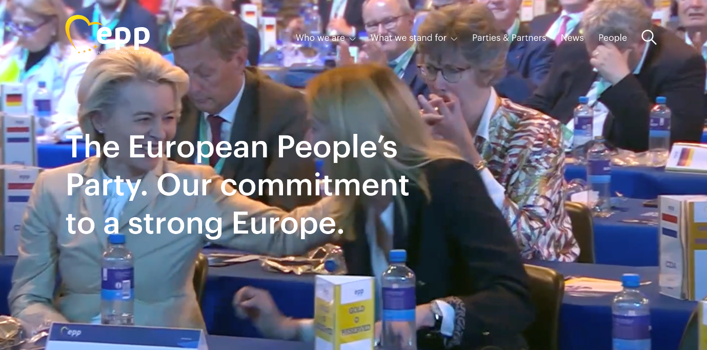
Figure 1: A screen capture of the top part of the start page a large moving video is continuously playing; there is no function to pause it. The menu items and main heading is displayed in white on top of the moving video.
“The EPP website has a constantly playing video in the large banner in the top of the start page. The users cannot pause the video. To make things worse, the main menu is placed on top of the video, making the text extremely hard to read.”

Party of European Socialists (PES)
There is a video playing in the background continuously, without any chance for the user to pause, which may be highly difficult to cope with for any user, especially for people with visual or cognitive impairments.
Many visual elements lack alternative text, which makes navigating difficult for visually impaired users. Social media links are actively removed in the code which hides them from users of assistive technology, excluding them from navigating to the social media channels from the website.
On mobile, the menu opens, but the menu items are not reachable for assistive technology. Furthermore, the “hamburger” menu icon changes name on each page, which makes it impossible to interact with for users of assistive technology.
The mobile interface also contains a Floating Action Button with headphones that starts reading random parts of the page. It's difficult to understand what this feature is intended to do or who the intended target audience would be.
Insufficient contrast makes it difficult for users with low vision to use the website, as they may miss important content. The use of the red colour may be problematic for users with visual impairments.
Hard of hearing users are supported by auto captioned video, which is positive.
The documents are not accessible.

Example – Party of European Socialists (PES)
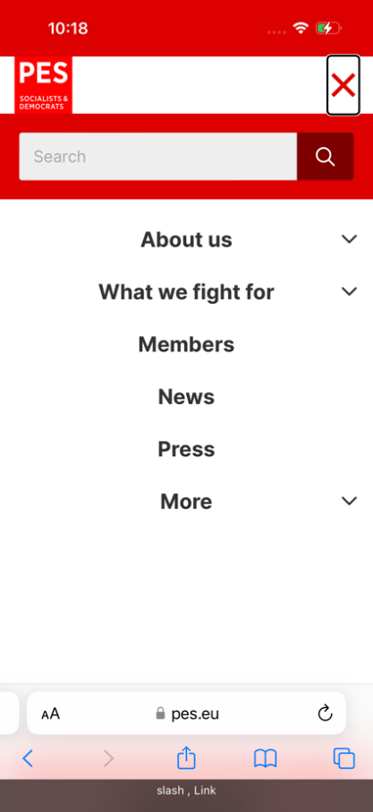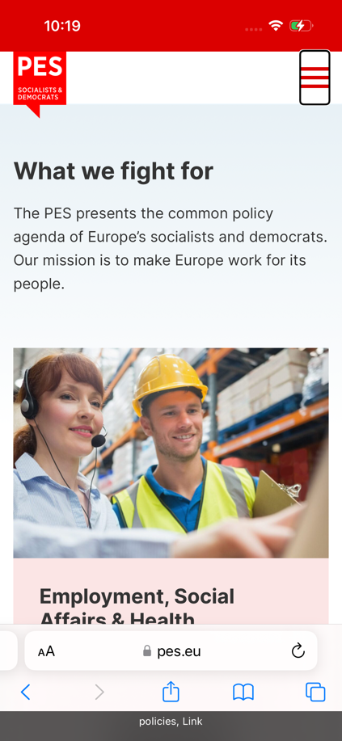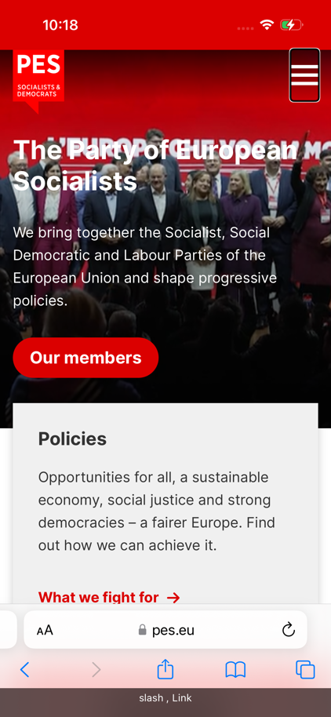
Figure 2: Three screen captures from an iPhone; the first shows that assistive technology announces the “hamburger” menu icon on the start page as “slash, link”. The second shows that assistive technology announces the “hamburger” menu icon on the “What we fight for”-page as “policies, link”. The third shows that assistive technology announces the “close menu” icon on the start page as “slash, link”.
In mobile, the “hamburger” menu is missing a name, and is announced as “slash, link” on the start page. Interestingly it changes name on all pages. So, when the user is on “What we fight for”, the menu is now announced as “policy, link”. The close button for the menu is also announced as “slash, link” or “policy, link”, etc. This makes the mobile menu highly inaccessible for users of assistive technology.

Alliance of Liberals and Democrats for Europe (ALDE)
The Alliance of Liberals and Democrats for Europe (ALDE) Party's website has accessibility issues that particularly affect users with visual, cognitive, and motor impairments.
The most severe problems found in the spot checks affect users with cognitive impairments, or users who are not tech-savvy. There is content that continuously changes without any chance for the user to pause, which may be highly difficult to cope with for any user, but especially these groups.
The absence of clear error messages, reliance on colour alone for cues, and inconsistent error handling in forms makes it difficult for many users to succeed in filling in forms.
Users who are blind and rely on assistive technology risk being completely or partly excluded from content because of a lack of alternative descriptions on images.
There is insufficient contrast in crucial areas such as the main menu, headers, buttons, and where text is placed on top of visually distracting images. These issues make it difficult or impossible for users with visual impairments to use the website.
It is possible to navigate the website using a keyboard, but the focus elements have been modified, making them nearly invisible and making navigation nearly impossible for motor-impaired users of assistive technology.
Hard-of-hearing users are supported by captioned videos, which is positive.
The mobile interface has the same issues as in desktop.
The documents are partly accessible.

Example – Alliance of Liberals and Democrats for Europe
No focus:
Figure 3: A screen capture of the header showing the white menu items in the header without focus.
Button in focus:
Figure 4: A screen capture of the header, the second menu item in the header has focus and it is now light blue instead of white.
ALDE Party has created a custom focus that is incredibly hard to see. Sometimes it is just a small colour change that is hardly noticeable and sometimes the focus is actively removed and not visible at all.
The menu alternative goes from white to light blue when it has focus.

European Conservatives and Reformists (ECR)
The European Conservatives and Reformists (ECR) Party website has multiple accessibility barriers related to various crucial areas. These issues significantly impact individuals with diverse impairments and make it difficult to navigate the website and access essential content.
The most severe problems found in the spot checks affect users who are blind and rely on assistive technology. This group risks being completely or partly excluded from content because of issues with keyboard navigation and a lack of alternative descriptions on essential navigational elements, links and images, which is needed for these users to receive the information via audio or Braille.
Other severe problems found in the spot checks affect users with cognitive impairments, or users who are not tech-savvy. There is content that continuously changes without any chance for the user to pause, which may be highly difficult to cope with for any user, but especially these groups. There is a lack of clear error messages and error indications, which makes it difficult for users to succeed in filling in forms.
On mobile, the menu is technically possible to open with assistive technology, but the menu is not properly named and therefore extremely difficult to interact with.
Insufficient contrast on vital components like headings, buttons, and form fields makes them difficult to find and distinguish between for individuals with visual impairments and unnecessarily unclear for other groups. Important information is conveyed with colour alone which creates barriers for many groups of users.
Users with motor impairments with and without assistive technology may face important barriers because the party – or the service provider working for it – deliberately removed the built-in visual keyboard focus of standard browsers, making it extremely hard for users of assistive technology to navigate. Despite these issues, it's positive that every function can still be accessed with a keyboard, providing some level of accessibility.
Hard of hearing users are supported by auto captioned video, which is positive.
The documents are scanned with low resolution and are highly inaccessible.

Example – European Conservatives and Reformists
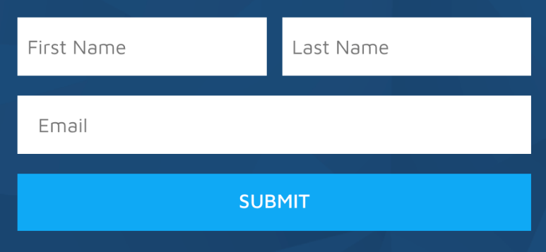
Figure 5: A screen capture of the input field in the start page without any error.
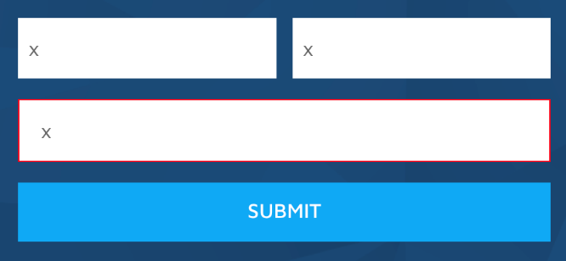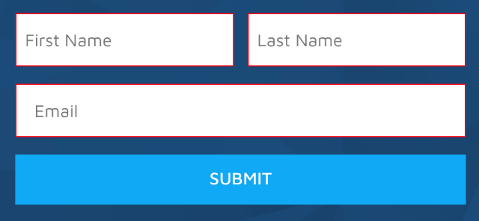
Figure 6: Two screen captures of the input field. The first one shows that when the input fields are left empty, there is no error message; the only indicator is a thin red line around the field. The second one shows that when an input field is incorrectly filled, there is no error message; the only indicator is a red thin line around the field.
The form on the start page only uses colour to show if there are mistakes. It doesn't show error messages or indicate which fields are required. Also, error messages are not announced for screen readers.

European Greens
The European Greens website struggles with contrast issues, particularly affecting readability for users with visual impairments. Low-contrast text on buttons and links, as well as inadequate contrast between text and background colours, makes the website hard or impossible to navigate and understand for several user groups. This is a very severe issue.
Hard of hearing users are supported with auto captioned video, which is positive, but the absence of alternative text for podcasts excludes the same user groups.
The website has alternative text for images, but the qualitive of these are inconsistent. For example, "link icon" doesn’t provide the necessary information for a user of assistive technology (what icon?).
On mobile, the “hamburger” menu is correctly announced and possible to open. However, the menu items are not possible to interact with using assistive technology.
Issues with keyboard navigation prevent users with motor impairments using assistive technology from accessing menus and the search function making it difficult or impossible to navigate the website.
Inconsistent error message placement and patterns make the forms difficult to use for all users, especially for users with cognitive impairments.
The documents are not accessible.

Example – European Greens
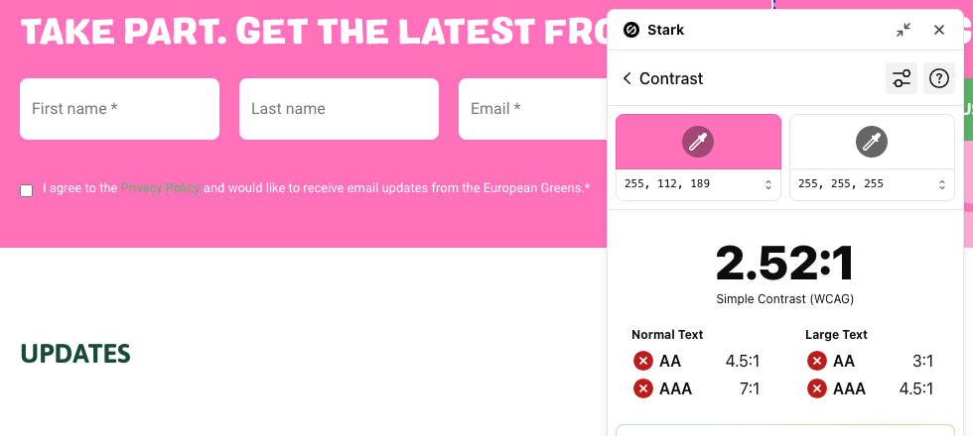
Figure 7: Example of white text on pink background, with a contrast ratio of 2.52:1.
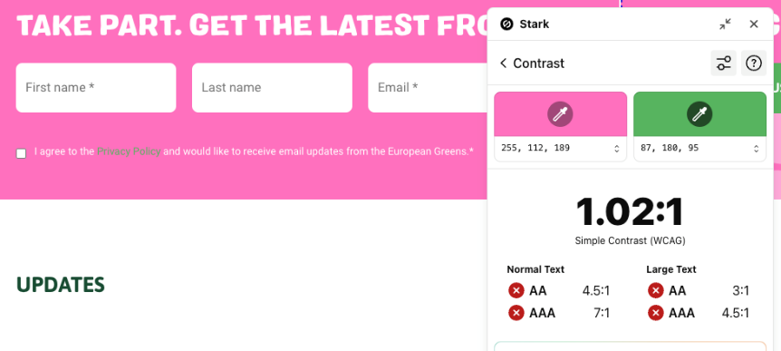
Figure 8: Example of light green link text on pink background, with an extremely low contrast ratio of 1.02:1.
White text on pink background is hard enough for readability, but the light green colour indicating link on pink background may be one of the worst contrasts we have ever measured.

European Left
The continuous auto-updating carousels on the European Left website, with no possibility to pause or stop the movement, make it very hard to use for many users.
Alternative text for essential elements like the logo and search icon is missing, making the interface difficult to use for screen readers. These elements are instead marked as “decorative”, which indicates that someone has actually considered accessibility but made decisions that result in less access for users.
On mobile, the menu is not accessible via any assistive technology.
The use of the red colour may cause readability issues and also risks signalling an error (when that is not intended). The non-standard type of font and moving navigation objects make the website generally hard to read. Contrast issues on the website, including low contrast on important objects such as links and dates, makes it hard to use for users with visual impairments.
The inability to access the search function using only the keyboard makes it difficult or impossible for users with motor impairments and users of screen readers to navigate the website.
Hard of hearing users are supported by auto captioned video, which is positive.
The documents are not accessible.

Example – European Left
Figure 9: A screen capture of the header, showing the tab order; the search function is excluded from the tab order.
On the website of the European Left, it isn’t possible to reach the search function using only the keyboard.

Identity and Democracy Party (ID Party)
Outside of the tests carried out for this study, the structure of the whole website is a disaster for users of assistive technology.
The most severe problems found in the spot checks have to do with understandability, as the website uses a mix of languages. For citizens who do not read French, this website is very hard to handle as links, buttons, error messages etc. are all in French. This is of course confusing for all users but may be especially hard to cope with for people with reading and writing difficulties or cognitive impairments.
Another severe problem is that blind users who rely on assistive technology risk being completely or partly excluded from content because of issues with keyboard navigation and forms and error messages that are not made accessible to screen readers.
On mobile, the menu is possible to open with assistive technology, but all menu items are announced “commande de menu” (menu item), making it impossible to interact with.
Users with motor impairments with and without assistive technology may face barriers because of the malfunctioning keyboard navigation.
Low vision users may find the website difficult to handle because of low contrast on input fields and information being dependent on perception of colour, making it hard or impossible to reach and understand some content.
Hard of hearing users are supported auto-captioned video, which is positive.
The document found is not accessible.

Example – Identity and Democracy
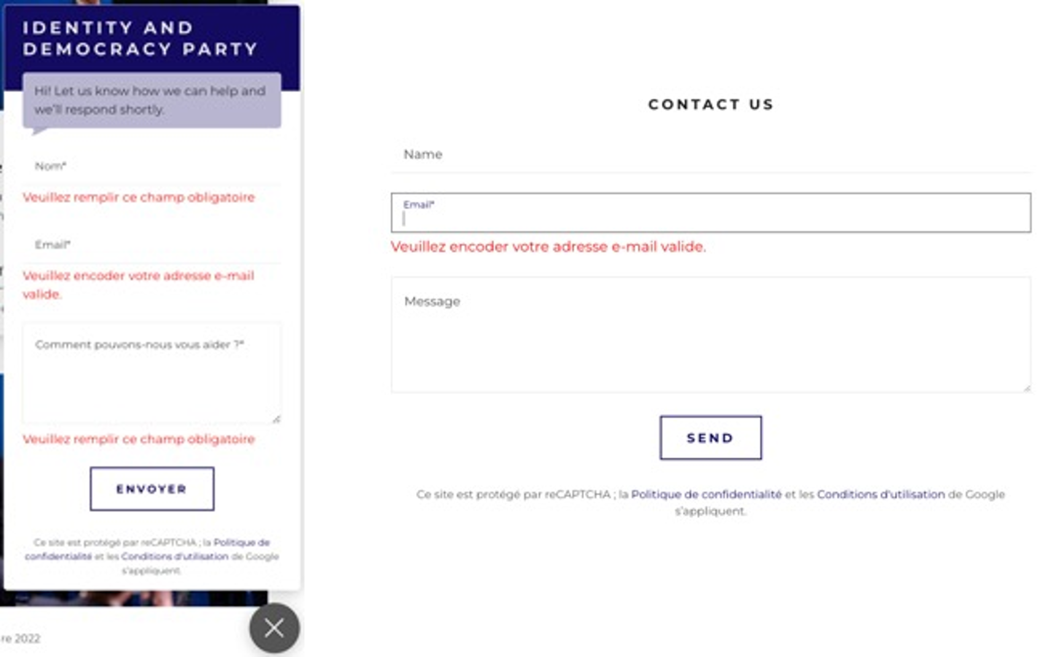
Figure 10: Two screen captures of the contact forms’ input fields; one is from the form on the chat function and one from the form on the contact page. Both show that there are error messages close to the input fields, but the error messages are in French and not in English.
The required fields are not set as required programmatically which means that users with assistive technology won’t get this information. Error messages are in French, and the language changes without notice. This means the content will be pronounced wrongly in text-to-speech assistive technology. The error messages are marked by colour only, and not announced to assistive technology. The error messages do not represent the error: the same error message is presented, no matter if the field is left empty or if the field is filled in incorrectly.

Conclusion
This report is a starting point. It illustrates the scope of the problem and highlights issues that political parties can remediate. Some are relatively easy and quick to fix, while others require more planning.
The results are disappointing but there is a path forward. There is a wealth of actionable knowledge that political parties can draw from to ensure the accessibility of their campaigns. European Union legislation such as the Web Accessibility Directive and the European Accessibility Act have created strong obligations for the public sector and some actors in the private sector. Political parties just need to join other sectors in the journey towards full accessibility.
During this journey, political parties must reach out to both accessibility experts and to representative organisations of persons with disabilities. They have the expertise necessary to ensure no one is left behind in political discourse.
We now call on EU political parties and all political actors to:
- Train web authors and other relevant staff in accessibility for websites, digital channels and publishing.
- Involve end users with disabilities in designing, developing and testing digital interfaces, in order to make sure they work for everyone.
- Use the European standard for accessible ICT (EN301549) when procuring, designing and developing digital interfaces. The standard is free of charge.

These are essential to ensure that our democracies represent everyone and reflect the motto of the disability movement: “nothing without us”.

European standards EN 301 549 v 3.2.1

