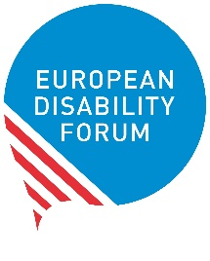
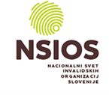

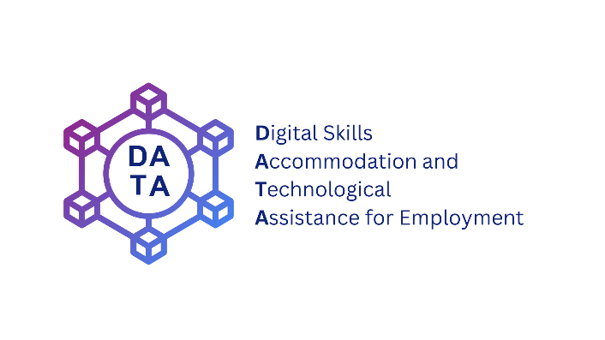

EU Conference

Technology in employment. A step towards inclusion

Saturday 11th May

Venue: Four Points by Sheraton Ljubljana Mons

Address: Pot za Brdom 4, Ljubljana, Slovenia, 1000

Time: 8:00 am - 13.00 am CET

Room Plečnik 1-3
08:00 – 08:45 Registration of participants
09:00 – 10:00 Official opening of the AGA and Conference
- Nataša Pirc Musar, President of Slovenia (Video message)
- Dan Juvan, State Secretary at the Ministry of Labour, Family, Social Affairs and Equal Opportunities
- Marko Lotrič, Member of the National Council of the Republic of Slovenia
- Mateja Toman, President of NSIOS
- Yannis Vardakastanis, EDF President

10:00 – 10:10 Conference “Technology in employment. A step towards inclusion”.
Opening of the conference
- Rachael Bleakley, Regional Manager Google.org
- Humberto Insolera, EDF Executive Committee

10:10 – 10:30 Presentation of findings: European research on Digital Skills, Accommodation and Technological Assistance for Employment (DATA)
Introduction by Humberto Insolera, EDF Executive Committee
- Álvaro Couceiro, Social Policy Officer, Ayuntamiento de Zaragoza
- Roberta Lulli, EDF Project Officer
- Filippo Sinicato, EDF Policy and Project Officer

10:30 - 10:40 Q&A
10:40 – 11:15 1st Panel “Technologies for an inclusive labor market”
Moderator: Humberto Insolera, EDF Executive Committee
- Maureen Piggot, Artificial intelligence focal point, EDF Executive Committee
- Tea Jarc, Confederal Secretary, European Trade Union Confederation
- Tomaž Čučnik, Secretary-General, Alliance of Companies Employing Persons with Disabilities
11:15 – 11:45 Coffee break
11:45 – 12:00 1st panel Q&A
12:00 – 12:40 2nd Panel “Employees and employers: ask, listen, implement”
Moderator: Catherine Naughton, EDF Director
- Ibrahim Tamditi, Testimony
- Jonathan Elebjörk Wahlström, EDF Youth committee
- Branka Jovanović, HR Senior Specialist Spar Slovenija

12:40 – 12:55 2nd Panel Q&A
12:55 – 13:00 Closing remarks
- Maureen Piggot, EDF Executive Committee

