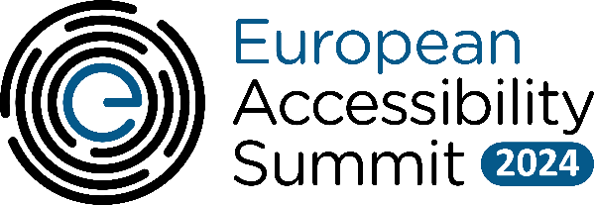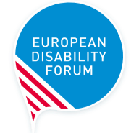

European Accessibility Summit 2024:

Date: 7 May 2024
Location: Hybrid and Microsoft forum, Rue Montoyer 51, 1000 Brussels

Draft agenda:

Time | Agenda item
09:30 – 10:00 | Registrations and breakfast
10:00 – 10:10 | Introductory remarks  - Nanna-Louise Linde, Vice President, European Government Affairs, Microsoft  - Catherine Naughton, Director, European Disability Forum (EDF)
10:10 – 10:20 | High-level welcome remarks  - Belgian Minister of Pensions and Social Integration, in charge of Persons with Disabilities, Combating Poverty and Beliris
10:20 – 11:20 | Panel 1: Reflecting on accessibility achievements & the road ahead in the next 5 years  - Alejandro Moledo, Deputy Director and Head of Policy, European Disability Forum  - Dr. Klaus Miesenberger, Head of Instituten Johannes Kepler University Linz, Austria  More speakers will be announced soon.  Panel moderated by Chiara Giovannini, Deputy Director-General and Senior Manager Policy and Innovation at ANEC, the European consumer voice in standardisation.
11:20 – 11:40 | Break
11:40 – 13:00 | Panel 2: Accessible Technology and Political Participation in the EU Elections  - Nellika Valder, Deputy Head of State Electoral Office of Estonia  - Helga Stevens, Member of the European Parliament  - Dave Leichtman, Director, Corporate Civic Responsibility, Democracy Forward, Microsoft  - Thijs Degheldere, Product Design Lead, Itsme  Panel moderated by Nadia Hadad, Executive Committee Member of the European Disability Forum.
13:00 – 14:00 | Lunch break
14:00 – 15:00 | Panel 3: Inclusive Employment: the potential impact of the Corporate Sustainability Reporting Directive on workplace inclusion:  Speakers will be announced soon.  Panel Ornella Cosomati-Koschwitz, Director of Sustainability Policy at Microsoft.
15:00 – 15:45 | Artificial Intelligence for accessibility: Opportunities for users and organisations  - Rylin Rodgers, Disability Policy Advisor, Microsoft Accessibility  - Thorkild Oelsen, EDF Executive Committee Member
15:45 – 16:30 | AI Demo: What is AI? How to interact with AI? How to do prompts? How to use Copilot?  - Hector Minto, Senior Accessibility Evangelist, Microsoft
16:30 – 16:40 | Closing remarks  - Rylin Rodgers, Disability Policy Advisor, Microsoft Accessibility  - Catherine Naughton, Director, European Disability Forum (EDF)
16:40 – 18:00 | Networking reception in Brussels

