

Summary of EDF Human Rights Report on
Legal Capacity

Plain language

The European Disability Forum | May 2024
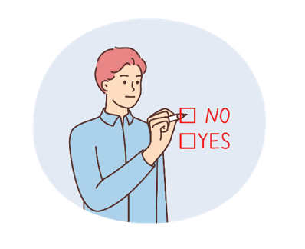
Legal capacity means having the right to make choices and control your own life. But in Europe, some persons with disabilities face problems with this right. Even though laws exist to protect them, not all countries follow these laws properly.

Current laws in Europe
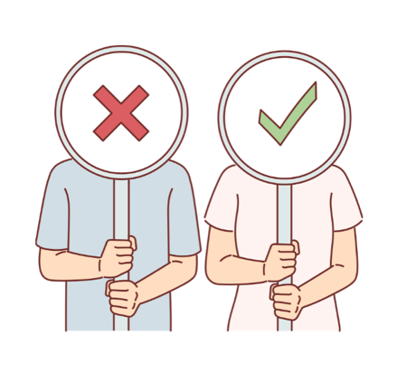
- In some countries, persons with disabilities can have all their rights to decide taken away. This is called full guardianship.
- In other countries, they can have some of their right to decide taken away, but not all of it. This is called partial guardianship.
- Some countries are doing better, where they've almost stopped taking away the right to decide completely.

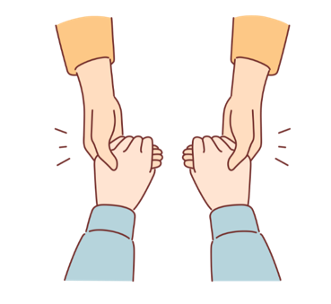
Supported decision-making
- Some countries are trying a new way where persons with disabilities can make decisions with help from someone they trust. This is called supported decision-making.
- This helps them have more control over their own lives.

Challenges people face
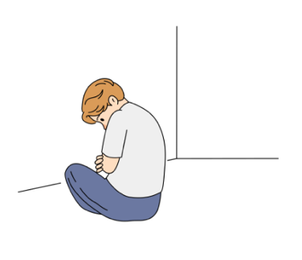
- When people can't make their own decisions, it can lead to bad things like being forced to do things they don't want to do or being treated unfairly.
- Some groups, like women with disabilities and older people, have an even harder time because of discrimination.
- Many persons with disabilities are put in institutions instead of being allowed to live in their communities.

Recommendations to make things better
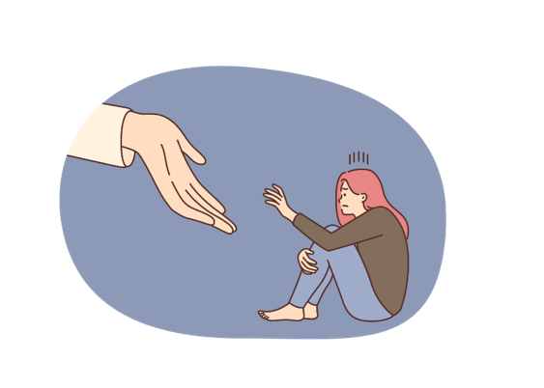
- Countries need to stop taking away all decision-making power and instead help people make their own choices with support.
- Coercive measures, like forcing someone to do something, should be banned.
- Laws and policies should be changed to make sure people with disabilities are treated fairly.
- More support should be given to help persons with disabilities live on their own and be independent.
- Everyone who works with persons with disabilities should be trained properly.

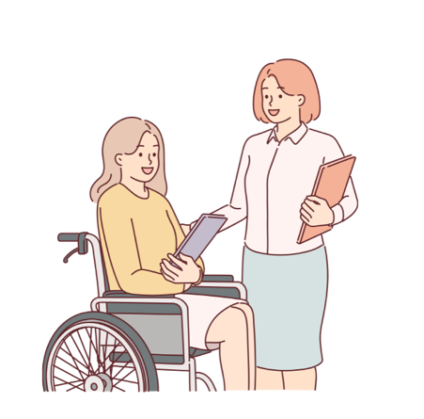
Conclusion
The report talks about the problems persons with disabilities face in Europe and how things can be made better. By following these recommendations, we can make sure everyone can make their own choices and live the life they want.

