

EDF Human Rights Report on legal capacity:
Personal choice and control
The European Disability Forum | May 2024

Executive Summary

Legal capacity is a fundamental human right, enabling individuals to make decisions and exercise control over their lives. Despite the ratification of the United Nations Convention on the Rights of Persons with Disabilities (CRPD) by all European Union (EU) member states, many persons with disabilities continue to face significant barriers in exercising their legal capacity.
Our Human Rights Report highlights the current legal frameworks, challenges, and human rights violations faced by persons with disabilities in Europe. It also gives recommendations for policymakers to address these issues effectively.

Current legal framework
While legal capacity is protected under the CRPD, the report identifies persistent gaps and inconsistencies in its implementation across EU member states. Notably, many countries still permit the deprivation of legal capacity, either fully or partially.
Full deprivation is allowed in 12 member states, while 9 member states allow for partial guardianship or similar systems. Additionally, 6 member states have nearly abolished guardianship but maintain exceptions in specific cases. These variations in legal frameworks underscore the need for a more consistent and rights-based approach to legal capacity across Europe.

Legal capacity regimes in the European Union
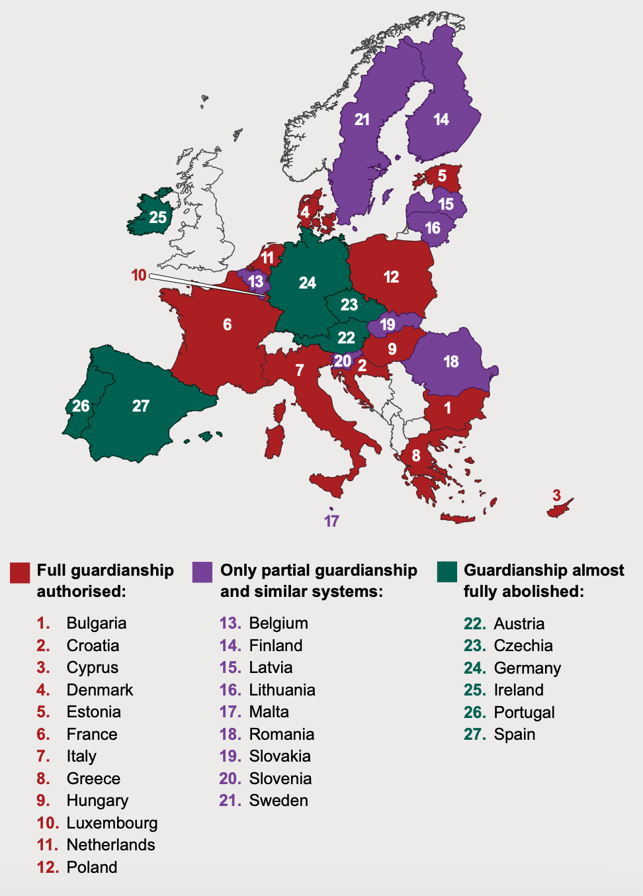

Supported decision-making
The report acknowledges some progress in developing supported decision-making systems to respect the rights and autonomy of persons with disabilities.
13 EU member states have established supported decision-making systems by law, with additional countries implementing informal programs.
Supported
decision-making systems in the
European Union

These initiatives aim to empower persons with disabilities to make decisions with the support of trusted allies, rather than having decisions made for them by guardians or authorities. However, challenges remain in ensuring the accessibility and effectiveness of supported decision-making mechanisms for all individuals, particularly those with complex support needs or communication barriers.

Challenges and human rights violations
Deprivation of legal capacity leads to various human rights violations, including coercion, abuse, and segregation. The report highlights the disproportionate impact of legal capacity restrictions on certain groups, such as women with disabilities and older persons. These individuals face intersectional discrimination, compounding the barriers to exercising their rights and autonomy.

Moreover, involuntary institutionalisation remains a pervasive practice, with millions of persons with disabilities confined to residential institutions across the EU. Mental health laws also allow for coercive measures, which compounds situations of abuse, endangers persons with disabilities and multiplies human rights violations.
Additionally, forced sterilisation and other forms of reproductive coercion persist in several EU member states, violating the reproductive rights of women and girls with disabilities. The report condemns these practices as clear violations of human rights and calls for comprehensive legal reforms to protect the autonomy and dignity of all individuals, regardless of disability status.

Key recommendations

We call for strong actions at all levels of policymaking to promote and protect the legal capacity of persons with disabilities. Specific recommendations include:

For European countries:
- Abolish all forms of substituted decision-making and establish robust supported decision-making mechanisms.
- Ban coercive measures and promote deinstitutionalisation, with a focus on community-based services and independent living supports.
- Review laws and policies to align with Article 12 of the CRPD and ensure the full inclusion and participation of persons with disabilities in decision-making processes.
- Invest in measures supporting autonomy and independent living, including accessible housing, transportation, and education.
- Provide comprehensive training for professionals in contact with persons with disabilities, emphasising the principles of autonomy, free and informed consent, and the CRPD.

For the European Union:
- Ensure legislative proposals do not violate CRPD articles and actively promote the rights and inclusion of persons with disabilities in all policy areas.
- Revise proposed regulations violating legal capacity rights and ensure alignment with international human rights standards.
- Provide guidance and support to member states on legal capacity reforms, including best practices for implementing supported decision-making and deinstitutionalisation initiatives.



For the Council of Europe:
- Withdraw the draft additional protocol to the Oviedo Convention violating CRPD provisions and prioritise initiatives that promote legal capacity and prevent coercion in all areas of life.
- Support the development and dissemination of guidelines and resources to assist member states in implementing CRPD principles effectively.
- Take action against coercion faced by women and girls with disabilities, including the adoption of strong recommendations and monitoring mechanisms to ensure compliance with international human rights standards.

Conclusion
The EDF Human Rights Report on Legal Capacity: Personal Choice and Control provides a comprehensive analysis of the current state of legal capacity for persons with disabilities in Europe, highlighting both progress and persistent challenges.
By offering detailed recommendations for European countries, the European Union, and the Council of Europe, the report aims to catalyse meaningful change and advance the rights and autonomy of all individuals, regardless of disability status.
Through concerted efforts and collective action, policymakers can ensure that legal capacity is upheld as a fundamental human right for all persons with disabilities across Europe.


Funded by the European Union. Views and opinions expressed are however those of the author(s) only and do not necessarily reflect those of the European Union. Neither the European Union nor the granting authority can be held responsible for them.

