EDF Youth Committee Terms of Reference
Easy Read Version
This explains how the Youth Committee will run, and what they do to support the work of the European Disability Forum.
What the words mean.
These words are in bold in the document.
LGBTIQ+ | It stands for lesbian, gay, bisexual, transgender, intersex, queer or questioning, and the "+" represents all other identities and people who stand with them.
Psychosocial disability | Psychosocial disability is about the day-to-day experience of someone living with a mental health condition. It is about the impact and barriers caused by their condition and also because of how they are treated by services and other people.

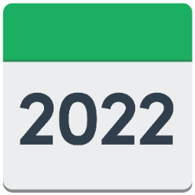 | These terms of reference were agreed in 2022
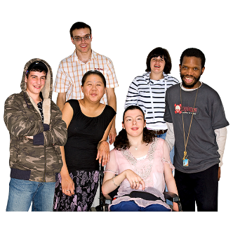 | They make sure the Youth Committee play an important part in European Disability Forum’s work. They support the members of European Disability Forum about the rights of young people from their lived experience.
 | The Youth Committee is also a network to share information and learning.
The Youth Committee will
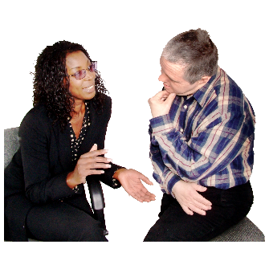 | Talk to each other and the paid staff team and Board at European Disability Forum, about important things that affect young people.
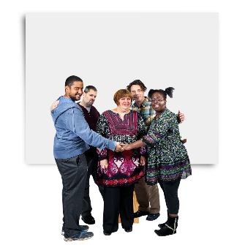 | Say what they think about the rights of young people to help European Disability Forum know what to say about policies to make.
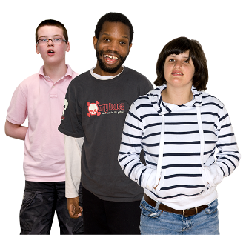 | Make sure that there the voice of young people is in the papers that European Disability Forum writes. Unemployment in the EU is having a big impact on young people with disabilities so their voice is very important.
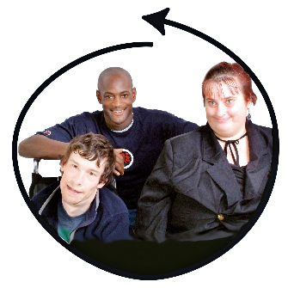 | Say what work the European Disability Forum should do, so that they include things important to young people.
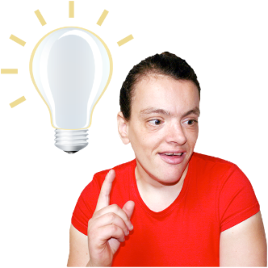 | Share good ideas and information about youth rights from different EU countries.
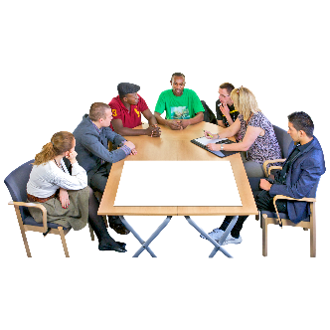 | Go to meetings to speak up about young people’s issues.
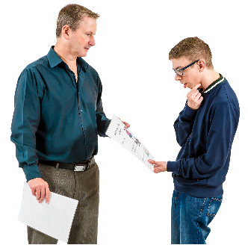 | Help European Disability Forum improve information and communication to young people.
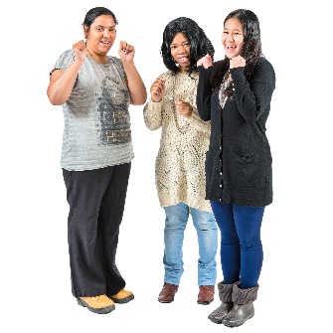  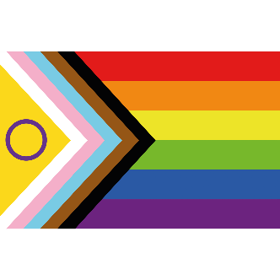 | Make sure they include the rights of women, LGBTIQ+, migrants, Roma, other ethnic minorities and people with high support needs in their work.  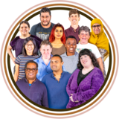
Who can be a member of the youth Committee?
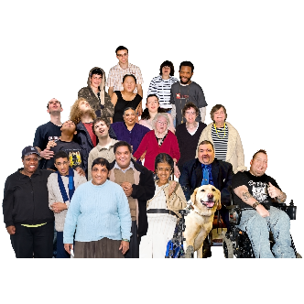 | Anyone who represents a European Disability Forum member.
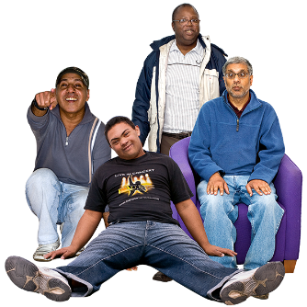 | Be 18 to 35 years old
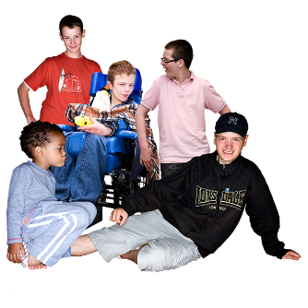 | You must be 27 or younger when you are chosen to be a member. You can be older if you have high support needs.
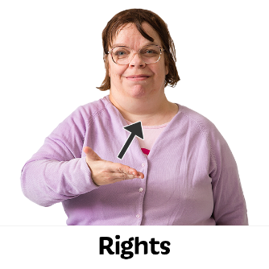 | You must have experience and know about rights and young people at a national or European level.
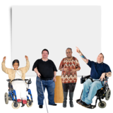 | Members will represent different types of disability, including those with an intellectual disability or a psychosocial disability.
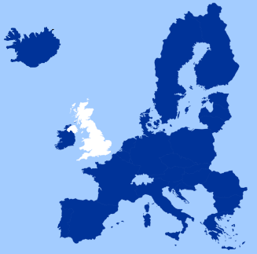 | You must come from a country in the EU.
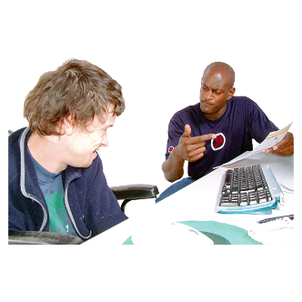 | You must give time to European Disability Forum’s work and respond when asked what you think about reports. Usually, you must reply within 15 days.
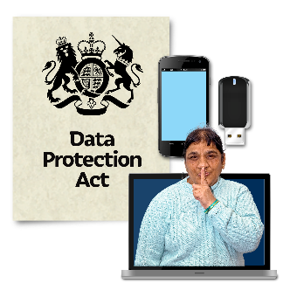 | You must not share the information in the reports with people outside of European Disability Forum.
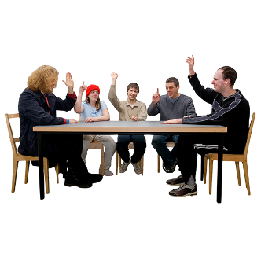 | You can only represent European Disability Forum if you are officially chosen to do this by the European Disability Forum.
Observer status
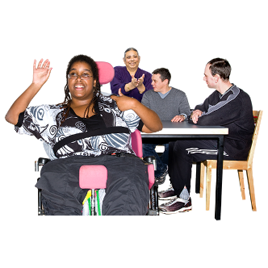 | When a young person with a disability is put forward but not chosen to be a Committee member, then can have observer status. This means they can say what they think about new ideas and go to meetings.
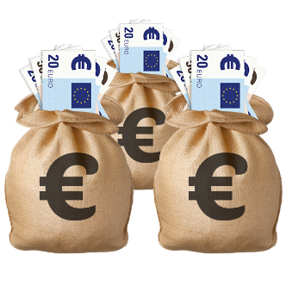 | But they can’t claim the money for this from European Disability Forum. They must pay themselves or ask their organisation to pay.
Rules of taking part
 | The European Disability Forum Youth Committee works mainly through emails and other technology.
 | Every year there is one face to face meeting. This is with the Board or the General Assembly.
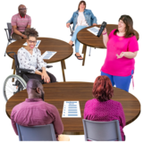 | Some Youth Committee members will also take part in the European Day of Persons with Disabilities.
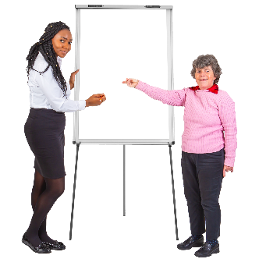 | When there is money to pay for it there can be other meetings or training events.
 | There is a shared folder on the cloud such as Drop Box, Google share point.
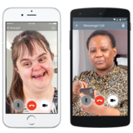 | There are also other ways of communicating together with everyone, such as using WhatsApp.
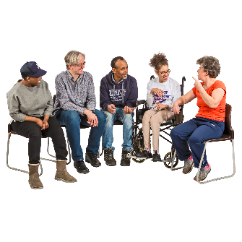 | If anyone says they want to leave the Youth Committee, or they stop getting involved, European Disability Forum will see who wants to take their position on the Committee.
Language used in the Youth Committee
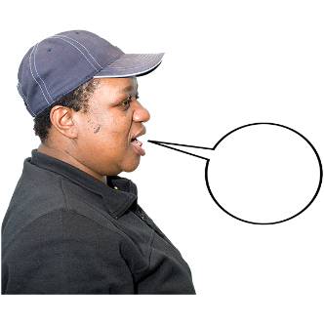 | Members need to be able to speak, read and write in English, or have support from their own organisation to do this.
Human rights
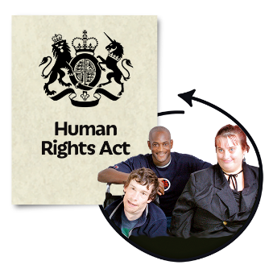 | Members and observers must respect and promote human rights in their work in the Committee. These are in written in the UNCRPD – the United Nations Convention on the Rights of Persons with Disabilities.
 | They must promote inclusion – a Europe where all young people with disabilities are included.
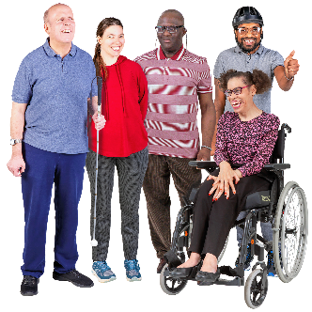 | All the work must include all young people with disabilities whatever their gender, sexuality, ethnicity or disabilities.
The Chair of the Youth Committee
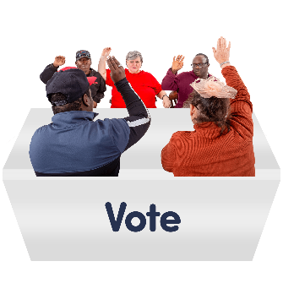 | The Committee will elect its Chair persons.
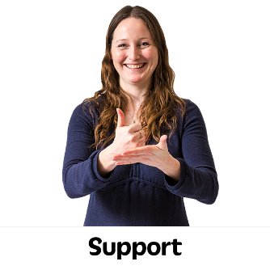 | The Chairs must organise the work of the Committee with support from the Youth Officer, who is on the European Disability Forum staff team.
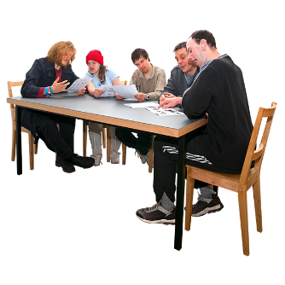 | The Chairs will report on the Committee’s work to the Board. They will go to the Board meeting as an observer.

