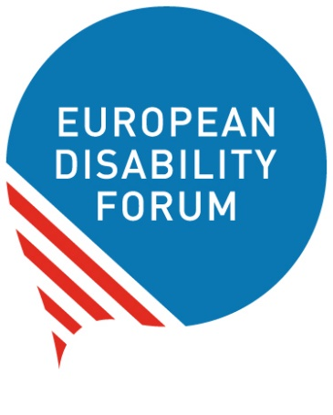

The risks of Artificial Intelligence
for people with disabilities
How to push for our rights

Easy-to-read version

Easy-to-read is information
that is written in a simple way
so that all people can understand it.
You can find more information at:
www.inclusion-europe.eu/easy-to-read

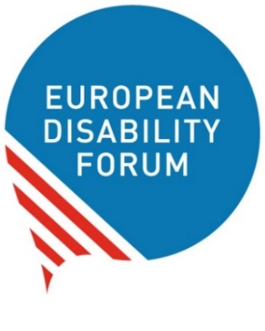
Who we are
We are the European Disability Forum.
We are an organisation
of people with disabilities in Europe.
In short, we are called ‘EDF’.
At EDF, we work to protect the rights
of all people with disabilities in Europe.
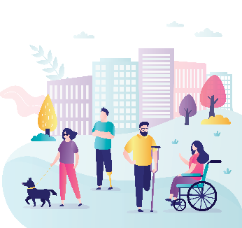
We think that people with disabilities
should have the same chances in life
and take part in the community
like everyone else.
We also think that people with disabilities
should decide about their lives.
Nothing should be decided about us without us!

What this booklet is about
At EDF, we wrote this booklet to talk about the risks
Artificial Intelligence has to our rights.
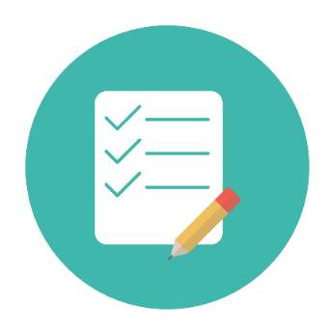
In the next few pages, we will explain:
- What Artificial Intelligence is;
- What risks Artificial Intelligence
has for our rights;
- How the European Union tries
to protect us from these risks;

- What organisations of people with disabilities
can do to protect our rights.
This booklet and other work we do
on Artificial Intelligence are possible
thanks to money we received
from the ‘European Artificial Intelligence
& Society Fund’.
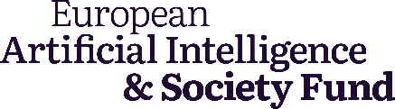
This is an organisation that helps
to make Artificial Intelligence
safer, fairer and better for people.

What is Artificial Intelligence?
Artificial Intelligence is technology that makes devices
and programmes do tasks like humans.
For example, they may:
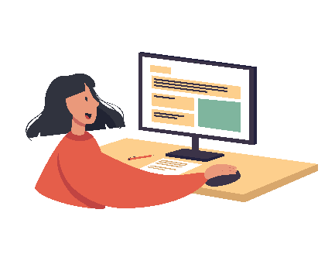
- Chat with us;
- Translate what we say in another language in real time;
- Make decisions
based on the information we give them;
- Recognise our faces or voices.
Today, most of us use devices and programmes
that work with Artificial Intelligence.

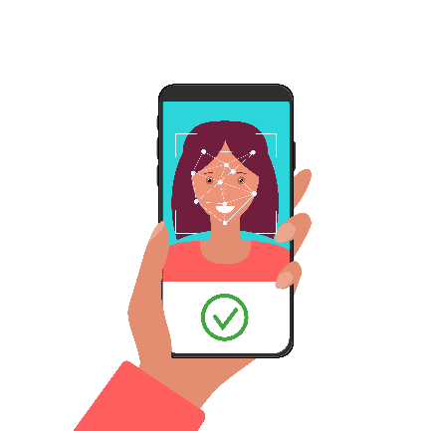
For example:
- We may use programmes that translate
what we say in other languages.

- We may use face recognition
on our phones.
That means that our phones
recognise our faces to unlock
and be used.
- We may use programmes
that recognise our voice
and type what we say.
- We may have a robot vacuum cleaner
that cleans our floors itself.
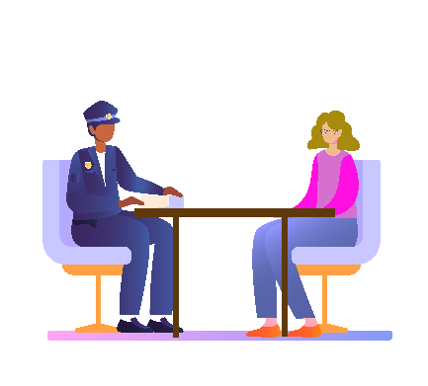
Many organisations and companies
also use Artificial Intelligence.
For example:
- The police may use programmes
that recognise faces
or check if a person is lying.
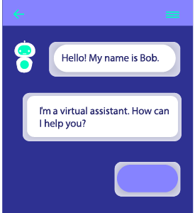
- Banks may use a chatbot
where you can write your problem
and it gives you advice on how to solve it.
- Companies may use Artificial Intelligence
to sort the job applications they receive.
- Online shops use Artificial Intelligence
to understand what you are looking for
and show you items
you may be interested in.
Artificial Intelligence can be very useful.
But it can also risk people’s rights,
if it is not used right.

What is the Artificial Intelligence Act?
The European Union is a group
of 27 countries in Europe.
These countries work together
to make things better for their people.
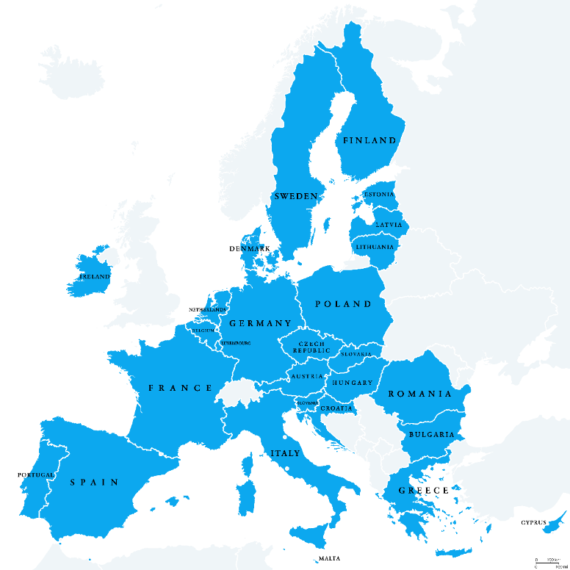
The European Union has made a law
to protect people from the wrong or unfair use
of Artificial Intelligence.
This law is called the ‘Artificial Intelligence Act’.
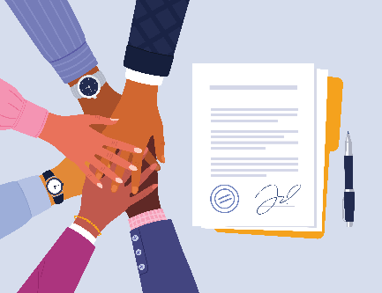
The law sets rules that organisations
that use Artificial Intelligence
must follow.
The law wants to protect people in Europe
from the risks caused
by Artificial Intelligence systems.

What are the risks of Artificial Intelligence
for people?
The law says that different Artificial Intelligence systems
have different levels of risk for people.
There are Artificial Intelligence systems that have:

Low or no risk for people
These systems use Artificial Intelligence
that has low risk and no harm for us.
For example, when we watch movies online,
the system understands what movies we like
and suggests more movies like these.
Medium risk for people
These are systems that have
a few risks for us.
For example, when we use the chatbot
on the website of our bank.
The bank should make it clear to us
that we chat with
an Artificial Intelligence system.
It is not a human who chats with us.
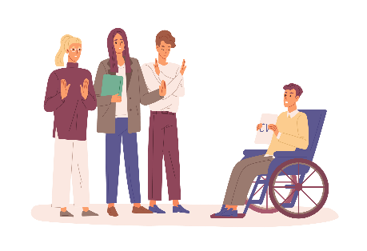
High risk for people
These are systems that may have
a bad impact on our lives.
For example, when we apply for a job,
the company may use Artificial Intelligence
to sort and choose from the applications they receive.
This system may ignore our disability
and may reject our application.
This way, we do not have a fair chance to get the job.

Or when we study at university,
the university may use Artificial Intelligence
to check who may be cheating in exams.
This system may not recognise our disability
and may mark us as cheaters.
For example, if we move or act in a certain way
because of our disability,
the system may think we are stressed
because we are cheating.
This way, we may be punished unfairly.
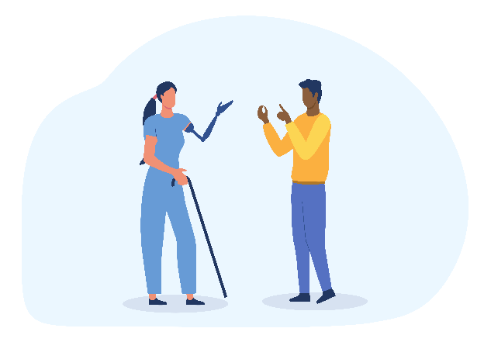
Or when the police use Artificial Intelligence
to check if people lie
based on their expressions and moves.
These systems may not understand
how deaf people use sign language.
The systems may think that the moves they make with their faces and hands
mean they are angry or stressed.

Unacceptable risk for people

These are systems that may use
and harm people.
These systems should be banned.
For example:
- Systems that judge people
by their skin colour and looks.
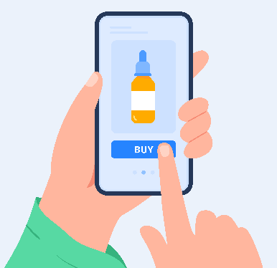
- Systems that guess
if someone is a criminal
just by their personality or looks.

- Systems that use people with disabilities
to make money.
For example, if the website of a pharmacy
uses your disability to sell you products
that are not necessary for you
at higher prices.
This is unacceptable.
These systems must be banned.


How to help make the Artificial Intelligence Act happen in our countries
The use of Artificial Intelligence
can have a big impact on our lives and rights.
That is why we should have a say too
when it comes to laws and decisions about it.
As we said before,
the European Union
has made a law to make sure that
Artificial Intelligence is used safely and fairly
for people in Europe.
This law is called ‘the Artificial Intelligence Act’.
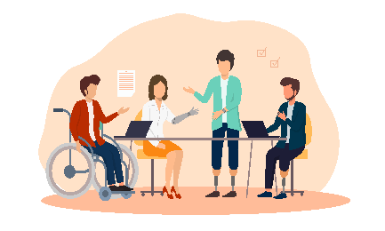
The law started in August 2024.
Now all countries in the European Union
must make this law happen.
Organisations of people with disabilities
can play an important role
in making this law happen in their countries.
Amongst others,
organisations of people with disabilities should:

- Share their views with people
who work to make this law happen
in their countries.
They should push them
to protect people with disabilities
from Artificial Intelligence
that can harm them.
- Check the progress their countries make
to make this law happen.
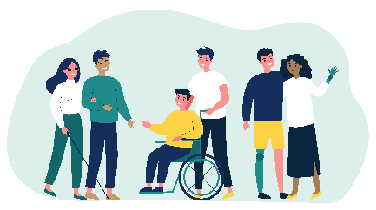
- Push their countries
to make all systems
easy to use by people with disabilities.
Artificial Intelligence systems
should take into account
the needs of people with disabilities too.
- Spread the word about the impact
Artificial Intelligence has on our rights.
For example, they can do that by:
- Sharing useful information on social media;
- Organising training
for people with disabilities and their families
to help them understand their rights.

- Work with other organisations
that protect the rights of people.
For example, organisations of patients,
organisations of older people and others.
Together we are stronger to push for our rights
than each of us alone.

More information

For more information
about EDF and our work,
you can visit our website at
www.edf-feph.org.
You can also send us an email at
info@edf-feph.org.
This easy-to-read text is written by ‘Say it easy’
www.sayiteasy.eu


