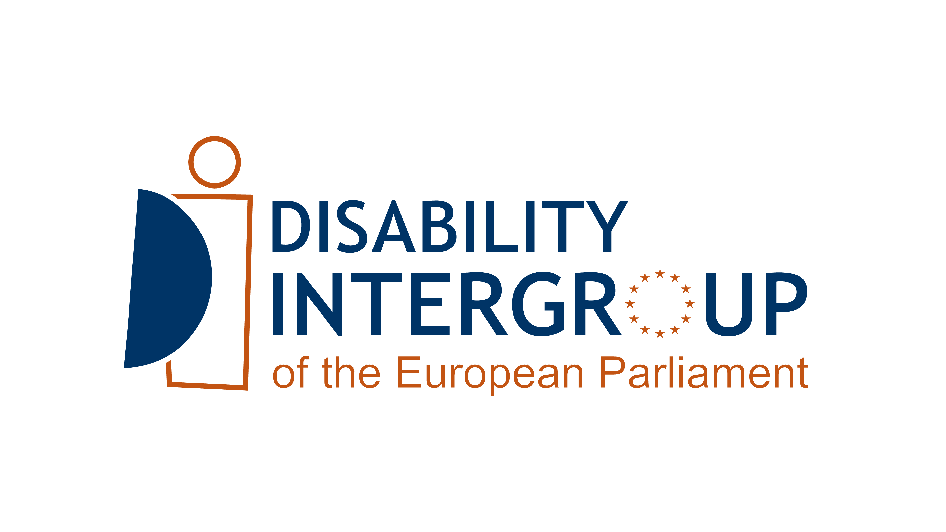

DISABILITY INTERGROUP

OF THE EUROPEAN PARLIAMENT

TERMS OF REFERENCE

2025-2029

Mission

The overall objective of the European Parliament (EP) Disability Intergroup is to promote the full and equal enjoyment of all human rights and fundamental freedoms by all persons with disabilities, without discrimination of any kind on the basis of , racial or ethnic origin, religion or belief, disability, age or sexual orientation and gender identity, in line with the UN Convention on the Rights of Persons with Disabilities (UN CRPD).

As the EU is a party to the UN CRPD, the European Parliament needs to be compliant with, and contribute to the realisation of, the Convention, including by dedicating appropriate structures and mainstreaming the rights of persons with disabilities in all EU policies. The Disability intergroup promotes and contributes to the full implementation of the CRPD. The intergroup itself is committed to comply with the CRPD in its functioning.

The Disability Intergroup endeavours to hold a fruitful dialogue with all persons with disabilities and their representative organisations.

Structure

1. The Disability Intergroup is led by a Bureau, which includes Co-Chairs and Vice-Chairs ensuring gender equality among their members and representation of EU countries and EP political groups. There shall not be more than one co-President from the same political group.

2. Decisions in the Bureau are taken by consensus, including its composition.

3. The Bureau steers the implementation of the Disability Intergroup work programme.

4. Bureau members can take responsibility for a specific topic, policy, or campaign, (e.g. accessibility, employment, de-institutionalisation, CRPD obligations to the EP as public administration, etc.).

Disability Intergroup actions and coordination

1. The Disability Intergroup secretariat shall ensure the coordination of actions aiming at the fulfilment of the Disability Intergroup mission and work programme (e.g. when there is a relevant policy file being prepared in the EP).

2. Disability Intergroup members and the Disability Intergroup secretariat can initiate such actions. Disability Intergroup members can seek for support or advice to the Intergroup Bureau and secretariat.

3. Disability Intergroup members leading such actions shall inform the Disability Intergroup secretariat of any relevant outcome to be communicated to the rest of the Intergroup.

Disability intergroup meetings

Disability intergroup full meetings

1. The Disability intergroup will organise at least one full intergroup meeting per year.

2. The Disability intergroup may also organise 2 additional meetings to be able to react to important developments.

3. For each Disability intergroup meeting, one of the intergroup co-chairs will have a coordinating role in the preparation of the meeting and will chair it. The coordinating co-chair will be in contact with the other Bureau members and will closely involve them in the preparatory work.

Disability intergroup Bureau meetings

1. The Disability intergroup Bureau will meet at least twice per year, including the Disability Intergroup full meeting.

2. The co-chairs will chair the meeting in rotation.

3. During those meetings, Bureau members will report to their colleagues on relevant developments in their Committees as well as on their external representation activities related to disability issues.

4. The decisions of the Disability Intergroup bureau will be communicated to all members by the secretariat.

5. One or more Bureau meetings per year may be dedicated to an exchange of views with EDF’s Executive Committee (11 members from across the European disability movement).

Disability Intergroup events

1. All members of the Disability Intergroup can request to the Disability Intergroup bureau to use the Disability Intergroup logo in the organisation of public events. The Disability Intergroup bureau shall decide by consensus whether the event can become a Disability Intergroup event.

2. In case of acceptance by the Bureau, the Disability Intergroup member shall ensure the accessibility of the event and inform the secretariat if there is any outcome to be communicated to the rest of the Intergroup.

3. If agreed by the Bureau, the Disability Intergroup secretariat will support the Disability Intergroup member in the organisation and promotion of the event, except when this implies a financial contribution or an excessive workload.

Disability Intergroup secretariat

1. The secretariat of the Intergroup is ensured by the European Disability Forum (EDF), the European umbrella organisation representing the 100 million persons with disabilities in Europe. EDF allocates at least one staff member to work on the Intergroup matters approximately 20% of his/her/their working time.

2. EDF shares a commitment with the Members of the Intergroup to work to ensure that the rights of persons with disabilities are included in all aspects of the work of the European Parliament and are placed high on the political agenda of the EP. EDF will work in a spirit of cooperation with the Intergroup Bureau and members of the Intergroup, sharing information, developing joint initiatives and cooperating in the monitoring and implementation of the UN CRPD within the work of the EP.

3. EDF will endeavour to bring the direct perspectives of persons with disabilities in the EU to each forum, to assist the intergroup in adhering to article 4.3 of the CRPD which calls on Parties to the CRPD: In the development and implementation of legislation and policies to implement the present Convention, and in other decision-making processes concerning issues relating to persons with disabilities, States Parties shall closely consult with and actively involve persons with disabilities, including children with disabilities, through their representative organizations.

4. The Intergroup and EDF commit to principles of good will, transparency, partnership and mutual consultation in their joint work. Visibility of the Intergroup (as an informal EP entity) and of the EDF (as the representative umbrella organisation of persons with disabilities) is mutually ensured in all joint activities. The disability Intergroup Bureau members, as well as all other Disability Intergroup members, shall work closely with EDF in the definition and agreement on the agenda/programme of the Intergroup activities.

5. EDF will work together with the intergroup to implement the Intergroup work programme. According to the topic of the meeting/activity, EDF will work with the co-chair charged with the coordinating role for that meeting/activity.

6. MEP’s staff will cooperate with the intergroup secretariat in the organisation of Intergroup activities in a spirit of mutual respect. MEP’s staff will in particular take charge of arrangements which can be requested only by MEPs under EP rules (e.g. room and interpretation bookings in Brussels and Strasbourg and other logistic requests, access to EP facilities and accreditation of visitors, etc.), in collaboration with EDF.

7. The Secretariat will maintain the website of the Disability Intergroup www.disabilityintergroup.eu, relying on members to update us on their activities.

Accessibility

1. All Disability Intergroup meetings including public events as well as documents and communication must be in the most accessible manner for persons with disabilities.

2. Coordinating MEP(s) for meetings shall cover the costs of any required accessibility service (e.g. sign language interpretation, live subtitling).

Do you need to contact the Disability Intergroup secretariat?

For any information, contact Alejandro Moledo at alejandro.moledo@edf-feph.org or +32486741508

For communication, contact Ness James at ness.james@edf-feph.org

www.disabilityintergroup.eu – subscribe to the Disability Intergroup Newsletter

