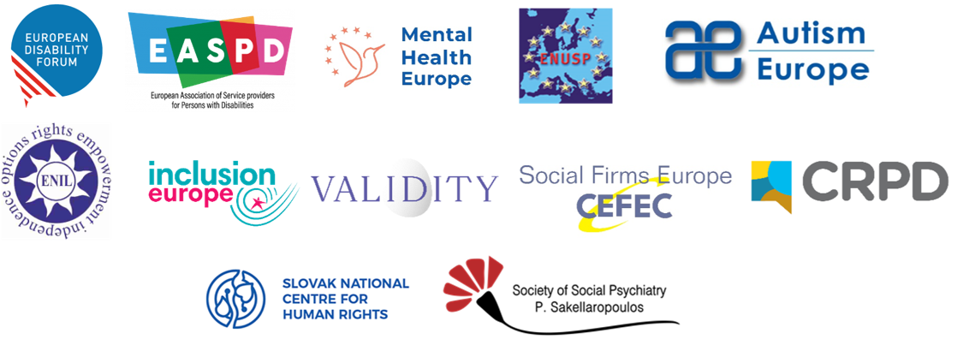

TO:
Committee of Ministers of the Council of Europe
Council of Europe
Avenue de l'Europe
F-67075 Strasbourg Cedex, France
CC:
Ministers’ Deputies
Brussels, 9 January 2025

RE: Open letter to the Council of Europe’s Committee of Ministers and Ministers’ Deputies regarding the draft Additional Protocol to the Oviedo Convention

Dear Ministers and Ministers’ Deputies of the Council of Europe,
In 2014, the Council of Europe’s Steering Committee for Human Rights in the fields of Biomedicine and Health (CDBIO, formally Committee on Bioethics or DH-BIO) started work on the draft Additional Protocol to the Oviedo Convention, with the purpose to “protect the rights of people with mental disorders” subject to involuntary treatment and involuntary placement in psychiatry. Facing widespread opposition from various stakeholders including the United Nations, the Council of Europe and civil society, we welcomed your decision to suspend the adoption of the draft Additional Protocol until 2024.
Throughout the suspension, we have been pleased to contribute to various deliverables produced by CDBIO including the draft Recommendation on respect for autonomy in mental healthcare. We recently welcomed its approval and reiterate here our support for its adoption by the Committee of Ministers. Nevertheless, we are aware that with the upcoming evaluation of the draft Recommendation and other deliverables, the Committee of Ministers must decide whether or not to advance the draft Additional Protocol.
In light of this pending decision, we, the undersigned reiterate our profound concerns and unwavering opposition to any further development and adoption of this Protocol. This open letter acts as a reminder of the key arguments comprising our opposition, informed by recent developments within the Council of Europe and in the field of mental healthcare.
International standards against coercion in psychiatry
Forced treatment and forced placement of persons on the basis of their disabilities, including persons with psychosocial disabilities and persons with mental health problems, is prohibited under the UN Convention on the Rights of Persons with Disabilities (CRPD), ratified by all 47 Member States of the Council of Europe. These practices, even if regulated by law, breach the rights of non-discrimination, legal capacity, liberty and security, physical and mental integrity, and health enshrined in the CRPD.
Several other bodies and mandate holders of the United Nations hold a similar position against involuntary treatment and placement, even when States try to justify these practices on the basis of a “medical necessity” or for the alleged security of the person or others. Instead, they have stressed that coercive practices amount to torture, calling for a paradigm shift to rights-based approaches through the involvement of persons with psychosocial disabilities and mental health issues, and through respect for their will and preferences.
Opposition within the Council of Europe
The Council of Europe’s former Commissioner for Human Rights expressed clear opposition against the protocol and recommended “developing minimum standards concerning alternatives to involuntary measures in psychiatry."
The Parliamentary Assembly has:
- Called on member states to immediately start the transition to the abolition of coercive practices in mental health settings
- Invited the Committee of Ministers to redirect efforts from the drafting of the additional protocol to the drafting of guidelines on ending coercion
- Urged the Committee of Ministers to integrate the global shift towards a more modern, human rights-based approach to mental healthcare fully in line with the CRPD
Finally, the European Committee of Social Rights has stated that one of the minimal elements of a human rights-compliant approach to mental health should be “mental health legislation and strategies that are in line with the Convention on the Rights of Persons with Disabilities.” The Committee of Ministers should not depart or support the departure from the case law of the Committee.
Opposition from civil society and users of mental health services
Civil society organisations, users of mental health services and survivors of psychiatry have strongly opposed the draft additional protocol since 2014.
While we understand the goals of the draft Additional Protocol, the draft Recommendation on respecting autonomy in mental healthcare achieves these objectives more effectively while avoiding unnecessary harm. The Additional Protocol risks entrenching coercion and institutionalization, worsening human rights abuses for people with psychosocial disabilities, and creating legal conflicts between Council of Europe obligations and the CRPD.
A growing consensus against coercion within the provider community
An increasing number of medical and scientific professionals are questioning coercive measures in mental healthcare, with some deeming them incompatible with human rights-based care. They highlight a lack of evidence supporting the generalisability or sustainability of such practices, while pointing to clear harm to physical and mental health, poorer outcomes, and significantly reduced life expectancy for those subjected to them. Researchers are also challenging the validity of justifications like dangerousness and proportionality, noting these assumptions are often unjustified and biased by factors such as race, gender, and disability.
Human rights-based solutions are feasible and effective
Since the suspension of work on the draft Additional Protocol, the World Health Organization (WHO) has launched the QualityRights initiative. The programme, based on the CRPD, has helped hospitals, regions, and countries evaluate their mental health systems and implement trainings for providers to address stigma and the use of coercion, as well as structural changes that improve service user satisfaction and treatment adherence by decreasing the use of coercion. The programmes early successes across diverse countries demonstrate the feasibility and positive impacts, for persons and for health systems, of eliminating coercion in mental healthcare. CDBIO recognised the importance of WHO QualityRights, referencing it in the Preamble of the draft Recommendation on respect for autonomy in mental healthcare.
Complementing this initiative, CDBIO also developed the “Compendium Report: Good practices to promote Voluntary Measures in Mental Health Services,” which is a non-exhaustive list of existing practices aimed at reducing and preventing coercion.
Find additional testimonials from health and social care providers in the Annexes, to demonstrate the various ways in which alternative practices are not only possible, but preferable.
Collectively, these references speak to the need for more investment and research as well as the feasibility and success of alternative practices in diverse settings and with diverse populations.
Considering the level and extent of this opposition, and the success of alternative rights-based practices, the undersigned organisations again reiterate a call to the Council of Europe to withdraw the draft Additional Protocol to the Oviedo Convention. Instead, we must lead the way together in ending coercion in mental health practices, promoting good practices, and creating legal clarity for the implementation of human rights law.
Sincerely,
Civil Society Organisations

Yannis Vardakastanis, President
European Disability Forum

Olga Kalina, Chair
European Network of (Ex)-Users and Survivors of Psychiatry

Andrej Vršanský, President
Mental Health Europe

Kirsi Konola, President
European Association of Service providers for Persons with Disabilities

Jyrki Pinomaa, President
Inclusion Europe

Ines Bulic Cojocariu, Director
European Network on Independent Living

Harald Neerland, President
Autism-Europe

Steven Allen, Executive Director
Validity Foundation - Mental Disability Advocacy Centre
Athina Fragkouli – Sakellaropoulou, President
Society of Social Psychiatry P.Sakellaropoulos

Felicitas Kresimon, General Secretary
Confederation of European Firms, Employment Initiatives and Cooperatives (CEFEC)

National Human Rights Institutions and Equality Bodies

Rhoda Garland, Commissioner for the Rights of Persons with Disability
Commission for the Rights of Persons with Disability (Malta)

PhDr. Silvia Porubänová, Executive Director
Slovak National Centre for Human Rights

Support for the adoption of the recommendation is limited to the European Disability Forum, the European Network of (Ex)-Users and Survivors of Psychiatry, Mental Health Europe and the European Association of Service providers for Persons with Disabilities, Autism Europe and Inclusion Europe.
See the Report of the Special Rapporteur on the right of everyone to the enjoyment of the highest attainable standard of physical and mental health, A/HRC/38/36.
See the Report of the Special Rapporteur on the right of everyone to the enjoyment of the highest attainable standard of physical and mental health, A/HRC/41/34.
See the Report of the UN Special Rapporteur on Torture and Other Cruel, Inhuman or Degrading Treatment or Punishment, A/HRC/43/49.
See the Report of the Special Rapporteur on the right of everyone to the enjoyment of the highest attainable standard of physical and mental health, A/HRC/44/48, and the 2020 UN Human Rights Council resolution on Mental health and human rights, A/HRC/43/L.19.
See Resolution 2291 on Ending coercion in mental health: the need for a human rights-based approach
See Recommendation 2158 on Ending coercion in mental health: the need for a human rights-based approach
See Recommendation 2275 on Ending the detention of “socially maladjusted” persons
See ECSR’s decision on Complaint No. 188/2019
For examples of literature on the topic see: MONCRIEFF, J. 2013. The Bitterest Pills: The Troubling Story of Antipsychotic Drugs, Hampshire: Palgrave Macmillan; UK.MONCRIEFF, J. 2016. Myth of the Chemical Cure In: HALL, W. (ed.) Outside Mental Health: Voices and Visions of Madness. Northampton MA: Madness Radio, 155 -162.; WHITAKER, R. 2010. Anatomy of an Epidemic: Magic Bullets, Psychiatric Drugs, and the Astonishing Rise of Mental Illness in America New York: Broadway Paperbacks; KUPFER, D. 2013. Chair of DSM-5 Task Force Discusses Future of Mental Health Research. American Psychiatric Association news release,13-33.
Seo MK, Kim SH, Rhee M. Coercion in psychiatric care: Can paternalism justify coercion? International Journal of Social Psychiatry. 2013;59(3):217-223. doi:10.1177/0020764011431543
Faissner M, Braun E. The ethics of coercion in mental healthcare: the role of structural racism. Journal of Medical Ethics 2024;50:476-481.
See the list of participating countries and activities at https://qualityrights.org/in-countries/
Giovanni Carta, M. et al. (2020) Implementing WHO-Quality Rights Project in Tunisia: Results of an Intervention at Razi hospital.
Morrissey, F.E. (2020). An evaluation of attitudinal change towards CPRD rights following delivery of the WHO QualityRights training programme. https://doi.org/10.1016/j.jemep.2019.100410
Pathare S. et al. (2021). Systematic evaluation of the QualityRights programme in public mental health facilities in Gujarat, India. Br J Psychiatry. 218(4):196-203. doi: 10.1192/bjp.2019.138. PMID: 31218972.; Shah S, Desai N, Shah S, Pathare S, Chauhan A, Sharma E. (2017). Impact of Quality Rights Gujarat program on dropout rate of patients visiting outpatient psychiatry department of tertiary care hospital. Asian J Psychiatr. 2017 Aug;28:4-8. doi: 10.1016/j.ajp.2017.03.016. Epub. PMID: 28784394.

