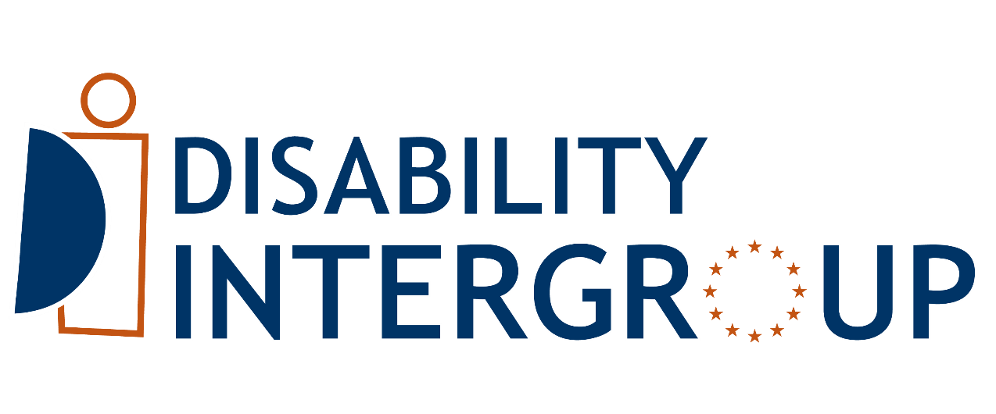

DISABILITY INTERGROUP

OF THE EUROPEAN PARLIAMENT

Work Programme

2025-2027

Introduction

This document highlights the selected themes related to the rights of persons with disabilities that the European Parliament (EP) Disability Intergroup (DIG) plans to work on. The activities can take a range of forms, such as:
- Written and oral questions
- Amendments
- Reports
- Resolutions
- Debates and public hearings
- Interventions
- Joint actions and statements
- Events (including with other intergroups)
- Expert meetings
- Communication initiatives
- Projects
- Letters

1. Overarching themes

UN Convention on the Rights of Persons with Disabilities
This item covers the CRPD Committee review of the EU taking place in March 2025, and the EU’s follow-up to the Committee Concluding Observations, the elections in the CRPD committee, the EU’s independent CRPD monitoring framework in which PETI, LIBE and EMPL committees are involved, the Conference of State Parties to the CRPD, the EP CRPD network, and general matters concerning the Convention, including the establishment of a CRPD focal point in the EP.

European Disability Rights Strategy 2021-2030
General matters concerning the Disability Rights Strategy 2021-2030, particularly the second phase of the Strategy to be prepared by the Commission with new set of actions and flagship initiatives for 2025-2030. This item also covers the Disability Platform and monitoring the implementation of the Strategy.

The next EU budget
DIG actions aiming at ensuring that the next Multiannual Financial Framework for the period 2028-2034 will support the implementation of the CRPD, with a particular attention to Cohesion Funds, mobility programmes, funding for civil society organisations representing persons with disabilities, and EU external action funds.

Petitions regarding persons with disabilities
Petitions submitted by citizens to the Petitions committee concerning the rights of persons with disabilities, which the DIG can discuss and take action if needed. It also covers activities regarding persons with disabilities organised by the PETI committee.

CRPD obligations to the EP as public administration
EP actions aiming at fulfilling its obligations under the CRPD as a public administration, it covers work related to the EP High Level Group on Gender Equality and Diversity, and the Accessibility and Inclusion Group, and other activities aiming at making the EP more inclusive to persons with disabilities. Topics include the accessibility of the EP websites and IT tools, buildings, information and communications; the provision of reasonable accommodation for staff with disabilities, and the meaningful collaboration with the Disability Support Group in the Parliament.

2. Human rights

Equal Treatment and antidiscrimination
Legislation on Equal Treatment, the Employment Equality Directive, the Equality Bodies Directives, and any other matter related to equality and non-discrimination.

Gender Equality and women with disabilities
The upcoming Gender Equality Roadmap and Gender Equality Strategy, the monitoring of the Directive on combating violence against women, and any other topic concerning women and girls with disabilities, as well as the gender dimension of the Disability Rights Strategy.

Children with disabilities and inclusive education
All actions concerning inclusive education and children with disabilities, such as the Child Guarantee, or initiatives to support Early Childhood Intervention.

Young and older people with disabilities
Related work concerning young people with disabilities, such as the Traineeship Directive or Erasmus+, Solidarity Corps, and the European Youth Event, and actions focused on older people with disabilities.

Intersectionality
All the DIG activities aiming at ensuring an intersectional approach in the EU policies, to address when disability intersects with other elements, such as racial or ethnic origin, religion or belief, disability, age or sexual orientation and gender identity.

Forced sterilisation
DIG actions aiming at prohibiting forced sterilisation of persons with disabilities, and the compensation and reparation of those who suffered this practice.

Justice, protection of adults, protection of victims and fight against hate
All work on judicial cooperation and access to justice in the EU, activities aiming at protecting victims (e.g. revision of the Victims Rights Directive), and fight against hatred and hate speech. This item includes the proposed Regulation on the protection of vulnerable adults.

Legal capacity
DIG initiatives concerning the equal recognition before the law to all persons with disabilities. This includes the promotion of supported-decision making systems.

Political participation and right to vote
European elections (including the potential reform of the EU Electoral Law), the accessibility and inclusiveness of EU’s elections, including for mobile EU citizens with disabilities.

Migration policies
DIG actions aiming at ensuring that all migrants, refugees and asylum seekers with disabilities will be treated with respect to the rights enshrined in the CRPD.

3. EU challenges

Social inclusion, social protection, and adequate standard of living
This item covers all activities aiming at reducing the poverty and social exclusion of persons with disabilities, including homelessness, and to support a decent standard of living of all persons with disabilities.

Green Transition and fight against the climate emergency
Any activity concerning the green transition and the EU’s policies regarding climate action, including the meaningful involvement of disability organisations at global and regional discussions, and policies aiming at fighting energy poverty by persons with disabilities.

Digital Transition
Policies and initiatives on the digital domain aiming at ensuring the inclusion of persons with disabilities. This includes policies related to Artificial Intelligence, and the right to access public and essential services through non-digital means.

Humanitarian action and disaster risk reduction
DIG actions aiming at ensuring that EU’s humanitarian action will address the specific requirements of persons with disabilities, and that all EU actions regarding preparedness in case of crisis and natural disasters will incorporate a disability-inclusive approach.

EU in the world
The EU is largest donor of aid in the world. This item covers the EU external action work, international cooperation and international matters, including EU’s leadership and human rights dialogues with partner countries.

War in Ukraine and other armed conflicts
All actions aiming at supporting Ukrainians with disabilities who remain in Ukraine and those who sought refuge in the EU due to the war. This item also includes EU humanitarian actions in other places suffering armed conflicts, such as in Palestine, where people with disabilities are amongst the most affected.

4. Social Policies

Deinstitutionalisation and independent living
All the activities, including the monitoring of EU funds, concerning the transition from institutional to community-based independent living.

Employment
All related activities concerning employment policies and funding programmes (e.g. a potential Disability Employment and Skills Guarantee) aiming at increasing the participation of persons with disabilities in the open labour market, and other potential actions derived from the European Pilar of Social Rights (EPSR), including the upcoming Action Plan on the EPSR.

Health, rehabilitation, habilitation and mental health
EU work on health policies, including the fight against cancer, as well as issues concerning safety and mental health. This item also includes actions related to the rehabilitation and habilitation of persons with disabilities.

Public procurement and state aid
DIG initiatives regarding the use of public procurement and state aid to improve the living conditions of persons with disabilities.

Statistics
Actions aiming at gathering disaggregated data on disability in different fields, including the work of Eurostat.

5. Accessibility & free movement

Accessibility and assistive technologies
All actions in which accessibility plays a central role (e.g. the establishment of a European agency for accessibility) or is incorporated in (products and services, ICT, built environment, transport, culture, sports, media, etc.). This also covers work on assistive technologies.

Accessible and adapted housing
DIG actions aiming at ensuring that the current EU’s priority to address the housing crisis will take into consideration the specific needs of persons with disabilities, and the lack of accessible, affordable and adapted housing in the EU.

Transport and Passengers’ Rights
Work concerning the rights of persons with disabilities as passengers in the different modes of transport. This includes, for example, specific measures to improve transport accessibility or the Passengers Rights package launched by the Commission in 2023.

EU Disability Card, Parking Card, and beyond
This item covers all activities regarding the adopted Directives establishing the EU Disability Card and Parking Card, as well as other activities aiming at ensuring the free movement of persons with disabilities when moving permanently to another EU country.

6. Raising awareness and collaboration

Collaboration with the Commission
Covering all the activities concerning the cooperation of the Disability Intergroup with the European Commission, and particularly the collaboration and communication with Commissioner for Equality, Preparedness and Crisis Management, Hadja Lahbib.

Visibility and raising awareness of specific disabilities
Activities regarding the specific needs of the diverse community of persons with disabilities, e.g. deaf-blindness, intellectual and learning disabilities, hearing loss, rare diseases, etc. This item also includes the promotion of the full diversity of sign languages in Europe.

Collaboration and dialogue with disability organisations
DIG members work with organisations of and for persons with disabilities.

Collaboration with other equality intergroups
Activities carried out jointly with other Equality intergroups (e.g. LGBTI, Anti-racism, children rights, Mental Health etc.).

Do you need to contact the Disability Intergroup secretariat?

For any information, contact Alejandro Moledo at alejandro.moledo@edf-feph.org or +32486741508

For communication, contact Ness James at ness.james@edf-feph.org

www.disabilityintergroup.eu – subscribe to the Disability Intergroup Newsletter

