EDF Annual General Assembly and associated meetings

June 20th- 22nd 2025

Vilnius, Lithuania

Practical & logistics information

Welcome Note

On behalf of the European Disability Forum, I would like to extend a warm welcome to all our delegates who are attending this year’s EDF Annual General Assembly and associated meetings in Vilnius. We are delighted you can attend and my team are here to help you have a productive and enjoyable AGA.

In this practical guide you will find some useful information on logistics, as well as some details of your programme for the AGA and associated meetings. Further information on the programme can be found on the agenda.

EDF are here to ensure that you get the most from the AGA and your visit to Vilnius and so please do not hesitate to ask us if you have any specific queries or requests.

Enjoy your visit!

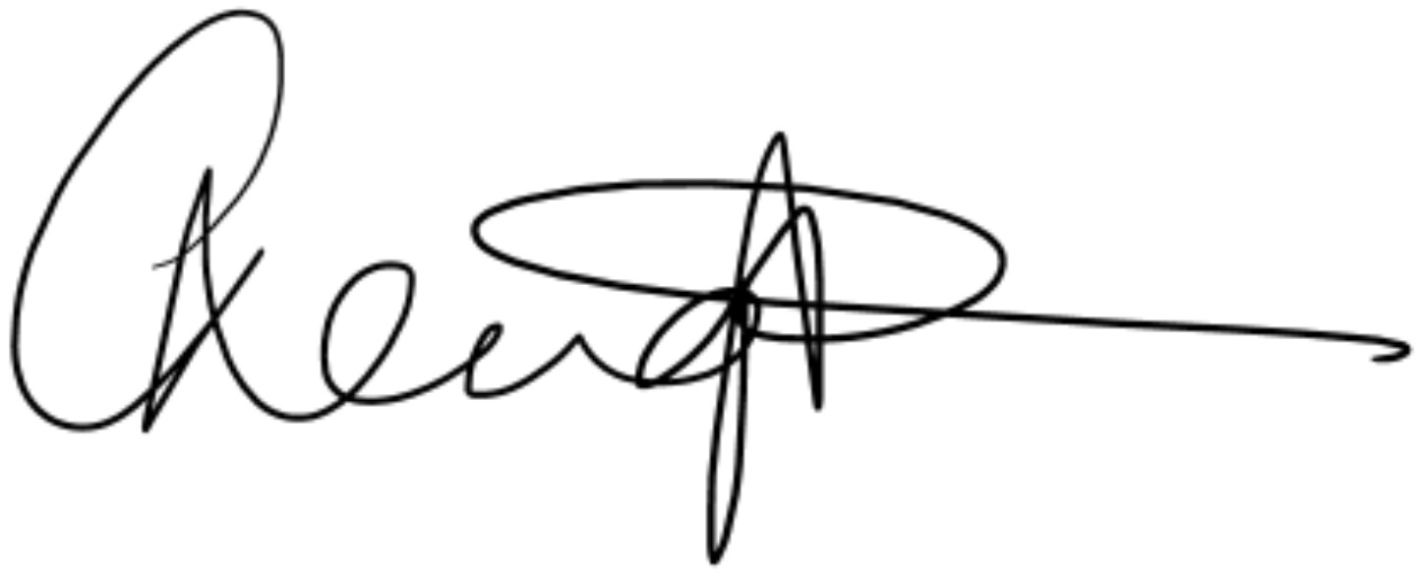

Catherine Naughton

Executive Director

Venue and Accommodation
Rooms for all participants attending the event in person are booked by EDF. The rooming list is now closed.
At your arrival, the hotel may ask you for a credit card to guarantee the extra charges during your stay (for example laundry services, minibar, and others) and this must be settled by you upon check-out. You will also be asked to present your Identity Card/Passport at check-in.

Hotel information:

Conference Venue
Radisson Blu Hotel, Vilnius
Address: Konstitucijos pr. 20, Vilnius, 09308 Vilniaus m. sav., Lithuania
Telephone: +370 5 272 6270
Check-in from 15:00 p.m.
Check out up to 12:00 p.m.
Most conference participants are staying at this hotel, the Radisson Blu Hotel Lietuva. It is located in the city centre of Vilnius – on the bank of Neris River, making it attractive and easy-to-reach for travellers.
- Find the location of the hotel on Google Maps.
- You can read about the hotel amenities on their website.

Other hotels that delegates are staying are:

Hotel Novotel, Vilnius Centre
Address: 16 Gedimino av., Vilnius 01103
Hotel Neringa
Address: Gedimino Ave. 23, Vilnius, LT-01103

The Novotel and Neringa are located in the very centre of Vilnius, Gediminas avenue. Places to visit are situated within walking distance including the Old Town.

Event Whatsapp group
This year, we are trialling a Whatsapp community as a way to network, discuss and stay in touch after the event. It is intended to promote networking between all participants, and to create a welcoming space to those who have problems with hearing in noise, or speaking, or who feel overwhelmed in crowds
We invite you to join the community through this link.

Program

Friday 20 June 2025
The Executive Committee meeting will take place on Friday, 20 June from 09:00 to 12.30 EET in Room Zeta 1.
The Youth Committee meeting will also take place on Friday 20 June from 13.00 to 15.00 EET in Room Zeta 1.
The Amazon workshop: access at every step will take place on Friday 20 June from 15.30 to 17.30 in Room Beta 1.
The EDF Board meeting will take place on Friday 20 June from 18:00 to 19.00 EET in Room Zeta 1.

Saturday 21 June and Sunday 2 June 2025
Conference "The right to decide: legal capacity and pathways to reform" will take place on Saturday 21 June from 09:00 to 13:00 EET in Room Alfa. The Conference is open to external participants under approval of registration.
AGA Business Sessions will be held during Saturday 21st June from 14:30 to 18:00 and Sunday 22nd June from 09:00 to 13:00 EET in Room Alfa.

Stands and exhibition
There will be a number of stands presenting the work of EDF and also local stands from Lithuania in the lobby area. I would encourage you to visit and speak to the representatives of the stands during the breaks. There will also be an exhibition.
List of stands:
- Ukrainian Exhibition "The Sky Above: Stories from Ukraine about disability and war".
- Agency for the Protection of the Rights of People with Disabilities under the Ministry of Social Security and Labour, Lithuania: Innovation for Digital Skills Education for Disadvantaged Groups in Europe” (“Digital for All”)
- Artificial Intelligence
- Gender Mainstreaming
- Freedom of movement: Passenger Rights and European disability Card
- Lithuanian Audiosensory Library
- GoVilnius
- Amazon

Transport
Attention: When seeking reimbursed for flights, be aware that fares will not be reimbursed unless the scans of the original ticket and the boarding cards are submitted with the claim. Only economy class fares will be reimbursed.

From the airport to the hotel:
Vilnius International Airport (VNO) is 9 kilometres from the city centre.

EDF will provide adapted transport from the airport/ train station to the hotels and return only for delegates, and their personal assistants, who have requested this service. Confirmation of the adapted transport has been sent to the aforementioned participants.
For the other delegates and participants, we advise taking public transport or taxi from the airport to the hotel and return. The expense claim form will be uploaded in the Members Area dedicated page. Please be aware that reimbursement for taxi is subject to stricter conditions outlined in our EDF Guidelines to fill in Expense claim form.

There are a number of transportation options to get from Vilnius International airport to the hotel; you can either take a taxi, private transfer, Bolt taxi or you can take public transport. Please see links below for further information:
- All transport
- About Taxi
- About Bolt
- Public transport
- Special train

By taxi:

Taxi service/ Private transfer: The drive takes approximately 20 minutes, and the distance is 25 km.

Hotel taxi operator
Hotel reception does not arrange a pick-up service from the airport, but have a convenient tool in link below should you wish to book an external taxi:
https://www.welcomepickups.com/

The price is approximately EUR 25.00 one way. You can also download the Bolt app as this fare could be cheaper.

By public bus
For a more cost-savvy option, guests can take the bus from Vilnius airport to the city centre. The journey takes approximately 45-50 minutes. You can purchase tickets from the driver or the ticket machine located in front of the terminal.
Guests can either walk from where the bus drops you off which is approximately a 15-minute walk or you could take a taxi.
Arriving by bus or train
If you are arriving into the bus or train station in Vilnius you can take a Bolt Taxi for approximately 6 euros to the Radisson Hotel.

Meals
Breakfasts are included for those accommodated at the Radisson hotel including the Novotel and Hotel Neringa.
On Friday 20th June lunch will be provided only for Executive Committee members and Youth Committee members.
On Saturday 21st June a buffet lunch will be provided in the hotel for all participants to the Conference and AGA Business Sessions. In the evening, at 20:00, all participants are invited to attend the official dinner that will take place in the hotel. There will be entertainment provided by two local ‘Stand-up’ comedians with disabilities. For those who would like to come along to support and enjoy some local entertainment, please can you arrive at 19.20 for a welcome drink following by the ‘Stand-up’ at 19.40. For those just wanting to join for dinner, please can you arrive at 20.00 when the buffet will commence.
There will be no Lunch on Sunday 22nd June.
Coffee breaks will be provided for all participants on both days of the Conference and AGA Business Sessions in the hotel, as well as during the associated committee meetings.

Meeting Documents and Interpretation
For Members Only, AGA Business Sessions documents are available on EDF’s Website, Members area.
Please note that EDF does not provide the documents printed, so make sure that you bring all your documents with you if you require paper copies.
During the conference, we will provide:
- International sign interpretation,
- Real-time captioning in English
- English-Lithuanian audio interpretation
- English-French audio interpretation
During the AGA, we will provide:
- International sign interpretation,
- real-time captioning in English
- English-French audio interpretation
Attention: Real-time captioning in other languages apart from English will be provided on request, so you do need to indicate your preferences through the registration form.
Real-time captioning in English and automatic captions in other languages will be accessible through this links on Text-on-tap platform:

No remote participation
The Conference and the AGA Business Sessions will not be livestreamed on Zoom this year. However, we can provide you with the presentations on request.
- Registration
The registration for the Conference and AGA Business Sessions will be from 08:00 – 08.45 in the conference area on Floor 1. Please note that your signature is compulsory to attest your attendance.
Desks will be organized following alphabetical order of family names (A-E, F-K, L-P and R-Z).
During the registration, EDF will give all participants individual sticker badges as well as headphones for audio interpretation.

Contacts
EDF will be available to provide you with any support and reply to your questions.
- General issues related to organization of the logistics: Una Brown, mobile whatsapp: +44 773 00 36 304
- Financial and administration issues: Kateryna Ostashkova mobile: +32 470 96 52 78
- The agenda of the meeting: Catherine Naughton
- Hotel Radisson Blu: Rima Sackuviene +370 5 272 62 00

Reimbursement of Expenses
Expenses will be reimbursed upon receipt of expense claims. The expense claim form will be available through EDF dedicated page and you can download the form and guidelines below:
- EDF Expense claim form
- EDF Guidelines to fill in Expense claim form
Expense claim should be sent to Kateryna Ostashkova by email only in one single PDF document including the expense claim as a cover page and the justification documents attached behind.
Your main travel costs will be reimbursed according to real costs (documented with plane, train tickets, invoices, etc.).

Hotel Green policy
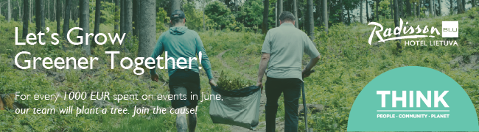
The policy can be found online:
- Green Key hotel
- Safe Hotel Premium hotel
- Hotel Sustainability Basics certified for 2nd year: https://wttc.org/initiatives/hotel-sustainability-basics
- BREEAM certified
- 100% green electricity from renewable sources.
- Responsible Business policy
- Green Housekeeping program.

Accessible Tourism in Vilnius
- 14 attractions that are wheelchair friendly
- Experience Vilnius Beyond Sight

Hop on Hop Off Tour of the Vilnius
There is also a city bus hop-on, hop-off tour of the city. There is a stop close to the hotel.

Parking at hotel
There is no carpark at the Radisson Blu hotel. However, there is a UNIPARK parking lot at Konstitucijos Ave. 20, Vilnius. Outdoor parking lot near the Radisson BLU Lietuva hotel.
When you enter the parking lot, the vehicle's license plate is scanned, and the paid rate begins to count. There is no need to activate parking or set the duration of the stay. Payment for parking is required only before leaving the parking lot.
Parking is charged 24/7. You can pay for parking in the parking lot using the UNIPARK app, at the on-site pay station, or through the actual parking contract with UNIPARK.

Food and Drink
The hotel has a bar and restaurant on the ground floor. If you would like to eat elsewhere there are a number of restaurants next door in a shopping mall. There is a selection of various restaurants including pizza, American, Italian, Crepes, Subway and Home Bakeries. There is also a supermarket in the mall as well as a pharmacy and other shops. There is an accessible route to the mall – when you come out of the hotel walk straight ahead and you will come to a set of steps. Beside these steps is a ramp that leads to the entrance of the mall.

Pet Policy
Please find a short summary of Radisson Blu Hotel Lietuva pet allowance policy:

- Radisson Blu Hotel Lietuva allow guide dogs and emotional support pets presence at the
hotel;
- An extra fee of 25 euros per night is charged for additional cleaning during a pet’s stay.
- Accommodation with pets is available only in Superior, Suite class and Wheel-chair
accessible rooms;
- The owner is responsible for pet’s behavior and do not interfere with staff members and
the stay of other guests, in particular during the night;
- Dogs should be kept on a leash on the hotel’s premises;
- The owner is responsible for cleaning up after the pet;
- Owner of the animal is obliged to provide the pet with clean water, food and any other
equipment required for taking care of the pet;
- It is not allowed to bring pets to catering facilities, conference rooms, Spa and Wellness
center;
- The owner is responsible for any damages caused by the pet to hotel’s property;

Emergency contacts
- 112 number is available in Lithuanian, English, Russian and Polish. You can download the 112 app on your phone and communicate with the emergency services using Lithuanian sign language. The sign language interpreters are available 24/7.
- Please also inform Una Brown on whatsapp 0044 77 300 36304 should you have a medical emergency.

