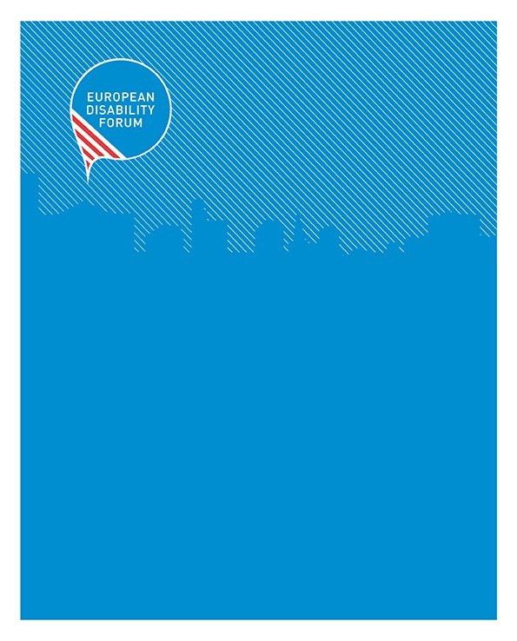

EDF Accessibility and Reasonable Accommodation Policy

EDF Accessibility and Reasonable Accommodation Policy
  - EDF | March 2018
35 square de Meeûs tel +32 2 282 46 00 info@edf-feph.org
1000 Brussels - Belgium fax +32 2 282 46 09 www.edf-feph.org

...................................................................................................................
The European Disability Forum (EDF) is an independent NGO that represents the interests of 80 million Europeans with disabilities. EDF is a unique platform which brings together representative organisations of persons with disabilities from across Europe. EDF is run by persons with disabilities and their families. We are a strong, united voice of persons with disabilities in Europe.
Contents
Introduction 3
Meetings and Events 3
• Choice of location, venue and room set-up 3
• Advance planning 4
• Services during the event or meeting 4
• Published Material 5
• Programme of the meeting/event 5
• Evaluation 5
Internal and External Communication 6
• Budgeting for Accessibility 6
• Capacity Building 6
• Evaluation and Feedback 6
Annex 1: Glossary of Terms 7
Annex 2: List of Accessibility Resources for Meetings 9
• Resources for accessibility for people with intellectual disability 9
• Sign Language Interpretation 9
• Captioning CART service providers 10
• Accessible Transport- Brussels 10
• Wheelchair Rental- Brussels 10
Annex 3: Reading list for further information 10
Contact person at the EDF secretariat: 11

Introduction

This policy is a guide for EDF and our members and partners on accessibility and reasonable accommodation for persons with disabilities at EDF meetings and events. It gives an outline of what EDF aspires to do to ensure we are accessible and inclusive. While ensuring that events and meetings are financially manageable, we strive to provide working practices, events, communication and meetings which all persons with disabilities can effectively participate in. It is not designed to be an extensive technical guide on accessibility. It should serve as a guide for EDF partners when we jointly organise events.

We intend to continuously improve this policy over time, making use of improved services and accessible new technologies when they become available.

Meetings and Events

Accessibility is a core requirement in the planning, implementation and evaluation for all EDF events and meetings. EDF aspires to arrange or co-organise events which are accessible to all persons with disabilities. We have events and meetings all over Europe. Together, with our members and partners, we aim for the highest level of accessibility and reachability through accessible public transport. However, due to the current lack of accessible transport and buildings in Europe and the fact that public authorities are often not providing support and assistance required for persons with disabilities in their personal and professional lives, EDF faces the reality of making difficult choices in regards to what we can provide.
EDF is especially grateful to its members who provide professional support to their EDF Delegates, such as personal assistance, Braille readers, Braille print-outs and a range of other assistance. This lessens the financial and organisational load from EDF and enables us to pool our resources to create an accessible working environment for as many people are possible.

Choice of location, venue and room set-up

- Venues are selected under these terms:
    - must have accessible entrance for person with disabilities, accessible conference room (including speaker’s podium/ stage), cafeteria/restaurant, toilets and bedrooms (where relevant)
    - reachable by public transport or affordable private transport. If not, EDF will ensure an easy means of accessible transport is organised.
    - We ensure suitable seating arrangements for persons with disabilities with ample space to manoeuvre either with or without wheelchairs and to ensure visibility for deaf, hard of hearing and Deafblind participants (i.e. to see clear the presenters, presentations, subtitles and/or sign language interpreters)
- We conduct events in good lighting, avoiding disturbing backgrounds noise
- If possible, but particularly in big events, an induction loop system should be available. In the absence of the induction loop system, the alternative of “neck loops” working with audio systems should be provided.

Advance planning

  - Measures planned for each meeting/event are planned on the basis of the information we receive in the registration.
  - The practical information we provide to participants in advance will include details of accessibility and reasonable accommodation provided
  - In our registration forms we ask about accessibility or assistance requirements so we can plan well for every participant; participants are expected to inform us of their specific requirements at the time of registration.
  - Documents are provided at least 2 weeks before in accessible formats
  - When EDF funds the invitation of a Delegate to one of our meetings, they are entitled (if they require personal assistance due to their disability) to travel with their personal assistant, whose travel and accommodation costs are also covered.
  - We provide presentation materials to sign language interpreters and captioners in advance of events
  - Moderators are briefed about the accessibility needs of speakers and participants; moderators are requested to strictly follow moderation guidelines and not to make last minute changes to the programme especially where speakers with intellectual disabilities are concerned.

Services during the event or meeting
  - EDF provides reasonable accommodation during the official procedures and official parts of the event and meeting programme
  - We ensure that participants are welcomed as they arrive and provided with any advice and assistance that they need
  - EDF meetings are translated/interpreted to Sign Language when Deaf sign language users have registered for the event; EDF ensures interpretation into International Sign (IS) because these events are diverse in nationalities and all events are considered international (2 interpreters for events of more than 1 hour). Please find links to help you find interpreters in this Annex.
  - Hearing loop if available at the venue should be checked if it is in working order prior to the event
  - If neck loops are provided for hard of hearing participants, there need to be clear signage for collection and return point
  - For all major events and conferences real time subtitling/captioning is provided. This means all that is said in the meeting can be read on a screen with large text. Service providers are listed here in the Annex. If remote captioning is used for an event this must be tested at least one week in advance of the meeting to ensure that the technology is working.
  - Live-streaming of events: We provide captions if events are being streamed live, and aim to ensure that sign language interpreters are also visible in the live stream
  - EDF will also endeavour to reserve hoists where needed for participants
  - For large events, with more than 50 people we aim to have a quiet/resting area where people have the chance to withdraw for rest from the main group.
  - EDF provides traffic light cards for participants

Published Material

  - We use accessible typeface (sans serif 12 or greater) on published materials and make published materials available in accessible formats, including easy to read, and we provide, on request formats that people can adjust according to their needs.
  - If media content like a video is used, we will make this as accessible as possible (e.g. including plain language to be understood by all, closed captions in the content itself) or, if not possible, by providing an alternative right before or after the media content is used. For example, if a video does not contain audio description and includes visual information, this will be presented through an accessible transcript or an oral description by the speaker.

Programme of the meeting/event
  - We structure our programmes with adequate length and breaks
  - We provide guidelines and tips for speakers/workshop leaders to make presentation materials (e.g., handouts and slides) and delivery (e.g., plain language that avoid jargon, pace to allow time for sign language/tactile interpreters/less loaded content or long sentences to allow for better processing) more accessible

Evaluation
- We include a range of questions on accessibility in the evaluations of our events to ensure we get continuous feedback to help us improve

Internal and External Communication
EDF uses a range of channels for internal and external communication including our website, www.edf-feph.org, social media, the Disability Voice newsletter and our regular updates via members mailing and email.
We follow basic accessibility principles in all these channels and have templates aligned to this:
- Using font at least of 12, sans serif, with readable colour contrasts
- Photos have alternative text
- Our major reports also come in accessible on-line forms and with easy to read versions (annual report, human rights reports)
- We use captioning for videos and audio description when needed.

Budgeting for Accessibility

- Because of the lack of accessible venues, renting/ using accessible venues, especially hotels, can be very costly. We hope this decreases over time as more hotels are accessible. We appreciate all the efforts made by partners and co-organisers to search with us for the most affordable, accessible solutions, and to try and keep costs at a minimum without compromising accessibility.

Capacity Building

- We aspire to ensure our staff are well equipped to ensure accessibility within EDF events and meetings and consider capacity building on accessibility and continuous process.
- EDF secretariat staff have had training on transport accessibility, accessible documents, website accessibility, and some staff have chosen to have more in-depth training in accessibility. Training has also been conducted for staff on issues concerning different disability groups and their accessibility needs and this training programme is ongoing.

Evaluation and Feedback

- Each major meeting of EDF is evaluated for its accessibility in our evaluation form. This is review after each event, and members are all encouraged to fill this in so that we can identify problems and address them.

Annex 1: Glossary of Terms

- Accessibility: extent to which products, systems, services, environments and facilities can be used by people from a population with the widest range of user needs, characteristics and capabilities to achieve identified goals in identified contexts of use.

- Reasonable accommodation: means necessary and appropriate modification and adjustments not imposing a disproportionate or undue burden, where needed in a particular case, to ensure to persons with disabilities the enjoyment or exercise on an equal basis with others of all human rights and fundamental freedoms;

- Easy to read: information designed specifically for people with intellectual disabilities as a group with particular literacy needs. It may include plain language and pictures.

- Communication access real-time translation (CART)/Captioning/Velotype: A person who is either physically present in the room or connected remotely via the internet types down word for word (verbatim) what is being said during the meeting in real time, similar to live subtitles on TV.

- Alternative text: Short text used described images on websites and in electronic documents, usually 125 characters or less.

- Screen reader: A software program used to allow reading of content and navigation of the screen using speech or Braille output. Used primarily by people who have difficulty seeing. JAWS and NVDA are examples.

- Transcript: A text only version of what has been said during a meeting or in a video; they are not real time and they generally are limited to speech only; they are not a recommended substitute for captions but can help to revisit the content later.

- Assistive devices: Devices used to assist a person with a disability, e.g., wheelchair, loop systems, or computer-based equipment.

- Braille: System of embossed characters for blind and partially sighted persons, formed by using a Braille cell, a combination of six dots consisting of two vertical columns of three dots each. Each simple Braille character is formed by one or more of these dots and occupies a full cell or space. Some Braille may use eight dots.

- Braille display: Hardware connected to a computer that echoes screen text on a box that has cells consisting of pins that move up and down to create Braille characters.

- Hearing loop/Audio induction loop: A special type of sound system for use by people with hearing aids and/or cochlear implants. The hearing loop provides a magnetic, wireless signal that is picked up by the hearing aid when it is set to ‘T’ (Telecoil) setting. It is a physical feature that must be pre-installed in a room or public location (e.g. at the ticket counter in a railway station).

- Portable loop: “neck loop”, which is essentially a small loop worn round the neck. These loops generally use an output on normal audio equipment designed to use standard headphones.

- Boarding aid: Device used to help persons with disabilities access a transport vehicles. This can be for example a bridging plate between the platform and the train, a ramp, an integrated lift on board of the train, or a separate lift outside on the platform.

- Obstacle-free route: A link between two or more areas that can be navigated by all persons with disabilities and reduced mobility. This includes the absence of physical obstacles that are not indicated, e.g. low-hanging cross beams, pillars, etc.

- Step-free route: A step-free route is a division of an obstacle-free route that meets the needs of mobility impaired persons. Changes in level are avoided or, when they cannot be avoided, they are bridged via ramps or lifts.

- Signage: Signs that indicate directions or locations both inside and outside buildings.

- Sign languages are natural languages that have the same linguistic properties as spoken languages. [eg: Italian Sign Language (LIS) in Italy, Spanish Sign Language (LSE) in Spain, etc]. They have evolved over the years in different Deaf Communities and vary greatly between countries and regions. There is not one universal sign language in the world; in fact some countries have more than one sign language or dialect. [eg: in Spain have LSE and Catalan Sign Language (LSC) too, French Belgian Sign Language (LSFB) and Flemish Sign Language (VGT) in Belgium, etc]

- International Sign (IS) has developed for use at international gatherings, and is provided at EDF events. This is a communication solution when having to provide access to a diverse audience.

- Sign Language Interpreter: A sign language interpreter is a professional who is fluent in two or more (sign) languages and interprets between a source language and a target language and mediate across cultures. The interpreter's task is to facilitate communication in a neutral manner, ensuring equal access to information and participation. Sign language interpreters can be both Deaf and hearing but should always carry appropriate sign language interpreter qualification from the respective country. A sign language interpreter is bound to a Code of Ethics, ensuring impartiality, confidentiality, linguistic and professional competence, as well as professional growth and development.

- “Assistive technology” means any item, piece of equipment, or product system that is used to increase, maintain, or improve functional capabilities of individuals with functional limitations, and persons with disabilities and older people;

- Subtitles for the deaf and hard of hearing (SDH or closed captions) means synchronized visual text alternatives for both speech and non-speech audio information needed to understand the media content.

- Audio description means additional audible narrative, interleaved with the dialogue, which describes the significant aspects of the visual content of audio-visual media that cannot be understood from the main soundtrack alone.

Annex 2: List of Accessibility Resources for Meetings

Resources for accessibility for people with intellectual disability

- To translate your document to Easy to Read, you should use a provider who follows the ETR. You can learn more about ETR here: http://easy-to-read.eu/european-standards/
- A list of organisations that can support you in this is available at: http://easy-to-read.eu/organisations/
- Your speakers should be aware your audience includes persons with intellectual disabilities and be given this guideline from Inclusion Europe before they write their speech or develop their presentation.

Sign Language Interpretation

- Booking interpretation should be done when the meeting date is booked as there is a shortage of sign language interpreters, and sometimes it is difficult to ensure this service. EDF books 2 interpreters for any meeting over 1 hour.
- You can read more about sign language and sign language interpreters on the website of the European Union of the Deaf: https://www.eud.eu/about-us/eud-position-paper/sign-language-interpreter-guidelines/
- Both of these networks can be a source of IS interpreters

- World Federation of the Deaf (WFD)/ World Association of Sign Language Interpreters (WASLI) https://wfdeaf.org/our-work/wfd-wasli-international-sign-interpreter-accreditation/wfd-wasli-accredited-is-interpreter/

For National Sign language contact the National Association of the Deaf (https://www.eud.eu/eud-members/) or the National Association of Sign Language Interpreters (http://efsli.org/membership/full-membership/

Captioning CART service providers

- Captioning is provided either on-site, or remotely. Both need to be planned well. On site captioning providers sometimes provide remote captioning also. Booking should be done when the meeting date is confirmed as there is a shortage of captioners. The list of service providers has been used successfully by EDF but the compatibility of your meeting requirements, technical resources, etc need to be checked with the service provider in advance.
- Global Real Time Captioning: www.grtcaptioning.com | office@grtcaptioning.com
- Velotype: www.velotype.com | info@velotype.com
- Note for remote captioning. It is extremely important to ensure that the remote captioning will work well at your event. It is obligatory to do an on-site test of the remote captioning service.

- Here is a technical guideline from ITU for remote participation in meetings.

Accessible Transport- Brussels

- Taxi Vert agency is more flexible and works everyday 24 hours. You can book it online or call them 4 or 2 hours in advance. Tel: 0032 3494949
- Taxi Hendrix has arrange of bigger vehicles. It is possible to book on the day, but better to reserve one day before. Tel: 0032 2 752.98.00 (06:00-19:00) Email: info.melsbroek@hendriks.be
- See also other companies http://bruxellespourtous.be/Taxi-1177.html?lang=fr;

Wheelchair Rental- Brussels
- Red Cross Brussels: http://www.croix-rouge.be/activites/sante/location-fauteuil-roulant-et-autre-materiel-paramedical/liste-complete-du-materiel-en-location/

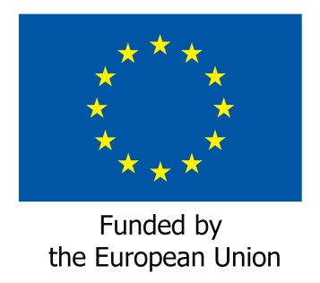
Contact person at the EDF secretariat:
Catherine Naughton, Director
Email: catherine.naughton@edf-feph.org

