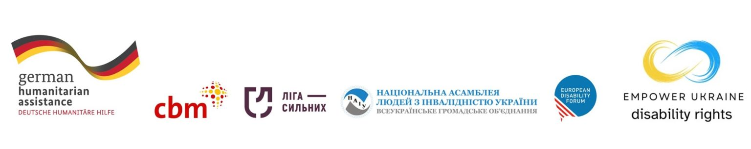

External Evaluation on Empower Ukraine for European Disability Forum

Call for applications

Deadline: 15 June 2025

Introduction
The European Disability Forum (EDF) is a non-governmental European umbrella organisation set up to represent organisations of persons with disabilities at EU level. EDF brings together representative organisations of persons with disabilities from across Europe, promoting the rights of 100 million Europeans with disabilities. EDF is run by persons with disabilities and their families.
EDF is seeking a consultant to undertake an external evaluation of its work responding to the war in Ukraine under the Empower Ukraine programme.
This programme started in July 2023 and is running until December 2025.
Empower Ukraine is a programme working towards the better inclusion of at-risk internally displaced persons (IDPs), returnees, veterans, older people, single-headed households, adults and children in institutions, and members of host communities with and without disabilities in specifically six oblasts (regions) in Ukraine.
The purpose of this evaluation is to help the programme partners to learn from the programme so far, identifying strengths and weaknesses, to make informed decisions moving forward during future programming and further extensions and tops ups to this programme to be able to provide the most effective possible response in future. It will also be used to inform new work.
Partners
Our partners on this programme are our EDF members in Ukraine:
- The National Association of Persons with Disabilities (NAPD)
- League of the Strong (LoS)
The programme is funded by the German Federal Foreign Office (GFFO) and CBM Christoffel-Blindenmission Christian Blind Mission e.V. to a value of 4.600.000,00 EUR.
The programme takes place in Ukraine in: West (oblasts: Volyn, Chernivtsi, Ternopil, Ivano-Frankivsk) + East of the Dnipro (oblasts: Poltava, Cherkassy).

Methodology
The consultant is expected to undertake an external evaluation based on the OECD DAC indicators:
- Relevance: is the intervention doing the right things?
- Coherence: how well does the intervention fit?
- Effectiveness: is the intervention achieving its objectives?
- Efficiency: how well are resources being used?
- Impact: what difference does the intervention make?
- Sustainability: will the benefits last?
- Disability Inclusion: was the inclusion of persons with all types of disabilities ensured in relevant programme activities?
- Safeguarding: did the intervention ensure safeguarding standards were in place at all times?
Additional evaluation questions
- Does the programme show adherence to the UN CRPD, IASC Guidelines and humanitarian principles?
- Was the initial design, including programme objectives and subsequent changes appropriate to the context and beneficiaries?
- Has the humanitarian support have been effective and timely?
- Has the advocacy work been effective and timely?
- Does programme strengthen the disability movement in the long-term?
- Are the programme activities being implemented to sufficient operational and professional degree?
- Are the programme partners fully involved in decision-making processes?
- Have available resources been managed and used responsibly for their intended purpose?
- Has the programme strengthened the partners capacity to function effectively in the field of humanitarian response?
- What are the emerging issues that the partners should consider for future work in Ukraine?
- How can partners improve the impact of the programme?
The consultant will likely be expected to visit programme partners in Ukraine involved in the programme.
The consultant will have the possibility to review relevant internal documents, to attend meetings of the partners and organize meetings with the implementing programme partners. The consultant will interview partners staff and members, and donors.

Requirements/selection criteria
- Official self-employed status (registered with VAT)
- The consultant/s is independent from EDF and its partners, has not been employed by EDF in the past or been part of its governing bodies
- 5-10 years evaluation experience
- 5 years’ experience in development, humanitarian and/or related fields
- Demonstrated analytical, communication and report-writing skills
- Ideally has a knowledge of the UN CRPD and accessibility and inclusion of persons with disabilities in humanitarian action
- Fluent in written and spoken English, Ukrainian an advantage
- Ukrainians are encouraged to apply
- Persons with disabilities are strongly encouraged to apply

Deliverables and timelines
- Evaluation plan presented to EDF by 15 July 2025
- Draft final report by 15 October 2025
- Final report to be delivered to the EDF by 15 November 2025
- A short summary of the evaluation for public communication 15 November 2025
EDF will be available to review each draft and provide feedback within 2 weeks.

Duration of work and rates
EDF will provide full remuneration for daily consultancy rates of a maximum 500 € all taxes included and for all expenses incurred.
EDF estimates that this process would take about 25 days including face to face meetings and attendance at EDF meetings:

How to apply
If you are interested in assisting EDF in growing to be a stronger and more effective advocate for the rights of persons with disabilities in Europe, and you have the experience we require, please send a letter of intention to Phillipa Tucker (phillipa.tucker@edf-feph.org and copy Kateryna.ostashkova@edf-feph.org) by 15 June 2025 at 17.00 Central European Time.
- Curriculum vitae
- A brief description of your experience in assessing the performance of international not for profit organizations, network and coalitions and your experience in the relevant fields, as described above
- A proposed methodology of how you would approach this work, including time schedule
- A written work sample

Note: Only shortlisted consultants will be contacted.
Appendix:
Proposal Narrative

