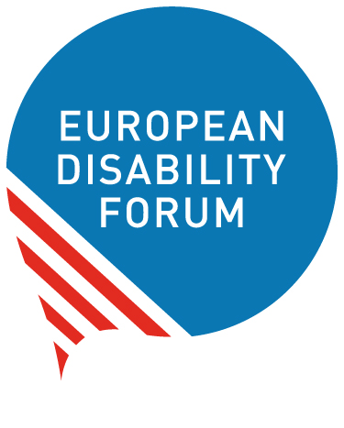 | European Disability Forum  nothing about us without us  Avenue des Art 7-8  1210  Bruxelles  www.edf-feph.org

EDF Sub-granting: Women with disabilities leading the change

The European Disability Forum (EDF) is opening a new funding stream under the project “Nothing without us: Women with disabilities leading the change” with grants of up to 3,000 euros to support our members and their members who want to undertake activities focused on women’s rights across the whole Europe (in geographical sense).
The aim is to empower EDF member organisations and their members to undertake initiatives on women’s rights, especially focusing on women with disabilities and their leading role at local, national or European level.

The programme is expected to create a significant impact across Europe by enabling organisations to implement projects that would otherwise be unfeasible.

Scope of the grants
The grants offer funding for a specific set of activities or objectives. Funding is available for activities aimed at supporting gender equality and women’s rights work, such as:
- Training sessions
- Awareness and advocacy campaigns, including the launch of these campaigns
- Conference organisation
- Participation in events
- Translation of resources on women’s rights and gender equality
- Conduct research on the rights of women and girls with disabilities
The total amount available for the grants in 2026 is 30.000 euros.
Individual grants can be from up to 3.000 euros.
The duration of the grant is 6 months, activities will start in January 2026 and should be completed no later than the 30 of June 2026. Reports should be sent to EDF no later than 31 of August 2026.

How to apply?
Please download and complete the short application form and budget template, fill them in and send these documents by email to EDF Women’s Rights Officer – Giulia Traversi by email: giulia.traversi@edf-feph.org Please write “Grant26Women” in the email subject line.
Applications can be submitted until Monday 17th of November 2025, end of day.
The application form and budget template are the only documents required for an application. However, we may ask you for additional documentation before issuing the grants.
The results will be announced to grantees by end of December 2025.

Who can apply?
All EDF member organisations and their members can apply for a grant. This programme addresses the limited resources that many organisations of persons with disabilities or organisations working on disability rights face, preventing comprehensive gender equality work. By allocating 30,000 euros, EDF aims to support around 10 organisations (EDF member organisations and their members) with up to 3,000 euros each.
Criteria for applications:
- Organisations must be EDF’s Members or members of EDF Members
- Organisations must be non-profit
- The activities must enhance the rights of women and girls with disabilities, with an explicit gender angle
- Activities must be carried out between January and June 2026
- Activities can be carried on local, national or European level
- All activities and outcomes must be accessible for persons with disabilities.
If you have any questions concerning the application process, please contact EDF Women’s Rights Officer – Giulia Traversi by email: giulia.traversi@edf-feph.org

Evaluation
An assessment will be carried out by the EDF’s selection committee composed of the Chair of the EDF Women’s Committee and EDF Staff. The EDF Women’s Committee will also be involved, to the exception of members and observers of the committee whose organisations may apply for the grant.
EDF will ensure women with disabilities have leadership and ownership of the sub-granting programme. Applicants will be required to explain how women with disabilities were involved in the proposal and why it is a priority for them. They will also have to ensure women with disabilities are involved in the implementation of the activities.

The award criteria for this call are as follows:
- Relevance: extent to which the proposal matches the priorities and objectives of the call; clearly defined needs and robust needs assessment; clearly defined target group (20 points)
- Quality: clarity and consistency of project; logical links between the identified problems, needs and solutions proposed (logical frame concept, organisation of work, timetable, allocation of resources); feasibility of the project within the proposed timeframe; financial feasibility (sufficient/appropriate budget for proper implementation; cost-effectiveness (20 points)
- Impact: ambition and expected long-term impact of results on target groups/general public; potential for a positive multiplier effect (10 points)
The following criteria will be taken under consideration:
Award criteria | Minimum pass score | Maximum score
Relevance | 15 | 20
Quality — Project design and implementation | n/a | 20
Impact | n/a | 10
Overall (pass) scores | 35 | 50

Maximum points: 50 points.
Individual threshold for the criterion ‘Relevance’: 15/20 points.
Overall threshold: 35 points.
Proposals that pass the individual threshold for the criterion ‘Relevance’ AND the overall threshold will be considered for funding — within the limits of the available call budget. Other proposals will be rejected.

Legal and financial set-up of the Grant Agreements
If you pass evaluation, your project will be invited for grant preparation, where you will be asked to prepare the Grant Agreement together with EDF Women’s Rights Officer.
This Grant Agreement will set the framework for your grant and its terms and conditions, in particular concerning deliverables, reporting, payments and funder’s acknowledgement.
The 80% of the grant will be paid immediately after the signature of the Grant Agreement, while the remaining 20% will be paid after the approval of the report.

Reporting

Deadline
Technical and financial reports should be submitted by 31thof August 2026.

Reporting templates
Reporting templates are 2 simple and separate documents, one for the technical report and one for the financial report.

The financial report shall be supported by a list of receipts, with adequate translation in English, documenting the project expenses. The invoices or equivalent documents shall be part of this financial report.

If you wish to receive more information about the reporting documents, please contact Giulia Traversi: giulia.traversi@edf-feph.org

