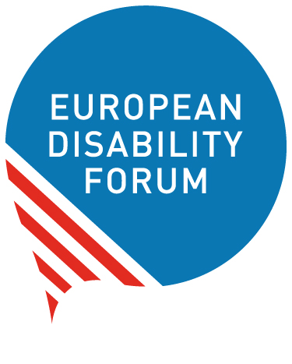 | European Disability Forum  nothing about us without us  Avenue des Art 7-8  1210  Bruxelles  www.edf-feph.org

EDF Sub-granting – Women with disabilities leading the change

Your organisation

Organisation's name
Type your answer here
Explain link with EDF (member of EDF, or member of a member of EDF)

Full address (including the country)
Type your answer here

Your Organisation's legal status:
Type your answer here

Name of legal representative
Type your answer here

Description of the organisation
Maximum 1000 characters
Type your answer here

Have you previously worked on Women’s Rights and Gender Equality and its impacts?
Maximum 2000 characters
Type your answer here

Your Organisation's website
Type your answer here

Your Organisation’s annual budget in Euros
Type your answer here

Is your organisation audited?
Type your answer here

Contact Person
Name
Type your answer here

Position
Type your answer here

E-mail Address
Type your answer here

Telephone number
Type your answer here

Your project proposal

Title of proposed work
Type your answer here

How much money are you requesting (in Euros) – Maximum is 3000 euros
Type your answer here

Proposed Work
Describe the work you would like to achieve with the grant and how our funding will strengthen your capacity to achieve it. Please describe your goal and how you would like to achieve it, as well as your potential impact, and how you will make a difference. Include timeline of implementation of your activities. Describe how you will disseminate and communicate the outputs and results of your activity.
Maximum 4000 characters
Type your answer here

