EDF Board Meeting and Danish Presidency Event

November 6 and 7 2025

Copenhagen, Denmark

Practical & logistics information

Welcome Note

On behalf of the European Disability Forum, I would like to extend a warm welcome to all our delegates who are attending this year’s Board Meeting and Danish Presidency Conference on Independent Living. We are delighted you can attend, and my team is here to help you have a productive and enjoyable event.

In this practical guide you will find some useful information on logistics, as well as some details of your programme for the Board meeting and Danish Presidency Conference. Further information on the programme can be found on the agenda.

EDF are here to ensure that you get the most from these meeting and your visit to Copenhagen, so please do not hesitate to ask us if you have any specific queries or requests. Enjoy your visit!

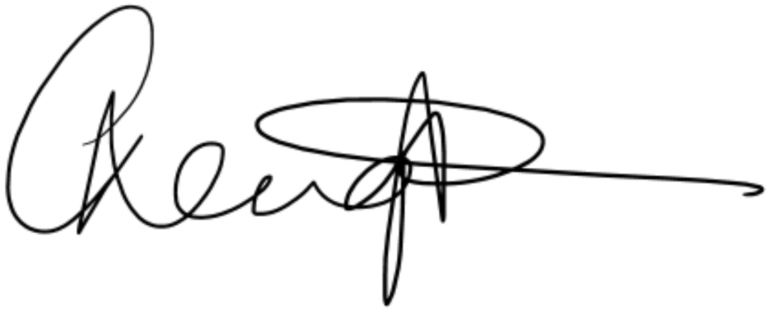
Catherine Naughton
Executive Director

Venue and Accommodation
Exceptionally, the hotel will be separate from the event venue. The venues are 2.6 km apart. You will find more information on the venues and on transport between the two below.

Hotel information:
Scandic Spectrum Hotel, Copenhagen
Address: Kalvebod Brygge 10, 6 sal, 1560 København, Denmark
Telephone: + 45 77 30 98 00
Check-in from 15:00 p.m.
Check out up to 12:00 p.m.
All conference participants who requested accommodation are staying at the Scandic Spectrum Hotel. It is located in the city centre of Copenhagen with a magnificent view of the Copenhagen waterfront.
- Find the location of the hotel on Google Maps
- You can read about the hotel amenities on their website
Rooms for all participants attending the event in person are booked by the Danish Presidency. The rooming list is now closed.
At your arrival, the hotel may ask you for a credit card to guarantee the extra charges during your stay (for example laundry services, minibar, and others) and this must be settled by you upon check-out. You will also be asked to present your Identity Card/Passport at check-in.
Conference Venue
The High-Level Conference on Independent Living, and EDF Board meeting, will take place at:
Forum Copenhagen,
Julius Thomsens Plads 1, Frederiksberg.

All necessary services will be available at the conference venues, including cloakroom, printers and copiers, working facilities and WiFi.

Forum Copenhagen is centrally placed, close to shops and next to the Metro stop, “Forum” (Metro line M2).

Transport
Attention: When seeking reimbursed for flights, be aware that fares will not be reimbursed unless the scans of the original ticket and the boarding cards are submitted with the claim. Only economy class fares will be reimbursed.
From the airport to the hotel, and from the venue to the airport
Copenhagen Airport (CPH) is 7 kilometres from the hotel and city centre.

EDF will provide adapted transport from the airport/train station to the hotels and return only for delegates and their personal assistants who have requested this service. Confirmation of the adapted transport will be sent to the aforementioned participants.
For the other delegates and participants, we advise taking public transport or taxi (please read guidelines on taxis) from the airport to the hotel and return. The expense claim form is uploaded in the Members Area dedicated page. Please be aware that reimbursement for taxi is subject to stricter conditions outlined in the EDF Guidelines to fill in Expense claim form.
There are a number of transportation options to get from Copenhagen airport to the hotel; you can either take a taxi, an Uber, private transfer or you can take public transport. Please see links below for further information:
For details on public transport, please visit journey planner (rejseplanen.dk)
- All transport
- About Taxi
- About Uber
- Public Transport
- Train

By public bus
From the airport you can travel to the hotel by bus as well. You can take bus 5c (direction: Herlev Hospital) and stop at Otto Mønsteds Plads (Rysensteensgade) – 21 stops from the airport. The journey takes around 35 minutes. The bus stop is just outside of Terminal 3.
If you are departing from the event venue to the airport, you can take Metro M2. You can take it at stop ‘Forum’ close to the venue. You will take direction Københavns Lufthavn St. and travel for 10 stops (19 minutes approximately) to the airport. The airport is the last station on the line.

By public train
The trains depart every 10 minutes from the airport to Copenhagen Central Station during the day. In evening hours, it will be every 20 minutes, and during the night just once an hour. 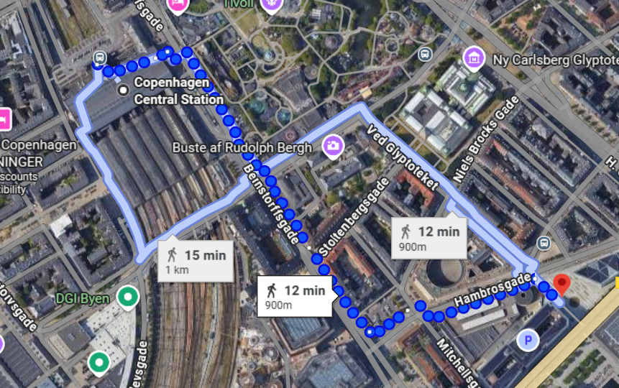
To get to the central station by train will only take 15 minutes. You can then walk around 12 minutes to hotel.
Copenhagen Central Station is located right in the city centre, within walking distance of attractions like Tivoli Gardens, Glyptoteket and Strøget, and it is surrounded by shops, restaurants and hotels.

By taxi:
Taxi service/ Private transfer: The drive takes approximately 10-15 minutes, and the distance is 7 km.
Taxis are located at designated stands directly in front of each Arrivals Hall exit. We encourage you to use electric powered taxis. Expect to pay approximately DKK 250-350 DKK (25-47 euros) for trips from Copenhagen Airport to the city centre.

Scandic Hotel to the Conference Venue:
EDF will provide a bus to and from the hotel to the conference venue on Thursday 6 and Friday 7 November. The bus will depart:
- Thursday 6 November pick up at 08.45am from hotel reception and pick-up from the conference venue back to the hotel will be 17.30. Please be at reception no later than 8.40am if you would like transported to the venue by bus.
- Friday 7 November pick up at 08.15am from hotel reception. There will be space in the bus for your luggage if you are checking out of the hotel on Friday morning. Please be at reception no later than 8.10am if you would like transported to the venue by bus. There will be no bus provided on the return as most delegates will be departing from the Forum conference venue to the airport.
**Please note for those who requested adapted transport, you will be emailed with timings separately for transport to and from the hotel to the conference venue.
For those that would prefer to walk, ride a bike or use public transportation, the Danish Presidency have created a guide for you to easily navigate these possibilities and includes the option to experience some of the sights in Copenhagen and Frederiksberg during your journey to and from the conference venue. You can find the guide here: Guide on transportation during eu2025dk.

Programme

Thursday 6th November 2025 – is the main conference on ‘Independent Living and Inclusion in Society’ from 09.00 to 17.30.
Thursday 6th November 2025 - The Danish Presidency has the pleasure to welcome you to an official dinner on Thursday 6 November from 19:00 to 22:00 at the Scandic Spectrum Hotel (Kalvebod Brygge 10, 1560 København K).
Friday 7th November 2025 – presentation by EUROFOUND following by the EDF Board meeting from 10.00-13.00. There will then be a panel discussion on input to the upcoming initiatives in the ‘Strategy for the Rights of Persons with Disabilities 2021-2030’ from 13.00 to 14.30 followed by lunch and close.
**Final programme for conference with more detail will be sent separately**

**Final Agenda for Board meeting can be accessed in the Members Area**

Stands and exhibition
There will be an EDF stand where you can find information reimbursement of expense claims.
Luggage
Please note if you are going to the airport after the conference on Friday 7 November, you will need to check out of the hotel on Friday morning before travelling to the conference venue. You can take your luggage with you to the conference venue and storage will be provided on your arrival.

Meals
Breakfasts are included for those accommodated at the Scandic Spectrum hotel.
On Thursday 6th November lunch will be provided at the conference venue. There will be a dinner hosted by the Danish Presidency at the Scandic Spectrum hotel at 19.00.
On Friday 7th November lunch will be provided at 14.30 at the conference venue.
Coffee breaks will be provided for all participants on both days of the Conference and Board meeting. All dietary requirements on your registration were passed to the Danish Presidency team.

Meeting Documents and Interpretation
For Members Only, Board documents are available on EDF’s Website, Members area.
Please note that EDF does not provide the documents printed, so make sure that you bring all your documents with you if you require paper copies.
During the conference and board meeting, the Danish Presidency will provide:
- International sign interpretation only for those that requested this service.
- Real-time captioning in English
- The conference will be in English with no interpretation to any other language
Attention: Real-time captioning languages will be in English only unless it has been requested in a different language.

No remote participation
The Board meeting and Danish Presidency Event will not be livestreamed.

Registration
The registration for the Danish Presidency conference and the EDF Board meeting will be from 09:00 – 10.00 on Thursday 6th November. Please note that your signature is compulsory to attest your attendance. The Presidency staff will receive the participants at the entrance and registration area, where the staff will help the participants in the process and hand out badges to access the venue. There will be multiple desks in order to facilitate a smooth process. The tables will be accessible for wheelchair users.
During the registration, the Danish Presidency team will give all participants individual personalized badges which must be worn at all times, due to security reasons. If you lose your badge, please report it immediately to the Presidency staff, or contact the Accreditation Desk at the meeting venue. The validity of the lost badge will immediately be terminated, and a new badge will be issued subject to the approval of the Presidency security team.
We will also require you to register for the EDF board meeting on Friday morning.

11. Contacts
EDF will be available to provide you with any support and reply to your questions.
- General issues related to organization of the logistics: Una Brown, mobile whatsapp: +44 773 00 36 304
- Financial and administration issues: Kateryna Ostashkova mobile: +32 470 96 52 78
- The agenda of the meeting: Catherine Naughton
- For any queries regarding accommodation please contact Line Yde Smidt on eu2025@croneimpact.dk

12. Reimbursement of Expenses
Expenses will be reimbursed upon receipt of expense claims. The expense claim form will be available through EDF dedicated page and you can download the form and guidelines below:
- EDF Expense claim form
- EDF Guidelines to fill in Expense claim form
Expense claim should be sent to Kateryna Ostashkova by email only in one single PDF document including the expense claim as a cover page and the justification documents attached behind.
Your main travel costs will be reimbursed according to real costs (documented with plane, train tickets, invoices, etc.).
13. Sustainability Policy
The Danish EU Presidency wants to organize and showcase a Presidency with focus on implementing sustainable actions throughout the events in Denmark. Denmark wants to ensure that environmentally, socially and economically responsible choices are made throughout the planning and execution. One objective is to achieve certification according to the internationally recognized ISO 20121 standard for event sustainability management systems.
As the case was in 2012, we want to implement sustainable initiatives throughout our Presidency. We hope that you will notice this around our venues in Denmark. For example, you will be asked to return your badge and lanyard - in that way you can contribute to recycling and waste management. You will also be guided towards more sustainable forms of transportation.
We wish to inspire you to take these actions with you and maybe even develop them further. To learn more about the sustainability efforts during the Danish EU Presidency and our five focus areas in this regard, please visit the website.

14. Accessible Tourism in Copenhagen
Please see below link to an accessible guide for tourists in Copenhagen.
Accessible guide for tourists to Copenhagen
Copenhagen Card
When visiting Copenhagen, you might want to go see some of the most popular, well known attractions. If so, we recommend that you look into the possibilities Copenhagen Card gives you – starting with transportation from the airport. When buying a Copenhagen Card you’ll get free transportation by bus, train or metro in the entire Capital Region. You can even buy it from home, and just activate it in the app upon arrival at Copenhagen Airport. The card is valid for 24-120 hours, depending on which type you choose.
Besides transportation, Copenhagen Card gives you free admission to 89 of the biggest and most popular attractions and museums in the Capital Region. It also gives you discount on varies cafes, restaurants and sightseeing tours.

Parking at venue

There will only be limited public parking available at the venue.

15. Emergency contacts
- Emergency number: 112 (fire brigade, ambulance, police)
- Electricity: The voltage in Denmark is 230V
- Local time: Central European Time (CET) – GMT +1:00
- Country code: Denmark +45
- Currency: The official currency of Denmark is Danish kroner
- Weather in Denmark: DMI (dmi.dk)
- Tap water: You can drink the tap water in Denmark
- Smoking: Smoking is only permitted in the designated areas of the official meeting venues.
- Please also inform Una Brown on whatsapp 0044 77 300 36304 should you have a medical emergency.

16. Security

The Danish Presidency will provide security during the meetings in cooperation with the Danish Police Authority and the Danish Security and Intelligence Service.

