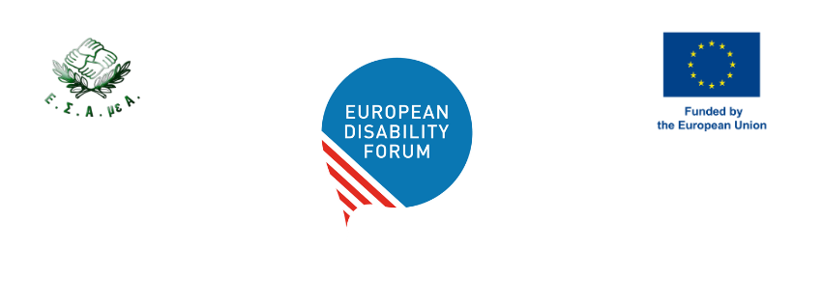

Meeting of EDF Executive Committee
NIKI hall, Titania Hotel, February 7, 2026

Contents
Meeting of EDF Executive Committee 1
1. Venue - TITANIA HOTEL 1
2. Meeting Rooms 2
3. Online participation 2
4. How to Get from Athens International Airport “Eleftherios Venizelos” to Titania Hotel 2
By public transport 2
By taxi/transfer (about 45 minutes) 3
5. Meals 3
6. Meeting Documents and Interpretation 4
7. Hotel Green Policy 4
8. Tourism in Athens 4
9. Emergency Contacts 5

For more important questions related to the event, please reach out to Mary Peterson, the Events Officer, by email: mary.peterson@edf-feph.org. For more pressing issues, by phone: +32 472 67 08 60.

1. Venue - TITANIA HOTEL
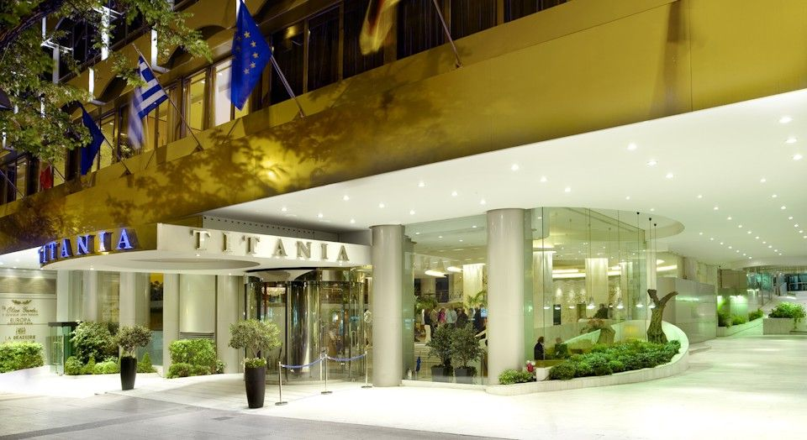

TITANIA HOTEL

Panepistimiou 52 Athens, Greece
T. +30 210 3326000

Check-in: from 15:00
Check-out: 11:00

Breakfast included: 6:30 to 10:00
Lunch will be provided on 7 Feb.

Rooms for all participants attending the event in person have been booked by EDF. At your arrival, the hotel may ask you for a credit card to guarantee the extra charges during your stay. You will be requested for payment during the check out for extra charges. You will also be asked to present your passport or ID card when checking in.

2. Meeting Room
February 7: “NIKI” meeting room, mezzanine level.
Accessible WC facilities are available nearby.
The Executive Committee meeting will take place on Saturday, 07 February in the “Niki” meeting room. The agenda can be found in the Members Area dedicated page.

3. Online participation
The following link is for participation online via zoom.

4. How to Get from Athens International Airport “Eleftherios Venizelos” to Titania Hotel

EDF will provide transport from the airport to the venue and return for wheelchair users and their personal assistants. Confirmation of the adapted transport will be sent to participants.

For detailed directions and transport options, please see the following link:
https://titania.reserve-online.net/directions

For the other participants, we advise taking public transport from the airport to the hotel. The expense claim form will be uploaded in

By public transport

Metro (about 50 minutes)

- Take the Blue Line (Line 3 – direction “Dimotiko Theatro”); exit at Syntagma Station
- From Syntagma Station, you have two options
  - 1. Take the Red Line Metre (Line 2 – direction “Anthoupoli”) and exit at Panepistimiou Station, then walk to Titania (5-minute walk)
  - 2. Walk from Syntagma station to Titania (15-minute walk)

Bus (1 hour and half)
- Take Bus Line X95 “Syntagma – Athens Airport Express” (Orange Line)
- From Syntagma Station, you have two options
  - 1. Take the Red Line Metre (Line 2 – direction “Anthoupoli”) and exit at Panepistimiou Station, then walk to Titania (5-minute walk)
  - 2. Walk from Syntagma station to Titania (15-minute walk)

By taxi/transfer (about 45 minutes)

You can provide the taxi driver with the hotel name. You should estimate a cost of 35€ (day) to 50€ (night).

5. Meals

Breakfasts
Breakfasts are included in your stay at the Titania Hotel. It is available from 6:30 to 10:00.

Lunch
Lunch will be provided during the Executive Committee meeting on Saturday.

Dinner
6 February at 19:00 – Athinaikon Restaurant

On Friday evening, we will provide participants with a dinner on 6th of February at the Athinaikon restaurant (address below). They describe themselves as serving traditional food in a contemporary setting. The restaurant is about a 15-minute walk from the hotel.

Restaurant “ΑΘΗΝΑΙΚΟΝ” (Athinaikon)
34 Mitropoleos str. & 9 Petraki str. Syntagma

Website: https://athinaikon.gr/contact-us-2/?lang=en

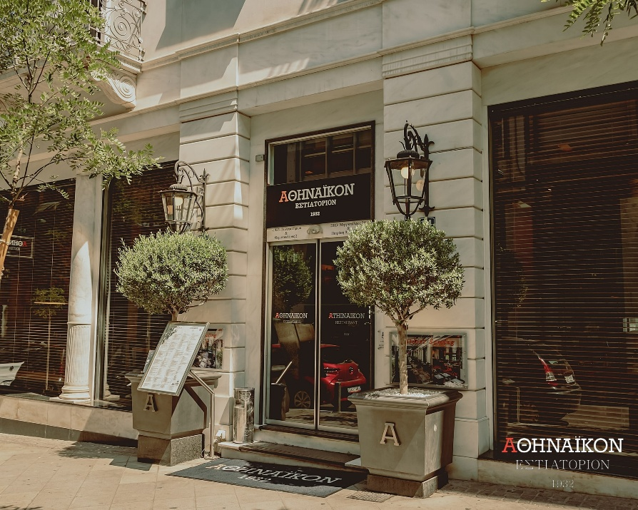

6. Meeting Documents and Interpretation

For Members Only, Executive Committee meeting documents will be available on EDF’s Website, on the Members Area dedicated page.

Please note that EDF does not provide the documents printed, so make sure that you bring all your documents with you if you require paper copies.

The event will provide international sign interpretation and captioning for those who requested this service.

7. Hotel Green Policy

The Titania Hotel follows an environmental policy that aligns with the Greek and European Community Environmental Legislations. They state the hotel is, “focused on its respect for the environment, by protecting it from the impacts of all of its hospitality services, accommodation, food-beverage and leisure. For this purpose, an Environmental Management System has been established, implemented and maintained, according to the requirements of ISO 14001:2015, which is continuously improved for its performance and effectiveness.”

8. Tourism in Athens
The Titania Athens Hotel is surrounded by some of the most important landmarks of Greek history, including the Acropolis, the Acropolis Museum, the Hellenic Parliament, the National Archaeological Museum, and the National Library. It is also within walking distance of theatres, contemporary shopping areas, and city malls, offering guests a wide range of sightseeing, cultural, and entertainment options. The Olive Garden Rooftop Bar & Restaurant, located on the 11th floor, is ideal for a delightful lunch or dinner with breathtaking views of the Acropolis and the city.

9. Emergency Contacts

In case of any emergency, dial the toll-free number 112.

Below is a list of other emergency numbers.

Ambulance 166

Fire Department 199

Police 100

Hospitals 106

General Telephone Assistance 11888

