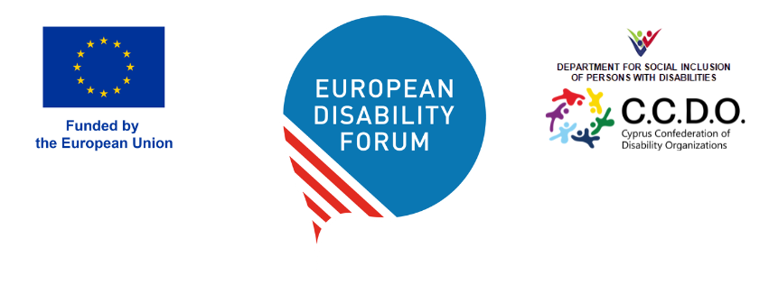

EDF Annual General Assembly

and associated meetings

9-10 May 2026|Limassol, Cyprus

Venue: City of Dreams Mediterranean
Address: Nikou Kavvadia, Limassol 3150, Cyprus

Wednesday, May 6th 2026
Arrival of Executive Committee and Board Members

Thursday, May 7th 2026

High Level Conference organised by the Cyprus Presidency, Deputy Ministry of Social Welfare
Inclusion of Persons with Disabilities: empowerment and support in a community for all

Friday, May 8th 2026
All day - Arrival of elected Board members and AGA participants
13:00 – 14:00 Lunch for Executive Committee and staff

14:00 – 17:00 Executive Committee meeting

18:00 – 19:00 Board meeting – to be confirmed

Free evening – No dinner arranged

Saturday, May 9th 2026

08:00 – 08:45 Registration of participants

09:00 – 10:00 Official opening of the AGA
- Themida Anthopoulou, President of the Cyprus Confederation of Disability Organizations (CCDO)
- Yannis Vardakastanis, President of the European Disability Forum and of the National Confederation of Disabled People – ESAMEA, Greece
- Roberta Metsola, President of the European Parliament (TBC)
- Hadja Lahbib, European Commissioner for Equality, European Commission (TBC)
- Clea Hadjistephanou Papaellina, Deputy Minister of Social Welfare of the Republic of Cyprus

10:00 – 11:00 AGA Business session 1
Chairperson: Yannis Vardakastanis, EDF President
- Roll Call
- Adoption of the agenda
- Appointment of the Scrutiny Committee and presentation of elections procedure (DOC-AGA-)
- Address by the EDF President
- Election of the EDF President
- Elections of Board members, Finance, and Membership and Credential Committees

11:00 – 11:30 Coffee break

11:30 – 13:00 AGA Business session 2
Chairperson: Yannis Vardakastanis, EDF President
- Finance
- Adoption of EDF final accounts 2025 (DOC-AGA)
- Vote of discharge to the Board for 2025
- Appointment of internal auditors for 2027 (DOC-AGA-)
- Adoption of EDF budget 2027 (DOC-AGA-22)
- Information note: Expense claims for the AGA
- Adoption of final activity report 2025 (DOC-AGA-22)
- Membership (DOC-AGA)
- Update on Disability Rights priorities in Cyprus

13:00 – 14:30 Lunch break

14:30 – 16:00 Policy Session
- Results of elections (possible second round at a time to be confirmed)
- EDF Work Plan 2027 (DOC-AGA and Annex)
- Policy update (DOC-AGA

16:00 – 16:30 Coffee break

16:30 – 17:30 AGA Business session 3
- Testimonies from Cyprus
- Panel with Youth Committee and Women’s Committees and adoption of terms of reference (DOC)
- Email expert groups (DOC)

19:00 Official Dinner

Sunday, May 10th 2026

09:00 – 10:30 Meeting of the newly elected Board and election of the Executive Committee

10:30 – 11:00 Welcome coffee for all Delegates

11:00 – 13:00 AGA Business session 4.

Announcements of the Executive Committee elections
- Testimony from Cyprus
- Advancing equality and combating hate speech in Europe
- Resolution on EDF statutes (DOC)
- Evaluation of the AGA
- Any other business
- Date of the next meeting

13:00 End of the meeting and departure of participants

