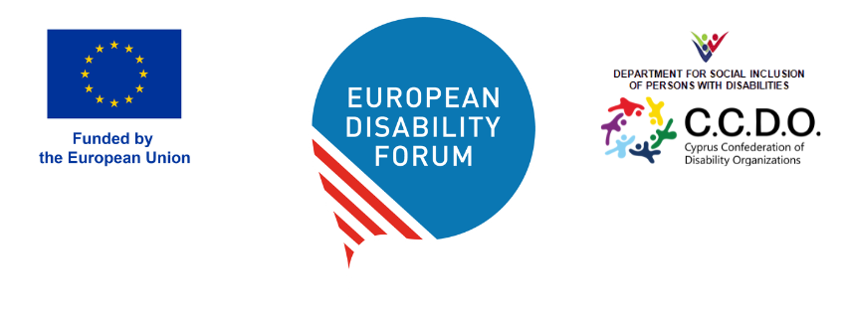
DOC-AGA-26-05-02

Elections: Procedure for the election of candidates to President, Board of Directors, Executive Committee, Finance Committee, Membership and Credentials Committee
This document explains the Election Procedures that will be used during the elections of all governing bodies. It follows EDF Statutes and Internal Rules.

Questions for the General Assembly
- Do you agree to appoint the proposed delegates and secretariat staff for the scrutiny committee?
- Do you have any questions regarding the electoral procedure?

Table of Contents

Introduction 2
1. Scrutiny Committee (Art. 10.3 of the Internal Rules) 3
2. President (Art. 25 and 27 of EDF Statutes and Art. 10.3 of the Internal Rules) 4
3. Board of Directors (Art. 23 of the EDF Statutes and Art. 10.3 of the Internal Rules) 4
4. Finance Committee (Art. 10.3 and 14 of the Internal Rules) 5
5. Membership and Credentials Committee (Art. 12 of EDF Statutes and Art. 10.3 of the Internal Rules) 5
6. Executive Committee (Art. 25 of the EDF Statutes and Art. 11.2 of the Internal Rules) 6
7. Electronic Voting System 8

Introduction
According to the EDF constitution adopted in 2004 and last revised in 2024, AGA delegates will elect, during the General Assembly 2026, the EDF governing bodies for the period 2026 - 2030.
In order to ensure smooth and transparent elections, a scrutiny committee will be appointed by the AGA delegates before the votes.
The AGA delegates will vote for the composition of the following:
- The President
- The Board of Directors
- The Finance Committee
- The Membership and Credentials Committee
The Executive Committee will be elected by the new Board of Directors after its election.

Scrutiny Committee (Art. 10.3 of the Internal Rules)
The General Assembly will appoint a scrutiny committee before proceeding to the election of the Governing bodies. Its task will be to verify the election procedure on the basis of EDF by-laws and the internal rules. It will be dissolved at the end of the scrutiny procedure.
The Scrutiny Committee will be composed of:
- 2 delegates, one from a National Council and one from an ENGO
- 2 EDF staff members

President (Art. 25 and 27 of EDF Statutes and Art. 10.3 of the Internal Rules)
AGA delegates will elect the EDF President. The President shall be proposed by an EDF full member and must be a person with disabilities or parent of a person with disabilities unable to represent herself/himself.

Board of Directors (Art. 23 of the EDF Statutes and Art. 10.3 of the Internal Rules)
AGA delegates will elect the members of the Board of Directors.
The Board will include 28 representatives from full members (16 from National Councils, 12 from full member ENGOs) and 2 representatives from ordinary member ENGOs.
- The delegates from National Councils will elect among themselves 16 delegates from National Councils to become members of the Board.
- The delegates from full member European NGOs will elect among themselves 12 delegates from ENGOs to become members of the Board.
- The delegates from ordinary member European NGOs, will elect among themselves 2 delegates from 2 different ordinary ENGOs to become members of the Board.

Finance Committee (Art. 10.3 and 14 of the Internal Rules)
The Finance Committee shall have five members, including the Treasurer who shall chair the committee.
AGA delegates will jointly elect four members of the Finance Committee while the Treasurer will be elected by the newly elected Board of Directors.
The four positions will be allocated as follows:
- 2 members from the National Councils
- 2 members from full member ENGOs
If a person withdraws from the Committee, the vacancy will be covered at the next Annual General Assembly.

Membership and Credentials Committee (Art. 12 of EDF Statutes and Art. 10.3 of the Internal Rules)
The membership and credentials committee shall have five members, including the Secretary, who shall chair the Committee.
AGA delegates will jointly elect four members of the Membership and Credentials Committee, while the Secretary will be elected by the newly elected Board of Directors.
The four positions will be allocated as follows:
- 2 members from the National Councils
- 2 members from full member ENGOs
If a person withdraws from the Committee, the vacancy will be covered at the next Annual General Assembly.

Executive Committee (Art. 25 of the EDF Statutes and Art. 11.2 of the Internal Rules)
The newly elected Board shall elect the following ten members of the Executive Committee, five of which from National Councils and five from full member ENGOs:
- Vice President (representing National Councils or ENGOs)
- Vice President (representing National Councils or ENGOs)
- Treasurer
- Secretary
- 6 members without portfolio
Candidates may run for different positions in the Executive Committee. If elected to a position, their candidature to the other positions will be withdrawn.
In order to ensure parity between both full membership categories, the following voting procedure will apply:
- To vote all the positions successively in the order suggested above (from a) to e).
- If the most voted candidate for a) comes from an ENGO, the following position (b) will be attributed to the most voted candidate coming from a National Council and vice versa. The same applies to (c) and (d).
- For e) the remaining six seats of the Executive Committee, the three most voted candidates from National Councils and the three most voted candidates from full member ENGOs will be elected.
Individual candidatures can be submitted to more than one governing body election. The elections will also be carried out via Choice Voting.
The deadline for the presentation of candidates for all positions is fixed according to the adopted procedure no later than (Sunday, March 8, 2026.)
Procedure for submitting an application:
Only complete applications received by the deadline will be considered.
- Applications of candidates must be presented by an organisation in writing via e-mail.
- The letter must indicate the name of the delegate(s) and the position(s) to which he/she/they are running.
- Applications should include a brief presentation by the same deadline.
- A scan of the Identity Card and a proof of the address where the candidate resides (e.g. electricity, phone bill) are required for the Belgian administration, and therefore also required for the EDF election

Electronic Voting System
We will use an electronic voting system, (using an online voting system), for accessibility reasons.
For our full elections we will use Choice Voting online election system. A team was set up by our secretariat under the coordination of the Membership Coordinator and supervised by the Scrutiny Committee They will be following carefully all the articles of our Statutes and Internal Rules. The team will be trained in using the system and to help solve technical issues and will assist those who need help.
The voting will take place via the electronic system for all delegates present in the room or remotely, during the General Assembly. The system sends to each Delegate a personalised e-mail with a personalised link and the system shows the results in an anonymous way. Neither the system manager, the candidates nor delegates can see personal details that would help to identify who voted for who. It guarantees a private ballot.
The system is known by many of the delegates and our Board members. We used it at all elections since 2022 and during board meetings. A test moment was organised in beginning of March in an online Information session. The exact date and connection information will be sent in due time to all delegates.
It is essential that Delegates ensure they give an email address in their registration which they will have access to during the AGA, as their voting ballot will arrive at this email address.

