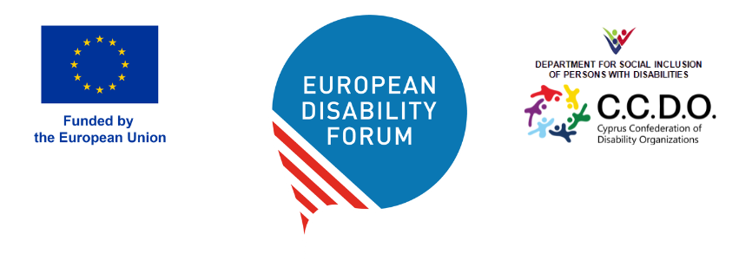

DOC-AGA-26-05-03F

Budget 2027
This document presents EDF draft budget 2027

Question for the General Assembly?
Do you agree to vote in favour of the adoption of the budget 2027

Projects | Expenses | Income | Grand Total
CERV | -2.145.886,75 € | 2.145.886,75 € | 0,00 €
Staff | -1.235.271,74 € |  | -1.235.271,74 €
Other | -529.869,01 € |  | -529.869,01 €
Accomodation | -163.102,00 € |  | -163.102,00 €
Travel | -147.270,00 € |  | -147.270,00 €
Subsistence | -63.374,00 € |  | -63.374,00 €
Equipment | -7.000,00 € |  | -7.000,00 €
Unrestricted income |  | 321.883,01 € | 321.883,01 €
Operating grant |  | 1.824.003,74 € | 1.824.003,74 €
EDF | -112.169,90 € | 101.284,00 € | -10.885,90 €
Other | -71.461,84 € |  | -71.461,84 €
Staff | -37.708,06 € |  | -37.708,06 €
Equipment | -3.000,00 € |  | -3.000,00 €
Indirect cost Yo-IN |  | 5.284,00 € | 5.284,00 €
Indirect cost Chanel |  | 15.000,00 € | 15.000,00 €
Unrestricted income |  | 38.000,00 € | 38.000,00 €
Corporate sponsorship |  | 43.000,00 € | 43.000,00 €
CBM International | -12.444,23 € | 12.444,23 € | 0,00 €
Chanel | -218.096,12 € | 218.096,12 € | 0,00 €
Disability inclusive AI | -81.023,40 € | 81.023,40 € | 0,00 €
DRF | -14.221,98 € | 14.221,98 € | 0,00 €
Empowered by AI | -79.619,65 € | 79.619,65 € | 0,00 €
IDA | -104.340,05 € | 104.340,05 € | 0,00 €
Ready Baltics | -184.570,71 € | 184.570,71 € | 0,00 €
Wellspring | -133.070,65 € | 133.070,65 € | 0,00 €
Yo-IN | -80.106,00 € | 80.106,00 € | 0,00 €
Grand Total | -3.165.549,43 € | 3.154.663,53 € | -10.885,90 €

Different types of Income
Income | 3.154.663,53 €
Corporate sponsorship | 43.000,00 €
Indirect cost Chanel | 15.000,00 €
Indirect cost Yo-IN | 5.284,00 €
Operating grant | 1.824.003,74 €
Other grants | 889.035,71 €
Unrestricted income | 378.340,08 €
Grand Total | 3.154.663,53 €

