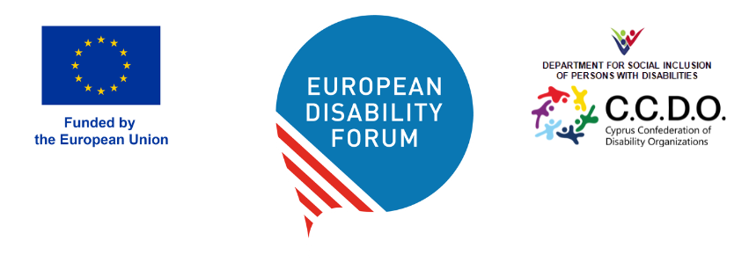
DOC-AGA-26-05-04

EDF Annual Report
Document for adoption

Purpose of this item
This document includes the achievements during 2025 by areas of work. All these achievements or activity reports will be included in the annual report along with other public information.

Questions for the delegates
- Do you have questions or comments or suggestions on the report (see Annex)
- Do you adopt the 2025 annual report?

Introduction
Below, you can find the main list of the EDF’s achievements in 2025 and key figures from our work.

Top highlights
- Calling for the next EU budget to support disability rights through our direct advocacy, securing commitments for social spending.
- Driving the European Disability Rights Strategy forward, with our campaign and proposals shaping EU commitments for 2026–2030.
- Advancing passengers’ rights, including our Human Rights Report on air travel and through successful advocacy towards policymakers, regulators, airlines and airports to improve accessibility.
- Participating actively in the review of the UN Committee on the Rights of Persons with Disabilities to the EU’s implementation of the UN CRPD, resulting in ambitious recommendations to the EU institutions.
- Re-establishing the Disability Intergroup in the European Parliament, a goal we campaigned for and achieved, securing a platform to influence policy and priorities for the 2024–2029 parliamentary term.

Campaigns highlights

Strengthening the EU Disability Rights Strategy 2026 - 2030
In 2025, we intensified our advocacy to ensure that the implementation of the second phase of the European Disability Rights Strategy 2021–2030 will deliver concrete improvements for persons with disabilities across Europe.
Throughout the year, we led the campaign “Updated EU Disability Rights Strategy”, mobilising the disability movement and raising awareness through our website and social media channels. The campaign called for stronger commitments, clearer timelines and new measures to address the remaining gaps in the Strategy’s implementation.
Key achievements:
- The European Parliament adopted a report on the future of the Disability Strategy beyond 2024 that incorporated several of our key proposals.
- The European Commission announced in its 2026 Work Programme its commitment to introduce new actions to strengthen the Strategy for the period 2026–2030. This represents an important step towards reinforcing the EU’s framework for advancing the rights and inclusion of persons with disabilities that we will see in 2026.

Advancing Passengers Rights
In 2025, we promoted stronger passenger rights for persons with disabilities, with a particular focus on accessibility in air travel.
Key achievements:
- We released our Human Rights Report 2025 ‘Rights Delayed: Air Travel for Passengers with Disabilities’, revealing that despite Regulation 1107/2006, passengers with disabilities still face significant barriers and discrimination. We strengthened collaboration with airports and disability organisations. The launch of the report became our best-attended event of 2025.
- A report adopted by the European Parliament on passenger rights (multimodal and enforcement) incorporated several of our key proposals, strengthening protections and enforcement for travellers with disabilities.
Through this work, EDF continued to advocate for more accessible and inclusive transport across Europe.

Ensuring the next EU budget supports disability rights
In 2025, we engaged actively on the future EU budget (Multiannual Financial Framework 2028–2034) to ensure that funding supports the rights and inclusion of persons with disabilities.
Key achievements:
- We met with Roxana Mînzatu, Commissioner responsible for social rights and skills, quality jobs and preparedness to whom we stressed the need for maintaining a stand-alone European Social Fund, preserving enabling conditions for social investment, and a Disability Employment and Skills Guarantee to strengthen employment opportunities.

Re-establishing the Disability Intergroup in the European Parliament
We successfully pushed for the re-establishment of the Disability Intergroup in the European Parliament.
As one of the longest-standing intergroups, originally established in 1980, our advocacy was instrumental in securing this platform and ensuring that disability rights continue to be a top priority in European policymaking.
Key achievements:
- The Intergroup includes 72 Members of the European Parliament (MEPs) from 23 countries and 7 political groups, as well as non-attached members.
- The first meeting was hosted on 13 February, where MEPs agreed on the Intergroup Bureau composition and set priorities for the 2024–2029 term.

Our policy impact
- 11 EU policies changed and adopted
- 36 high-level meetings with decision makers, including Commission Vice-President Mînzatu, Commissioners Lahbib, Micallef, and Roswall, Numerous members of the European Parliament such as MEP Langensiepen, Marczulajtis-Walczak, Agius Saliba or Li Andersson, the UN Special Rapporteur on the Rights of Persons with disabilities Heba Hagrass, the Director of Directorate-General of Employment Mario Nava, and the Director of the Fundamental Rights Agency Sirpa Rautio.
- 82 consultations to bring disability issues into policy initiatives
- 287 advocacy and technical meetings

Work together with our members
- We welcomed 7 new members, reaching a total of 120 EDF members at the end of the year.
- We organised:
  - 80 meetings with members
  - 23 trainings exclusively for members
  - 12 Governing Body meetings:
    - 1 Annual General Assembly in Vilnius (Lithuania)
    - 3 Board meetings in Vilnius (Lithuania), Copenhagen (Denmark) and online
  - 8 Executive Committee meetings
- We provided support to members in different ways to help them secure funding, on 192 occasions.

Joining forces through our events
- 46 events organised and co-organised online and in person
- Over 1300 participants
- Participants from 64 different countries

Making our voice heard
- 94 times references in media (EU and national) across at least 31 outlets, including Financial Times, Politico Europe, Euronews, and Il Sole
- Over 55,0000 followers in total on all our social media accounts (X, Facebook, LinkedIn, Instagram and our new account on Bluesky)
- 280,000 visits to our website
- We became members of the European Youth Forum and of the Climate Action Network Europe.

