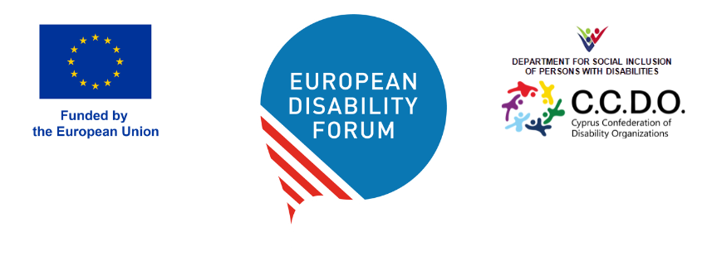

DOC-AGA-26-05-08

EDF Women’s & Youth’s Committee: Terms of Reference
This document gives information about the revision of the Terms of Reference (ToR) of the Women’s Committee and of the Youth Committee, for the adoption by the General Assembly.

Questions for the General Assembly

- Do you approve the Terms of Reference of EDF Women’s Committee?
- Do you approve the Terms of Reference of EDF Youth’s Committee?

Introduction
The Terms of Reference have been slightly revised by EDF staff, together with the committee’s input. It was also reviewed and adopted at the Executive Committee in February 2026. Successively, the Board adopted them, and the General Assembly will vote for their adoption.
The Terms of Reference will be used as a basis for the call-out for members of these committees.
New Committees will be established after the May 2026 elections. The nomination and selection process for the two committees will run between June to September 2026. The new Executive will be in charge of approving the selection of the candidates.

Terms of Reference of the Women’s Committee (Annex 1)
EDF Secretariat and the Chair of the Women’s Committee propose revision of the Terms of Reference of the Committee to respond to the reality of the committee and challenges observed in the past years.
The proposal is available in Annex 1.
The main changes are the following:
- Clarification of membership: The Committee will consist of 8 full members (4 from national councils and 4 from ENGOs) and 4 observers (who can be nominated by any EDF member).
- Structured application and selection procedure: The application and selection process has been formalised, with clear selection criteria and a scoring system (detailed in the annex). The evaluation is based on 7 key criteria: personal experience of disability; knowledge and experience on gender equality and the rights of women and girls with disabilities; intersectional perspective; motivation to join the Committee; ideas and proposed contributions to the Committee’s work; geographical balance; and age balance.
- Clarification of the role and responsibilities of the Chair and Vice-Chair: the revised ToR formalise the roles of the Chair and Vice-Chair, reflecting the structure successfully piloted by the current Committee.
- Introduction of term limits: in order to promote inclusion and participation we propose that starting from 2026, full members may be re-nominated only once. After serving two consecutive terms (8 years), they must complete one full mandate before becoming eligible for nomination again.
- Resignation and exclusion due to inactivity: New provisions clarify the procedure for withdrawal or exclusion of members due to unjustified inactivity. EDF may launch a new call for participation to fill any resulting vacancies, first, giving priority to active observers. The Executive will review the membership of the Committee after 2 years of exercise.
We also propose adopting selection criteria for the selection of committee’s members and observers. The selection will be based on 2 eligibility criteria and use 7 selection criteria. The criteria will be assessed using a scoring system.
Eligibility criteria:
To be eligible for consideration, applicants must:
- Be a woman with a disability or a woman who is directly supporting a family member or a peer with a disability (for full membership); and
- Be nominated by an EDF member organisation.
Selection criteria:
The selection is based on the following criteria:
- Personal experience of disability
- Knowledge and experience on gender equality and the rights of women and girls with disabilities
- Intersectional perspective
- Motivation to join the committee and availability
- Ideas and proposed contributions for the Committee
- Geographical balance
- Age balance

Terms of Reference of the Youth Committee (Annex 2)
- The mandate of the Youth Committee is of 4 or 2 years. Due to the reality of young people’s life that change fast, and in the last terms of the Youth Committee we experience after one or two years many members drops out. They are not reacting to communication, they do not attend the meeting often with good reasons. Therefore, the Committee would like to propose alternatively a choice between a 4 or a 2 year mandate to that better corresponds with their reality.
- Organise shorter online meeting instead of half day meeting: The second meeting of the Committee is online. The possibility to advance on their work using short online sessions of 1 hours helped this committee and. Sometimes accessibility measures are needed to allow for example the participation of the sign language user member.
- The Committee is co-chaired The Youth Committee is chaired by two-chairs. Instead of a chair and a vice chair. Sharing the responsibilities with two is easier, and this system worked very well this past two years.
- Structured application and selection procedure: The application and selection process has been formalised, with clear selection criteria and a scoring system (detailed in the annex). The evaluation is based on 7 key criteria:
- Personal experience of disability
- personal background (e.g. disability); knowledge and experience on disability and youth field and rights of young people with disabilities;
- ntersectional perspective;
- motivation to join the Committee;
- ideas and proposed contributions to the Committee’s work;
- geographical balance;
- age balance (the possibility to include young people under 18 on exceptional basis has been included at the request of the board.
A representative appointed by the Youth Committee will participate in the selection process.
- Resignation and exclusion due to inactivity: New provisions clarify the procedure for withdrawal or exclusion of members due to unjustified inactivity. EDF may launch a new call for participation to fill any resulting vacancies. If two full members cease their participation, the Executive Committee will automatically seek to fill their positions, giving priority to active observers.

