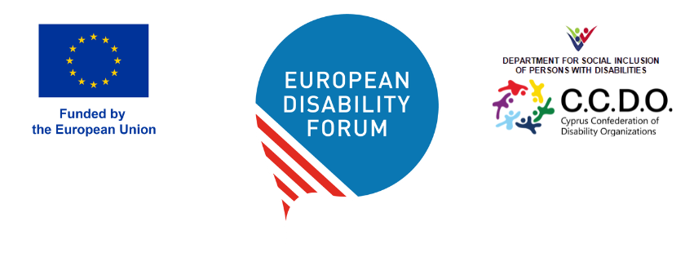

DOC-AGA-26-05-10

RESOLUTION ON EDF STATUTES
The German Disability Forum highlighted issues with EDF statutes, outlined in the Annex, which call for a revision of our statutes to bring them into line with the CRPD.

Resolution on the Revision of EDF Statutes: Addressing Outdated Language and Concepts
The General Assembly of the European Disability Forum (EDF), meeting in Cyprus on 09–10 May 2026, notes the communication from the German Disability Council (Deutscher Behindertenrat – DBR), which calls for the revision of Article 1, Sentence 2 of EDF’s Statutes and requests examination of other articles to ensure compliance with the UN Convention on the Rights of Persons with Disabilities (CRPD).
Recognising the concerns raised regarding outdated terminology—particularly the reference to “parents” and the phrase “unable to represent themselves”—the Assembly affirms that such language does not reflect the principles of legal capacity and supported decision-making as enshrined in Article 12 of the CRPD. The Assembly also notes the importance of inclusive terminology, such as “family members or peers,” and acknowledges the need for a broader understanding of support networks for persons with disabilities.
Therefore, the General Assembly resolves:
- To mandate EDF’s governing bodies to conduct a thorough review of all articles in the Statutes and Internal Rules to ensure alignment with the CRPD, particularly regarding legal capacity, support for decision-making, and inclusive terminology.
- To establish a Constitutional Working Group, comprising representatives from member organisations, self-advocates, and legal experts, tasked with preparing proposals for statutory amendments and reporting to the Board and General Assembly within twelve months.
- To include in the mandate of the Consitutional Working Group,
  - Examine and present proposals to replace outdated language in the EDF statutes
  - Propose new language for Article 1, removing references to people unable to represent themselves, replacing this with more inclusive terminology which captures the role of peers or family without replacing the central self-representation of persons with disabilities themselves.
The Assembly emphasises that these changes are vital to EDF. The Assembly calls on all members to participate actively in the review process and to support the adoption of the revised Statutes at the next General Assembly.
Annex: Full communication brief from the German Disability Forum

