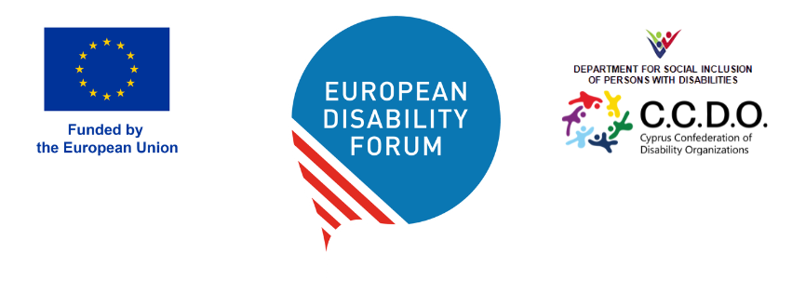

DOC-AGA-26-05-11

RESOLUTION ON RELOCATION OF CONFERENCE OF STATES PARITES
DPI Europe moves that the EDF General Assembly adopts the following positions:
Condemnation of barriers: We formally condemn the restrictive US visa measures as a violation of Article 40 of the CRPD and the UN Headquarters Agreement.
We call for Relocation: Urge the UN Secretary-General and the COSP Bureau to relocate COSP19 to a city that can guarantee unfettered participation. The COSP should take place in a location where the UN has hosting capabilities, and major UN headquarters or agencies. These cities should have visa frameworks that, while still requiring scrutiny, do not currently use a person's disability as grounds for exclusion.
Interim Protections: We demand that the UN grant « Hybrid Speaking Rights » with full procedural weight to any delegate denied a visa, should relocation not be achieved.
Rationale for EDF Action
A Conference of States Parties that excludes the Global South and persons with significant support needs ceases to be a global forum. As the leading voice for persons with disabilities in Europe, it is imperative that the EDF stands in solidarity with our colleagues who are being systemically excluded. We request that this motion be circulated to all EDF members ahead of the Cyprus GA to ensure a robust discussion on how we can protect the principle of « Nothing About Us Without Us ».

