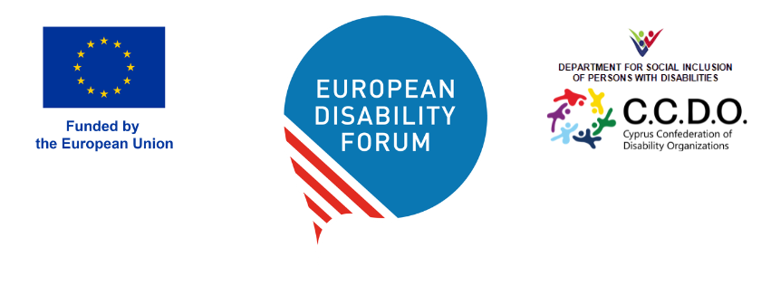

EDF Annual General Assembly

9-10 May 2026 | Limassol, Cyprus
This guide provides all practical details about the upcoming General Assembly in Cyprus.
For other questions related to the event, please reach out to Mary Peterson, EDF Events Officer, by email: mary.peterson@edf-feph.org.
For pressing issues, please contact by phone: +32 472 67 08 60.

Practical Information Guide
Contents

Use of passport on arrival 2
Registration on arrival with Cypriot Presidency 2
WhatsApp group 3
1. Venue – City of Dreams Mediterranean 3
2. Accommodation 4
3. Online participation 4
4. How to Get from Airports to City of Dreams 4
4. Agenda and Meeting Rooms 5
5. Group photos 6
6. Meals 7
7. Meeting Documents and Interpretation 7
8. Security 8
9. Map of hotel 8
10. Hotel Sustainability 10
11. Activities at the Resort 10
12. Emergency Contacts 11

Use of passport on arrival
Cyprus is not a member of the Schengen area . EDF requests that our delegates use their international passports for entering and exiting the country, as Cyprus is an EU Member State, but not yet a member of the Schengen region.
The official currency in Cyprus is the Euro.
The weather in Cyprus for our stay is predicted to be a sunny with highs of 27 °C and lows of 15°C.

Registration at the airport on arrival with Cypriot Presidency
Please be aware that you will have to register to the event with the Cypriot Presidency at the airport on arrival. Stands denoting the Cypriot Presidency of the EU are clearly marked after border control and/or at the arrival halls.
When you arrive at this stand, you will be provided information on your transport to the hotel.

WhatsApp group
Delegates are encouraged to join the official WhatsApp community, for networking and clarifying occasional doubts.
Joining the community remains optional. All key information will be available in the EDF members area.

1. Venue – City of Dreams Mediterranean
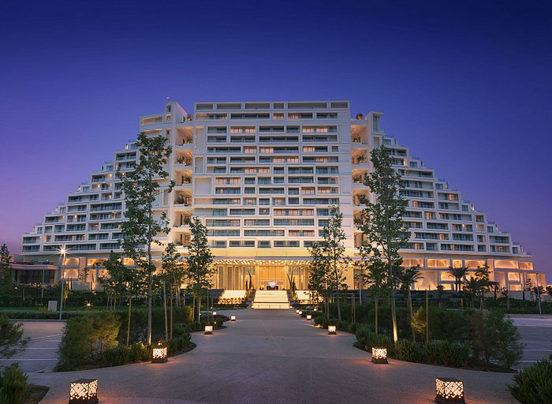
City of Dreams Mediterranean
Address: Nikou Kavvadia, Limassol 3150, Cyprus
Telephone: +35725088888
Website: www.cityofdreamsmed.com.cy
Check-in: from 15:00
Check-out: 12:00
Breakfast included: 6:30 to 10:00
Lunch and dinner will be provided on Saturday, May 9th
The venue will have a quiet room and a quiet room for networking.
On Friday, May 8th, we will provide you with a tour of the hotel starting at 18:00 in the hotel lobby.

2. Accommodation
Rooms for all participants attending the event in person have been booked by EDF.
At your arrival, you will be asked to present your passport or ID card when checking in. Please be aware that you will be responsible for extra costs, such as drinks in the bar or room service.

3. Online participation
Online participation will be available for those not attending in person. A link will be provided. Official Delegates who are participating in the room and online will also be voting via an electronic ballot. It is important you have access to the email you registered with EDF during the AGA, for voting.

4. How to Get from Airports to City of Dreams
Please be aware that no public transportation is available directly to the venue.
Transportation will be organised by the Cyprus Presidency for all of our delegates. Transfer buses, cars and adapted transport will be departing to and from the airports of Larnaca and Paphos. Transportation has been arranged according to the travel information provided by the delegates. When you arrive at the airport, please go to one of the Cyprus Presidency information booths and they will provide you with details for your transport to the hotel.
Please make sure you let EDF know if there are any changes in your travel plans or connections.
For departures following a day after the event, starting May 12th, delegates will need to arrange their own transportation.

By taxi/transfer (one hour)
You can provide the taxi driver with the hotel name. You should estimate a cost of 90€. Please remember that taxi won’t be reimbursed by the European Disability Forum, unless it’s under specific conditions (See: EDF Guidelines to fill in an expense claim.) . The expense claim form will be uploaded in the Members Area dedicated page.

4. Agenda and Meeting Rooms
The full agenda for EDF’s AGA can be found in the Members Area dedicated page.

Thursday, 7 May
  - Cyprus Presidency of EU Council: High Level Conference: Inclusion of Persons with Disabilities: Empowerment and Support in a Community for All
    - Time: 8:00 to 17:00
    - Location: Hotel Grand Room
Friday, 8 May
  - European Commission: Disability Platform
    - Time: 9:00 to 12:00
    - Location: Hotel Grand Room
  - EDF Executive Committee Meeting
    - Time: 14:00 to
    - Location: Hotel Grand Room
  - EDF Board Meeting
    - Time: 18:00 to 19:00
    - Location: Hotel Grand Room
  - Brief Hotel Tour (to see AGA entrance and breakfast)
    - Time: 18:00
    - Location: Meet in hotel lobby
Saturday, 9 May
  - Annual General Assembly Day 1
    - Time: 8:00 to 17:30
    - Location: Hotel Grand Room
Sunday, 10 May
  - Annual General Assembly – Day 2
  - Meeting of the newly elected Board
    - Time: 9:00 to 10:30
    - Location: Hotel Grand Room
  - Annual General Assembly continues (all delegates)
    - Time: 10:30 to 13:00
    - Location: Hotel Grand Room

5. Group photos
A group photo is planned during Saturday’s coffee break at 16h.
Delegates are encouraged to bring flags and other mementos that represent their country, their association/disability and/or other topics important to them.

6. Meals
Breakfast
Breakfasts are included in your stay at the City of Dreams, on the bottom floor (see map) at Aura. There are elevators that lead down to the buffet It is available from 7:00 to 11:00.
Lunch
Lunches will be provided for EDF delegates on Saturday, May 9th from 13:00 to 14:30. Location to be announced.
Dinners
Dinner will be provided for EDF delegates on Saturday, May 9th at 19:00. Location to be announced.
Restaurants outside the venue:
- My Mall Limassol – 15-minute walk – 1km
- Franklin Roosevelt Avenue – 25-to 35-minute walk – 1,5-2 km

7. Meeting Documents and Interpretation
Executive Committee and Board meeting documents are available on EDF’s website, on the Members Area dedicated page (log in required).
Please note that EDF does not provide the documents printed, so make sure that you bring all your documents with you if you require paper copies.
The event will provide international sign interpretation and captioning for those who requested this service.
There will be on-the-spot interpretation into Greek and French.

8. Security
Travel advisories regarding Cyprus have been restored without visitors facing any travel impact. Notably, a summit of EU leaders successfully took place in late April.
The Cypriot Presidency, the EDF and the venue have tight security measures, including during registration. The venue provides a dedicated security team. More information will be available at the venue.
There will be an ambulance on site.
The CCDO have appointed health and safety officer available 24/7 at the venue.
EDF will work closely with our Cypriot members and the Presidency and Commission, to ensure an efficient and professional response to any security incident, acting as a team and ensuring the best possible outcomes for all.

9. Map of hotel
Below is the full map of the resort, following this, you will see a closer view with a large yellow arrow pointing to the Grand Room, where our AGA will be held. The entrance and lobby are on the bottom of the map; the side of the hotel connected to the parking area (not the sea).
All of our events will take place in the Grand Room (alternatively named the Ballroom) and the reception room directly in front of it.
To get to the Grand Room, upon entering from the lobby, one can simply follow the hallway leading left all the way to its end. The room’s entrance is on the right. We will have signs in the hotel to guide you.
The breakfast area is on the lower floor, accessible by elevator and stairs, via the lobby and then through the Casino.
On Friday, May 8th, we will provide you with a small tour of the hotel starting at 18:00 in the hotel lobby. We will show you where the meeting room is located, as well as the breakfast area.

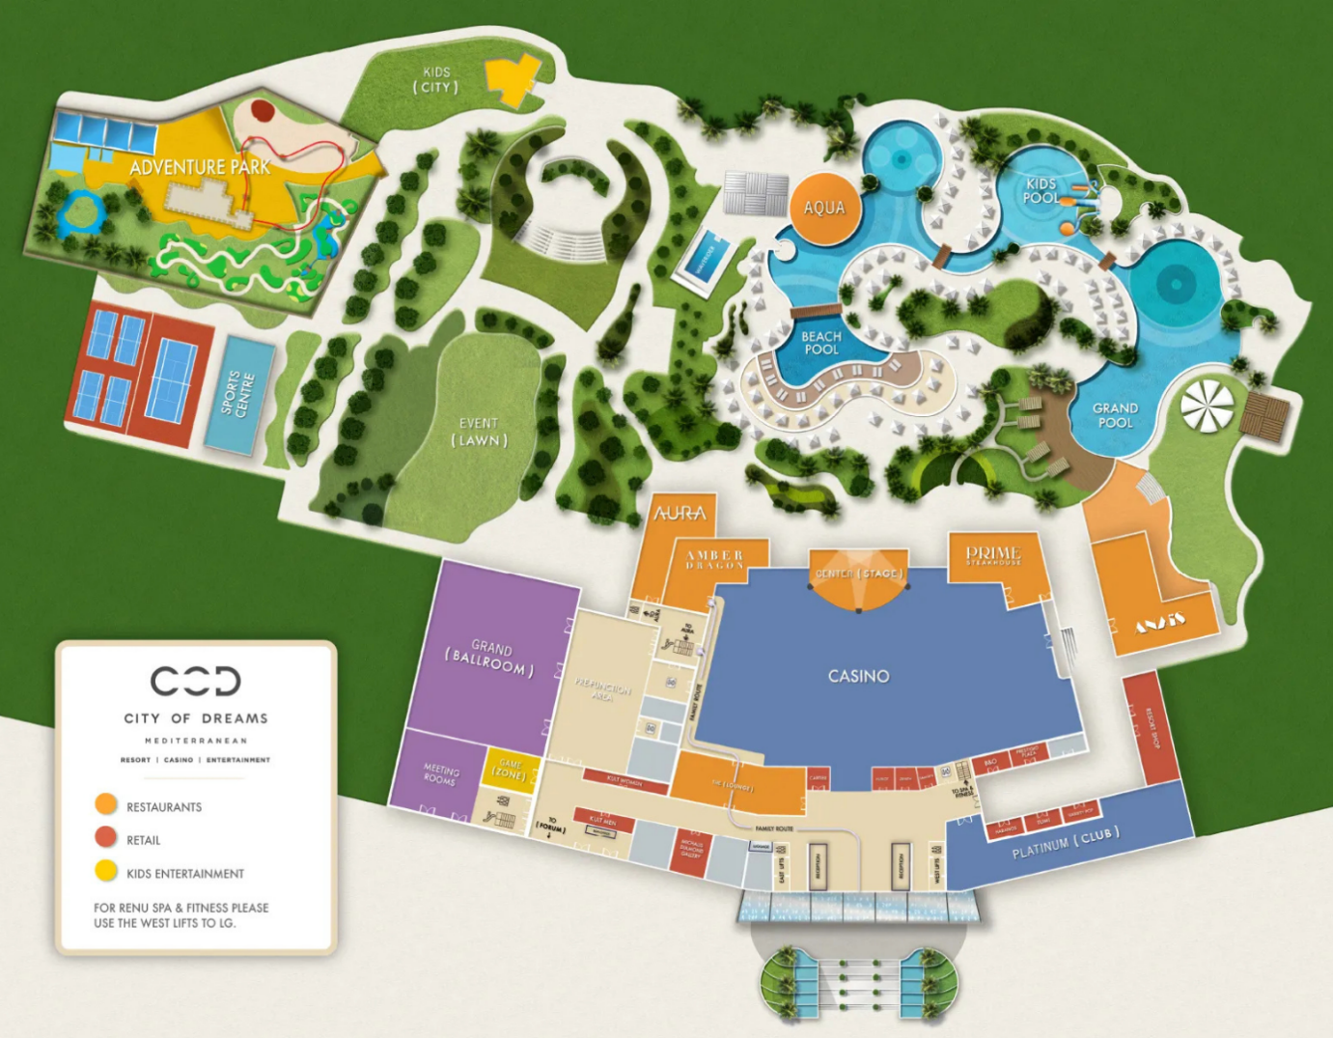

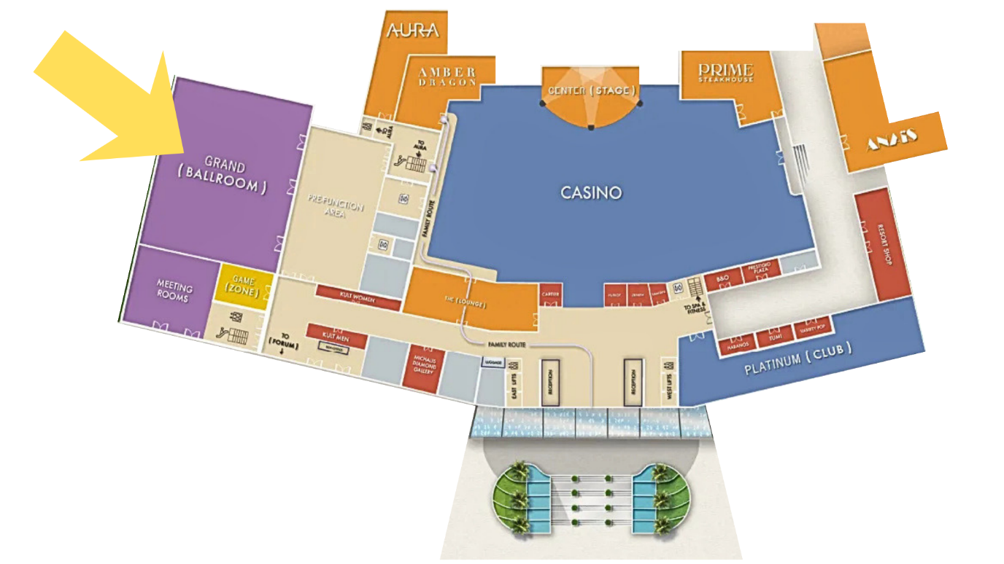
Figure 1. Yellow arrow indicates the Grand Room

10. Hotel Sustainability
City of Dreams Mediterranean received the “GOLD” position in the Best Sustainable Property category at the Cyprus Tourism 2023 Awards. The category included scoring against the following criteria: Sustainable Energy and Water Management, Renewable Energy Sources, Recycling, Waste management, and Environmental Footprint.
In 2024, the resort once again received the Gold Award, this time in the Sustainable Impact category at the Cyprus Tourism Awards 2024. For more information: Sustainability Strategy | City of Dreams Mediterranean

11. Activities at the Resort
Guests have access to several dining options, a spa and wellness area, and one of the island’s largest outdoor pool areas. The resort also includes a casino and hosts evening entertainment and cultural events.
We understand that this style of accommodation may differ from what some of our visitors are used to. Our choice was guided primarily by accessibility standards, availability, capacity, and logistical convenience for the group. We hope the facilities will provide a comfortable and practical setting for your stay.

12. Emergency Contacts
In case of any kind of emergency, dial the toll-free number 112.
C.C.D.O. designated two health and safety officers available 24/7.
There are no roaming charges for mobile phones within EU, but if you prefer, you can reach them via WhatsApp. Their names and contact details are:
Mrs Ioanna Maroulli: +35797754930
Mr Andy Papadopoulos: +35797722964
Below is a list of other emergency numbers.
Hospitals
Limassol General Hospital: +357 2580 5000 (very close to the venue)
Larnaca General Hospital: +357 2480 0300
Paphos General Hospital: +357 2680 3000
Tourist Police: 1460
Tourist information hotline: +357 2269 1111

For other questions related to the event, please reach out to Mary Peterson, EDF Events Officer, by email: mary.peterson@edf-feph.org.
For pressing issues, please contact by phone: +32 472 67 08 60.

