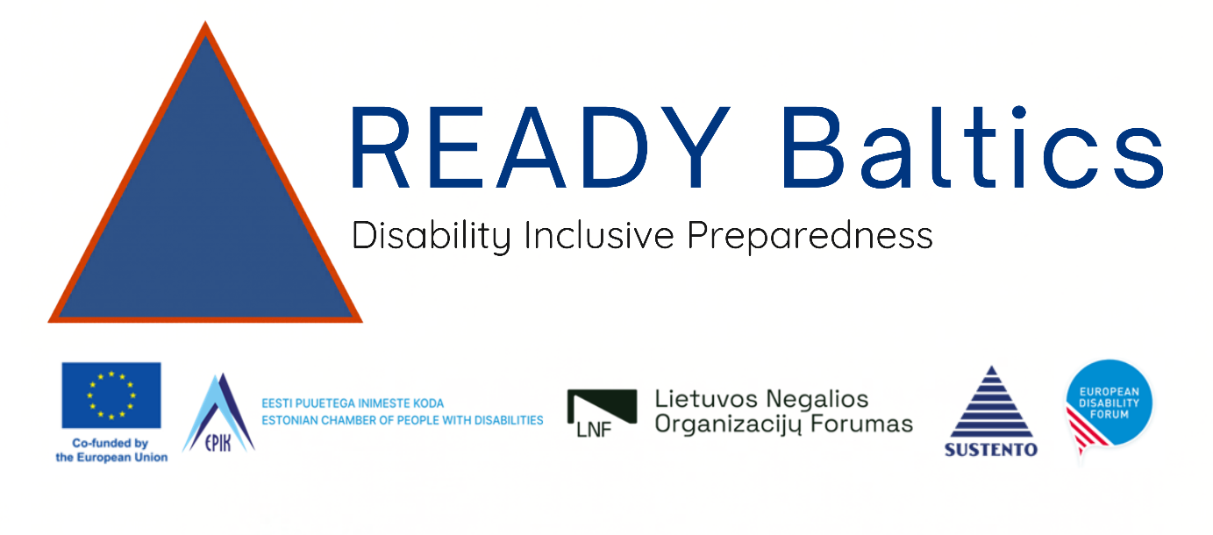

Training of Trainers on applying MCR2030 Scorecards Addendum for Persons with Disabilities

Wednesday, 15 April 2026 - 09h00-17h30

Thon Hotel EU Hotel, Rue De La Loi 75. Brussels

Background
As part of the READY BALTICS project — Building Resilience through Disability-inclusive Civil Protection and Disaster Risk Management in the Baltic Region — UNDRR will facilitate a Training of Trainers (ToT) on Disability Inclusion for the European Disability Forum (EDF) and its national partner organizations in Estonia, Latvia, and Lithuania. This one-day ToT is a strategic enabler of the project's broader capacity-building workstream, positioning EDF and its members to lead city-level engagements on disability-inclusive urban resilience across the three target countries.
Persons with disabilities are disproportionately affected by disasters: mortality rates during emergencies are two to four times higher than for persons without disabilities, and 91% lack a personal preparedness plan. Despite this, disability inclusion remains systematically underrepresented in disaster risk management (DRM) planning across the Baltic region and Europe more broadly. Significant gaps persist in policy, practice, and data — making the case for targeted, sustained capacity building.

Training Objectives
- Introduce the methodology and indicators of the MCR2030 Disaster Resilience Scorecard for Cities, including the Ten Essentials for Making Cities Resilient and the two crosscutting principles of participation and accessibility.
- Provide guidance on how to apply the Disability Inclusion Annex in urban resilience assessments, covering its 19 indicators, scoring methodology, and the process of translating results into context-specific action plans.
- Strengthen participants' understanding of disability-inclusive disaster risk reduction and participatory resilience planning, including how to meaningfully engage organisations of persons with disabilities (OPDs) and city stakeholders in the assessment process.
- Prepare national partners to facilitate city-level workshops and Scorecard implementation, equipping them with the facilitation skills, contextual knowledge, and practical confidence to lead or co-lead multi-stakeholder Scorecard workshops in their target cities.

Expected Outcomes
By the end of the ToT, participants will be able to:
- Explain the purpose, structure, and scoring methodology of the UNDRR Disaster Resilience Scorecard — Disability Inclusion Annex (Ten Essentials; 19 indicators; two crosscutting principles) to multi-stakeholder city audiences.
- Apply the Scorecard Annex indicators in a facilitated group self-assessment exercise, managing scoring discussions across diverse participants, including municipal officials, civil protection actors, and OPD representatives.
- Facilitate the transition from Scorecard assessment results to the development of context-specific, disability-inclusive urban resilience action recommendations.
- Engage organizations of persons with disabilities as meaningful co-participants in the Scorecard process, rather than as passive beneficiaries.
- Plan and prepare a city-level Scorecard workshop in their national context, including stakeholder mapping, tool localization, and co-facilitation arrangements.
- Sustain the capacities built through the ToT beyond the project timeline, serving as ongoing national/local anchors for disability-inclusive urban resilience planning.

Targeted Participants
- At least one national representative from each country
- At least one local/city representative from each targeted city

To be effective as future Scorecard facilitators, city-level participants should ideally have: a background in urban resilience, DRM strategic planning, or urban development; experience engaging with multi-stakeholder city networks; and the institutional standing to help anchor Scorecard findings in local policy and planning processes. Profiles from municipal DRM offices, urban planning departments, or social inclusion units are particularly well-suited.

Pre-requisites and other preparations
Participants are expected to have familiarity with the following frameworks and concepts:
- The Sendai Framework for Disaster Risk Reduction 2015–2030, including its four priorities and the principle of inclusive, all-of-society DRR. Participants should understand how disability inclusion relates to the Framework's targets and monitoring indicators.
- The Making Cities Resilient 2030 (MCR2030) initiative and its three-stage Resilience Roadmap, including the role of the Ten Essentials for Making Cities Resilient.

Please read the following: https://www.undrr.org/implementing-sendai-framework/what-sendai-framework

And here video: https://www.youtube.com/watch?v=s40zbXOxg1I

Main facilitators
- Andrew Bower, Country Support Manager, UNDRR ROECA
- Yigyeong Oh, DRR and Resilience Implementation Expert, UNDRR ROECA
- Phillipa Tucker, European Disability Forum

Workshop Language
English

Training Venue

Thon Hotel EU Hotel, Rue De La Loi 75. Brussels, Belgium

Required training materials
- Internet connection
- Projector and screen
- Flip chart and markers (1 set/table)
- Microphones (for speakers and 1 mic/table)

Organizers
- UNDRR Regional Office for Europe and Central Asia (link)
- European Disability Forum (link)

Time | Session
09:00-09:15 | Registration
09:15 – 09:30 | Welcome and opening  - Opening remarks  - Group photo
09:30 – 10:00 | - Introductory session  - Training overview, objectives, and agenda  - Getting to know each other
10:00 – 10:30 | - Disability inclusion in DRR  - Overview of the relevant global, regional frameworks  - Why disability inclusion matters in DRM and urban resilience (key data, Sendai Framework, EU Preparedness Union Strategy), 10:00-10:30
10:30-10:45 | Break
10:45- 12:00 | - Intro to the MCR2030 initiative and Urban Resilience, 10:45-11:05  - Disability inclusion case from Kazakhstan (Astana, Almaty) – online intervention from Kazakhstan, 11:05-11:25  - Tour de table – sharing the experience from each country/agency, 11:25-12:00
12:00 – 13:00 | Lunch
13:00 – 15:00 | - The Disaster Resilience Scorecard & Disability Inclusion Annex — Methodology and Indicators  - MCR2030 initiative and Urban Resilience  - Ten Essential for Making Cities Resilient  - Disaster Resilience Scorecard for Cities  - Introduction to the Annex for the Inclusion of Persons with disabilities (19 indicators)
15:00 – 15:15 | Break
15:15 – 16:15 | - Practical exercise: Using Disaster Resilience Scorecard for Cities – Annex for the Inclusion of Persons with disabilities
16:15 – 17:00 | - Practical exercise: Using Disaster Resilience Scorecard for Cities – Annex for the Inclusion of Persons with disabilities
17:00 – 17:30 | Closing  - Reflection, commitments and next steps

