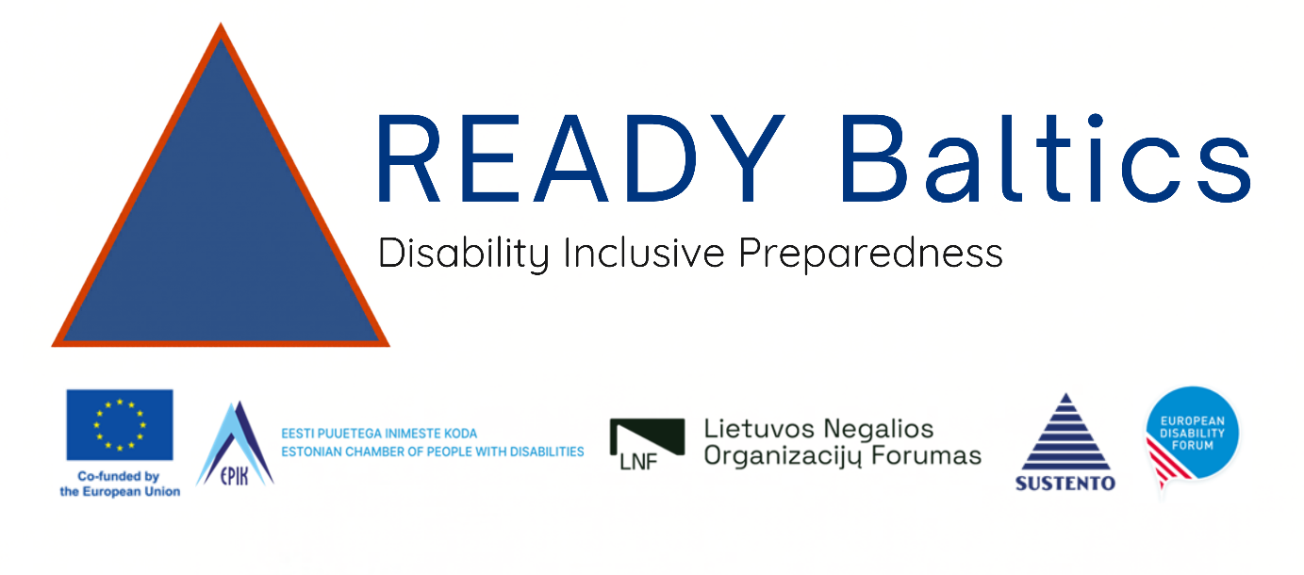

Stream 1

Finance and Admin with DG ECHO

Thursday 16 April – 09h00- 14h00

Mundo Madou, Av. des Arts 7/8, 1210 Bruxelles

Cosmos Room

DG ECHO allows only 2 in person participants. EDF will participate in person: Phillipa Tucker (Coordinator Central and Eastern Europe and Maja Denoyette (EDF Operations Manager).

For those that wish to join online, a Webex link is available in the original email documents: If you cannot locate, email Phillipa Tucker.

Stream 2

Learning and Planning

Thursday 16 April – 09h00- 14h00

Mundo Madou, Av. des Arts 7/8, 1210 Bruxelles

Cosmos Room

Background
As part of the READY BALTICS project — Building Resilience through Disability-inclusive Civil Protection and Disaster Risk Management in the Baltic Region — partners will spend a half day learning and planning the READY Baltics project during this kickoff meeting in Brussels.

Days Objectives
- Strengthen participants' understanding of disability rights
- Strengthen participants’ understanding of civil protection

Participants
- Colleagues from organizations of persons with disabilities
- Colleagues from civil protection authorities

Main facilitator
- Marion Steff, International Cooperation, EDF

Workshop Language
English

Venue

Mundo Madou, Av. des Arts 7/8, 1210 Bruxelles, Cosmos Room

Required training materials
- Internet connection
- Projector and screen

Provisional Agenda
Time | Session
09h00 – 09h20 | Registration and coffee
09h30 – 11h00 | First session (90 minutes)  Each speaker gets 10-15 minutes for presentation followed by 5-10 minutes discussion  - 09h30 - Good practice: Station 63 – Finland, Markku Salminen Zoom link  - 10h00 - Disability Inclusive Emergency Communications and EDF legislative work – Daniel Casas, Policy Expert Accessibility, EDF  - 10h20 - Inclusive Policy design in Estonia - Mari Puuram  - 10h40 - Discussion
11h00: | Coffee Break 15 minutes
11h15-12h45 | Second session (90 minutes)  - 11h15 - WHO Research TBC – Marion Steff  - 11h35 - Psycho-social disability - Marija Bocliarovaite  - 11h55 - Invisible disabilities - Diana Poder  - 12h15 - Discussion
12:45 – 13:30 | Lunch
13h30-14h00 | Closing  - Reflection, commitments and next steps  - KAP Survey for people who are leaving

