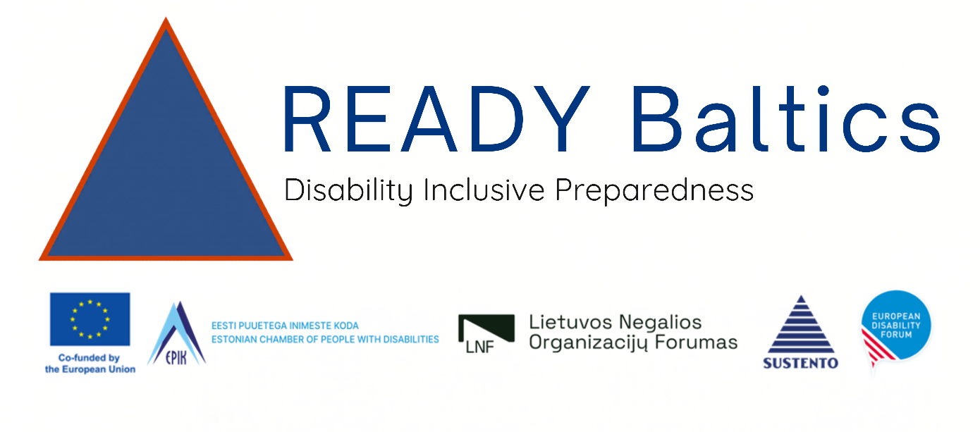

Day 3: Friday 17 April READY Baltics Implementing Partners Planning Workshop
The kick-off meeting will also include dedicated partners’ planning sessions, allowing partners to jointly refine the operational calendar, identify key national stakeholders, and coordinate preparations for upcoming activities such as national trainings, advocacy actions, and city-level workshops. The session will strengthen collaboration between organisations of persons with disabilities (OPDs), civil protection and disaster risk management (CP/DRM) authorities, and technical partners.
Overall, the meeting will establish the foundations for effective cooperation, ensure technical readiness for the project’s capacity-building activities, and support a coordinated regional approach to advancing disability-inclusive disaster risk management, especially on the use of the UNDRR Scorecard and on alignment with DG ECHO regulations and guidelines within EDF and our beneficiary partners, the OPDS in the Baltic states.
- 09h00-17h00
- Mundo Madou, Oxalis Room
- Finalise planning documents and ensure techncial readiness for project start

Time | Programme | Speaker/Facilitator
08h30 -09h00 | Participant Arrival and Registration Pre-workshop survey
09h00- 09h15 | Welcome and Opening  Day overview, objectives, and agenda | EDF
09h15-10h00 | Steering Committee Discussion  - decision-making procedures  - coordination routines  - monthly online coordination meetings  - bi-monthly progress reviews  two in-person meetings (kick-off + final meeting) | EDF
10h00- 12h30 | Discussions and finalisation of 3 documents  - Project Management Plan (PMP)  - roles and responsibilities  - workflows and coordination  - timeline and internal procedures  - Monitoring & Evaluation (M&E) Plan  - indicators and KPIs  - how progress will be tracked  - reporting and learning milestones  - Stakeholder Engagement & Communication Plan  - Our Goal  - Communication principles (inclusive, simple langauge, multi-lingual, transparency, visual identity, DG ECHO compliance)  - Mapping stakeholders and relevant info and channels  - Core messages and motto  - How to engage civil protection authorities, OPDs, etc.  - dissemination strategy  - communication responsibilities | EDF
12h30-13h30 | Lunch
13h30-15h00 | Kick off wrap-up and Reflections  - Discussion on next steps  - Workshop evaluation  - Photo  - Reflections from participants  - Closing | All

T1.1
Project initiation and setup
Establish an effective project management structure by setting up operational arrangements and formalising coordination through a written consortium agreement among the partners. Provide induction to relevant project staff on Granting Authority reporting requirements, financial management procedures, and compliance standards. Organise a joint project kick-off and work planning workshop, and finalise key project tools, including the (1) Project Management, (2) M&E, and (3) Stakeholder Engagement, Communications and Dissemination Plans. These actions will ensure a shared understanding of responsibilities, consistent project oversight, and a strong foundation for collaborative implementation.
Expected result: A fully operational and well-coordinated project team, equipped with clear procedures and shared tools to manage, monitor, and communicate project activities effectively.

T1.2
Formalisation of stakeholder partnerships and collaboration frameworks
Formalise key stakeholder partnerships and through the development and signing of Memoranda of Understanding (MoUs), grant agreements, and collaboration frameworks. This process will define roles, responsibilities, shared objectives, and planned activities to support inclusive disaster preparedness and response.
Expected result: Established stakeholder partnerships with clearly defined roles and collaboration mechanisms, enabling coordinated implementation and stronger engagement of national actors throughout the project.

