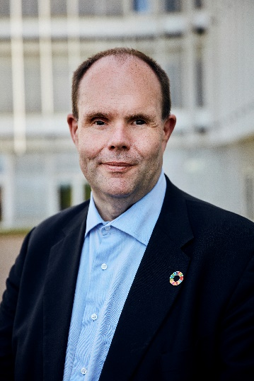
Thorkild Olesen, DPOD
Statement

We stand stronger together

Short presentation

Thorkild Olesen was born in 1970 in Denmark. From his birth, Thorkild was diagnosed with glaucoma. This means that he has been visually impaired since birth, but at the age of 21 years lost his sight completely. Thorkild has a master’s degree in history with a minor in religion from the University of Aarhus.

Thorkild’s career in the disability movement is long and rich. In 1993 he became the chair of the youth organisation of the Danish Association of the Blind. Later he became head of department, vice-chair, and 2009-2021 he was elected as president of the organisation. In 2011 he was also elected as vice-chair of Disabled People’s Organisations Denmark (DPOD) and in 2014 he became chair of the organisation.

Beside his work as chair of the Disabled People’s Organisations Denmark, Thorkild is a member of numerous boards within the disability area.

Date and place of birth

30 July 1970, Ringkøbing, Denmark.

Working languages

Danish and English.

Present position/function

- Since 2014 chair of the Disabled People’s Organisations Denmark (DPOD) – the umbrella organisation of the 38 democratic and national disability organisations in Denmark (representing all persons of all ages and genders with a specific functional impairments such as polio, autism, deafness, cerebral palsy or mental disorder)
- Since 2026 - board member of the Danish Institute of Human Rights

- Since 2010 member of and vice-chair of the Danish Disability Council (advises the Government on disability issues), appointed by the Minister of social affairs

- Since 2015 board member of the European Disability Forum (An umbrella organisation of persons with disabilities that promotes and defends the interests of over 100 million persons with disabilities in Europe).

- Since 2022 chair of The Independent Counseling Organisation for Persons with Disabilities (DUKH)

- Since 2022 member of strategic forum at the National Board of Social Services (advising the director of the board on development in the social area)

Principal tasks

As chair of the Disabled People’s Organisations Denmark:

- Represents the Danish disability movement locally, regionally, nationally and at European and international level in the disability policy areas where the various disability organisations have shared interests.

- Holds primary responsibility for the development of the disability organisations’ common political and organisational prioritisation, including understanding and implementation of human rights in the disability area.

- Is in charge of the dialogue with, among others, politicians, public officials, the Danish Institute for Human Rights, the media, educational institutions and other collaborators at all levels.

- Provides advice regarding issues in the disability area.

Educational background

- Master’s degree in history with a minor in religion, Aarhus University, 2005

Other relevant main activities

- 2011-2014 Vice-chair of Disabled People’s Organisations Denmark (DPOD)

- 2015-2016 Chair of the World Braille Council.

- 2013 Participant in the Danish delegation at the 68 UN General Assembly, New York

- 2009-2018 Chair at the National Institute for Blind and Partially Sighted Persons
- 2007- 2011 Member the Committee for Equal Treatment under The Danish Institute for Human Rights. The committee focuses on elimination of discrimination.

- 2007- 2014 Chair of the Executive Committee of ‘Blindes Arbejde’ (a business fund and production company employing blind and partially sighted persons)

- 2007-2009 Vice-president of the Danish Association of the Blind

