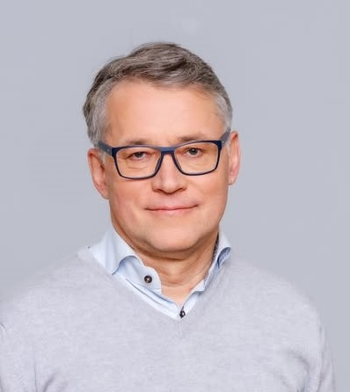
Meelis Joost - Chairman of the Board at Estonian Chamber of People with Disabilities EPIK
I have been involved in the movement of people with disabilities and chronicle disease patients since about 2000. My field of activity has been to strengthen the national umbrella organization with currently 55 member organizations and growing, supporting cross-border cooperation and work at EU and international level.
Estonian Chamber of People with Disabilities is member of European Disability Forum since 2001, first observer member, since 2004 when Estonian became member of EU, we continued as full member. I’m board member of Estonian Agrenska Foundation, an Estonian-Swedish permanent cross-border foundation to assist families with children with disabilities, with diminishing burden of care, provide peer counselling for rare diseases, advocate for rights to be fully included in the society.
I m member of European Economic and Social Committee, an advisory body to the European parliament and European Commission. I as well have been very hands on with the UN Convention on the right of people with disabilities, having been involved with the shadow report drafting for Estonia-s state review. Next report is due in 2026, where we are going to contribute as well.
I have been leading many cross-border cooperation projects, also with EDF as partner. Of recent ones EPIK participated at DREE - Disability Rights in the European Elections and currently we are finalizing Erasmus+ project Digital for all - Innovation for digital skills education for disadvantaged groups in Europe. The aim of the initiative is to highlight peer support for improving digital skills for people with disabilities, across EU and specific knowledge on accessible solutions for various groups. Currently European DG ECHO funded project for all the Baltic states, with EDF as lead partner is operational. The aim is to make the Baltic States disability movement and crisis preparedness authorities more knowledgeable about disability inclusive crisis preparedness.
In my capacity as Chairman of the Board for EPIK, the most important task is to keep our network active, capable of conducting high quality advocacy and be backed up with public support, which is a challenge in our crises-ridden societies. The ever deteriorating security situation in Europe and worldwide is keeping decision makers neglecting the most vulnerable, that we together with EDF membership and activists need to stop.
My long-term involvement in the disability movement at national and EU level, experience with projects and cross-border cooperation, good knowledge of UN CRPD and European legislation would be a strength with which to contribute to the work in EDF board and executive committee. I have been board member of EDF since June 2025 and have been keeping up with contributing, when contribution has been needed.

