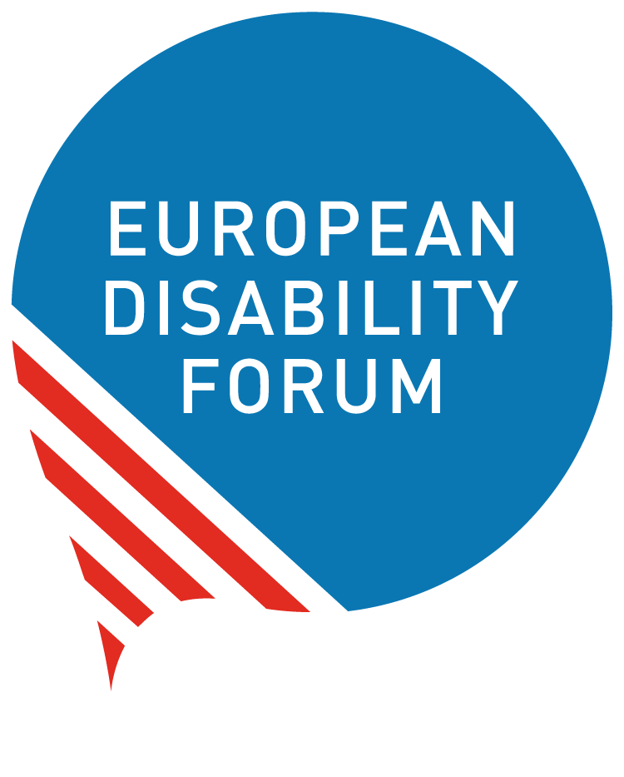

Supporting persons with disabilities in the Performance Framework and Horizontal Principles
  - European Disability Forum Position Paper
  - By Haydn Hammersley | February 2026
Positions and Amendments for the EU Multiannual Financial Framework 2028-2034
 | Views and opinions expressed are however those of the author(s) only and do not necessarily reflect those of the European Union or the European Commission’s CERV Programme. Neither the European Union nor the granting authority can be held responsible for them.

Table of Contents
Table of Contents 2
The European Disability Forum 2
Introduction 2
Summary 3
Amendments 3
Positive elements we want to preserve 6
Annex 7
Amendments 7
Positive elements we want to preserve 24
Document credits 27

The European Disability Forum
The European Disability Forum is an independent NGO that represents the interests of 100 million Europeans with disabilities. EDF is a unique platform which brings together representative organisation of persons with disabilities from across Europe. EDF is run by persons with disabilities and their families. We are a strong, united voice of persons with disabilities in Europe.

Introduction
This position paper refers to the EU draft regulation with the official title ‘Regulation establishing a budget expenditure tracking and performance framework and other horizontal rules for the Union programmes and activities’ for the period 2028 to 2034.
The Regulation does not refer to one single fund. It is overarching and sets out rules for different funding strands. This is particularly the case because of the creation of a new set of ‘horizontal principles’ which are rules that should be followed in the use of all EU funding. It replaces what was previously known as the ‘Common Provisions Regulation’. In its annex, it proposes how exactly to track the way funding us being used in the Member States.
Here we present our proposals for amendments to the draft regulation that was released by the European Commission on July 16 2025. With our amendments we aim to strengthen the provisions ensuring that funding goes towards further including persons with disabilities and ensuring accessibility in all areas of life, in line with the UN Convention on the Rights of Persons with Disabilities.

Summary
The European Disability Forum is proposing the following key amendments to support the rights of persons with disabilities:
- Integrating the United Nations Convention on the Rights of Persons with Disabilities into the Horizontal principles. This will give greater clarity to the Member States when drawing up the NRPPs regarding their legal obligations to abide by the Convention and will avoid steps back in protecting disability rights compared to the regulations for the current MFF.
- Bringing clarity on how to invest in inclusion and prevent segregation by clarifying how social funding should be used to promote independent living and inclusion in the community, particularly for persons with disabilities. Bringing attention to the Commission Guidance Notice on Independent Living and Inclusion in the Community for Persons with Disabilities, for the benefit of Member States when drawing up their National and Regional Partnership Plans, and for the National Managing Authorities, and thus reducing cases of misuse of EU funds.
- Indicators that can measure the impact of EU funding on persons with disabilities: adjusting a number of the proposed measuring indicators will better allow us to understand how EU funding has been used to support the EU’s 100 million persons with disabilities. In addition, a number of new indicators should be included that guide the Member States to invest in actions that will really make a positive difference to the lives of persons with disabilities.

Amendments

Article 6
Social policies
Title amendment: Human rights and social policies
Original | Amendment
1. The contribution from the budget to social policies within the Union shall be monitored by means of the budget expenditure tracking and performance framework laid down in Article 8, including by means of EU coefficients.  2. Programmes and activities shall, where feasible and appropriate in accordance with the relevant sector-specific rules, be implemented to achieve their set objectives respecting working and employment conditions under applicable national law, Union law, ILO conventions and collective agreements in accordance with Article 33(2), point (e), of Regulation (EU, Euratom) 2024/2509. | 1. The contribution from the budget to social policies within the Union shall be monitored by means of the budget expenditure tracking and performance framework laid down in Article 8, including by means of EU coefficients.  2. Programmes and activities shall, where feasible and appropriate in accordance with the relevant sector-specific rules, be implemented to achieve their set objectives respecting working and employment conditions under applicable national law, Union law, ILO conventions and collective agreements in accordance with Article 33(2), point (e), of Regulation (EU, Euratom) 2024/2509.  3. Programmes and activities shall, where applicable, demonstrate adherence to international human rights treaties and conventions to which the EU is a state party. There shall be proven respect of the EU Charter of Fundamental Rights. No activity shall be funded that runs counter to the EU and Member States’ obligations under the UN Convention on the Rights of Persons with Disabilities, as states parties.
Justification: The loss of proven respect for human rights as part of the horizontal conditions for the use of EU funds will only worsen the number of complaints against the EU for funding that breaches human rights conventions. This point needs to be more specific and present in this regulation than it was even in the Common Provisions Regulation for the previous MFF.

The UN Committee on the Rights of Persons with Disabilities, in its Concluding Observations to the EU in 2025, called for stronger controls to prevent EU funds going towards segregating settings for persons with disabilities. Compliance with the CRPD therefore needs to be explicitly mentioned here in order to address this.

Recital 10
Original | Amendment
The Charter of Fundamental Rights of the European Union prohibits discrimination on the grounds of disability and guarantees the right of persons with disabilities to independence, social and occupational integration, and participation in community life. Moreover, the Union is party to the UN Convention on the Rights of Persons with Disabilities, which requires that the protection and promotion of the human rights of persons with disabilities is taken into account in all policies and programmes. The budget should therefore ensure the effective promotion of the rights of persons with disabilities and their equal opportunities as well as aim to remove any inequalities, where feasible and appropriate. In particular, programmes and activities should aim to ensure accessibility for persons with disabilities in all infrastructures, products and services, including in the built environment, in transport and in information and communication also concerning information and communication technologies. They should also aim to support independent living and promote the transition from residential or institutional care to family and community-based services and support. | The Charter of Fundamental Rights of the European Union prohibits discrimination on the grounds of disability and guarantees the right of persons with disabilities to independence, social and occupational integration, and participation in community life. Moreover, the Union is party to the UN Convention on the Rights of Persons with Disabilities, which requires that the protection and promotion of the human rights of persons with disabilities is taken into account in all policies and programmes. The budget should therefore ensure the effective promotion of the rights of persons with disabilities and their equal opportunities as well as aim to remove any inequalities and forms of segregation, where feasible and appropriate. In particular, programmes and activities should aim to ensure accessibility for persons with disabilities in all infrastructures, products and services, including in the built environment, in transport and in information and communication also concerning information and communication technologies in accordance with EU harmonised accessibility requirements. They should also aim to support independent living and promote the transition from residential or institutional care to family and community-based services and support in line with the Commission’s Guidance on Independent Living and Inclusion in the Community for persons with disabilities. As such, EU funding shall not go towards building or renovating segregating institutions for persons with disabilities.
Justification: One of the most common complaints about the use of funds going against the UN Convention on the Rights of Persons with Disabilities, is funding going towards building or renovating segregated institutions for persons with disabilities, rather than going towards support systems and personal assistance in the community.

Since it was so frequently the source of complaints in the current MFF, it needs to be better clarified in the text of this regulation.

Positive elements we want to preserve

Recital 7
On 17 November 2017, the European Pillar of Social Rights was jointly proclaimed by the European Parliament, the Council and the Commission as a response to social challenges in Europe and to ensure no one is left behind. A system should be put in place to ensure a systematic and transparent monitoring of the contribution from the budget towards those social objectives within the Union. It is important in particular to promote social rights and fair working and labour conditions, in line with the European Pillar of Social Rights and in accordance with Article 9 TFEU and Article 33(2), point (e), of Regulation (EU, Euratom) 2024/2509, which lays down the requirement for programmes and activities to be implemented, where feasible and appropriate, respecting working and employment conditions under applicable national law, Union law, International Labour Organization conventions and collective agreements.

Article 6
Social policies

Paragraph 2
Programmes and activities shall, where feasible and appropriate in accordance with the relevant sector-specific rules, be implemented to achieve their set objectives respecting working and employment conditions under applicable national law, Union law, ILO conventions and collective agreements in accordance with Article 33(2), point (e), of Regulation (EU, Euratom) 2024/2509.

Annex

Amendments

Indicator 72 A [New]
Policy area (level 1) | Policy area (level 2) | # | Intervention field | CCM | CCA | ENV | SOC | Output indicator | Result indicator
Business support | Inclusive employment | 72A [New] | Specific actions to support employers in targeted initiatives and workplace adaptations to employ and support workers with disabilities | 0% | 0% | 0% | 100% | - Number of employers supported  - Number of employees with disabilities supported into employment | - Number of jobs created and sustained – by disability and gender

Indicator 91
Policy area (level 1) | Policy area (level 2) | # | Intervention field | CCM | CCA | ENV | SOC | Output indicator | Result indicator
Culture, tourism and media | Media | 91 | Media and entertainment: support creation, circulation and access to audiovisual works | 0% | 0% | 0% | 20% | - Number of enterprises supported – by micro, small & medium, large;  - Number of audiovisual works supported for creation and for distribution/promotion;  - Number of cinemas, film festivals and markets supported;  - Number of supported audiovisual works in lesser-used languages;  - Number of supported audiovisual works containing subtitles for hard of hearing people and/or sign language  - Number of co-production supported; | - Number of works supported for development that are released within 4 years after being given support;  - Number of video games supported for development that are released;  - Number of jobs sustained or created in enterprises supported – by gender;

Indicator 91A [New]
Policy area (level 1) | Policy area (level 2) | # | Intervention field | CCM | CCA | ENV | SOC | Output indicator | Result indicator
Culture, tourism and media | Media | 91A [New] | Representation of marginalised groups in the media | 0% | 0% | 0% | 100% | - Number of audiovisual works that mainstream representation of marginalised groups  - Number of actors / presenters / writers / directors from a marginalised background | - Number of works produced that enhance representation of marginalised groups in the media – by disability, ethnic background, LGBTQI community.

Indicator 94A [New]
Policy area (level 1) | Policy area (level 2) | # | Intervention field | CCM | CCA | ENV | SOC | Output indicator | Result indicator
Culture, tourism and media | Tourism | 94A [New] | Tourism financial support accessible tourism | 40% | 40% | 40% | 40% | - Number of Destination Management Organisations supported in investing in improving the accessibility of public tourism assets and services for persons with disabilities;  - Number of tourist accommodation places made accessible for persons with disabilities | - Number of tourist sites that have undergone improvements in accessibility for visitors with disabilities  - Number of accessible tourist accommodations reacted – by capacity for number of visitors with disabilities  - Number of visitors with disabilities accessing these sites

Indicator 129
Policy area (level 1) | Policy area (level 2) | # | Intervention field | CCM | CCA | ENV | SOC | Output indicator | Result indicator
Education and skills | Skills | 129 | Basic digital skills | 0% | 0% | 0% | 100% | - Number of participants – by gender, by disability status, by labour market status, by age, and by education level;  - Number of organisations involved in transnational cooperation activities; | - Number of participants gaining a qualification or self reported skills improvement – by gender and disability status;  - Number of organisations benefitting from their participation in cross-border cooperation activities;  - Number of participants who have reached at least a basic level of digital skills according to the ESTAT’s DSI definition – by gender and disability status;

Indicator 217 / 218 / 219
Policy area (level 1) | Policy area (level 2) | # | Intervention field | CCM | CCA | ENV | SOC | Output indicator | Result indicator
Energy | Energy efficiency | 217 | Other social infrastructures (including pre-school and care centres, excluding segregated residential institutions for persons with disabilities) – Deep renovation*, including climate resilience measures | 100% | 100% | 40% | 40% | m² renovated and number of places improved – by types of pre-schools, care facilities, other; | - Annual GHG emissions avoided in tCO₂e;  - MWh of energy savings;  - Average kWh/m² primary energy (before-after);  - Number of annual users of modernised facilities – by types: pre-schools, care facilities, other – by gender;  - Value of assets and / or Population benefitting from climate resilience measures;
Energy | Energy efficiency | 218 | Other social infrastructures (including pre-school and care centres, excluding segregated residential institutions for persons with disabilities) – Medium renovation*, including climate resilience measures | 100% | 40% | 40% | 40% | m² renovated and number of places improved – by types: pre-schools, care facilities, other; | - Annual GHG emissions avoided in tCO₂e;  - MWh of energy savings;  - Average kWh/m² primary energy (before-after);  - Number of annual users of new or modernised facilities – by types: pre-schools, care facilities, others;  - Value of assets and / or Population benefitting from climate resilience measures;
Energy | Energy efficiency | 219 | Other social infrastructures (including pre-school and care centres, excluding segregated residential institutions for persons with disabilities) – Light renovation* | 40% | 0% | 0% | 40% | m² renovated and number of places improved – by types: pre-schools, care facilities, other; | - Annual GHG emissions avoided in tCO₂e;  - MWh of energy savings;  - Average kWh/m² primary energy (before-after);  - Number of annual users of modernised facilities – by types: pre-schools, care facilities, other – by gender;  - Value of assets and / or Population benefitting from climate resilience measures;

Indicator 317A [New]
Policy area (level 1) | Policy area (level 2) | # | Intervention field | CCM | CCA | ENV | SOC | Output indicator | Result indicator
Housing and infrastructure | Accessible housing for persons with disabilities and older people | 317 A  [New] | Creation of affordable and accessible housing in the community | 0% | 0% | 0% | 100% | - m² of accessible and affordable housing constructed;  - m² of existing housing retrofitted to provide accessibility | - number of users – by gender, disability, age and level of income

Indicator 353 A [New]
Policy area (level 1) | Policy area (level 2) | # | Intervention field | CCM | CCA | ENV | SOC | Output indicator | Result indicator
Research and innovation | Digital | 353 A  [New] | New emerging assistive technologies for persons with disabilities | 0% | 0% | 0% | 100% | Same as existing ones for all actions under “Research and innovation” | Same as existing ones for all actions under “Research and innovation”

Indicator 419
Policy area (level 1) | Policy area (level 2) | # | Intervention field | CCM | CCA | ENV | SOC | Output indicator | Result indicator
Rights, equality and justice | Democracy and rights | 419 | Ending violence against women and girls and other groups at risk and measures to support victims and survivors of gender-based violence* | 0% | 0% | 0% | 100% | - Number of civil society organisations reached by support and capacity building activities;  Number of measures to support services for victims of gender violence (e.g., number of shelter places, of rape crisis centre and of counselling centres); | Number of people reached by activities – by gender and disability status;

Indicator 481
Policy area (level 1) | Policy area (level 2) | # | Intervention field | CCM | CCA | ENV | SOC | Output indicator | Result indicator
Social | Social inclusion | 481 | Long-term care, including the delivery of family and community-based care services (excluding infrastructure)* | 0% | 0% | 0% | 100% | Number of new or improved services implemented;  Number of institutional care facilities closed down; | Number of people benefitting – by gender and disability status;

Indicator 481A [New]
Policy area (level 1) | Policy area (level 2) | # | Intervention field | CCM | CCA | ENV | SOC | Output indicator | Result indicator
Social | Social inclusion | 481A  [New] | Transition from institutional care to community-based services and independent living | 0% | 0% | 0% | 100% | - Number of people moving from institutional care to community-based services;  - Number of people supported to find personal assistance;  - Number of places in institutions reduced. | Number of people benefitting – by gender and disability status;

Indicator 493
Policy area (level 1) |  | Policy area (level 2) | # | Intervention field | CCM | CCA | ENV | SOC | Output indicator | Result indicator
Transport | Air transport | Other airport infrastructure (e.g. runways, CNS equipment) | 493 | 0% | 40% | 0% | 0% | 40% | - Additional airport flight handling capacity (number of passengers);  - Number of additional aircraft movements capacity;  Number of flights benefitting from modernised CNS capacities;  - number of projects aimed at improving accessibility of persons with disabilities

Indicator 509
Policy area (level 1) | Policy area (level 2) | # | Intervention field | CCM | CCA | ENV | SOC | Output indicator | Result indicator
Transport | Inland waterway transport | 509 | New and retrofitted vessels adapted to low water levels in inland waterways | 0% | 100% | 0% | 40% | - Number of vessels by type;  - Number of vessels made accessible to persons with disabilities | - Annual number of passengers using the infrastructure;

Indicator 514
Policy area (level 1) | Policy area (level 2) | # | Intervention field | CCM | CCA | ENV | SOC | Output indicator | Result indicator
Transport | Multimodal | 514 | Multimodal transport | 40% | 0% | 40% | 40% | - Number of new or modernised intermodal/multimodal connections, including hubs and terminals;  - number of hubs that are accessible to persons with disabilities;  - number of single points of contact for assistance in multimodal passenger hubs;  - Number of intermodal/multimodal projects completed; | - Annual number of passengers or freight tonnage using the infrastructure;  - Annual number of passengers or freight tonnage using the new intermodal/multimodal services;  - Annual GHG emissions avoided in tCO₂e;

Indicator 523
Policy area (level 1) | Policy area (level 2) | # | Intervention field | CCM | CCA | ENV | SOC | Output indicator | Result indicator
Transport | Rail transport | 523 | Railway station or terminal capacity | 100% | 40% | 40% | 40% | - Additional railway station/terminal capacity (passengers) (– by TEN-T/not TEN-T);  - Additional railway station capacity (cargo) (– by TEN-T/not TEN-T);  - Number of railway terminals built;  - Number of railway stations made accessible for persons with disabilities. | - Annual number of passengers using the infrastructure;  - Time savings due to improved rail infrastructure (in hours);  - Pollutant reduction in tonnes (PM2.5 and NOx);

Indicator 526
Policy area (level 1) | Policy area (level 2) | # | Intervention field | CCM | CCA | ENV | SOC | Output indicator | Result indicator
Transport | Road transport | 526 | Recharging and refuelling infrastructure enabling low- or zero-emission transport for busses/trucks/coaches/cars/vans | 100% | 40% | 40% | 40% | - Number of refuelling and recharging stations (– by TEN-T/not TEN-T) by fuel type;  - Output (kgH2/day or MWh/day) of refuelling/recharging stations (– by TEN-T/not TEN-T) by fuel type  - Number of stations that are accessible to persons with disabilities | - Annual GHG emissions avoided in tCO₂e;  - Volume of fuels distributed through the refuelling/recharging stations;

Indicator 543
Policy area (level 1) | Policy area (level 2) | # | Intervention field | CCM | CCA | ENV | SOC | Output indicator | Result indicator
Transport | Urban transport | 543 | Urban planning for transport | 40% | 40% | 40% | 40% | - Number of strategies for integrated territorial development supported;  - Number of integrated projects for territorial development;  - Number of actions improving accessibility for persons with disabilities | - Population covered by projects in the framework of strategies for integrated territorial development;

Positive elements we want to preserve

Indicator 116
Education and skills | Education | 116 | Improving access of people with disabilities to inclusive education | 0% | 0% | 0% | 100% | - Number of participants – by gender and by age; | - Number of participants in education or trainings – by gender;

Education and skills | Skills | 133 | Up-skilling and re-skilling for persons with disabilities | 0% | 0% | 0% | 100% | - Number of participants – by gender, by labour market status, by age, and by education level;  Number of organisations involved in transnational cooperation activities | - Number of participants gaining a qualification or self reported skills improvement – by gender;  Number of organisations benefitting from their participation in cross-border cooperation activities;

Indicator 205
Energy | Energy efficiency | 205 | Deep renovation of buildings for social housing, including climate resilience measures | 100% | 100% | 40% | 40% | m² renovated and Number of social housing units renovated or added; | - Annual GHG emissions avoided in tCO₂e;  - Pollutant reduction (PM2.5 and NOx)  - MWh of energy savings;  - Average kWh/m² primary energy (before-after);  - Number of annual users – by gender;  Value of assets and / or Population benefitting from climate resilience measures;

Indicator 424
Rights, equality and justice | Democracy and rights | 424 | Support to civil society organisations | 0% | 0% | 0% | 40% | - Number of civil society organisations supported;

Indicator 445
Social | Employment and labour market | 445 | Improving access of people with disabilities to employment | 0% | 0% | 0% | 100% | - Number of participants – by gender, by labour market status, by age and by level of education; | - Number of participants – by status after participating (gaining a qualification, engaged in job searching, in education or training, in employment) and by gender;

Indicator 478
Social | Social inclusion | 478 | Measures for the social inclusion and access to quality services for people with disabilities | 0% | 0% | 0% | 100% | - Number of participants – by gender, by labour market status, by age and by level of education; | - Number of participants – by status after participating (gaining a qualification, engaged in job searching, in education or training, in employment) and by gender;

Document credits
This document was prepared by Haydn Hammersley
Assisted/Supervised by Alejandro Moledo
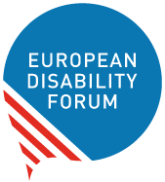
The European Disability Forum
Mundo Madou
Avenue des Arts 7-8
1210 Brussels, Belgium.
www.edf-feph.org
info@edf-feph.org


Views and opinions expressed are however those of the author(s) only and do not necessarily reflect those of the European Union or the European Commission’s CERV Programme. Neither the European Union nor the granting authority can be held responsible for them.

