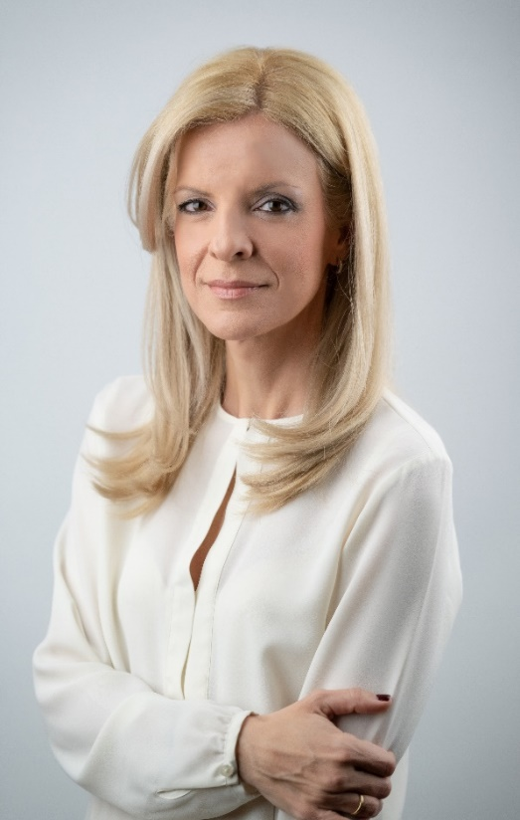
Mrs. Themida Anthopoulou – Chairperson

Mrs. Themida Anthopoulou is the Chairperson of the Cyprus Confederation of Disability Organizations (CCDO / KYSOA), the State’s officially recognized social partner on disability matters in Cyprus and the umbrella body representing the disability movement nationwide.
Born in Athens in 1978, with family roots in both Athens and the occupied city of Famagusta, she currently resides in Limassol. She is married and the mother of two children, aged 18 and 4. She studied Media and Management at the University of Leeds and began her professional career at the Cyprus Broadcasting Corporation (CyBC), where she presented two daily economic programmes.

She subsequently served as Communications Advisor at the Cyprus Stock Exchange. In 2003, following the election of President Tassos Papadopoulos, she was appointed Special Associate to the President of the Republic of Cyprus and Head of the Office of the First Lady, Mrs. Fotini Papadopoulou. Mrs. Anthopoulou later held senior positions in communication and strategic development, serving as Marketing and Brand Manager at Antenna Broadcasting and subsequently leading Public Relations at the A.G. Leventis Gallery.

In 2015, following a workplace accident that resulted in a severe mobility disability, her professional and personal trajectory took a decisive turn. Transforming personal experience into purpose, she dedicated herself to advancing the rights, dignity, and full inclusion of people with disabilities.

With more than two decades of public engagement and leadership, she has become a leading advocate for disability rights in Cyprus. She serves as Secretary General of the Pancyprian Organization for the Rehabilitation of the Disabled (POAA) and is widely recognized for her dynamic advocacy in promoting equality, accessibility, and meaningful participation in all areas of public life for every person with disability. She is also a committed advocate for the rights and empowerment of women and children with disabilities, highlighting the need for inclusive policies and stronger protections against discrimination and exclusion.

Since September 2024, she has served as Chairperson of the Cyprus Confederation of Disability Organizations. In this capacity, she actively contributes to national policy development and legislative reform, advocating for inclusive education, legal capacity, accessibility, and the full implementation of international human rights standards for people with disabilities.

Through her work, she continues to promote a society where diversity is valued, barriers are removed, and every person has the opportunity to participate fully and equally in public life.

