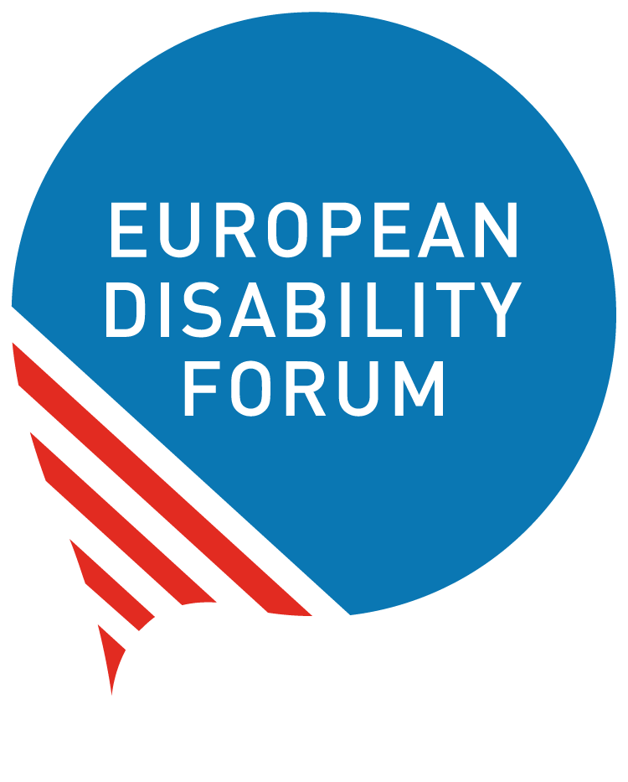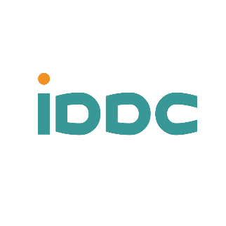

Global Europe Instrument Negotiation Briefing

Delivering on Disability Rights in the Global Europe Instrument
  - Input by the European Disability Forum (EDF) and the International Disability and Development Consortium (IDDC)
As the European Union (EU) prepares the next generation of its external financing architecture under the Multiannual Financial Framework (MFF) 2028–2034, the Global Europe Instrument (GEI) must ensure that increased scale and geopolitical focus do not come at the expense of human rights and social inclusion, including disability rights.
The current proposal (COM(2025) 551) risks falling short of the EU’s legal and political commitments. While the UN Convention on the Rights of Persons with Disabilities (CRPD) is referenced in Recital 48, it is not included in the GEI Regulation’s Articles and therefore does not create a binding legal obligation within the Instrument.
This is particularly concerning in light of the CRPD Committee’s 2025 Concluding Observations to the EU, which call on the EU to ensure that in the next MFF its external financing instrument is fully aligned and compatible with the Convention, promotes disability inclusion and has an intersectional approach (para. 75b).

Legal and Policy Coherence
This matters because the EU and its Member States are all State Parties to the CRPD.
External financing instruments must therefore be fully consistent with these obligations. Without explicit reference to the CRPD in the Articles, there is a risk that disability inclusion is treated as a policy preference rather than a legal requirement.
Without binding provisions:
- Disability inclusion risks being applied inconsistently across programmes.
- Civil society organisations, including organisations of persons with disabilities (OPDs), may face reduced access to funding and participation.
- There is a risk that EU funding supports approaches that are not fully aligned with accessibility, inclusion and community-based approaches and independent living principles.

What Needs to Change
- A binding reference to the CRPD within the Regulation’s Articles.
- A consistent, rights-based approach across objectives, implementation and monitoring of the Instrument.
- Predictable, accessible and dedicated funding for civil society, including OPDs.
- Meaningful participation of civil society, including OPDs, throughout the programme cycle.
- A twin-track approach combining mainstreaming with targeted measures on disability inclusion.
- Clear safeguards to ensure accessibility and inclusion, prevent harm, and promote community-based approaches.

Rationale

Enshrine a Binding Disability Rights-Based Approach (Recital 16; Article 9(4))
The current proposal for the Global Europe Instrument (COM(2025) 551) risks falling short of the EU’s legal and political commitment on disability rights, including the CRPD and the Committee on the Rights of Persons with Disabilities’ 2025 Concluding Observations to the EU, which call for full alignment of the EU’s external financing with the Convention, including an intersectional approach to inclusion in the MFF framework.
While Recital 48 mentions the UN Convention on the Rights of Persons with Disabilities (CRPD), there is no specific reference to it in the Regulation's Articles, and therefore no binding obligation within the Instrument.
This gap is addressed through our proposed targeted amendments, especially to Article 9(4) and Recital 16 to ensure legal consistency with the EU’s human rights and CRPD obligations.

Strengthen the GEI Architecture to Ensure Funding for CSOs, including OPDs, and for Human Rights (Recital 46; Article 9(9); Article 23)
The proposal must ensure predictable, accessible and dedicated funding for civil society organisations, including organisations of persons with disabilities (OPDs), as well as for the promotion and protection of human rights, including disability rights. This requires either reinstating dedicated thematic funding streams or establishing clearly defined, ring-fenced allocations within the Instrument.
In addition, funding modalities must be accessible, flexible and proportionate, enabling the meaningful participation of civil society, especially OPDs, throughout the full programme cycle. This is essential given that the EU Strategy for Civil Society 2025 recognises engagement with civil society organisations, including OPDs, as a cornerstone of EU policymaking and a key means to promote and protect EU values within Europe and globally.
These elements are strengthened through our proposed amendments to Recital 46, Article 9(9) and Article 23, ensuring both participation and resourcing are effectively secured.

Apply a Twin-Track Approach to Disability Inclusion (Article 10)
The European Strategy on the Rights of Persons with Disabilities 2021-2030 commits the EU to a twin-track approach, which combines mainstreaming (integrating disability rights into all EU policies) with targeted actions (specific initiatives to fund and empower persons with disabilities), from design, implementation and monitoring of all EU external action funding and programmes
However, disability inclusion is not explicitly included in the current mainstreaming provisions of the Instrument. Amendments to Article 10, therefore, introduce disability as a cross-cutting priority and require a twin-track approach to ensure systematic and effective disability inclusion across EU external action.

Strengthen Safeguards on Accessibility and Community-Based Approaches (Article 21)
To ensure coherence with a human rights-based approach, the Instrument should include safeguards that promote accessibility and universal design across infrastructure, services and digital solutions, while excluding investments in segregated settings and prioritising community-based services and independent living.
The current provisions do not provide sufficient operational guidance to guarantee this in practice. Amendments to Article 21 introduce clearer safeguards, aligned with the 2025 Concluding Observations to the EU, which call on the EU to “ensure that all European Union funding, policies and programmes related to international cooperation and sustainable development, including all Team Europe and Global Gateway initiatives, adhere to the principles of accessibility and participation of persons with disabilities (para. 75)”. and “to ensure that no European Union funding is used for the construction or maintenance of institutional facilities, including small group homes, and that the Multiannual Financial Framework is shaped accordingly (para. 49).”

Targeted Amendments
The IDDC-EDF concrete targeted amendments are in bold red. They strengthen disability rights and inclusion in the GEI Regulation. They are based on text of the Council compromised text (in bold black) and some include CONCORD amendments (in red not bold). We support the positions of CONCORD, VOICE and Human Rights and Democracy Network (HRDN).

Recital 16 – International Human Rights Framework
Recital 16 sets the overall framing for the EU’s commitment to international human rights law within the Instrument. However, it does not explicitly reference the UN Convention on the Rights of Persons with Disabilities (CRPD). Including the CRPD at this level is important to ensure that disability rights are recognised as an integral part of the EU’s human rights framework, rather than treated as an optional or secondary consideration.
Commission Proposal
Recital 16: “Union action should promote respect for and be rooted in international human rights law, including the Universal Declaration of Human Rights adopted by the United Nations General Assembly on 10 December 1948, and in international humanitarian law, and should be guided by the universality and indivisibility of human rights.”
Council Compromise | IDDC - EDF Proposal
Union action should promote respect for and be rooted in international human rights law, including the Universal Declaration of Human Rights adopted by the United Nations General Assembly on 10 December 1948, and in international humanitarian law, including the relevant Geneva Conventions, and should be guided by the universality and indivisibility of human rights. | Union action should promote respect for and be rooted in international human rights law, including the Universal Declaration of Human Rights adopted by the United Nations General Assembly on 10 December 1948, and in international humanitarian law, including the relevant Geneva Conventions and the UN Convention on the Rights of Persons with Disabilities, and should be guided by the universality and indivisibility of human rights.

Article 9(4) – Human Rights-Based Approach
Article 9(4) establishes the principles guiding the implementation of the Instrument. While the Council compromise strengthens the human rights-based approach, it does not explicitly anchor this approach in the EU’s legal obligations under the CRPD. Clarifying this link is essential to ensure that disability inclusion is consistently applied across all actions and aligned with the EU’s international commitments.
Commission Proposal
Article 9 General Principles: 9.4: ‘shall apply a human rights-based approach encompassing all human rights. Guided by the principles of ‘leaving no one behind’ equality, non-discrimination on any grounds, including towards persons with disabilities.
Council Compromise | IDDC - EDF Proposal
.Actions under this The Instrument shall apply a human rights-based approach encompassing all human rights, whether civil and political or economic, social and cultural in order to integrate human rights principles, to support the right holders in claiming their rights, with a focus on poorer, marginalised and vulnerable people and groups, including persons with disabilities, and to assist partner countries in implementing their international human rights obligations. That approach shall be guided by the principles of ‘leaving no one behind’, equality, and non-discrimination on any grounds, including towards persons with disabilities. | .Actions under this The Instrument shall apply a human rights-based approach encompassing all human rights, whether civil and political or economic, social and cultural in order to integrate human rights principles, to support the right holders in claiming their rights, with a focus on poorer, marginalised and vulnerable people and groups, including persons with disabilities ensuring that actions under this Instrument are consistent with the Union’s own obligations under international human rights law, including the UN Convention on the Rights of Persons with Disabilities, and to assist partner countries in implementing their international human rights obligations. That approach shall be guided by the principles of ‘leaving no one behind’, equality, and non-discrimination on any grounds, including towards persons with disabilities.

Recital 46 – Civil Society Participation and Civic Space
Recital 46 addresses the role of civil society and local authorities in EU external action. While it recognises the importance of consultation and participation, it does not sufficiently guarantee inclusive, accessible and structured engagement, nor does it reflect the specific role of organisations of persons with disabilities (OPDs) and the CRPD obligation to ensure the meaningful participation of OPDs. Strengthening this provision is key to ensuring meaningful participation and protecting civic space.
Commission Proposal
Recital 46: “The Union should foster close consultation with local authorities and civil society, as well as support their participation in contributing to sustainable development and to the implementation of the sustainable development goals at local level. The Union should also support an enabling environment for civil society, in which these organisations can carry out their work effectively. The Instrument should provide Union support to civil society organisations and local authorities in order to pursue the values, interests and objectives of the Union. Civil society organisations and local authorities should be duly consulted and have timely access to relevant information allowing them to be adequately engaged.”
Council Compromise | IDDC - EDF Proposal
The Union should foster close consultation with local authorities and civil society, as well as support their participation in contributing to sustainable development and to the implementation of the sustainable development goals at local level. The Union should also support, enabling environment for protect and promote civic space that enables civil society, in which these organisations can to carry out their work effectively and safely. The Instrument should provide Union support to civil society organisations and local authorities taking into account their specific needs in order to pursue the values, interests and objectives of the Union. Civil society organisations and local authorities should be duly actively consulted and have timely access to relevant information allowing them to be adequately engaged. | The Union should foster close, inclusive, accessible and structured consultation with local authorities, and civil society and trade unions, as well as support their meaningful participation in contributing to sustainable development and to the implementation of the sustainable development goals at local, national and regional level. The Union should also support an enabling environment for protect and promote civic space that enables civil society, in which these organisations can to carry out their work as independent development actors effectively and safely. The Instrument should provide Union support and funding to civil society organisations and local authorities taking into account their multiple roles and specific needs in order to pursue the values, interests and objectives of the Union. Civil society organisations, trade unions and local authorities should be duly actively consulted throughout the full programme cycle, from design to implementation and evaluation and have timely access to relevant information allowing them to be adequately meaningfully engaged in programming and policy dialogues.

Recital 48 – Non-Discrimination and Disability Inclusion
Recital 48 includes positive references to disability and non-discrimination, and the Council compromise strengthens the recognition of intersecting forms of discrimination. We support this approach, as it aligns with a comprehensive and intersectional understanding of inequality and inclusion.
Commission Proposal
Recital 48: “The Instrument should support children and youth as key agents of change, giving particular attention to their needs and empowerment. It should seek to prevent and combat discrimination-based on age, ethnic origin, religion and belief, disability or sexual orientation. It should promote the rights of persons with disabilities, in line with the UN Convention to the Rights of Persons with Disabilities.”
Council Compromise | IDDC - EDF Proposal
The Instrument should support children and youth as key agents of change, giving particular attention to their rights, needs and empowerment. It should seek to prevent and combat discrimination-based on multiple and intersecting forms of discrimination including discrimination based on age, ethnic origin, religion and belief, disability or sexual orientation in order to ensure a human rights based approach to tackling inequalities. It should promote the rights of persons with disabilities, in line with the UN Convention to the Rights of Persons with Disabilities. | We fully support the compromised text of the Council.

Article 9(9) – Inclusive Partnership
Article 9(9) sets out the principle of inclusive partnership in the design and implementation of programmes. While the existing text ensures consultation, it does not guarantee predictable funding or meaningful participation for civil society organisations, including OPDs. Strengthening this provision is necessary to ensure that participation is both effective and adequately resourced.
Commission Proposal
Article 9(9) General Principles: “In accordance with the principle of inclusive partnership, where appropriate, the Commission shall ensure that relevant stakeholders of partner countries, including civil society organisations and local authorities, are duly consulted and have timely access to relevant information allowing them to play a meaningful role during the design, implementation and associated monitoring processes of programmes and actions under the Instrument.”
Council Compromise | IDDC - EDF Proposal
None | In accordance with the principle of inclusive partnership, where appropriate, the Commission shall ensure that all relevant stakeholders of partner countries, including civil society organisations and local authorities, are duly consulted and have timely access to relevant information allowing them to play a meaningful role during the design, implementation and associated monitoring processes of programmes and actions under the Instrument.  The Commission shall ensure predictable and accessible funding for civil society organisations, including organisations of persons with disabilities, and for human rights, including through dedicated or ring-fenced allocations. Funding modalities shall enable their meaningful participation throughout the programme cycle.

Article 23 – Implementation and Forms of Union Funding
Article 23 governs how funding is delivered under the Instrument. Although it recognises the need to adapt funding modalities to different actors, it does not ensure predictable, accessible or dedicated funding for civil society and human rights. Introducing these elements is critical to enable effective engagement and delivery, particularly for Organisations of Persons with Disabilities (OPDs).
Commission Proposal
Article 23(3) Implementation and Forms of Union funding: 3. When working with civil society organisations and stakeholders of partner countries such as local authorities, the Commission shall take into account their specificities, including their needs and the relevant context, when defining the financing modalities, the type of contribution, the participation, the evaluation and award modalities and the administrative provisions for the management of grants, with a view to reaching and best responding to the widest possible range of such stakeholders. Specific modalities shall be encouraged in accordance with Regulation (EU, Euratom) 2024/2509, such as financial framework partnership agreements, financial support to third parties, grants awarded without a call for proposals, or simplified forms of funding referred to in Article 125(1) of Regulation (EU, Euratom) 2024/2509.
Council Compromise | IDDC - EDF Proposal
None | 3. When working with civil society organisations and stakeholders of partner countries such as local authorities, especially of partner countries, the Commission shall take into account their specificities, including their needs and the relevant context, when defining the financing modalities, the type of contribution, the participation, the evaluation and award modalities and the administrative provisions for the management of grants, with a view to reaching and best responding to the widest possible range of such stakeholders. Specific modalities shall be encouraged in accordance with Regulation (EU, Euratom) 2024/2509, such as financial framework partnership agreements, financial support to third parties, grants awarded without a call for proposals, or simplified forms of funding referred to in Article 125(1) of Regulation (EU, Euratom) 2024/2509.  Added paragraph:  The Commission shall ensure predictable, accessible and dedicated funding for civil society organisations, including organisations of persons with disabilities, and for the promotion and protection of human rights, including through dedicated funding streams or clearly defined and ring-fenced allocations within the Instrument. Funding modalities shall be accessible, flexible and proportionate, enabling the meaningful participation of civil society organisations throughout the full programme cycle, from design to implementation, monitoring and evaluation.

Article 10 – Mainstreaming
Article 10 defines the cross-cutting priorities to be mainstreamed across the Instrument. While it includes climate, environment and gender equality, it does not explicitly include disability inclusion. Adding disability and adopting a twin-track approach—combining mainstreaming with targeted measures—is necessary to ensure systematic and effective inclusion.
Commission Proposal
Article 10 Mainstreaming: Programmes and actions under the Instrument shall mainstream the fight against climate change, environmental protection and gender equality, in accordance with Regulation (EU, Euratom) [XXX] [Performance Regulation]. Those priorities shall be considered in the design and implementation of actions under the Instrument, with the aim to create co-benefits and meet multiple objectives in a coherent way.
Council Compromise | IDDC - EDF Proposal
None | Programmes and actions under the Instrument shall mainstream the fight against climate change, environmental protection, gender equality and disability rights and inclusion, in accordance with Regulation (EU, Euratom) [XXX] [Performance Regulation]. Those priorities shall be considered in the design and implementation of actions under the Instrument, with the aim to create co-benefits and meet multiple objectives in a coherent way.  Programmes and actions under the Instrument shall adopt a twin-track approach to disability inclusion, combining systematic mainstreaming across all external action with dedicated, targeted measures and funding to support the rights of persons with disabilities and their representative organisations.

Article 21 – Safeguards and Excluded Activities
Article 21 establishes safeguards to prevent EU funding from contributing to human rights violations. However, it does not provide sufficient operational guidance to ensure accessibility, prevent segregation, or promote community-based approaches. Strengthening this provision is essential to ensure that EU funding consistently upholds human rights in practice.
Commission Proposal
Article 21 - Excluded activities: “Union funding under the Instrument shall not support actions or measures which may result in the violation of human rights in partner countries.”
Council Compromise | IDDC - EDF Proposal
None | Union funding under the Instrument shall not support actions or measures which may result in the violation of human rights in partner countries. Funded actions shall be designed, implemented, and monitored in accordance with a human rights-based approach, ensuring coherence through safeguards and operational guidance that promote accessibility and universal design across infrastructure, services and digital solutions, while excluding investments in segregated settings and prioritising community-based services and independent living. This includes: (i) conducting regular human rights risks assessments and stakeholder analyses to identify potential or actual violations, (ii) ensuring meaningful and inclusive participation of rights-holders and relevant stakeholders, particularly civil society organizations, in decision-making, (iii) establishing clear accountability mechanisms and access to remedies for affected persons, and (iv) maintaining transparency and access to disaggregated information to enable independent oversight. When the independent monitoring identifies a risk or occurrence of human rights violations, funding may be suspended immediately until verified corrective measures are implemented and compliance with human rights obligations is ensured. The European Parliament shall have timely access to all relevant information regarding such suspensions, including the justification, corrective actions, and follow-up.

Contacts:
International Disability and Development Consortium (IDDC), European Union Task Group (IDDCEuropeanUnion@iddcconsortium.net) - Sarah Hull and Ruth Faber
European Disability Forum (EDF) - An-Sofie Leenknecht, Human Rights Coordinator (ansofie.leenknecht@edf-feph.org)

