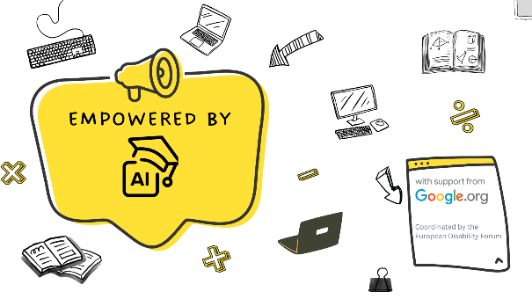
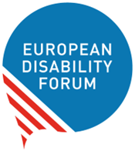
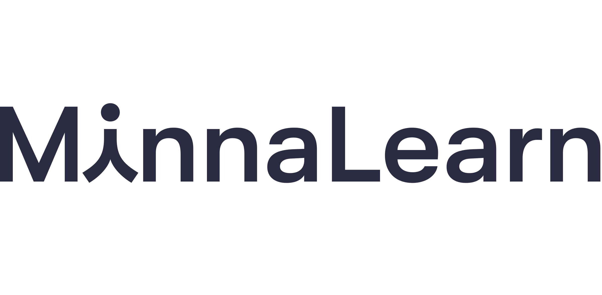

Become a certified trainer with the “Get AI Ready” course
We are inviting motivated individuals from EDF members, including their members to join the “Get AI Ready - Train-the-Trainer" programme by MinnaLearn.
This programme prepares you to confidently deliver inclusive Artificial Intelligence (AI) literacy training and support others in understanding and using AI in everyday life and work.

Why become a trainer?
By joining this programme, you will:
- Strengthen digital and AI literacy within your community
- Empower persons with disabilities to confidently engage with AI tools
- Become part of a growing network of inclusive digital trainers
- Receive structured support throughout your learning journey
- Receive an official Trainer Certificate upon completion

Trainer’s journey:
- The European Disability Forum (EDF) onboards the 20 trainers to the course
- Trainers attend the first session delivered by MinnaLearn
- Trainers receive the train-the-trainer and workshop materials and access to “Get AI Ready” module
- Trainers complete the independent study module “Get AI Ready” and familiarise themselves with the workshop materials
- Trainers attend the second session delivered by MinnaLearn
- Get ready to train other people: each trained participant will then organise a multiplier session for 10 people within their organisation or country
- Trainers receive certification upon completion of multiplier training

Who is the training for?
- EDF members, including their members
- People who use computers or digital tools as part of their everyday work
- Employees who are new to AI or want to feel more confident using it safely and effectively
- Organisations rolling out AI tools like Copilot, ChatGPT, or Gemini
- Anyone who wants to build essential AI literacy as part of their modern digital skill set

What will you learn?
- Understand what AI is and how large language models like ChatGPT work
- Use AI tools effectively by writing clear, high-quality prompts
- Recognise AI’s limits, including bias, hallucinations and overconfidence in outputs
- Use AI responsibly, protecting privacy, intellectual property, and workplace data
- Follow organisation’s AI rules as examples, knowing what’s safe and approved
- Build confidence and curiosity developing an open, informed mindset toward emerging AI technologies

What are the outcomes?
- Certificate of Completion in General AI Literacy
- Practical skills for safe and productive AI use at work
- A foundation for further AI learning and experimentation

Implement the multiplier training
After completing the programme, you will be responsible for delivering a multiplier training session to 10 participants within the organisation or its target group.
The costs related to organising and delivering the multiplier training (e.g., materials, logistics, facilitation, accessibility) can be covered under the grant through the subgranting call. Apply for the multiplier training on AI.

Supporting languages:
The workshops delivered by MinnaLearn will be in English. The course materials will be available in English, German, Polish, French, Spanish, Finnish, and Swedish.

Certification pathway
You will receive an official certification as a Get AI Ready Trainer once you:
- Complete the Train-the-Trainer programme
- Successfully deliver your first training session to 10 learners

No advanced technical background is required, just motivation to learn and share knowledge!

