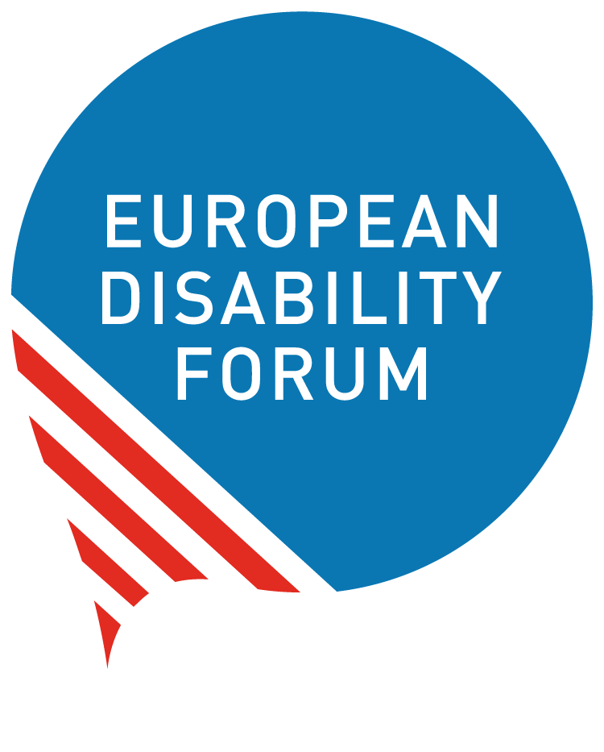

Strengthening Disability Rights in the next EU Action Plan on Human Rights and Democracy
Input by the European Disability Forum (EDF), the International Disability and Development Consortium (IDDC)

Strengthen the policy framework and move from references to disability rights and inclusion to operational commitments and concrete action
Disability rights must be strengthened in the next Action Plan, in line with the European Union’s (EU) obligations as a State Party to the UN Convention on the Rights of Persons with Disabilities (CRPD), and with the European Strategy for the Rights of Persons with Disabilities 2021-2030 and its recent commitment to reinforce the EU’s role as a global leader on disability rights and ensure that the Action Plan has a stronger emphasis on disability rights. The next Action Plan should build on the positive elements in the current Action Plan. Disability is referenced in the current Action Plan, but it is still not consistently reflected or translated in the priorities, funding, implementation and monitoring. It must ensure a genuine twin-track approach which combines targeted disability-specific measures with the systematic mainstreaming of disability across all EU external action and the Action Plan. It needs concrete operational commitments, and not just language on inclusion and disability rights.

Adopt and apply an intersectional and human rights-based approach aligned with the CRPD
Implementation should be grounded in the CRPD, the CRPD Committee’s Concluding Observations to the EU after last year’s CRPD review, and the EU’s own commitments to human rights and disability inclusion. This includes supporting partner countries in their implementation of the CRPD through concrete actions; ensuring that disability rights are systematically addressed in human rights dialogues, in programming and partnerships, and in cooperation frameworks; and upholding the positive elements on disability rights from the current Action Plan. It also means ensuring the meaningful participation of diverse organisations of persons with disabilities, especially local OPDs in partner countries, throughout the design and implementation of the Action Plan.

Ensure adequate funding and robust accountability for implementation
Disability rights and inclusion cannot be optional. Policy commitments must be backed by dedicated, predictable and accessible funding, for the implementation of the Action Plan and for disability rights, including through the next MFF and the Global Europe instrument. This must include binding CRPD safeguards on accessibility, inclusion and community-based approaches across all EU-funded programmes and actions. Funding should also directly support local OPDs and disability-inclusive civil society. At the same time, stronger inclusive monitoring and accountability mechanisms are needed so that disability inclusion is not optional but is systematically implemented, measured and reported on - any accountability and monitoring mechanism must include disability inclusive indicators.

Make OPD participation systematic and meaningful and in line with the CRPD
Organisations of persons with disabilities (OPDs), including local organisations of women with disabilities and other underrepresented groups, must be meaningfully involved at all stages of EU external action — policy dialogue, programming, implementation and monitoring — rather than consulted on an ad hoc basis. Consultation with civil society in partner countries should systematically include national and local OPDs, and where EU actors do not know which organisations to engage with, they should actively ask and seek guidance rather than proceed without disability representation.

Ensure accessibility and disability inclusion across EU external action
EU Delegations, consultations, civic space mechanisms, elections, democratic processes, humanitarian responses and digital governance and Global Gateway initiatives should all be fully accessible and disability inclusive. Existing guidance should be properly implemented, and disability and human rights focal points should be designated and adequately resourced and trained on disability rights and inclusion, including within EU Delegations, to ensure follow-up and expertise on disability rights.

Strengthen focus on underrepresented groups and defenders with disabilities
The next EU Action Plan on Human Rights and Democracy should place stronger emphasis on women and girls with disabilities, persons with psychosocial and intellectual disabilities, and human rights defenders with disabilities. This should include accessible protection mechanisms, asylum and family reunification procedures, support services, and targeted measures to address intersectional discrimination and exclusion.

Contact
Sarah Hull, International Disability and Development Consortium (IDDC), European Union Task Group (S.Hull@light-for-the-world.org)
Marion Steff, European Disability Forum (EDF) (Marion.Steff@edf-feph.org)

