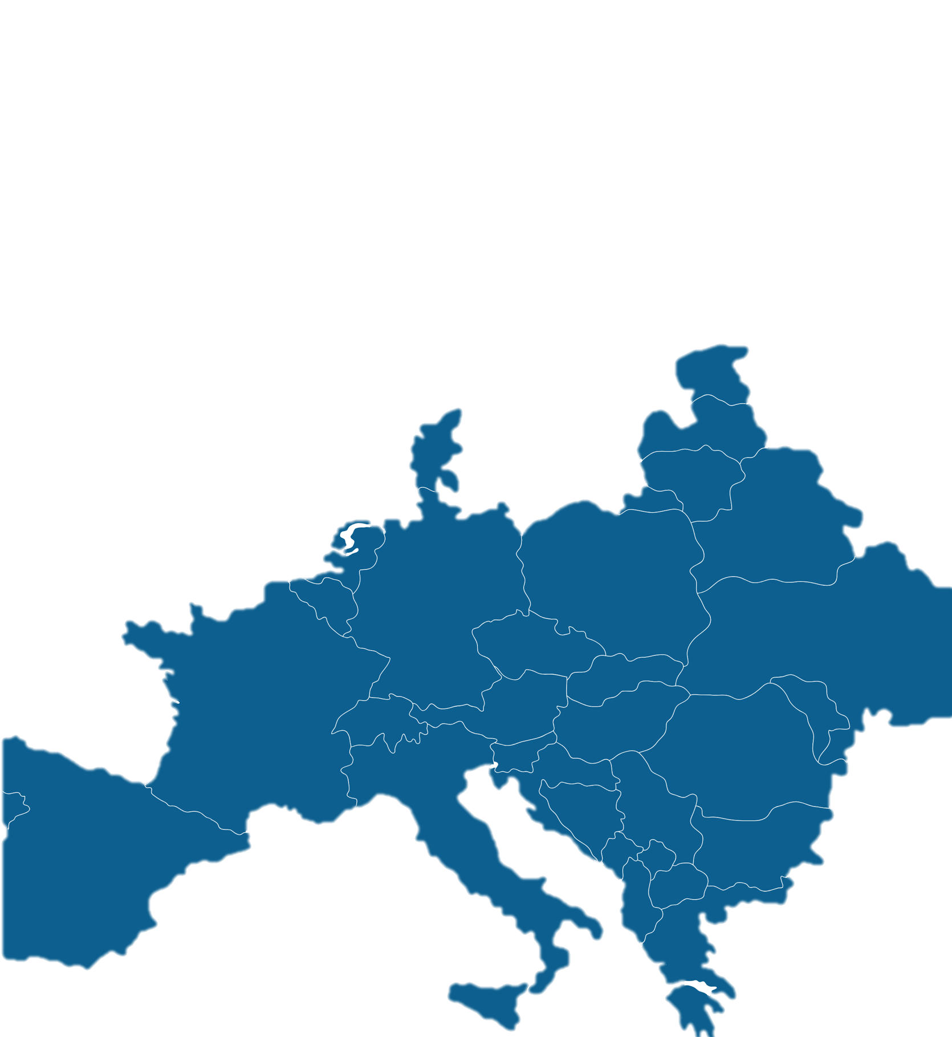
The right
to shape our future

The second EDF Manifesto on the rights of young persons with disabilities


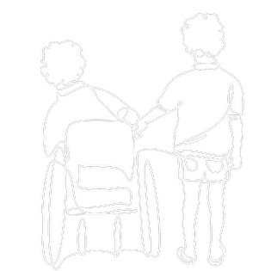

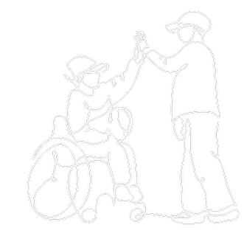

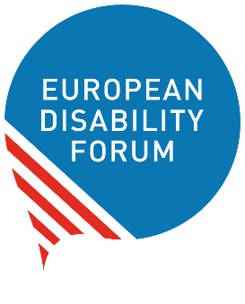
2026

Table of Contents
Introduction 3
Context 4
Methodology 4
Who participated? 5
Survey findings: The right to live in a just and accessible society 8
Housing 8
Health 8
Call to Action 12
Policy Makers 12
The European Disability Movement 12
Survey findings: The right to form your own future 12
Education 13
Employment 15
Financial Status 17
Call to Action 19
Survey findings: The right to shape society 20
Social Inclusion 20
Political Life 23
Call to Action 27

Introduction
Across the European Union (EU), 6.1% of the young people aged 16 to 19 years old have a disability or chronic disease. That figure rises to 7.9% in the 20 to 24 years-old demographic (Eurostat, 2024). This group represents a significant part of the youth population in the European Union.
The European Disability Forum’s (EDF) Youth Committee decided to run a survey to see what other young people face in Europe, to include all young people’s voices within their advocacy work, and to better represent their group.
The Committee is the voice of young people in EDF. Each of the members comes from a different region in Europe, has one or multiple disabilities, and is confronted with several difficulties. While some are common challenges shared across disabilities, others are disability specific. This report presents relevant findings on the topics included in the survey. It also includes recommendations towards the EU institutions to improve the lives of young people with disabilities and all other populations in the Union.
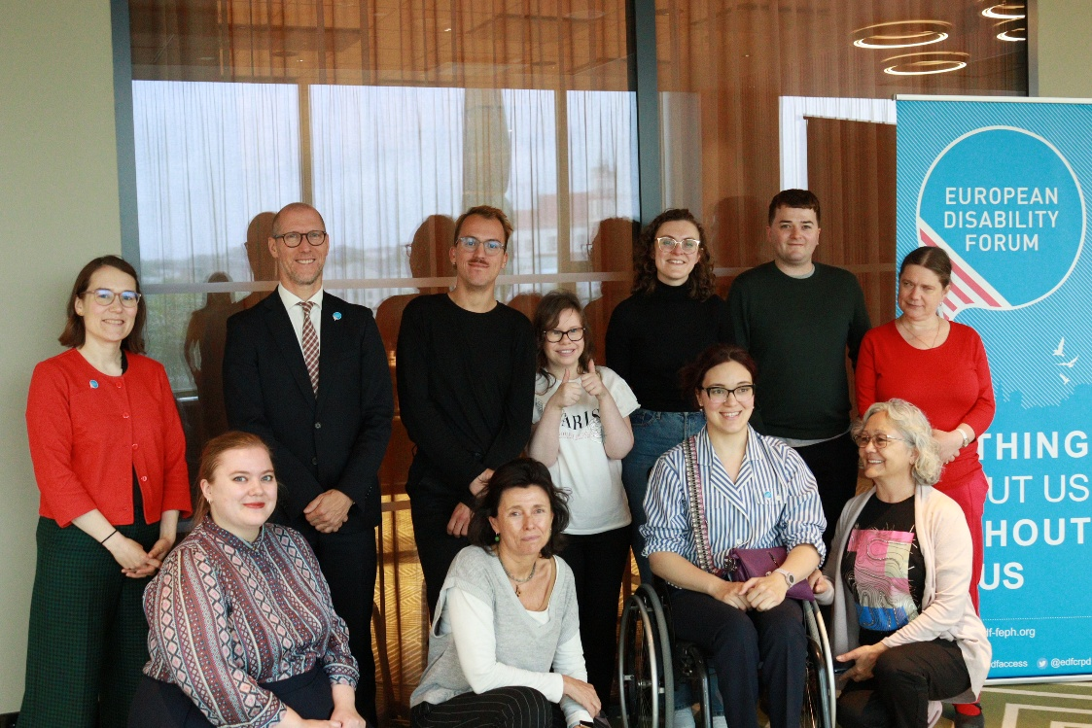
Figure 1: Some members of the EDF Youth Committee

Context
In 2025, the Youth Committee launched a survey that aimed to gather information about the experiences of young people with disabilities in Europe. This data will help inform policies and programmes designed to support young people with disabilities. The survey covered topics such as housing, education, climate change, leisure, employment and participation in society and political life.
The Committee also wished to gather information on how young people handle social media and the overload of information online – including misinformation.
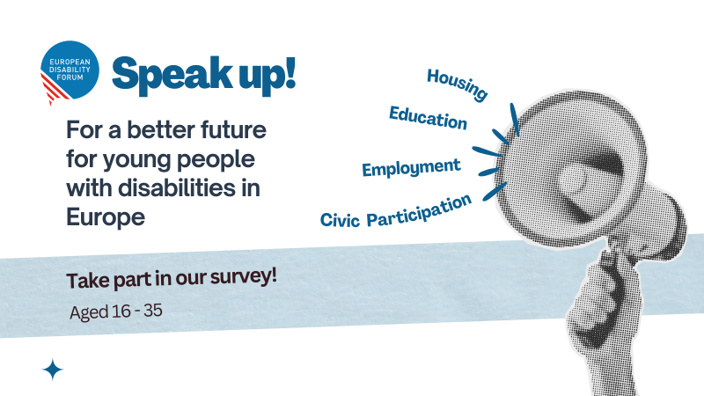Methodology
Young people with disabilities, between the ages of 16 and 35 were invited to participate. The survey was also open for contributions from parents of young people with disabilities and service providers to young people with disabilities.
Figure 2: Banner promoting the survey

Young people under the age of 18 had to request permission from their parents before completing it. The survey was launched in April 2025, and it was open until the end of November 2025. It was widely circulated within the disability community via EDF channels and the youth movement via EuroDesk.
The Survey had 51 questions. Apart from the last two, they were all one or multiple-choice types. The estimated time to fill in was 30 minutes. The thematic fields were not all compulsory to fill in.
The survey included several questions on diversity, which will help to make EDF a more diverse and inclusive organisation in the future and provide a better understanding of the diversity within disability. All personal information was provided on a voluntary basis.

Who participated?
The survey received 183 responses from people aged 16 to 60 years old.
The average age was 28 years old. 87% of the respondents were young persons with disabilities, 8% were parents of young people with disabilities, and the remaining people were working with young people with disabilities. Nearly 60% of the respondents consider themselves women and 31% men; 4,37% non-binary; 2.19% trans; and the rest prefer not to declare their gender.
When it comes to the geographical coverage, our aim was to reach participants from all European Union countries. the Youth Committee managed to reach most of the European Union countries, as well as the United Kingdom, the United States and Egypt. We did not receive responses from Cyprus, Czechia, Denmark, Estonia, Norway or Ukraine.
The group of respondents represented a large diversity within the disability movement:
- 40% said they have a physical disability;
- 30% have a sensory or psychosocial disabilities;
- 27% are persons with a chronic disease;
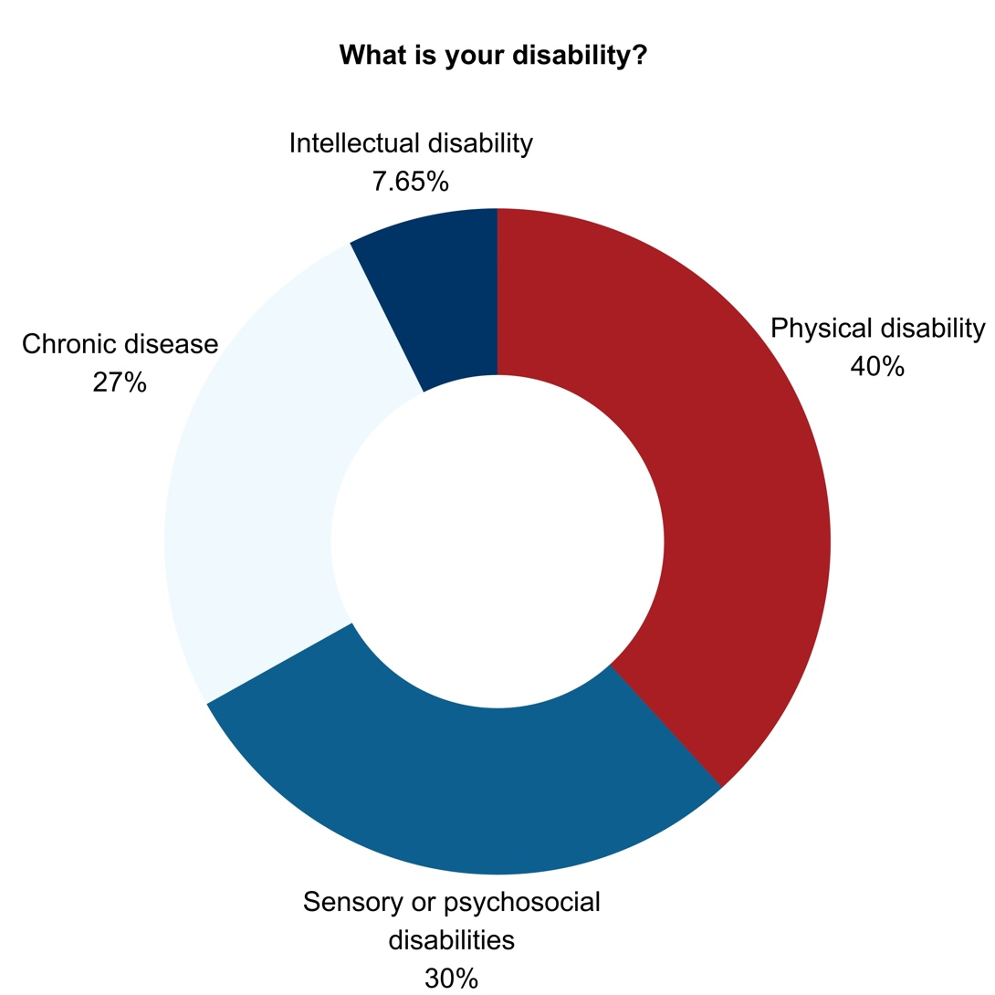
- 7.65% have an intellectual disability.

Figure 3: What is your disability?
It is important to have in mind that some people may have more than one type of disability, which explains why the sum of the percentages goes beyond 100.
Overview of participants per country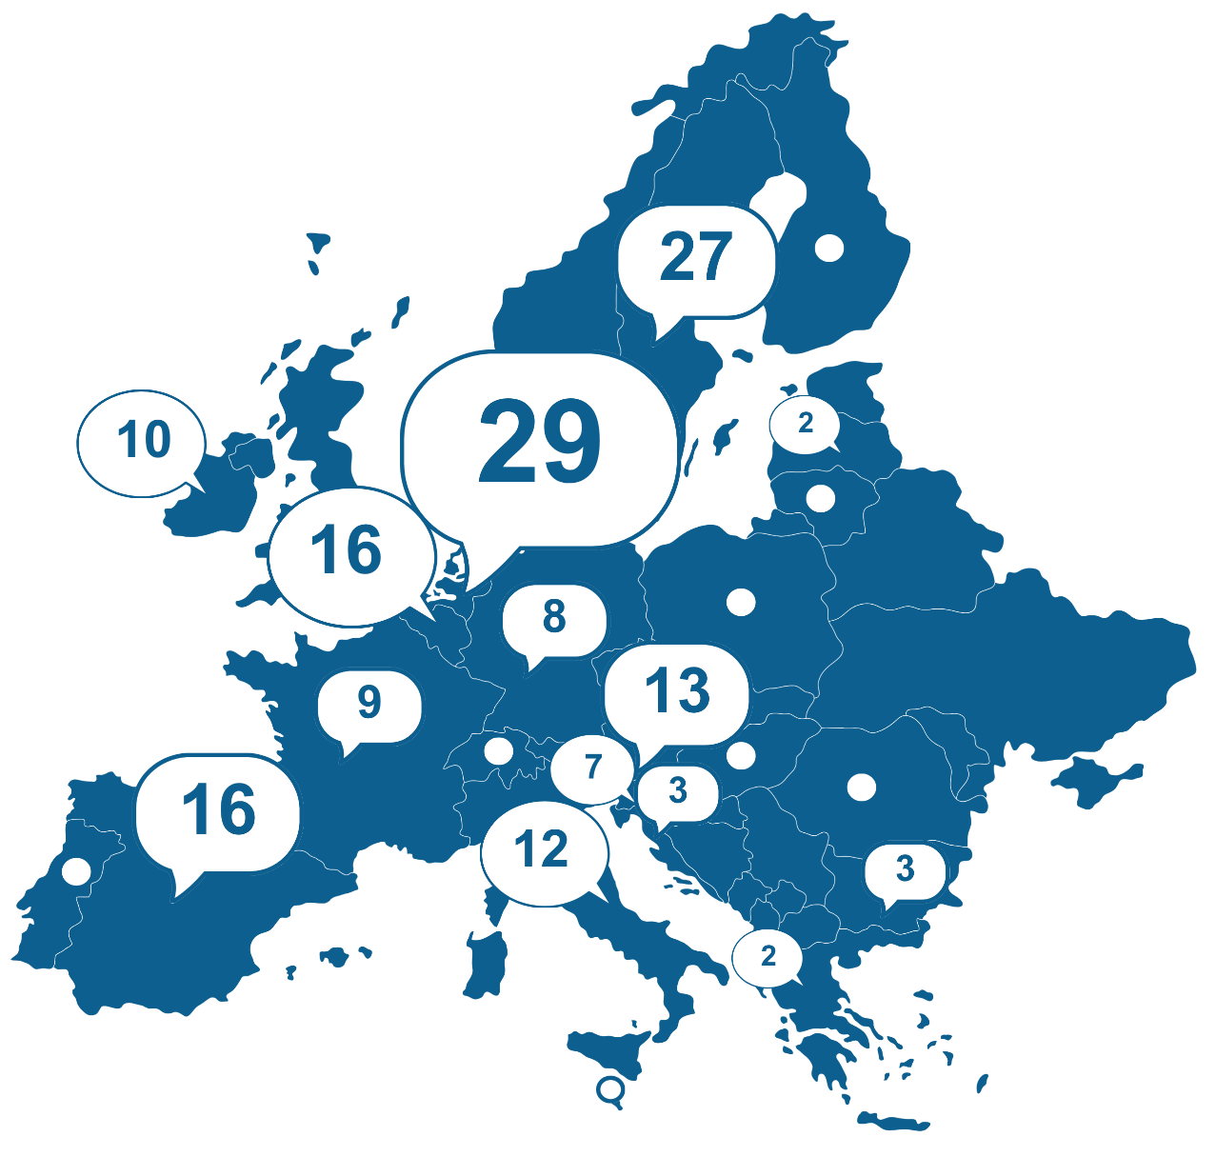
Figure 4: Map of survey respondents in the EU
EU Member States
The Netherlands – 29
Sweden – 27
Belgium – 16
Spain – 16
Austria – 13
Italy – 12
Ireland – 10
France – 9
Germany – 8
Slovenia – 7
Bulgaria – 3
Croatia – 3
Greece – 2
Latvia – 2
Finland – 1
Hungary – 1
Lithuania – 1
Luxembourg – 1
Malta – 1
Poland – 1
Portugal – 1
Romania – 1

Non-EU Member States
United Kingdom – 6
Switzerland – 3
Iceland – 2
Turkey – 2
Armenia – 2
Serbia – 1
United States – 1
Total Responses: 183


Survey findings: The right to live in a just and accessible society
For too long, accessibility has been treated as a "polite suggestion" rather than a fundamental right. Persons with disabilities face a "disability tax" – paying more for housing, transport, and healthcare while navigating a world designed without them in mind. From silent bus stops to inaccessible cafes, the environment remains hostile to independence. True equality requires an infrastructure that anticipates diversity, not one that treats it as an afterthought.

Housing
The majority of survey respondents live with their parent(s) – 42%, followed by living alone with 25% and with their partners with 21%. Only two respondents report living in a care institution.
A large majority (77%) live in the capital city of their country or in another urban area. The most common barrier, reported by over half of housing seekers is the insufficient availability of accessible housing.

Health
68% of survey respondents report regular use of health services because of disability. Of those, 96% report concerns including:
- communication with medical staff (58%);
- access to medical centres, such as hospitals and local services (51%);
- receiving medical equipment and medicine (50%);
- health insurance (35%);
- other (12%), including long waiting times.
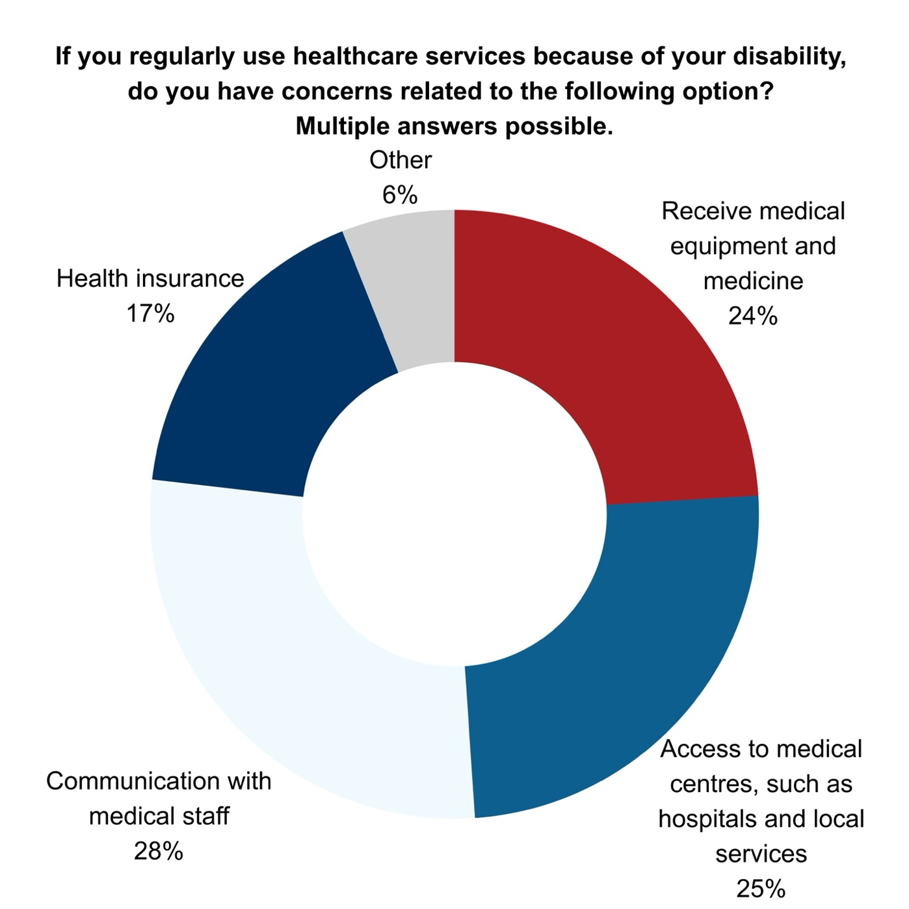
Figure 5: Donut chart: If you regularly use healthcare services because of your disability, do you have concerns related to the following option?
An analysis of the open questions reveals that there are few places where disability related training is provided to health care workers. Respondents pointed out that this creates communication issues. Persons with disabilities are not taken seriously, and when they are accompanied, the healthcare worker often speaks to the accompanying person and not to the patient directly.
45% of respondents encountered barriers in the transition from minor to adult healthcare services including:
- cost increases or changes to reimbursement and health coverage; in some EU countries, such as Slovenia and Belgium, healthcare is free until certain ages, or until finalising tertiary education Romania. After this period, patients need to partly or completely cover the provided health care services;
- lack of supported transition to adult services;
- inaccessible communication, especially when unaccompanied;
- longer intervals for equipment or device upgrades.
Several respondents, however, noted some benefits to the transition to adult services, including that they were taken more seriously as adults. A respondent wrote “A lot of things [are] easier as an adult than kid. As a kid I was accused of lying every time I needed help. As an adult they trust me (most of the times)”.
A large portion (45%) of respondents reported that they rarely or never have access to free and adequate mental health services. An analysis of the open questions shows that there is not enough training on disability during the educational process of mental health professionals. For instance, one respondent noted that “in adult psychiatry and related facilities, I experienced much more structural and individual violence against disabled people.”.
Some of the service providers for persons with disabilities do provide some mental health services in north and western European countries. Since COVID-19, we do see that insurance also covers some mental health services for adults, and the offer of mental health services is becoming more significant. However, respondents noted that problems still remain when it comes to providing sign interpreters, captioning, transport or accessibility to mental health care infrastructure.
Testimonial:
“I would change the legislation regarding health culture and education programs, as well as information campaigns for people with disabilities and their environment.”

Figure 6: Do you have free and adequate access to mental health services?
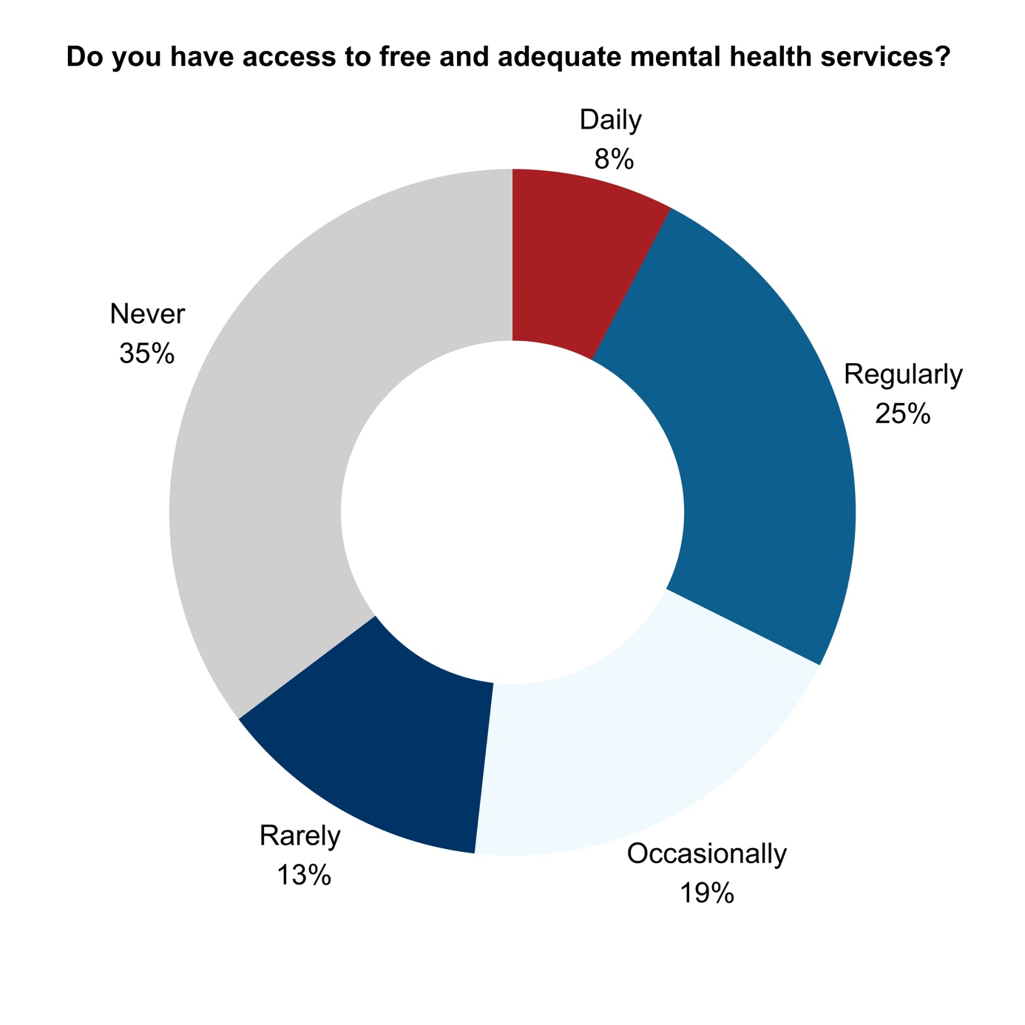


Call to Action

Policy Makers
- Legislative Teeth: Even if steps have been taken to adopt mandatory accessibility legislation for both digital and built environments, we still see the need to ensure that these are properly instituted on national areas. All accessibility barriers in the built environment must be resolved by 2035, with strict fines for public and private providers who fail to comply with them.
- The Right to Move: Standardise a European-wide system for personal assistants, parking passes, and public transport. Every bus, train, and station must include audio-visual announcements and speech-based consultation.
- Healthcare Justice: Expand the "Long-Term Illness" list to include invisible and neurodevelopmental conditions.
- Housing and Wealth: End Institutionalisation. Implement a Universal Basic Income for young persons with disabilities and provide financial pathways to homeownership, ensuring that the "disability allowance" isn't stripped away the moment a person begins to earn a living or when they inherit money.

The European Disability Movement
- Monitor and Report: Act as the primary watchdogs for the 2030 accessibility deadline, documenting failures and filing for the enforcement of fines.
- Cross-Border Solidarity: Campaign for the "Single Market of Support" to ensure that the rights and assistant services of disabled persons don't vanish when they cross an EU border.

Survey findings: The right to form your own future
Autonomy begins with education and ends with a career, yet many young people with disabilities are funnelled into segregated systems that limit potential. When schools are segregated, society remains ignorant; when workplaces lack accommodations, talent is wasted. The "poverty trap" – where earning a salary leads to a total loss of essential social support – effectively punishes ambition and forces poverty.
As one respondent puts it:
“I would enable subsidised work programs where you work 3 days, and the other 2 are paid by the government so that you can preserve energy but still be in the labour market. And I would do that also for leadership positions, not only junior or low-pay positions. Being disabled does not mean you are not ambitious.”

Education
An overwhelming majority of survey respondents (94%) study or work on a daily basis. University is the most common level of education attained by both current (50%) and former learners (53%), with 57% of respondents reporting satisfaction with their level of education achieved. Despite general satisfaction with the level of education attained, most feel that they were not able to reach their full potential in school.
A majority of respondents (88%) studied in a regular setting, with 20% studying in a segregated school and just 1% in a hospital school. These figures must be interpreted taking into account the large number of respondents from Western European countries.
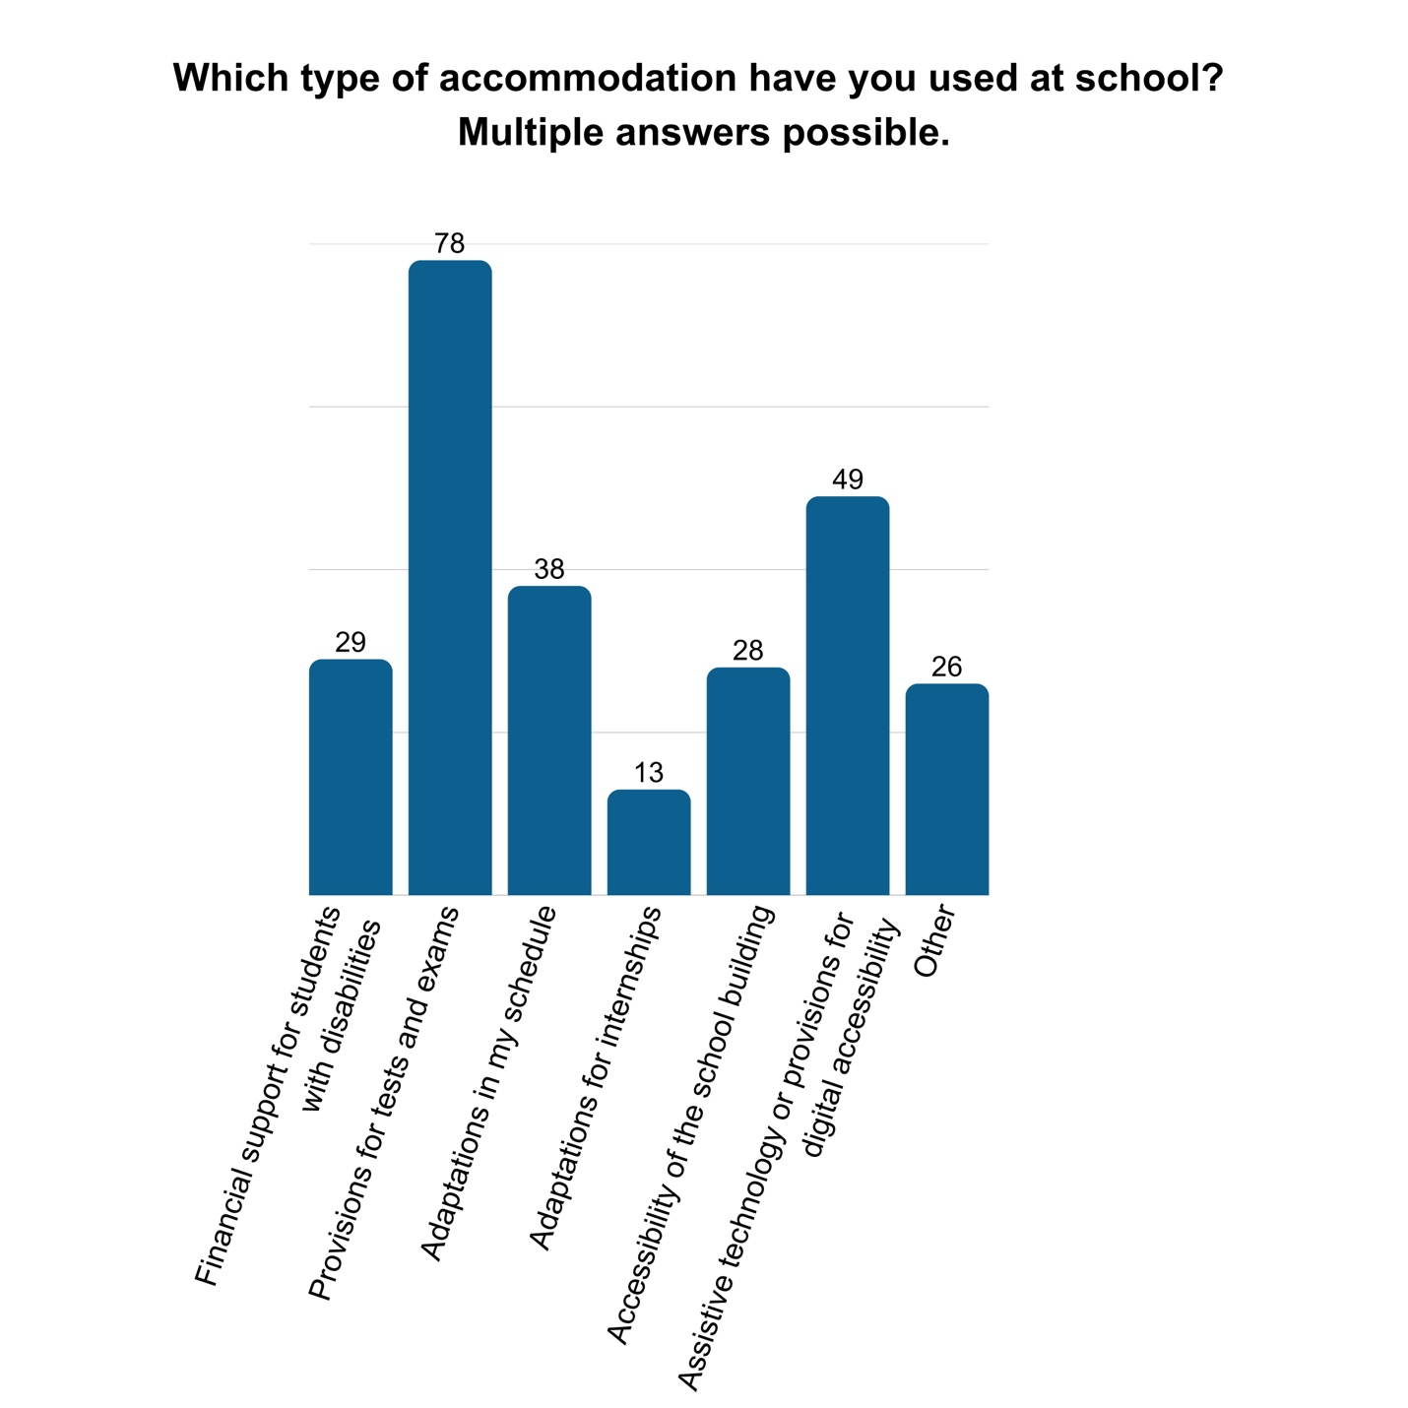
Across all settings, 62% reported feeling included in their classroom or school. Most respondents (87%) made use of accessibility or reasonable accommodation provisions at school, either arranged by the school or by themselves. Of those making use of accessibility or reasonable accommodation measures, slightly less than half (45%) were using more than one. The most common accommodations were provisions for tests and exams, followed by assistive technology or provisions for digital accessibility, and schedule adaptations.
Figure 7: Bar chart: Which type of accommodation have you used at school?
33% of those who were not satisfied with their level of educational achievement did not use or know if they used accessibility or reasonable accommodation provisions. Similarly, 35% of those who felt that they did not reach their full potential in school also reported not using or not knowing if they used accessibility or reasonable accommodation provisions.
An analysis of the open questions shows that many students and parents are not aware of existing services provided by the education system to support their pupils and students. This is compounded by complicated administrative procedures. Another factor cited is that parents are struggling to accept that their child is different and needs support. Additionally, long waiting lists to obtain certain services discourage students and parents from accessing them.

Employment
The majority of respondents report their employment status as not in work (30%), in part-time work (23%), or in full-time work (22%).
16% were job seekers at the time of survey completion. Among job-seekers, 42% have a higher education degree. One third of job seekers report not receiving reasonable accommodations as a barrier to finding employment.
68% of respondents said they ‘surely’ or ‘maybe’ experienced or suspected discrimination in the labour market. Respondents shared the experiences of discrimination that reflected common barriers including:
- Negative reactions to disclosure of disability;
- Lack of accessibility of the workplace or systems;
- Negative judgement for communication/presentation differences (e.g., stims, lack of eye contact, etc.);
- Employer concern for capacity to complete duties due to disability, chronic illness or mental health status;
- Assumed incompetency due to disability status;
- Low or lower pay compared to persons without disabilities.
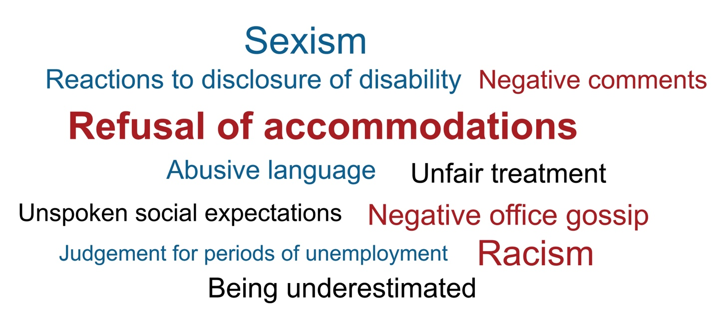
In the open-ended questions, many young people raise the issue of the incompatibility between disability allowance and salaries. When they work, they lose their disability allowance, and getting back on it (if the job ends) requires a gap period during which they are without financial means. Roughly 30% of respondents report problems with receiving a decent salary and maintaining disability allowance while working, contributing to financial concerns. 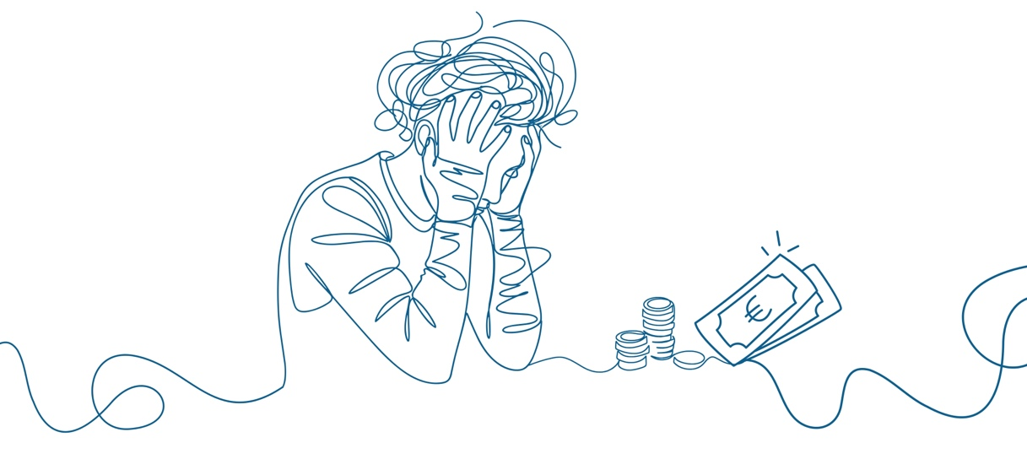
Figure 8: Word cloud of types of workplace discrimination
Figure 9 Word cloud of common barriers in the workplace
Figure 9: Graphic representing financial concerns

Financial Status
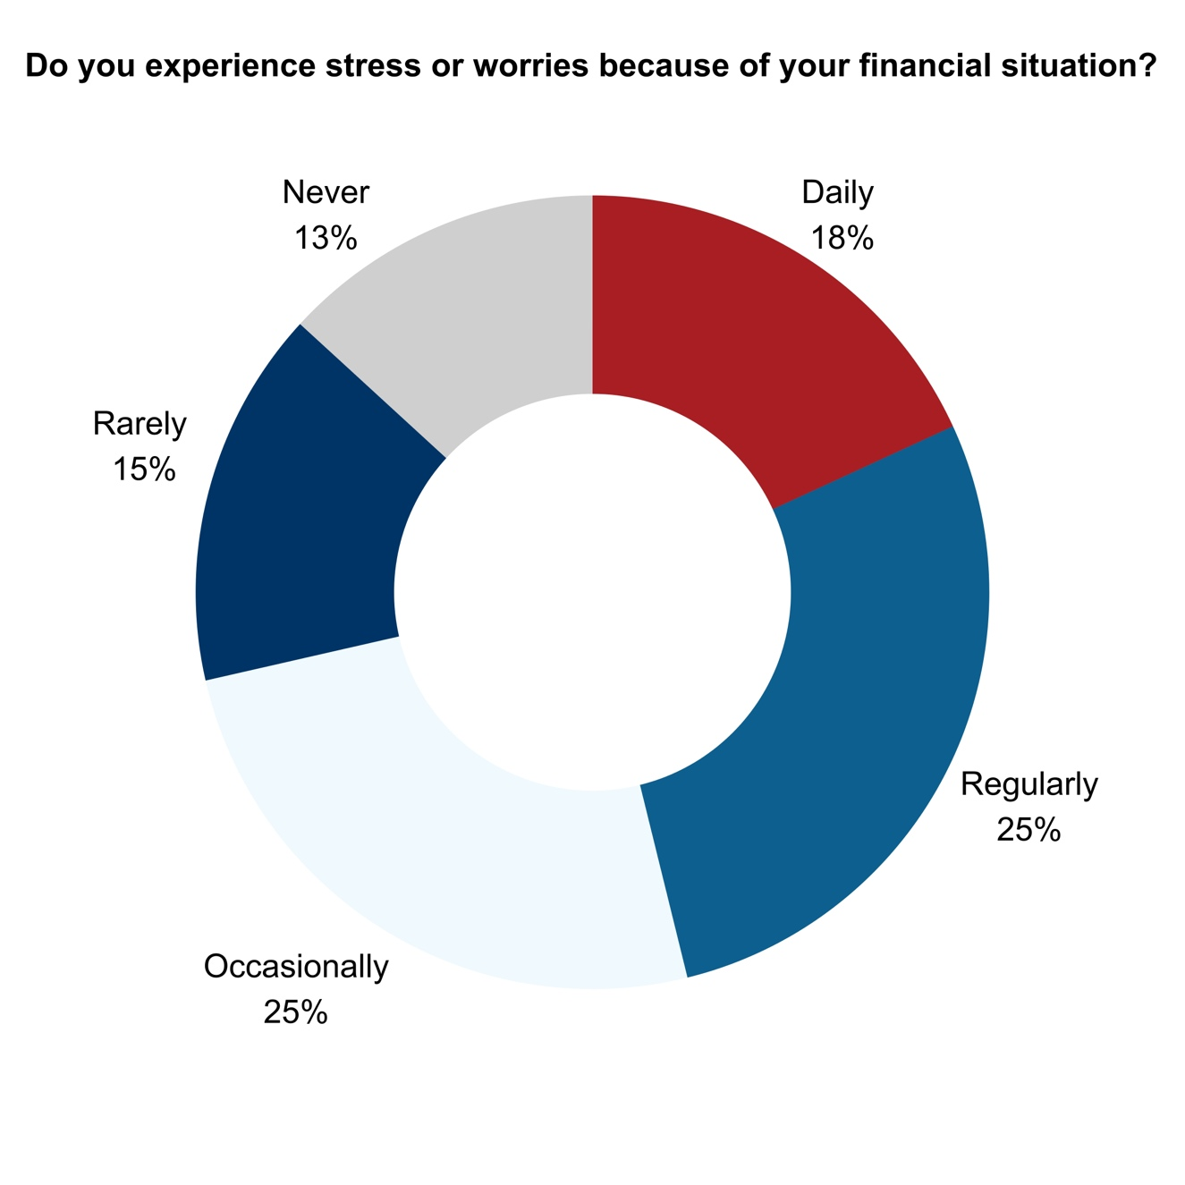
Nearly half of respondents (46%), experience regular or daily stress or worries due to their financial situation. Roughly 54% of respondents report financial debt, including student loans and medical bills. Among those working part-time, full-time, or as self-employed, just under half report financial debt and 42% still report regular or daily financial stress.
Figure 10: Do you experience stress or worries because of your financial situation?
67% of respondents say that their biggest obstacles to improving their financial situation is low income, high expenses or both. These obstacles are more pronounced for those working. All respondents working full-time, part-time, or as self-employed reported one or both challenges.
In many cases, disability involves high additional costs. People may need more frequent access to healthcare services. They also require specialised services that help them live independently. These can include mobility services, daily living adaptations for blind and partially sighted persons, physiotherapy for wheelchair users, coaching and support for neurodivergent persons. Many people also rely on assistive technologies, personal assistance, adapted transport, or other disability-related supports.
The availability and affordability of these services vary widely between countries. Some costs may be fully or partially covered by public authorities, while in other countries individuals must pay most or all expenses themselves. As a result, disability-related costs can place considerable pressure on personal and family finances.
The interaction between work and disability allowances often creates challenges. In some countries, persons with disabilities can continue to receive part of their allowance when they enter employment. In others, taking up work may result in their loss or of related support measures, such as reduced utility bills, telecommunications discounts, or other forms of assistance. This can create financial uncertainty and discourage labour market participation.
Persons who rely solely on disability allowances face obstacles when applying for loans or credit, making it harder to purchase a home, a vehicle, or other resources that could increase their independence and quality of life.
Because of these financial pressures, some persons with disabilities must make difficult choices about which services, therapies, or supports they can afford to keep. These decisions can directly affect their health, independence, employment opportunities, and overall participation in society. Even for young people who can work full time in an appropriate job, the cost of disability can eat up a significant portion of their income, leaving them with less ability to afford basic life items like food or recreational activities."

Call to Action

Policy Makers
- Inclusive Education: Transition funding from segregated institutions to mainstream schools. Mandate smaller class sizes, specialised learning paths, and universal disability awareness training for every teacher and professor.
- Mandatory Employment Quotas: Enforce hiring quotas for persons with disabilities and mandate that vocational institutions, apprenticeships, and internships are fully accessible and inclusive. Shift away from sheltered employment.
- Economic Freedom: Remove all salary limitations for those collecting social benefits. Assistive devices and personal assistance should be provided free of charge as a right of employment, not a luxury.
- Neurodiversity in the Workplace: Legislate "sensory leave" for neurodivergent employees and mandatory workshops for business owners to eliminate stigmas around overstimulation and mental health.

The European Disability Movement
- Peer Mentorship: Build a network of "Success Coaches" to help young disabled people navigate the transition from child services to adult autonomy.
- Demand Supported Decision-Making: Fight to replace restrictive guardianship laws with "Supported Decision-Making" models that respect the individual’s right to choose where they live and how they work.

Survey findings: The right to shape society
"Nothing about us without us" is not just a slogan; it is a prerequisite for democracy. Currently, information is often locked behind inaccessible formats, and the media either ignores disabled lives or reduces them to stereotypes. Without voices of persons with disabilities in parliaments, newsrooms, and film studios, the cycle of exclusion will never be broken.

Social Inclusion
Respondents report a variety of social activities, the most common of which include:
- activities from home, including drawing, watching series, or reading (86%);
- social activities, including seeing friends, taking part in clubs (70%);
- outdoor activities such as cycling or going for a walk (60%);
- indoor activities in other locations, such as visiting a cinema or going to a restaurant (59%).
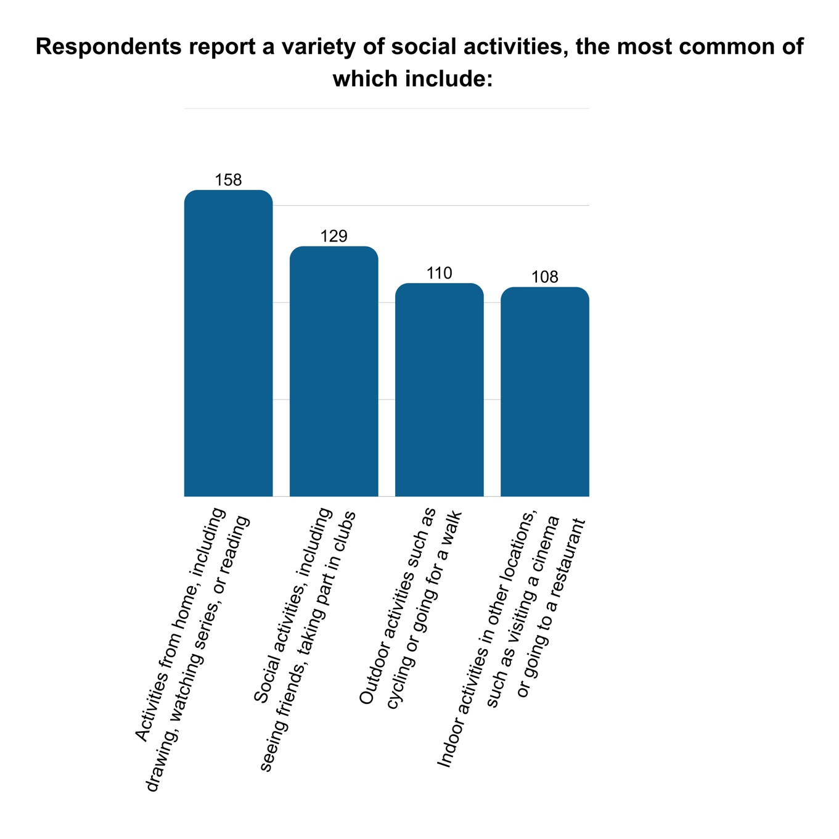
Figure 11: Bar chart: Common social activities
Nearly half of respondents (43%) report that their social interactions take place in an even split between in-person and online environments.


Figure 12: Graphic representing online communication
48% describe their social life as unfulfilling, likely explained by a range of disability-specific barriers, including:
- social barriers (55%);
- accessibility barriers (54%);
- financial barriers (33%);
- lack of access to information (23%);
- other (11%), including fatigue (3%), health problems, and lack of flexibility by friends or family members.
The barriers mentioned above can be explained by the fact that participation in mainstream activities is often difficult for young people with disabilities. Many activities may take place in venues that are not accessible to wheelchair users. Deaf and hard of hearing participants may be excluded when sign language interpretation or captioning is not provided. Crowded or overstimulating environments can present challenges for young people with certain disabilities. In addition, activities may be difficult to access for blind or partially sighted individuals when there is limited or no accessible public transport available. A respondent said, “It's hard to exist in public life in Portugal when most public spaces, public transport and universities don't even do the bare minimum to ensure wheelchair users and other physically disabled people can access their spaces”.
Only 10% of respondents report no disability-specific barriers preventing them from spending their free time in the way that they prefer.
Testimonial:
“I don't have a legal education, and I'm too young to have the capacity to propose legal changes, but I am convinced that we need to work on the cultural development and awareness of society, towards easy integration of people with disabilities.”

Political Life
68% of survey respondents feel like their voice is rarely or never represented adequately in politics, while 46% engage in civic or political movements. Respondents report the following disability-related barriers to engage:
- social barriers (49%);
- accessibility barriers (48%);
- lack of access to information (36%)
- financial barriers (26%);
- other (8%).
19% report no such barriers.

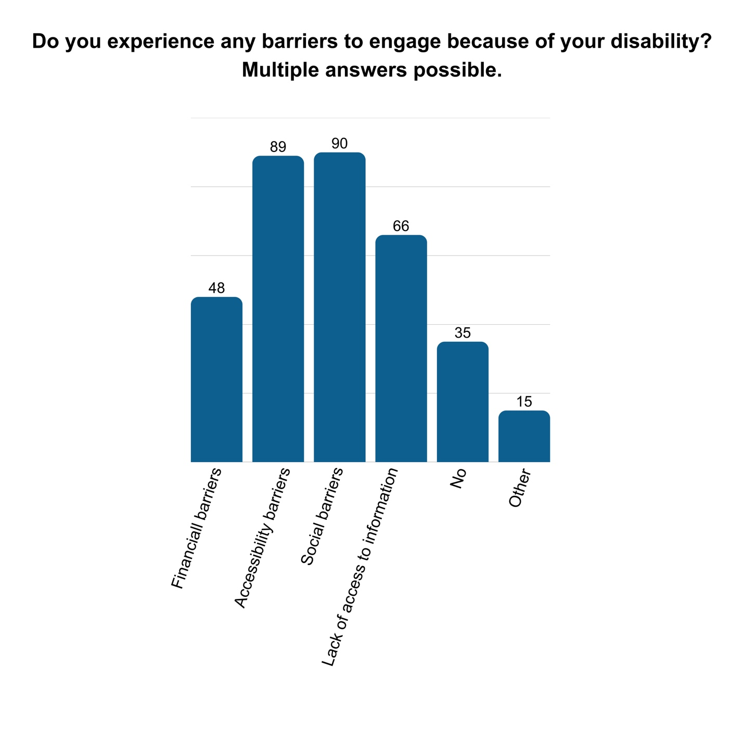
Figure 13: Do you experience any barriers to engage because of your disability?
Inaccessible information is at the heart of exclusion of political life. There is rarely information made accessible about elections. This is mostly provided by organisations of persons with disabilities and focuses on the voting process. Electoral programmes and other activities of political parties are often inaccessible. As a respondent said:

“Information and all documentation should be accessible in the spoken and sign languages of the area it concerns, and alternative formats such as audio, braille video text should be available, so more people could be reached and have proper access to information.”
Respondents, however, demonstrate interest across societal themes including:
- international politics (70%);
- national politics (67%);
- climate and the environment (60%);
- social or economic affairs (58%);
- sports (31%);
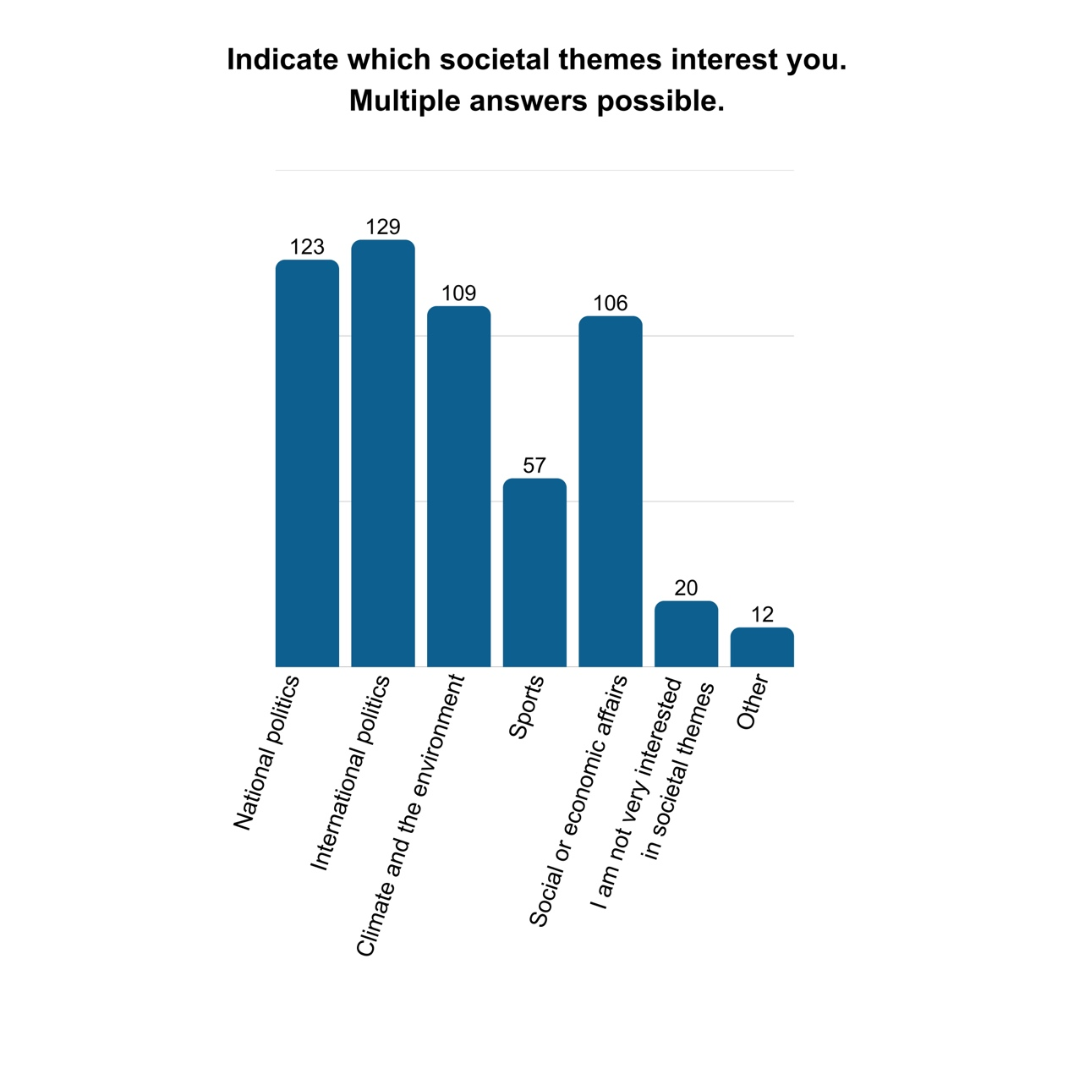
- other (7%), including human rights, accessibility, diversity and inclusion, and sight-seeing.
Figure 14: Bar chart: Interest in societal themes
The large majority of respondents keep informed on current affairs through social media (80%) and by talking to friends, family and others (78%). They also keep informed by:
- reading newspapers (45%);
- watching television (44%);
- listening to podcasts (42%);
- reading books (37%);
- listening to the radio (22%);
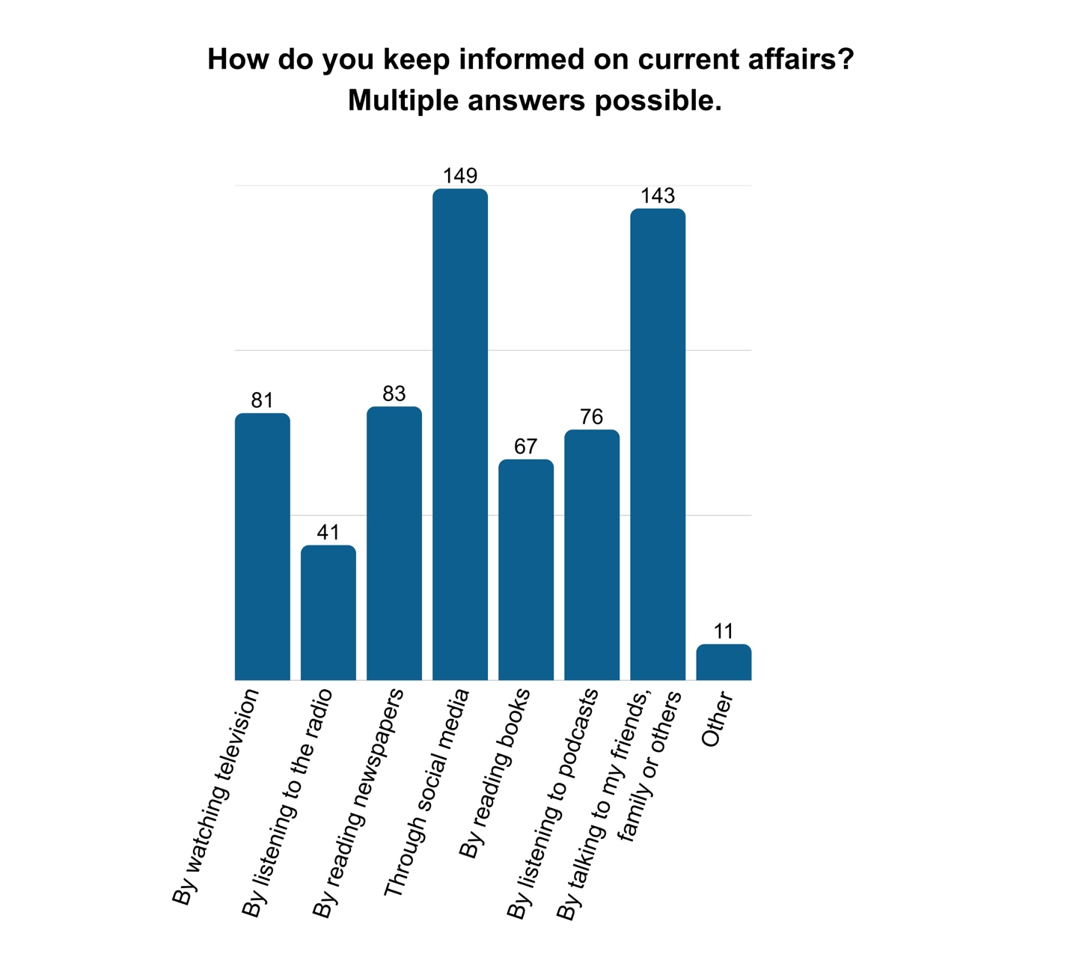
- Other (6%).
Figure 15: Bar chart: How do you keep informed on current affairs?

85% of respondents say they can safely and actively use online tools for
85% of respondents say they can safely and actively use online tools for communication, play, work or school, and recognise fake news, but over half (55%) say they would like to make sure their skills are up to date. 93% of those with a university degree or higher report high digital literacy, while 80% of those with lower education attainment (completed) report the same literacy.
Only half of the respondents say that they have a healthy relationship with technology.
A respondent outlines the views they would put forward:
“I would ask for a Job Guarantee and easy access to financial aid that really supports people. Overcoming capitalism, the gender binary and fighting climate change would be necessary as well to really improve our lives. Reforming educational systems and making them more accessible is crucial as well. We also need to rethink urban planning to reduce the number of barriers. A shift in society's mindset – away from neoliberalism, meritocracy and the "work hard, play hard" attitudes is another aspect that needs to change.”

Call to Action

Policy Makers
- Political Representation: Create incentives and pathways for persons with disabilities to hold office at all levels of government.
- Total Information Access: Mandate that all public documentation be available in Sign Language, Braille, audio, and Easy-to-Read formats.
- Media Accountability: Implement quotas or financial incentives for media outlets to hire disabled presenters, actors, and writers, ensuring authentic representation on TV, in books, and in film.
- Inclusive Social Spaces: Legislate that all community hubs – cinemas, board game clubs, and cafes – must have accessible entrances and facilities to ensure disabled people are seen as regular patrons, not "guests."

