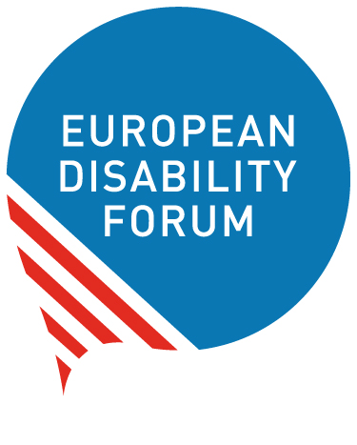 | European Disability Forum  nothing about us without us  Avenue des Art 7-8  1210  Bruxelles  www.edf-feph.org

Second cycle of EDF Sub-granting: Women with disabilities leading the change

The European Disability Forum (EDF) is opening a second cycle of funding stream under the project “Nothing without us: Women with disabilities leading the change” with grants of up to 3.000 euros per organisation or up to 9.000 per coalition, to support our members, their members, and partners who want to undertake activities focused on women’s rights across the Council of Europe area.
The aim is to empower EDF member organisations and their members and partners to undertake initiatives on women’s rights, especially focusing on women with disabilities and their leading role at local, national or European level.

The programme is expected to create a significant impact across Europe by enabling organisations to implement projects that would otherwise be unfeasible.

Scope of the grants
The grants offer funding for a specific set of activities or objectives. Funding is available for activities aimed at supporting gender equality and women’s rights work, such as:
- training sessions;
- awareness and advocacy campaigns, including the launch of these campaigns;
- organisation of events;
- participation in events;
- translation of resources on women’s rights and gender equality;
- research on the rights of women and girls with disabilities.
The total amount available for the grants in 2027 is 30.000 euros.
Individual grants can be from up to 3.000 euros. We also welcome organisations to apply in coalition for up to 9.000 euros per coalition composed of a minimum of 3 organisations.
The duration of the grant is 6 months, activities will start in January 2027 and should be completed no later than 30 June 2027. Reports should be sent to EDF no later than 31 August 2027.

How to apply?
Please download and complete the short application form and budget template, fill them in and send these documents by email to EDF Women’s Rights Officer – Giulia Traversi by email: giulia.traversi@edf-feph.org Please write “Grant27Women” in the email subject line.
Applications can be submitted until Monday 16 November 2026, 18:00 CEST.
The application form and budget template are the only documents required for an application.
Please note that we may ask you for additional documentation before issuing the grants.
The results will be announced to grantees by 21 December 2026.

Who can apply?
All EDF member organisations and their members and partners working on disability rights and/or women’s rights can apply for a grant, as individual organisation or as a coalition. This programme addresses the limited resources that many organisations face, preventing comprehensive work on the rights of women and girls with disabilities. By allocating 30.000 euros, EDF aims to support around 10 organisations with up to 3.000 euros each or coalitions of organisations with up to 9.000 euros for each coalition.
Criteria for applications:
- Organisations must be EDF members, members of EDF members or a partner organisation working on disability rights and/or women’s rights.
- Organisations must be non-profit.
- The activities must enhance the rights of women and girls with disabilities, with an explicit gender angle.
- Activities must be carried out between January and June 2027.
- Activities can be carried on local, national or European level.
- All activities and outcomes must be accessible for persons with disabilities.

Evaluation
An assessment will be carried out by the EDF selection committee composed of the Chair of the EDF Women’s Committee and EDF Staff.
EDF will ensure women with disabilities have leadership and ownership of the sub-granting programme. Applicants will be required to explain:
- how women with disabilities were involved in the proposal and
- why it is a priority for women with disabilities.
They will also have to ensure women with disabilities are involved in the implementation of the activities.

The award criteria for this call are as follows:
- Relevance: extent to which the proposal matches the priorities and objectives of the call; clearly defined needs and robust needs assessment; clearly defined target group (10 points maximum).
- Quality: clarity and consistency of project; logical links between the identified problems, needs and solutions proposed (logical frame concept, organisation of work, timetable, allocation of resources); feasibility of the project within the proposed timeframe; financial feasibility (sufficient/appropriate budget for proper implementation); cost-effectiveness (10 points maximum).
- Impact: ambition and expected long-term impact of results on target groups/general public; potential for a positive multiplier effect (10 points maximum).
- Budget quality: clarity, feasibility and originality of the budget (10 points maximum).

Legal and financial set-up of the Grant Agreements
If your proposal is selected, your organisation or the leading organisation of the coalition will be invited for grant preparation, where you will be asked to prepare the Grant Agreement together with the EDF Women’s Rights Officer.
This Grant Agreement will set the framework for your grant and its terms and conditions, in particular concerning deliverables, reporting, payments and funder’s acknowledgement.
100% of the grant will be paid immediately after the signature of the Grant Agreement.

Reporting

Deadline
Technical and financial reports should be submitted by 31August 2027.

Reporting templates
Reporting templates are 2 simple and separate documents, one for the technical report and one for the financial report.

If you have any questions concerning the application process, please contact EDF Women’s Rights Officer – Giulia Traversi by email: giulia.traversi@edf-feph.org

