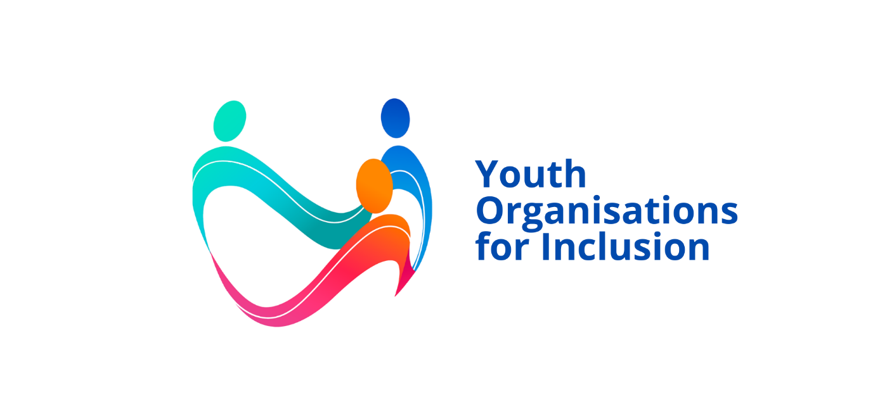

YO-IN: Youth Organisations for Inclusion
D3.1 Journey towards inclusion for youth organisations
Work Package 3: A to Z Toolkit
Prepared by EDF

Funded by the European Union. Views and opinions expressed are however those of the author(s) only and do not necessarily reflect those of the European Union or the European Education and Culture Executive Agency (EACEA). Neither the European Union nor the granting authority can be held responsible for them.
Table of Contents
Introduction 4
Instructions 4
Journey visual map 5
Step 1: Get curious 5
Tag 5
Summary 5
Actions 5
Milestones 6
Considerations and Decisions 6
Step 2: Commit 6
Tag 6
Summary 6
1.1 Institutional commitment 7
1.2 Organisational responsibility 7
1.3 Internal rules 7
5.6 Information about accessibility 8
6.5 Inclusive safety 8
Step 3: Partner 8
Tag 8
Summary 8
2.4 Support network 9
2.5 Partnerships 9
Step 4: Enable 9
Tag 9
Summary 9
6.1 Inclusive design 10
6.3 Information on support needs 10
5.1 Physical accessibility 10
5.2 Information accessibility 11
5.3 Digital accessibility 11
5.4 Communication accessibility 11
5.5 Sensory accessibility 12
6.2 Accommodations and support 12
Step 5: Empower 12
Tag 12
Summary 12
3.5 Inclusive communication 13
4.1 Recruitment 13
4.2 Internal adjustments 13
4.3 Onboarding and continuing education 14
2.3 Organisational knowledge 14
3.3 Leadership 14
Step 6: Embed 15
Tag 15
Summary 15
2.1 Inclusion planning 15
2.2 Resource planning 16
1.4 Continuity 16
4.4 Safety and safeguarding 16
6.4 Equal participation 16
Step 7: Reflect and Renew 17
Tag 17
Summary 17
3.4 Participatory evaluation 17
3.1 Consultation 18
3.2 Co-design 18
1.5 Monitoring and Learning 18
Step 8: Champion Inclusion 18
Tag 18
Summary 19
Actions 19
Milestones 19
Decisions 19

Introduction
The YO-IN Journey Towards Inclusion is a practical roadmap designed to help youth organisations strengthen disability inclusion efforts step by step.
It is both a flexible improvement tool and a structured pathway towards YO-IN Quality Label certification. Organisations can begin with Step 1 and progress through the Journey according to their maturity level, identified through the YO-INclusiometer. Alternatively, they can start with any step that reflects their current priorities, needs, or areas for improvement.
Each step contains practical actions that organisations can adapt to their own context and capacity. Actions are numbered according to the YO-INclusiometer categories and indicators, allowing organisations to easily identify the actions relevant to their assessment results.
Actions shown in bold are required actions linked to the YO-IN Quality Label certification levels and must be completed to achieve the corresponding level of certification.

Instructions
Start by completing the YO-INclusiometer self-assessment to understand your organisation’s current maturity level and identify priority areas for action.
Based on your results, decide what you want to achieve, whether that means improving in a specific area or working towards a particular level of YO-IN Quality Label certification.
You do not need to tackle everything at once: choose a manageable starting point based on your priorities, needs and resources.
From there, move step by step along your inclusion journey, using the YO-IN resources, tools and guidance linked to each area to help you progressively strengthen your organisation’s approach.

Journey visual map
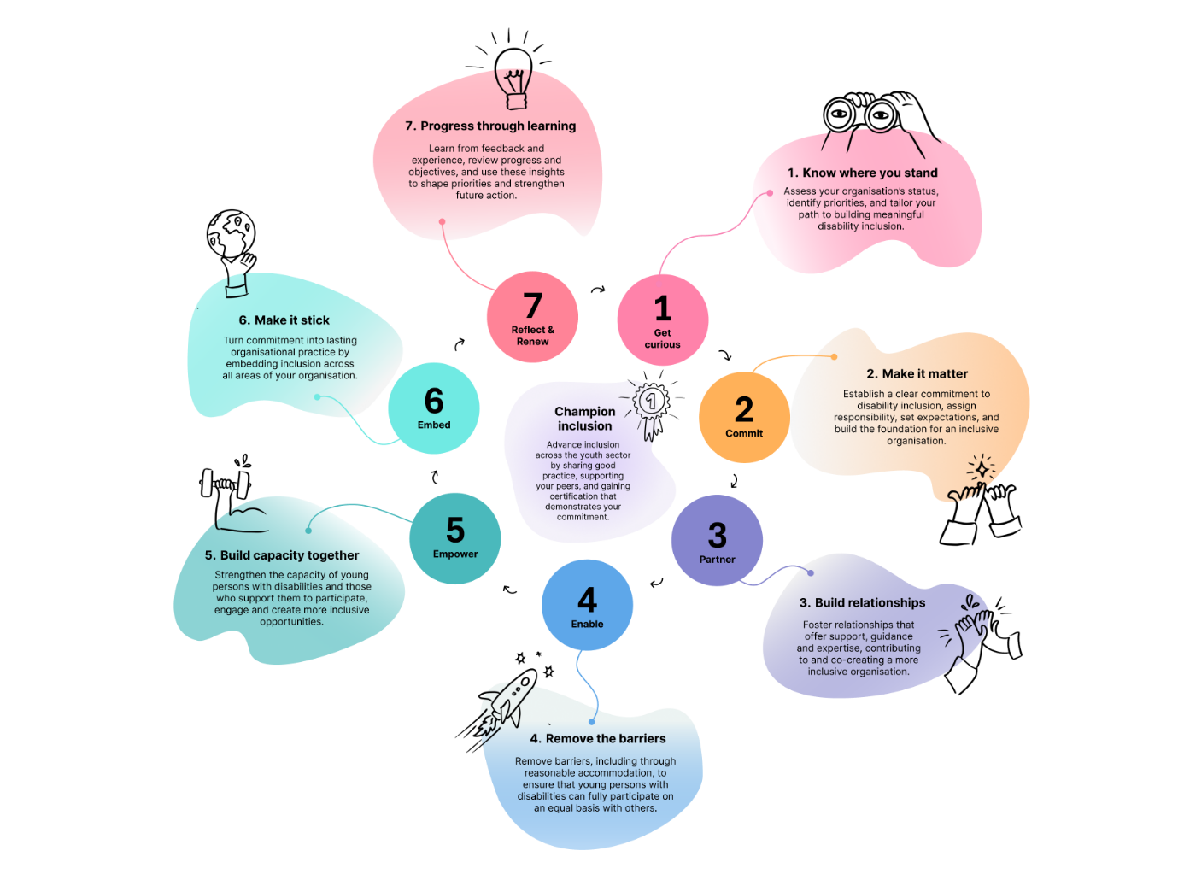

Step 1: Get curious

Tag
Assess your organisation’s status, identify priorities, and tailor your path to building meaningful disability inclusion.

Summary
Begin by understanding where your organisation currently stands on disability inclusion. Complete the YO-Inclusiometer and review the report, adapt the findings into a Disability Inclusion Plan, identify strengths and challenges, and choose the level of ambition or certification that is realistic for your organisation.

Actions
All organisations will:
- Complete the self-assessment, YO-INclusiometer.
- Review the report to understand strengths, challenges, and priority areas for action.
- Assess and adapt the Disability Inclusion Plan with immediate, medium-term and longer-term priorities.
- Contact the certification body for support with initial steps.

Milestones
- The organisation, or those responsible for disability inclusion, has a clear picture of its starting point.
- The identified level of certification or ambition is identified.

Considerations and Decisions
- Who should be involved in these initial discussions and decisions?
- Which certification level should the organisation work towards?
- Which priorities should enter the first implementation cycle, and which can be addressed later?

Step 2: Commit

Tag
Establish a clear commitment to disability inclusion, assign responsibility, set expectations, and build the foundation for an inclusive organisation.

Summary
Create the organisational mandate for change by making disability inclusion visible, establishing responsibility and putting the initial rules, expectations, and safety conditions in place. Commitment involves actions to address:
- 1.1 Institutional commitment
- 1.2 Organisational responsibility
- 1.3 Internal rules
- 5.6 Information about accessibility
- 6.5 Inclusive safety

1.1 Institutional commitment
Basic actions | Make a public statement expressing the organisation’s commitment to equal opportunities, non-discrimination, and disability inclusion.
Intermediate actions | Formalise the commitment in the organisation with a policy, reference in the constitution or statutes, and communicate it across teams.
Advanced actions | Use the commitment to guide strategic priorities, accountability, and organisational decision-making.
Milestones | The organisation’s commitment to disability inclusion is visible and understood by staff, board members, and volunteers.
Considerations and Decisions | - Where should the commitment to disability inclusion be formalised (e.g., in the board, by the responsible staff, etc.)?  - How should the commitment be displayed and shared?

1.2 Organisational responsibility
Basic actions | Identify who currently takes initiative on disability inclusion, even if responsibility is informal. If no one is currently responsible, assign at least one person.
Intermediate actions | Formalise responsibility for disability inclusion (e.g., include it in job description for responsible staff, board member, volunteer or group).
Advanced actions | Integrate disability inclusion into rules and accountability mechanisms to ensure broad organisational responsibility.
Milestones | Responsibility for disability inclusion is identifiable.
Considerations and Decisions | What authority, time, and support does the responsible person/group need to ensure disability inclusion progresses?

1.3 Internal rules
Basic actions | Review existing rules and identify whether disability discrimination and routes for raising concerns are covered.
Intermediate actions | Update statues, codes, or internal rules to prohibit disability discrimination and establish an accessible complaints mechanism.
Advanced actions | Integrate disability inclusion, reasonable accommodation and accountability consistently across relevant organisational policies and review cycles.
Milestones | Internal rules explicitly prohibit disability discrimination.
Considerations and Decisions | Does the organisation need to amend or improve existing instruments or develop dedicated provisions?

5.6 Information about accessibility
Basic actions | Proactively tell staff, volunteers, and beneficiaries what accessibility measures are and are not provided, including a contact for questions.
Intermediate actions | Systematically include accessibility information in event and activity registration and other communications.
Advanced actions | Standardise accessibility information across channels by creating a template for different activities and channels; assign responsibility to keep it current.
Milestones | Accessibility information is communicated proactively for events.
Considerations and Decisions | What accessibility information is mandatory for different activities and events?

6.5 Inclusive safety
Basic actions | Identify disability-related gaps in emergency, mobility, and support arrangements and provide practical information where possible.
Intermediate actions | Adopt or adapt emergency, mobility, and support protocols and brief staff or volunteers on support needs for different beneficiaries.
Advanced actions | Systematically ensure prevention, emergency, mobility, and support protocols address the needs of persons with disabilities. Protocols are made available in accessible formats (e.g., venue evacuation information in tactile form).
Milestones | Safety arrangements consider persons with disabilities.
Considerations and Decisions | What risks or safety protocols will require specialist review or partner support?

Step 3: Partner

Tag
Foster relationships that offer support, guidance and expertise, contributing to and co-creating a more inclusive organisation.

Summary
Build relationships that provide the organisation with knowledge, lived experience, practical support and specialist services. Partnerships should evolve with organisational maturity, from knowing where to seek help to sustained cooperation and co-development with organisations of persons with disabilities and other relevant partners. Partnering involves actions to address:
- 2.4 Support network
- 2.5 Partnerships

2.4 Support network
Basic actions | Identify organisations, experts, suppliers and services than can answer disability inclusion or accessibility questions.
Intermediate actions | Create an accessible contact/resource map and establish initial relationships for recurring areas of support.
Advanced actions | Maintain a strategic network, in practice and documentation, that can provide specialised expertise, referrals, training, accessible services, and peer exchange.
Milestones | The organisation knows where to turn for support.
Considerations and Decisions | What expertise does the organisation have or want to develop and what should be externalised?

2.5 Partnerships
Basic actions | Begin informal exchanges with Organisations of Persons with Disabilities at the local, regional and/or national levels.
Intermediate actions | Cooperate on selected activities, trainings, accessibility reviews or referrals and establish regular contact.
Advanced actions | Maintain reciprocal, sustained partnerships, including co-development of activities, events, and projects.
Milestones | External relationships influence organisational practices.
Considerations and Decisions | - Which relationships should deepen into long-term or co-creation partnerships?  - Does the organisation prefer a formal or informal path to establish partnerships (e.g., Memorandum of Understanding)?

Step 4: Enable

Tag
Remove barriers, including through reasonable accommodation, to ensure that young persons with disabilities can fully participate on an equal basis with others.

Summary
Create the practical conditions for participation by anticipating barriers, understanding individual support needs, improving accessibility and providing reasonable accommodation. The aim is to progressively shift from reacting to access needs to anticipating and removing barriers by design. Enabling involves actions to address:
- 6.1 Inclusive design
- 6.3 Information on support needs
- 5.1 Physical accessibility
- 5.2 Information accessibility
- 5.3 Digital accessibility
- 5.4 Communication accessibility
- 5.5 Sensory accessibility
- 6.2 Accommodations and support

6.1 Inclusive design
Basic actions | Discuss what barriers could prevent participation before planning an activity and make simple changes early.
Intermediate actions | Establish or use a consistent accessibility check during activity design and assign responsibility for addressing barriers.
Advanced actions | Apply inclusive design systematically, suing evidence and lived experience to anticipate diverse needs before individual accommodations are requested.
Milestones | Accessibility is considered before delivery of an activity or event.
Considerations and Decisions | - What activities can be designed inclusively and what others may require individual accommodations?  - How can the organisation move towards more inclusive design while staying in scope?

6.3 Information on support needs
Basic actions | Provide a voluntary way for beneficiaries to tell the organisation about access or support needs before an activity.
Intermediate actions | Establish or use a template questionnaire for event and activity registrations where beneficiaries can state support needs.
Advanced actions | Include the provision of support measures in evaluation processes for activities and events.
Milestones | Support needs are known in time to act.
Considerations and Decisions | How will the organisation ensure the security and privacy of support information?

5.1 Physical accessibility
Basic actions | Ask venues and providers about the physical accessibility of the spaces the organisation uses and communicate known measures and limitations to beneficiaries.
Intermediate actions | Establish or use a venue checklist or comparable process covering, venue access, toilets, navigation and safe participation.
Advanced actions | Systematically audit or verify venues, procure accessible spaces, and address recurring infrastructure barriers including for the office of the organisation.
Milestones | Venue selection includes accessibility criteria.
Considerations and Decisions | What are essential criteria for venue selection to ensure physical accessibility?

5.2 Information accessibility
Basic actions | Avoid acronyms and use plain language for priority information.
Intermediate actions | Establish or use a basic guide to creating accessible documents, in form and content.
Advanced actions | - Audit organisational communications to improve the accessible information guide.  - Consistently provide alternative formats for information and documents when requested (e.g., Braille, Easy-to-Read, Word or PDF versions, etc.).
Milestones | Core information adheres to basic information accessibility practices.
Considerations and Decisions | Which formats will be provided standard versus on request for core information?

5.3 Digital accessibility
Basic actions | Apply basic practices to digital content including automatic captions for videos, alternative text for images, readable fonts, and good colour contrast.
Intermediate actions | Establish or use a digital accessibility checklist to ensure the organisation’s website, social media, digital documents, and other digital forms and channels are accessible.
Advanced actions | - Integrate digital accessibility into procurement, content workflows, and quality assurance processes.  - Conduct a formal, external audit of the organisation’s website with a digital accessibility expert.
Milestones | Main digital channels are consistently applying accessibility measures.
Considerations and Decisions | Which barriers to digital accessibility can the organisation address internally and what must be externalised?

5.4 Communication accessibility
Basic actions | Proactively share what communication accessibility measures are and are not included for an event, meeting, activity (e.g., automatic captions via webinar platform, sing language interpretation, plain language summaries, etc.).
Intermediate actions | Arrange communication supports such as captioning or interpretation when requested and troubleshoot budget friendly alternatives as needed.
Advanced actions | Plan for communication accessibility in operational and activity budgets (e.g., sign interpretation and captioning for events, sing language video for the executive summary of a publication, etc.).
Milestones | Communication needs do not prevent the participation of persons with disabilities.
Considerations and Decisions | What kind of communication accessibility measures can be provided routinely, on request, or through alternative measures?

5.5 Sensory accessibility
Basic actions | Consider noise, lighting, predictability and quiet-space needs when planning activities.
Intermediate actions | Routinely provide support for sensory needs for activities and events. This can range from low budget, low effort options such as pre-event site visits, quiet corners or times, and alternative networking options to high budget, higher effort options such as established quiet rooms.
Advanced actions | Make sensory accessibility a criterion for venue selection, activity design, working arrangements, and evaluation.
Milestones | Sensory and psychosocial barriers are anticipated for activities and events.
Considerations and Decisions | What are the essential criteria for venue selection and activity design to ensure sensory accessibility?

6.2 Accommodations and support
Basic actions | Try to respond to individual accommodation needs using available resources and identify likely cost areas for the future.
Intermediate actions | All new activity and project proposals include a budget provision for reasonable accommodations and accessibility.
Advanced actions | Collect and use data on accessibility and accommodation resources to forecast needs.
Milestones | Accommodation is resourced rather than improvised.
Considerations and Decisions | Will the organisation fund accommodations and support through organisational or project-specific resources, or both?

Step 5: Empower

Tag
Strengthen the capacity of young persons with disabilities and those who support them to participate, engage and create more inclusive opportunities.

Summary
Strengthen both sides of inclusive participation: build the skills, confidence, agency and opportunities of young persons with disabilities, while equipping staff, volunteers, members and leadership with the knowledge and tools needed to support inclusion effectively. Empowerment involves actions to address:
- 3.5 Inclusive communication
- 4.1 Recruitment
- 4.2 Internal adjustments
- 4.3 Onboarding and continuing education
- 2.3 Organisational knowledge
- 3.3. Leadership

3.5 Inclusive communication
Basic actions | Use respectful disability terminology and portray young persons with disabilities as active and diverse participants in the organisation and activities.
Intermediate actions | Provide simple communication guidance and involve persons with disabilities when reviewing representation and language.
Advanced actions | Integrate inclusive representation standards into communication guides, training and quality review or audits.
Milestones | Communications reinforce participation rather than stereotypes and exclusion.
Considerations and Decisions | What guidance and review processes are needed for inclusive communication?

4.1 Recruitment
Basic actions | State equal-opportunity commitments and make applicants aware that adjustments are available.
Intermediate actions | Actively share recruitment information with disability networks.
Advanced actions | - Monitor recruitment and progression, review barriers to recruitment and retention with persons with disabilities.  - Embed inclusive recruitment across workforce and volunteer planning.
Milestones | Young persons with disabilities are represented as staff, volunteers, and/or members.
Considerations and Decisions | Where are candidates being lost or excluded and how will the organisation address this?

4.2 Internal adjustments
Basic actions | Respond flexible to adjustment requests from applicants, staff, volunteers, or members using an identified contact point.
Intermediate actions | Establish a clear, confidential process for requesting, deciding, resourcing, and reviewing reasonable accommodation requests from staff, volunteers, members, and leadership.
Advanced actions | Raise awareness of reasonable accommodation among staff and managers, integrating the practice further across employment, volunteering and membership systems.
Milestones | Reasonable accommodation mechanisms are in place.
Considerations and Decisions | - Who oversees reasonable adjustment requests and related processes?  - What are the legal obligations and financial supports related to reasonable accommodation in your context?

4.3 Onboarding and continuing education
Basic actions | Give new staff, volunteers, and members basic disability inclusion and accessibility information.
Intermediate actions | Include accessibility guides in onboarding and offer recurring awareness raising, materials or role-relevant training.
Advanced actions | - Maintain a structured learning programme with refreshers, applied practice, and differentiated training for roles and responsibilities.  - Encourage staff to link disability inclusion to annual objectives.
Milestones | People have the knowledge to apply inclusion in their role.
Considerations and Decisions | What competencies are required for each role and when should learning recur?

2.3 Organisational knowledge
Basic actions | Identify key knowledge gaps among leadership and use trusted resources or external learning to address them.
Intermediate actions | Integrate disability inclusion training and awareness into mandates for leadership positions.
Advanced actions | Schedule recurring leadership learning on disability inclusion, accessibility and organisational responsibilities.
Milestones | Leadership knowledge survives personnel changes.
Considerations and Decisions | Which capabilities must be retained internally, even in the face of leadership change?

3.3 Leadership
Basic actions | Encourage young persons with disabilities to take visible leadership roles.
Intermediate actions | Identify barriers to youth leadership and representation in the organisation and establish a plan of action.
Advanced actions | Create or designate supported representative, coordination, or leadership roles specifically for young persons with disabilities.
Milestones | Participation of young persons with disabilities extends to power and responsibility.
Considerations and Decisions | Do leadership structures need to be redesigned to support access for young persons with disabilities?

Step 6: Embed

Tag
Turn commitment into lasting organisational practice by embedding inclusion across all areas of your organisation.

Summary
Move inclusion beyond individual projects and committed champions by integrating it into organisational systems, planning, budgets, recruitment, safeguarding and recurring practices. The goal is to make inclusion resilient to changes in personnel, projects, leadership and funding. Embedding involves actions to address:
- 2.1 Inclusion planning
- 2.2 Resource planning
- 1.4 Continuity
- 4.4 Safety and safeguarding
- 6.4 Equal participation

2.1 Inclusion planning
Basic actions | Choose one realistic disability inclusion priority from the self-assessment and assign a timeframe and owner.
Intermediate actions | Set annual inclusion objectives/actions and integrate them into work planning, with appropriate resources.
Advanced actions | Integrate disability inclusion across strategic, operational and programme planning with measurable objectives and accountability.
Milestones | Inclusion priorities appear in organisational plans.
Considerations and Decisions | Which priorities move from pilot action to recurring commitment?

2.2 Resource planning
Basic actions | Identify the financial resources, people, time and materials needed for priority accessibility actions.
Intermediate actions | Plan resources for accessibility and support in operational and project budgets and staffing plans.
Advanced actions | Institutionalise recurring accessibility resources, scenario planning and responsibility for resourcing across portfolios.
Milestones | Inclusion has identifiable resources.
Considerations and Decisions | Which costs must become core organisational expenditures?

1.4 Continuity
Basic actions | Document key inclusion actions so knowledge is not held only by one person or project.
Intermediate actions | Share responsibility, store guidance and integrate recurring measures into ordinary operating routines.
Advanced actions | Build inclusion into governance, planning, budgets, handovers and evaluation so it withstands staff, volunteer, leadership and funding changes.
Milestones | Inclusion continues through organisational change.
Considerations and Decisions | Where are the remaining single points of failure for the continuity of disability inclusion?

4.4 Safety and safeguarding
Basic actions | Make safeguarding contacts and routes for reporting harassment or concerns clear and accessible.
Intermediate actions | Ensure safeguarding/anti-harassment procedures cover disability, assign responsibility and train relevant staff and volunteers.
Advanced actions | - Embed accessible reporting, response, review and recurring training across staff, volunteers and governing body activities.  - Monitor whether procedures work for persons with disabilities.
Milestones | Safety is supported by systems, not only individual judgement.
Considerations and Decisions | What requires formal policy, training or independent review for safety and safeguarding?

6.4 Equal participation
Basic actions | Avoid segregated activities and make mainstream activities available to young persons with disabilities wherever possible.
Intermediate actions | Use accommodations, access planning and support to enable participation across mainstream programmes.
Advanced actions | Review participation patterns and redesign recurring activities so young persons with disabilities have equitable access, influence and outcomes across organisational life.
Milestones | Inclusion is mainstream rather than exceptional.
Considerations and Decisions | Where do parallel or segregated practices remain?

Step 7: Reflect and Renew

Tag
Learn from feedback and experience, review progress and objectives, and use these insights to shape priorities and strengthen future action.

Summary
Close the improvement loop by learning from young persons with disabilities, organisational experience and evidence. Use feedback and evaluation to review progress, update priorities and resources, and return to the next self-assessment cycle with stronger knowledge and new ambitions. Reflecting and renewing includes actions to address:
- 3.4 Participatory evaluation
- 3.1 Consultation
- 3.2 Co-design
- 1.5 Monitoring and learning

3.4 Participatory evaluation
Basic actions | Ask young persons with disabilities what worked, what did not, and what support could improve participation.
Intermediate actions | Collect feedback consistently and analyse disability-related accessibility/support experiences separately where useful and appropriate.
Advanced actions | Use participatory evaluation methods in which young persons with disabilities help define questions, interpret findings and shape responses.
Milestones | Lived experience informs improvement.
Considerations and Decisions | What needs immediate change versus deeper review based on participatory evaluation?

3.1 Consultation
Basic actions | Ask young persons with disabilities for views on a defined issue before making a relevant decision.
Intermediate actions | Establish recurring consultation mechanisms linked to organisational, policy or programme decisions.
Advanced actions | Ensure consultation has visible influence and is integrated into governance and planning cycles.
Milestones | Consultation changes and informs decisions.
Considerations and Decisions | Which upcoming choices require consultation with young persons with disabilities?

3.2 Co-design
Basic actions | Identify opportunities where young persons with disabilities could contribute earlier than final feedback.
Intermediate actions | Invite young persons with disabilities to jointly develop selected activities, tools or improvements and provide the support needed to participate.
Advanced actions | Make co-design a standard approach for significant policies, programmes, or decisions affecting young persons with disabilities, with shared influence over outcomes.
Milestones | Persons affected help shape solutions, from initial stages.
Considerations and Decisions | Which next-cycle priorities should be co-designed rather than merely consulted on?

1.5 Monitoring and Learning
Basic actions | Record key inclusion actions and simple lessons learned after implementation.
Intermediate actions | Review progress against objectives, combine quantitative information with participant feedback and update the Disability Inclusion Plan.
Advanced actions | Report on results, analyse trends and impact, involve young persons with disabilities in learning, and use findings to revise strategy, resources and future targets.
Milestones | Evidence closes the improvement loop, informing new actions.
Considerations and Decisions | What should continue, change, stop, or become the next priority based on monitoring outcomes?

Step 8: Champion Inclusion

Tag
Advance inclusion across the youth sector by sharing good practice, supporting your peers, and gaining certification that demonstrates your commitment.

Summary
Use recognition of your progress to strengthen disability inclusion beyond your own organisation. Certification becomes a milestone rather than an endpoint, while experience gained through the journey becomes a resource that can support peers and contribute to more inclusive youth work across the sector.

Actions
All organisations should:
- Retake the self-assessment, YO-INclusiometer.
- Review readiness against the YO-IN Quality Label standards and criteria.
- Address outstanding essential criteria for certification or before pursuing the next technical level of disability inclusion.
- Pursue certification and publicise Label.
- Participate in peer learning or mentoring.
- Consult the certifying body and certified organisations for support.

Milestones
- The organisation achieves the YO-IN Quality Label.
- The organisation contributes to wider peer learning.
- The Label is visible on the organisation’s website or communication materials.

Decisions
- Does the organisation have capacity to offer peer support? If so, what does that look like?

