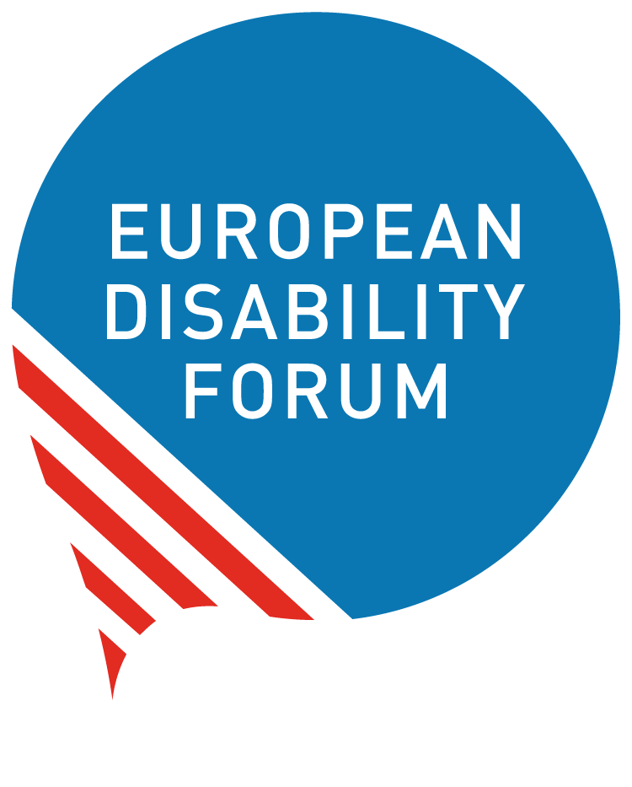

Youth with Disabilities at the Frontlines of Climate Action
  - November 2026

Youth with disabilities at the frontlines of climate action
Contents
Youth with disabilities at the frontlines of climate action 2
Why are youth with disabilities disproportionately affected by the climate crisis? 3
Why must youth with disabilities be leaders in climate action — not just included? 3
Where are youth with disabilities currently excluded from climate decision-making? 4
What barriers prevent their meaningful participation and leadership? 4
Why is climate engagement often pushed to the margins for youth with disabilities? 5
What does meaningful leadership by youth with disabilities look like in practice? 5
How does centring youth with disabilities strengthen climate movements and policy? 5
What must organisations and allies do differently to enable their leadership? 6
What must policymakers and funders do differently? 6
Document credits 8
Acknowledgements 8

Why are youth with disabilities disproportionately affected by the climate crisis?
1.2 billion people make up the global population of youth, or persons between the ages of 15 and 24 (UN). An average of 1.9% of youth have a disability, and there are roughly 22.8 million youth with disabilities (UN YOUTH 2030). This population is one of the most vulnerable to the effects of the climate crisis, but is also one of the least visible. Many compounding risks of exacerbated inequalities create a challenge of survival and justice. These factors vary from country to country, but they are typically worsened in developing countries with limited resources or support for youth with disabilities. Due to the climate crisis, youth with disabilities face:
- exclusion from emergency preparedness planning (Stein);
- limited access to early warning and evacuation systems;
- loss of assistive and medical devices;
- reduced access to caregivers an medical assistance;
- heightened water and food insecurities (Harvard);
- worsening poverty;
- greater psychological burden than previous generations (Sanson).

Why must youth with disabilities be leaders in climate action — not just included?
Youth with disabilities should be given opportunities to take leadership over climate action work that will directly affect them. When their voices are heard and uplifted, they can act as activists, innovators, negotiators, and implementers on the same level of youth without disabilities. It is crucial that youth with disabilities are not treated solely as victims or survivors of climate change but are given the agency to act. In addition, decisions that are made now will impact the inclusion of the next generations of youth for years in the future. Youth with disabilities, like all young people, should have a stake in decision making and should be able to meaningfully and actively participate. Youth with disabilities have lived experience of the effects of climate change. When given opportunities to lead, they can help create climate solutions that are unique to their needs and experiences.

Where are youth with disabilities currently excluded from climate decision-making?
Persons with disabilities (and youth with disabilities in particular) have historically been poorly represented in decision-making spaces at local, national, and global levels. On an international scale, youth with disabilities have sought for greater inclusion and recognition at the Conference of the Parties (COP), the annual climate change conference of the United Nations Framework Convention on Climate Change (UNFCCC). The UNFCCC recognises YOUNGO as a formal constituency of children and youth (UNFCCC YOUNGO), and has recently recognised the Disability Caucus as an informal group of stakeholders (EDF).
The Disability Caucus continues to advocate for their formal recognition as a constituency. This would establish an internationally recognised platform for inclusive climate action, open funding avenues, and enable caucus members to participate more directly in negotiations. To date, there has been limited involvement of young persons with disabilities in the YOUNGO constituency. Youth with disabilities face significant barriers to entry into COP, including physical barriers in venue inaccessibility (Franklin, Ruehl) as well as the challenge of gaining admittance into formal negotiations.

What barriers prevent their meaningful participation and leadership?
Overall, youth with disabilities face many pressures that delay or limit their involvement in climate action. One of the most impactful is education access — an average of 29% of young persons with disabilities have never attended school, compared to only 6% of young persons without disabilities (UN YOUTH 2030). Some additional barriers include:
- barriers and delays in access to education and training;
- low employment rate due to ableism and discrimination in hiring;
- stigma and discrimination (UN YOUTH 2030);
- Financial hardship, often due to medical costs (UN DESA);
- limited support from society and family members;
- lack of sustainable funding for inclusion and accessibility;
- lack of research and data on youth with disabilities;
- programs designed with youth with disabilities as beneficiaries, rather than partners or leaders;
- inaccessible infrastructure;
- limited availability of accessible communication formats.

Why is climate engagement often pushed to the margins for youth with disabilities?
Across many social movements, youth with disabilities are often treated as though they do not have the capacity to lead and are directly infantilised—treated like they are helpless or immature. This is often due to ableist or ageist presumptions. Within climate action, this means that the few programs that do exist for youth with disabilities may only offer a surface-level education on climate change and rarely include ways to engage with climate issues (Harvard). In general, youth with disabilities face limited access to resources and opportunities that will allow them to take leadership in the climate crisis. Additionally, disability is often seen as a social welfare or medical issue (not an underlying priority in climate action) despite the vulnerabilities persons with disabilities face due to climate change.

What does meaningful leadership by youth with disabilities look like in practice?
It is key that youth with disabilities are empowered to lead and not simply observe climate action efforts. The phrase ‘nothing about us, without us’ is central to the disability rights movement (Charlton). Youth with disabilities should have opportunities to consult, contribute, partner, and lead in the development of programming that impacts them across social movements. Additionally, youth with disabilities should be empowered and involved in climate negotiations and collaboration with civil society, youth movements, and activists already working on climate (UN YOUTH 2030).

How does centring youth with disabilities strengthen climate movements and policy?
Climate-related natural disasters and heatwaves can be disabling, and communities often struggle to effectively prepare for their effects. It is essential that systems are built to prioritise inclusion and resilience to improve accessibility and representation. Youth with disabilities can strengthen these systems by:
- offering firsthand experience of accessibility needs during extreme weather events;
- advocating for inclusive, equitable solutions using universal design principles that improve accessibility for everyone (Centre for Excellence in Universal Design);
- representing and speaking out for highly vulnerable groups;
- providing critical insights on adapting to and improving ineffective or inaccessible systems;
- naturally innovating and finding solutions for problems, using skills they have built from a lifetime of having to adapt to a world that is not made with their needs in mind;
- designing accessible climate solutions made by and for persons with disabilities.

What must organisations and allies do differently to enable their leadership?
Organisations and allies must do the following:
- Prioritise initiatives led by youth with disabilities and Organisations of Persons with Disabilities (OPDs).
- Remove access barriers by providing interpreters at events, publishing documents that are screen reader friendly, offering wheelchair accessible routes of entry into meeting spaces, etc.
- Amplify voices of and provide platforms for young leaders with disabilities.
- Coordinate meaningful, active engagement with youth with disabilities (UN YOUTH 2030).
- Prioritise inclusion in climate-resilient development (Lancet).
- Dedicate funding to accessibility and support for youth with disabilities.
- Collaborate with organisations like the Youth Negotiators Academy to provide training, capacity building opportunities, mentorship, and psychological support.
- Recognise the impact of intersectional issues and avoid tokenism.

What must policymakers and funders do differently?
Policymakers and funders must do the following:
- Prioritise funding for youth with disabilities and OPDs in climate action.
- Ensure accessibility and user-friendly design in all stages of grantmaking, from applications to award reporting requirements (Disability Rights Fund).
- Facilitate collaboration and networking opportunities between OPDs, and work with OPDs to inform inclusive political and financial strategies.
- Directly engage with youth with disabilities in the development of disability-inclusive policies (UN YOUTH 2030).
- Integrate disability inclusion into the policy areas of Just Transition, Nationally Determined Contributions, Global Goal on Adaptation, Gender Action Plan, and the institutional mechanisms of the UNFCCC (EDF).
- Use the Convention on the Rights of Persons with Disabilities as the basis to guide policy surrounding the involvement of youth with disabilities in climate action (Convention on the Rights of Persons with Disabilities).
- Provide long-term support for projects led by youth with disabilities, not just short-term support or symbolic approval.
- Develop policies that incorporate inclusion into climate action and resilience.

Document credits
This document was prepared by Marie Renahan, Consultant, European Disability Forum
Assisted/Supervised by Marion Steff, International Cooperation Manager, European Disability Forum

Acknowledgements
Thanks to all who participated in the drafting of this position paper: Ogunrinu Anuoluwapo, Oyedapo Emmanuel, and Hannah Omokhaye from Ecological Smart for Green Transition LTD/GTE; Kudzai Sharon Kandemiri, youth negotiator from Zimbabwe; Victoria Lee from Disability Rights Fund.

The European Disability Forum
Mundo Madou
Avenue des Arts 7-8
1210 Brussels, Belgium.
www.edf-feph.org
info@edf-feph.org
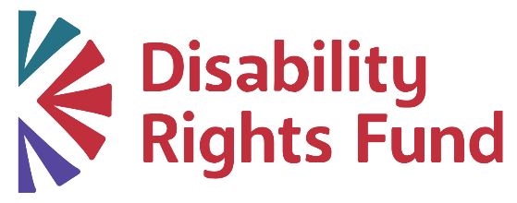
Disability Rights Fund
68 Harrison Ave., Suite 605
PMB 655441
Boston, MA 02111-1929
USA
https://www.disabilityrightsfund.org/
info@disabilityrightsfund.org
Youth Negotiators Academy
https://www.youthnegotiators.org/

